## Front End Test Cases

|  |  |  |  |
| --- | --- | --- | --- |
| **Test Case** | **Expected Result** | **Test Description** | **Actual Result** |
| **Homepage** | Homepage with all the features of site displayed. | To start the front-end client program, type the path to the project’s default location. | Home page was loaded. |
| **Registration** | By providing all user details correctly, a new account should be created. | On login page click on create new user. You will need to type all the required info for creating an account. | By typing all the details, a new account was created. |
| **Login** | By providing correct username and password, user will be logged in | To do the test type valid user and password. | User is logged in successfully. |
| **Account Information** | Displays the current logged in user’s details. | After logging in, click on the username that has appeared on the top right corner of the page. | The details of user are successfully displayed. |
| **Categories** | Displays categories dynamically | Select categories section on top right corner of the home page. | Categories are being displayed on left side of screen for selection. Since no category is selected initially, all products are displayed. |
| **Products** | Displays products based on category selected on categories page. | Select category POP from right side of the page. | The products Items in category pop are displayed. |
| **ProductInformation** | Display the details of Product/CD | Select on Video Killed the Radio Star item on Products page. | The productinfo page with the exact details of cd is displayed. You can add the cd to your shopping cart. |
| **AddToCart** | Adds the CD to the current user’s shopping cart. | On the productInfo displaying details of “Video Killed the Radio Start”, click on Buy button. | The CD was successfully added to the cart. |
| **RemoveFromCart** | Removes the CD from the current user’s shopping cart. | On the MyCart page displaying “Video Killed the Radio Start” item on the list, click on Remove button. | The CD was successfully removed from the cart. |
| **ViewCart** | Displays all items added to current shopping cart. | On top right corner of the screen, click on MyCart to view all the items in shopping cart. | The CD with title “Video Killed the Radio Start” can be viewed on the shopping cart. |
| **OrderCheckout** | To check out and confirming the order. | On my cart page click on “check out” button. | The Order Check out page is displayed with total price and option of modifying shipping address. |
| **PaymentManager** | Displays payment options and card details. | On Order Check Out page click on proceed to payment. | The payment manager page is displayed. |
| **PaymentHandler** | Displays third party payment page. | On Payment manager page click on submit. | The Third Party Payment page is displayed. |

**Screenshots**

**Login Page:** It allows an existing user to login. If the user is new, it provides an option to register.

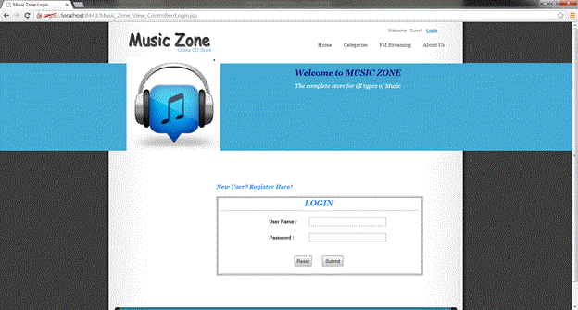

**Registration Page:** It allows the user to enter the necessary details and register.

Returns Error Message if username already exists

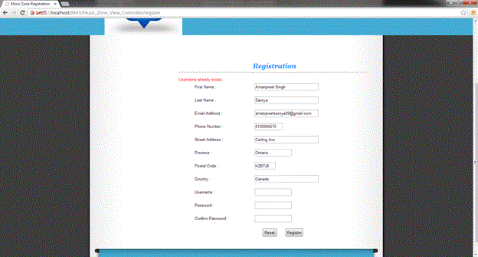

**Categories Page:** The user clicks on ‘Categories’ in the header and all items are displayed and genres are made visible in left sidebar

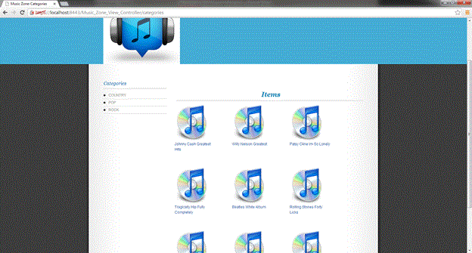

**Product Information page:** It displays the product information and its price. It has an option to buy the product. The user can only buy the product if he is logged in. If he is a ‘guest’ and tries to buy, he is mapped to the login page and after successful login is guided back to the same page.

Click on ‘Buy’ and that item is added to the cart.

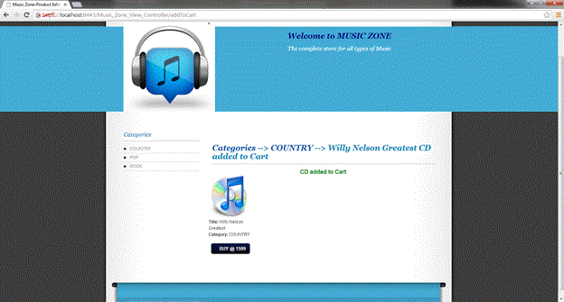

**My shopping cart page:** It displays all the items added by the user in the shopping cart. The user can

Press ‘Remove’ button and that item is removed from the cart

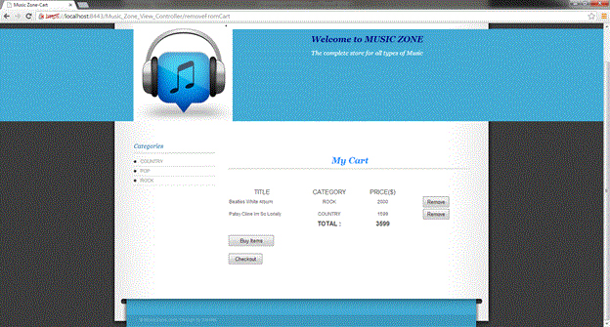

**Order Checkout Page:** It displays the final order details along with final amount which includes 10% taxes. If user wants to use another shipping address instead of default, he/she can enter and edit it here.

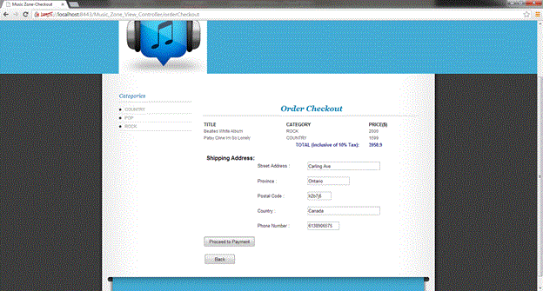

**Payment page:** It allows user to enter card details and make payment

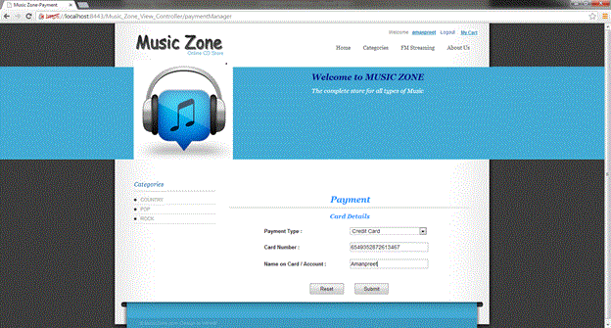

**Third Party Payment page:** It is a separate page as it authenticates the transaction.

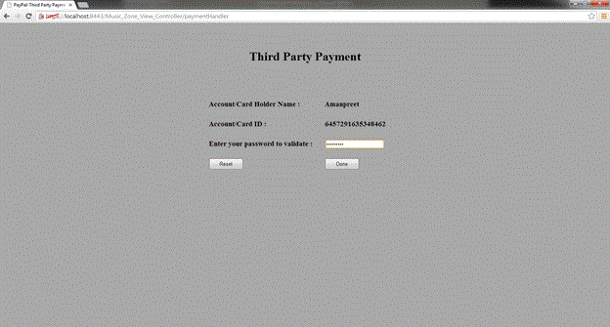

**Order Confirmation Page:**It confirms the order if payment authentication is success and returns the Order ID.

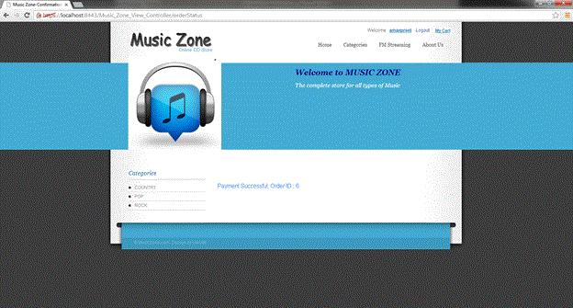

**Account Information page:** It displays the information of the registered user which was entered during registration. It can be accessed by clicking on the username displayed in the header after login.

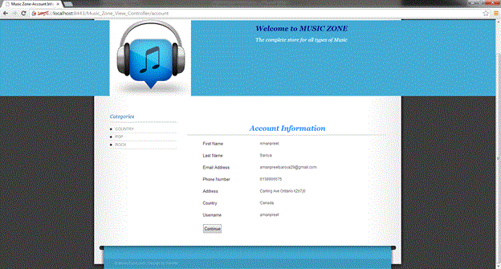

## Backend Test Cases:

|  |  |  |
| --- | --- | --- |
| **#** | **Test Case** | **Expect Result** |
| **1** | ProductCatalog.getCategoryList | COUNTRY,POP,ROCK |
| **2** | ProductCatalog.getProductList:  input category is POP | Return cd007, cd008, cd009 |
| **3** | ProductCatalog.getProductList:  input category is null | Return all cds in database: cd001 to cd009 |
| **4** | ProductCatalog.getProductInfo:  input cdid is cd001 | Return cd001’s detail: <category>COUNTRY</category>, <cdId>cd001</cdId>, <price>1599</price>, <title>Johnny Cash Greatest Hits</title> |
| **5** | ProductCatalog.getProductInfo:  input cdid is wrong, like cd00189256 | Null |
| **6** | OrderProcessor.createAccount  Input: - existing UserName  missing username or password | false |
| **7** | OrderProcessor.createAccount  Input: correct info | Adds account to database  Return true |
| **8** | OrderProcessor.getAccount  Input :missing or wrong username/password | Returns an account obj with a blank username and password |
| **9** | OrderProcessor.getAccount  Input:correct username/password | Full user info is retrieved |
| **10** | OrderProcessor.createOrder  Input: empty list of CDs | ERROR : Empty cd list |
| **11** | OrderProcessor.createOrder  Input: list of CDs | Total price is calculated |
| **12** | OrderProcessor.createOrder  Input: no existing cdid | Returns purchase order object with PurchaseOrder.errorString = Invalid CD Id. |
| **13** | OrderProcessor.confirmOrder  Input: full and correct info | Adds the order to PO and POItem table and returns the purchase order object with errorString=”” and purchaseOrderId set to the generated ID in database. |
| **14** | OrderProcessor.confirmOrder  Input: missing cdid | ERROR:missing cd list |
| **15** | OrderProcessor.confirmOrder  Input: missing status or paymentType | ERROR:posting purchase order |
| **16** | OrderProcessor.confirmOrder  missing username | ERROR: missing username |

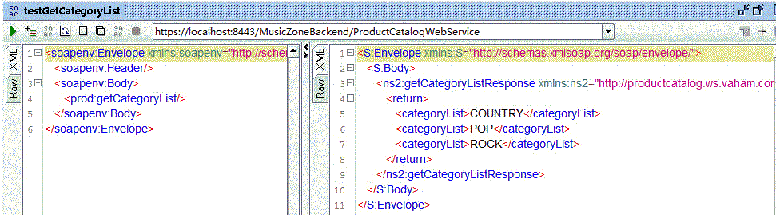

Testcase: Categorylist

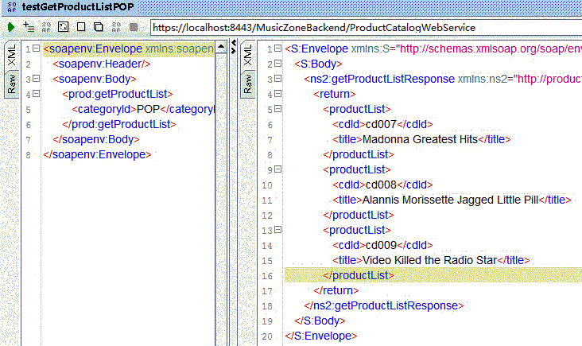

Testcase: get product list for a category

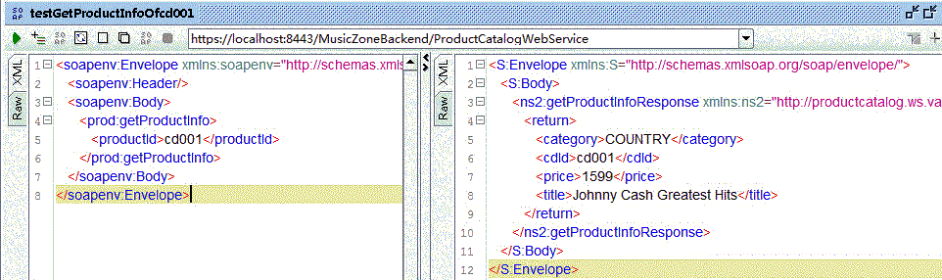

Testcase: Cd Info

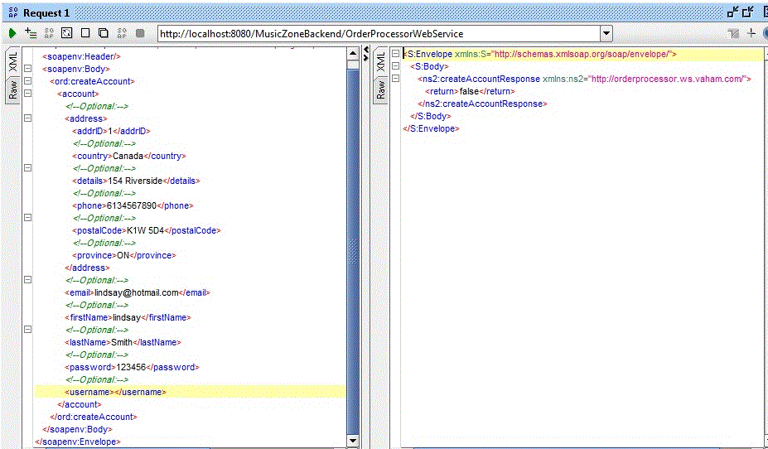

Testcase : Blank username

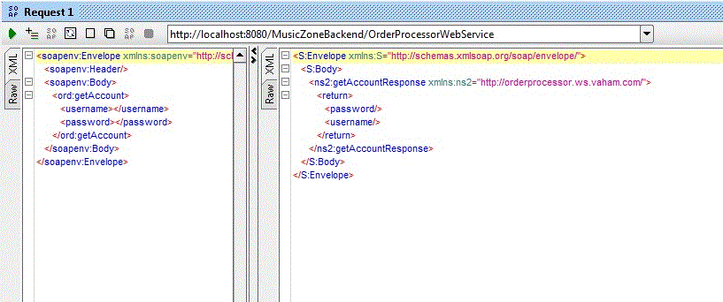

Testcase: For blank username/password

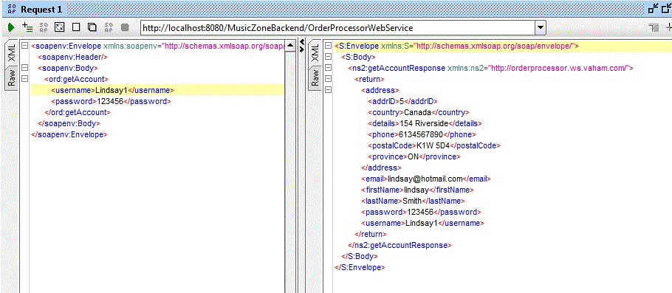

Testcase: Correct username/password

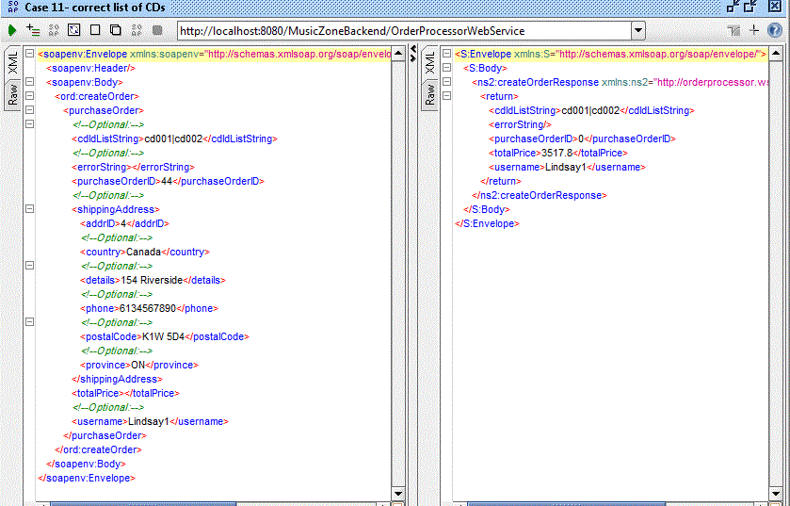

Testcase: Correct total price calculated by createOrder

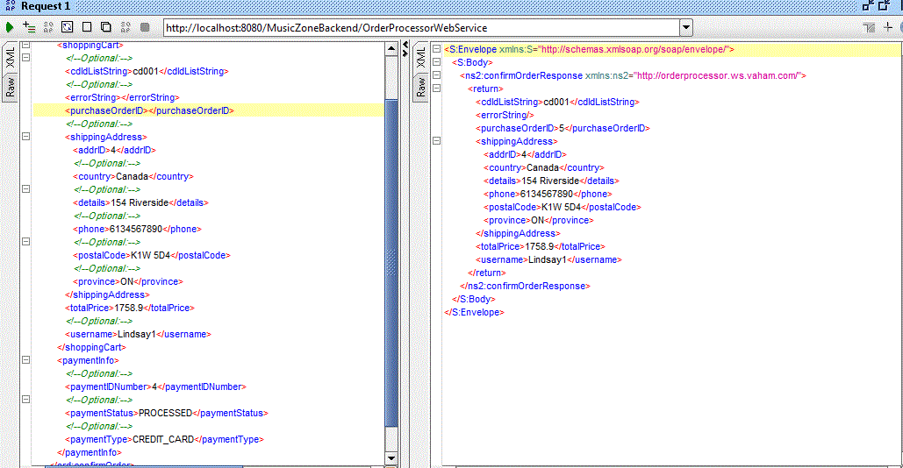

Testcase: Shopping cart id populated for correct posting of shopping cart (confirmOrder)

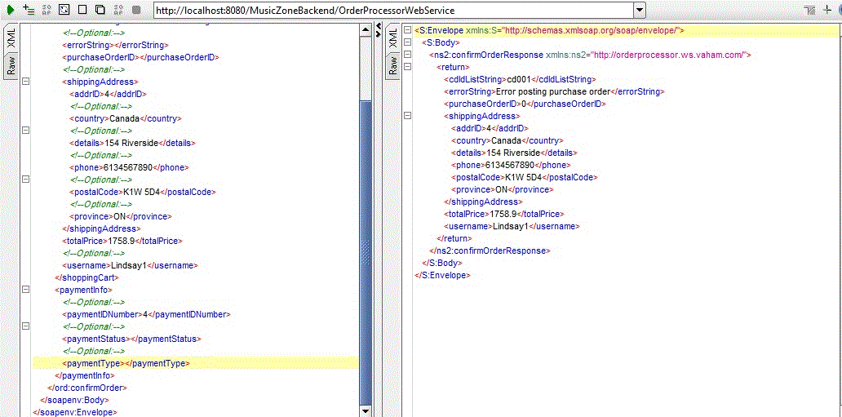

Testcase:Missing payment type handling