**A**

**MINI PROJECT REPORT**

**on**

**Crisis Connect**

**BE(IT)-III Sem**

**By**

**Anvesh(160122737050)**

**Tomson(160122737056)**

**Under guidance of**

**Mr. K .Rajesh Kannan**

**Assistant professor**

**IT Department**



**DEPARTMENT OF INFORMATION TECHNOLOGY**

**CHAITANYA BHARATHI INSTITUTE OF TECHNOLOGY (A)**

**(Affiliated to Osmania University; Accredited by NBA(AICTE) and NAAC(UGC), ISO Certified 9001:2015)**

**KOKAPET(V), GANDIPET(M), RR District HYDERABAD - 75**

**Website:** [**www.cbit.ac.in**](http://www.cbit.ac.in/)

**2022-2023**



This is to certify that the project work entitled “**Crisis Connect** ” submitted to CHAITANYA BHARATHI INSTITUTE OF TECHNOLOGY, in partial fulfillment of the requirements for the completion of Mini Project-I of III Semester B.E. in Information Technology, during the Academic Year 2021-2022, is a record of original work done by Anvesh(160122737050) and Tomson(160122737056) during the period of study in the Department of IT, CBIT, HYDERABAD, under our guidance.

|  |  |
| --- | --- |
| **Project Guide** | **Head of the Department** |
| **Mr. K. Rajesh Kannan** | **Dr. Rajnikanth Aluvalu** |
| Assistant Professor, Dept. of IT, | Professor, Dept. of IT, |
| CBIT, Hyderabad. | CBIT, Hyderabad. |

## 

## **ACKNOWLEDGEMENTS**

We would like to express our heartfelt gratitude to Mr. K Rajesh Kannan, our project guide, for her invaluable guidance and constant support, along with her capable instruction and persistent encouragement.

We are grateful to our Head of Department, Dr. K. Radhika, for her steady support and for the provision of every resource required for the completion of this project.

We would like to take this opportunity to thank our Principal, Dr. P. Ravinder Reddy, as well as the Management of the Institute, for having designed an excellent learning atmosphere.

Our thanks are due to all members of the staff and our lab assistants for providing us with the help required to carry out the groundwork of this project.

**CONTENTS**

|  |  |  |
| --- | --- | --- |
| S.NO | Topics | Page No. |
| 1 | Abstract | **5** |
| **2** | List of figures | **6** |
| **3** | **Introduction**   1. Motivation 2. Problem statement | **7** |
| **4** | Existing system | **7** |
| **5** | **Proposed methodology**   1. System specifications 2. System design | **8** |
| **6** | Datasets and Algorithms/ models | **11** |
| **7** | Implementation and Results | **13-20** |
| **8** | Conclusion and Future scope | **20-21** |
| **9** | References | **22** |
|  |  |  |

**­**

**ABSTRACT**

Crisis Connect is an innovative disaster management system designed to streamline relief efforts, facilitate fundraising, and coordinate volunteer activities during emergencies. The significance of this project lies in its ability to offer a unified platform where affected individuals can receive timely assistance and volunteers can efficiently organize and respond to crises. By leveraging modern technology, Crisis Connect ensures that critical information about new disasters is swiftly disseminated to volunteers, enhancing the speed and effectiveness of relief operations.

The primary objectives of Crisis Connect are to provide a reliable system for generating funds, create a centralized platform for volunteer coordination, and ensure real-time updates and notifications about emerging disasters. Utilizing a robust methodology that combines web and mobile technologies, the platform integrates social media alerts, geolocation services, and automated notifications to keep all stakeholders informed and engaged. This approach not only maximizes the reach and impact of relief efforts but also fosters a community-driven response to disasters.

Major findings from the prototype development of Crisis Connect highlight its potential to significantly reduce response times and improve the organization of volunteer efforts. Initial tests indicate that the platform can successfully manage high volumes of data and communications, ensuring that aid reaches those in need promptly. By bringing together donors, volunteers, and disaster-stricken communities on a single platform, Crisis Connect promises to revolutionize the way we respond to and manage disasters, ultimately saving lives and resources.

**List of Figures**

| **Figure No** | **Name** | **Page No** |
| --- | --- | --- |
| 1 | Homepage Components | 14 |
| 2 | Disasters page  Implementation | 15 |
| 3 | Donation page  Implementation | 15 |
| 4 | Routes related to Application | 16 |
| 5 | Home section | 16 |
| 6 | Recent Crisis | 17 |
| 7 | Donation Form | 17 |
| 8 | Footer and Help Section | 18 |
| 9 | Crisis detail view | 18 |
| 10 | Add images, comments dialogs | 19 |
| 11 | Volunteers and Donations | 21 |
| 12 | Mail Notification to Volunteers | 21 |
|  |  |  |

**INTRODUCTION**

**1.Motivation**

The motivation behind creating Crisis Connect is rooted in a profound desire to make a tangible difference in the way communities respond to disasters. Witnessing the devastating impact of natural and man-made disasters on people's lives and livelihoods, I felt compelled to leverage my skills in technology to create a solution that could facilitate faster, more efficient, and more coordinated responses. Crisis Connect is envisioned as a comprehensive platform that not only streamlines the process of generating funds for disaster relief but also serves as a hub for volunteers eager to offer their assistance.

By enabling real-time updates on new disasters, the platform ensures that volunteers and aid organizations can be promptly informed and mobilized, thereby maximizing the impact of their efforts. This project is driven by the belief that in the face of adversity, technology can be a powerful catalyst for change, enabling communities to come together, support one another, and rebuild stronger.

**2. Problem statement**

**Crisis Connect: Empowering Communities, Mobilizing Help**

Crisis Connect addresses the challenge of disaster management by providing a unified platform for efficient response and recovery. By enabling fund generation, volunteer coordination, and real-time disaster reporting, Crisis Connect ensures timely and effective assistance. The platform automatically notifies volunteers of new disasters, facilitating swift action and support when it is needed most.

**EXISTING SYSTEM**

**Literature Survey:**

In the realm of disaster management, numerous systems and platforms have been developed to address various aspects of disaster preparedness, response, and recovery. Traditional systems often focus on specific functionalities such as emergency alerts, resource management, or volunteer coordination. For instance, government and NGO-led platforms like FEMA's disaster management system in the United States provide crucial information and resources during emergencies.

Similarly, platforms like Google Crisis Map and various social media channels have been instrumental in disseminating real-time information during disasters. However, these systems often operate in silos, lack integration, and are sometimes inaccessible to the general populace, particularly in developing regions.

Other platforms, like GoFundMe, have revolutionized the way funds are raised for disaster relief but do not offer a comprehensive suite of services necessary for a holistic disaster response. Volunteer management systems such as All Hands and Hearts offer great volunteer coordination but may not effectively integrate with other aspects of disaster management such as fundraising and real-time disaster reporting.

**How Crisis Connect differs:**

Crisis Connect distinguishes itself by offering a unified and integrated platform that combines fund generation, volunteer coordination, and real-time disaster reporting into a single, user-friendly interface. Unlike traditional systems that address individual aspects of disaster management in isolation, Crisis Connect provides a holistic approach, ensuring seamless coordination between fundraising efforts, volunteer mobilization, and disaster notifications. This integration not only enhances the efficiency and effectiveness of disaster response but also ensures that volunteers are promptly informed and resources are mobilized swiftly.

Furthermore, this allows for more precise targeting of resources and better coordination among responders. By fostering a community-driven approach, Crisis Connect also empowers individuals to contribute to disaster management efforts, ensuring that help is not only top-down but also driven by grassroots participation. This comprehensive and integrative approach makes Crisis Connect a pioneering solution in the disaster management landscape.

**PROPOSED METHODOLOGY**

**System specifications**

**1. Functional Requirements**

The functional requirements of Crisis Connect are designed to ensure the platform is comprehensive, user-friendly, and capable of addressing the various needs associated with disaster management. The primary functional requirements include:

* **Disaster Reporting and Notification**: The system must allow users to report new disasters, including details such as location, severity, and type of disaster. Upon receiving these reports, the system should automatically notify registered volunteers and relevant authorities through multiple channels including email, SMS, and push notifications.
* **Volunteer Management:** The platform should facilitate the registration, organization, and deployment of volunteers. This includes features for volunteer sign-up, skills and availability tracking, task assignment, and communication tools to coordinate efforts efficiently.
* **Fundraising and Resource Management:** Crisis Connect must include a robust mechanism for generating funds, which could involve integrating with payment gateways for donations and providing transparent tracking of funds received and allocated. Additionally, it should manage the procurement, storage, and distribution of physical resources like food, water, and medical supplies.

**2. Non-Functional Requirements**

To ensure that Crisis Connect operates effectively and reliably, several non-functional requirements must be addressed. These include:

* **Scalability:** The platform must be able to scale to accommodate a large number of users and high volumes of data, especially during major disasters when usage spikes. This requires a robust backend infrastructure that can handle increased load without performance degradation.
* **Security:** Ensuring the security of user data and financial transactions is paramount. The system must implement advanced security measures such as encryption, secure authentication protocols, and regular security audits to protect against data breaches and cyber-attacks.
* **Reliability and Availability:** Crisis Connect must be highly reliable and available 24/7, especially during emergencies. This includes implementing failover mechanisms, redundant systems, and regular backups to minimize downtime and ensure continuity of service.
* **Usability:** The platform should be intuitive and easy to use for people with varying levels of technical expertise. This involves a user-centered design approach, comprehensive user guides, and responsive customer support to assist users in navigating the system.
* **Performance:** The system must deliver fast and efficient performance, with quick load times and responsive interactions. This is critical in emergency situations where delays can have significant consequences.

**System design**

**User Interface Design**

The user interface (UI) design of Crisis Connect focuses on creating a seamless and intuitive experience for its diverse user ,home, registration disasters, volunteers, donors, and the general public.

1. **Dashboards**: Crisis connect contains varies dashboards like Donations,Volunteers which give details information about list of volunteers and there details .Also have Donors which contains how many users are donated for crisis .
2. **Navigation:** Navigation across the platform is designed to be intuitive and efficient. A responsive menu provides quick access to key sections such as Disaster Reports, Volunteer Coordination, Fundraising, and Resource Management. Each section is logically organized to ensure users can find and access the tools and information they need with minimal effort. The use of visual cues, such as icons and color-coding, helps users quickly identify important information and actions.
3. **Database Design:** The database design for Crisis Connect leverages MongoDB due to its flexibility, scalability, and ability to handle large volumes of unstructured data. MongoDB’s document-oriented model is particularly suited for the diverse data types and relationships involved in disaster management.

* **Schema Design**: The database schema is designed to accommodate various entities such as Users, Disasters, Volunteers, Donations, and Resources. Each entity is stored as a collection, with documents representing individual records.
* For example:
* **Users Collection**: Stores user profiles, including roles, contact information, and authentication details.
* **Disasters Collection**: Contains records of reported disasters, including location, type, severity, and status updates.
* **Volunteers Collection**: Tracks volunteer information, skills, availability, and assigned tasks.
* **Donations Collection**: Records donation details, amounts, donor information, and allocation statuses.

**DATASETS :**

Historical Disaster Data: This dataset comprises historical records of past disasters, including their types, locations, severity, impact on communities, response times, and effectiveness of relief efforts. Such data can be sourced from government agencies, NGOs, and international disaster databases like EM-DAT.

Volunteer Information: Dataset containing information about registered volunteers, their skills, availability, previous experiences, and preferences for deployment. This data helps in efficient volunteer coordination and task assignment during disasters.

Donation Records: Records of donations received during disasters, including donor details, donation amounts, allocation preferences (e.g., specific disaster relief funds), and utilization tracking.

**Algorithms/Models:**

* **Volunteer Matching and Task Assignment:**
* Matching Algorithms: Employ matching algorithms like the Gale-Shapley algorithm (used in stable matching problems) or Reinforcement Learning-based approaches to match volunteers' skills and availability with specific disaster relief tasks effectively.
* **Donation Utilization Analysis:**
* Statistical Analysis and Forecasting: Conduct statistical analysis and time-series forecasting to analyze donation trends, predict future donation flows, and optimize donation utilization based on changing disaster needs and response effectiveness.
* **Resource Allocation and Optimization:**
* Optimization Algorithms: Use optimization algorithms such as Linear Programming or Genetic Algorithms to optimize resource allocation based on real-time disaster reports, volunteer availability, geographical constraints, and priority needs.
* **Machine Learning (ML) Algorithms**: Utilize ML algorithms like Random Forest, Support Vector Machines (SVM), or Deep Learning models (e.g., Convolutional Neural Networks) to analyze historical disaster data and predict future disaster occurrences, severity levels, and potential impact areas. Implement anomaly detection algorithms for early warning systems.

**Software Requirements**:

* **Text Editor/IDE:** Visual Studio Code, Sublime Text, Atom, or any other preferred text editor or integrated development environment (IDE)
* **Node.js and NPM:**

Node.js (LTS version recommended)

NPM (Node Package Manager)

* **MongoDB:**

MongoDB Community Edition or MongoDB Atlas (cloud-based)

* **Express.js:**

Express.js framework for building RESTful APIs

* **React.js:**

React.js library for frontend development frontend (React components, UI libraries like Bootstrap or Material-UI)

* **Version Control:**

Git for version control

GitHub, GitLab, or Bitbucket for hosting repositories (optional but recommended for team collaboration)

**Hardware Requirements**

▪ Windows 11

* ▪ Processor: Minimum 1 GHz; Recommended 2 GHz or more.
* ▪ Ethernet connection (LAN) OR a wireless adapter (Wi-Fi).
* ▪ Hard Drive: Minimum 32 GB; Recommended 64 GB or more.
* ▪ Memory (RAM): Minimum 1 GB; Recommended 4 GB or above.

**IMPLEMENTATION AND RESULTS**

**1.IMPLEMENTATION:**

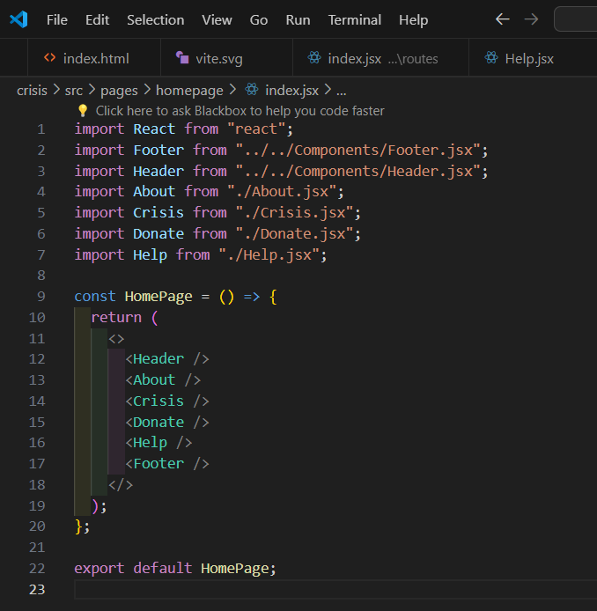

**Fig1:Homepage Components**

**Homepage:**

The homepage of Crisis Connect features a clean, user-friendly layout designed for easy navigation. It includes a prominent Header with the site logo and navigation menu, an informative About section that introduces the platform’s mission, a Recent Crises section displaying real-time updates and details of current disasters, a Donation Help section encouraging users to contribute funds to support relief efforts, and a comprehensive Footer.

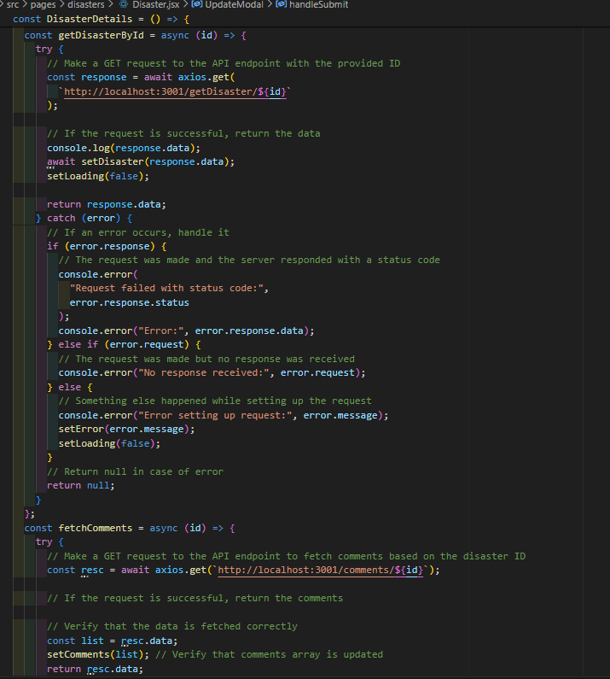

**Fig2:Disasters page**

**Disasters Page:** The Disasters page provides detailed information about each disaster, including its location, severity, and impact. Users can view real-time updates, access resources, and find ways to assist through volunteering or donations. This section ensures transparency and keeps the community informed and engaged with ongoing relief efforts.

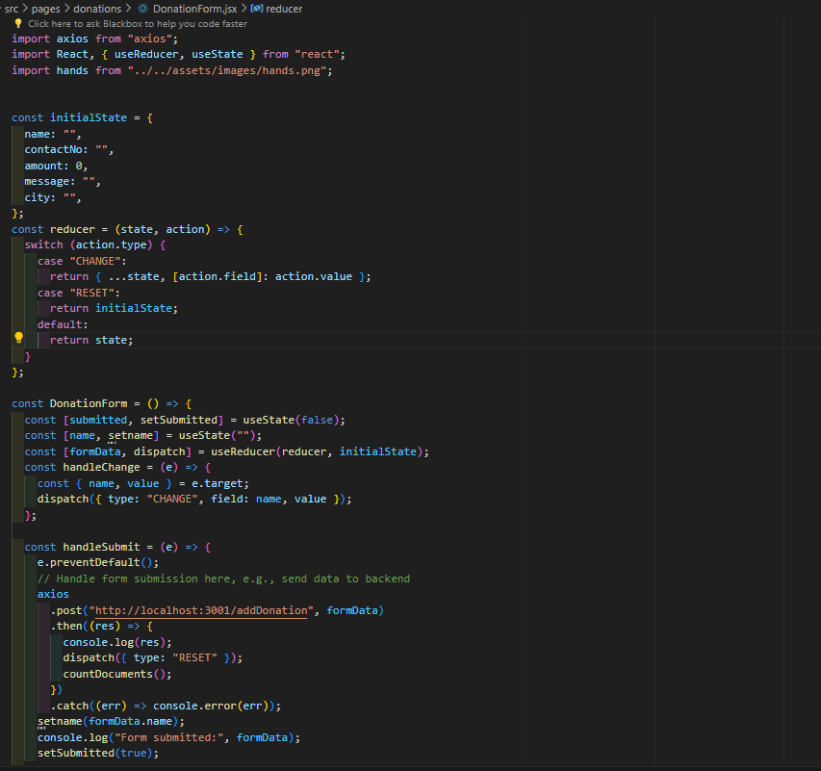

**Fig3 :Donation page**

**Donation Page:** The Donation page provides a comprehensive list of all user contributions, displaying donor names, donation amounts, and the specific causes or crises they supported. This transparent overview fosters trust and accountability, allowing donors to see the impact of their generosity.

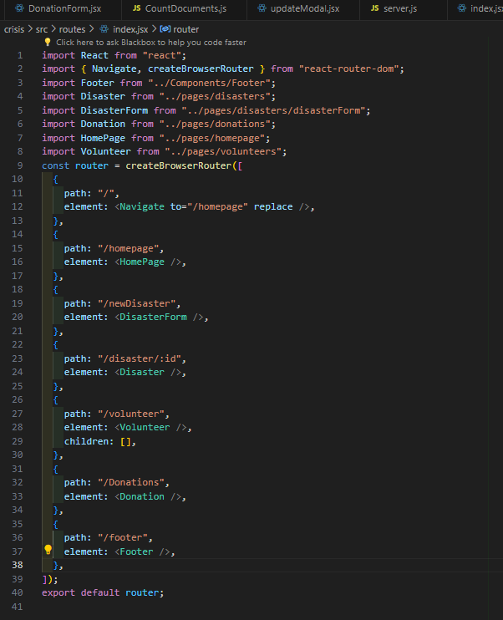

**Fig4: Routes**

**RESULTS**

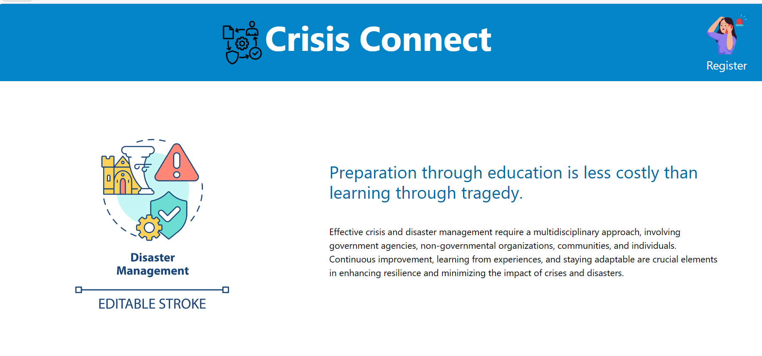

**Fig5:Home section**

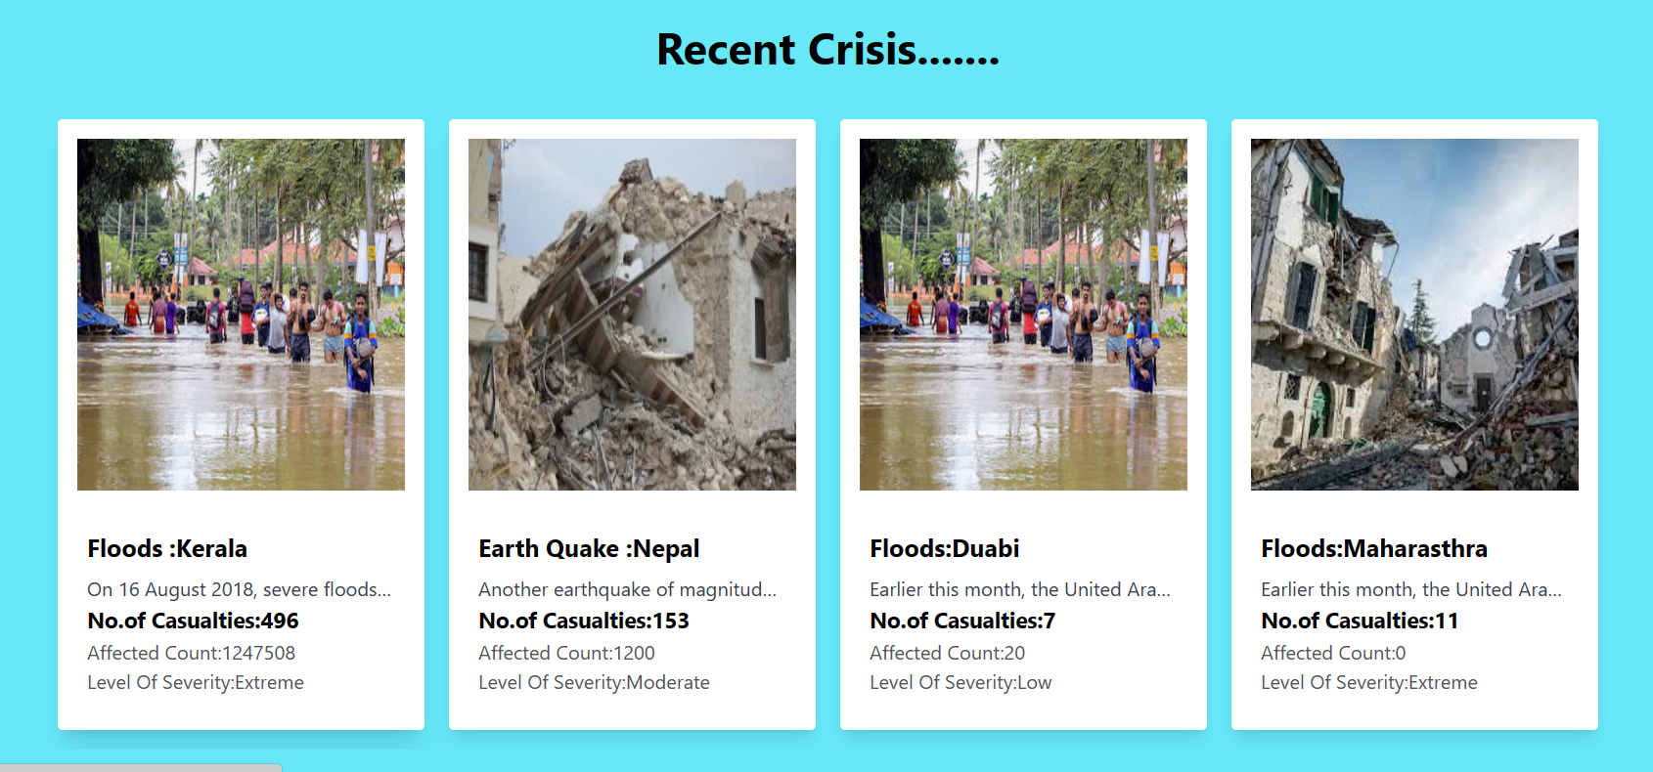

**Fig6: Recent Crisis**

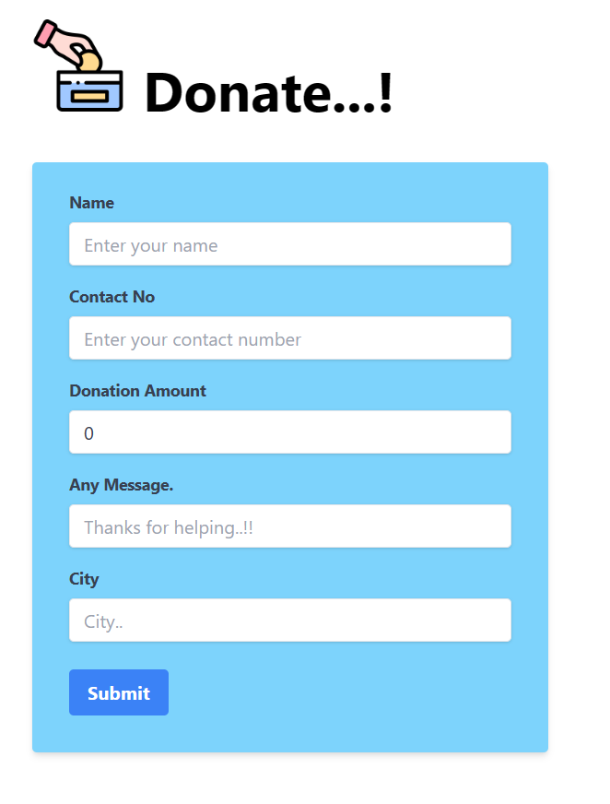

**Fig7: Donation Form**

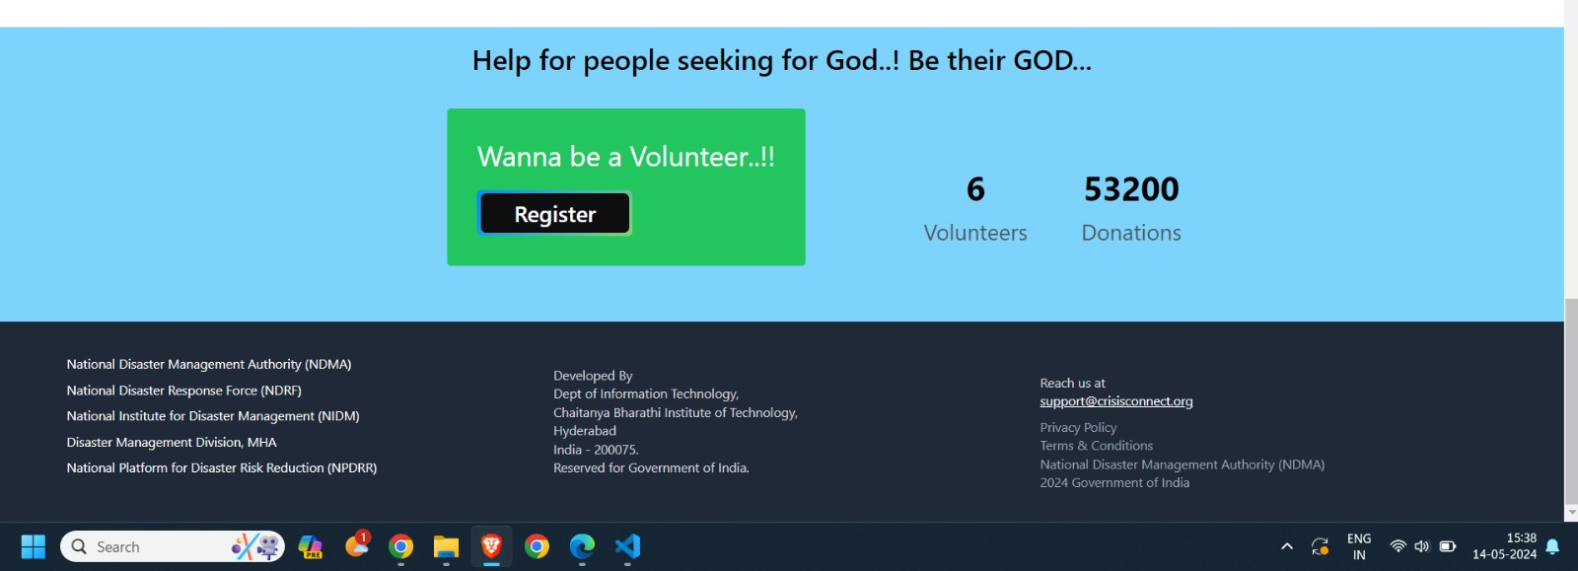

**Fig8 :Footer**

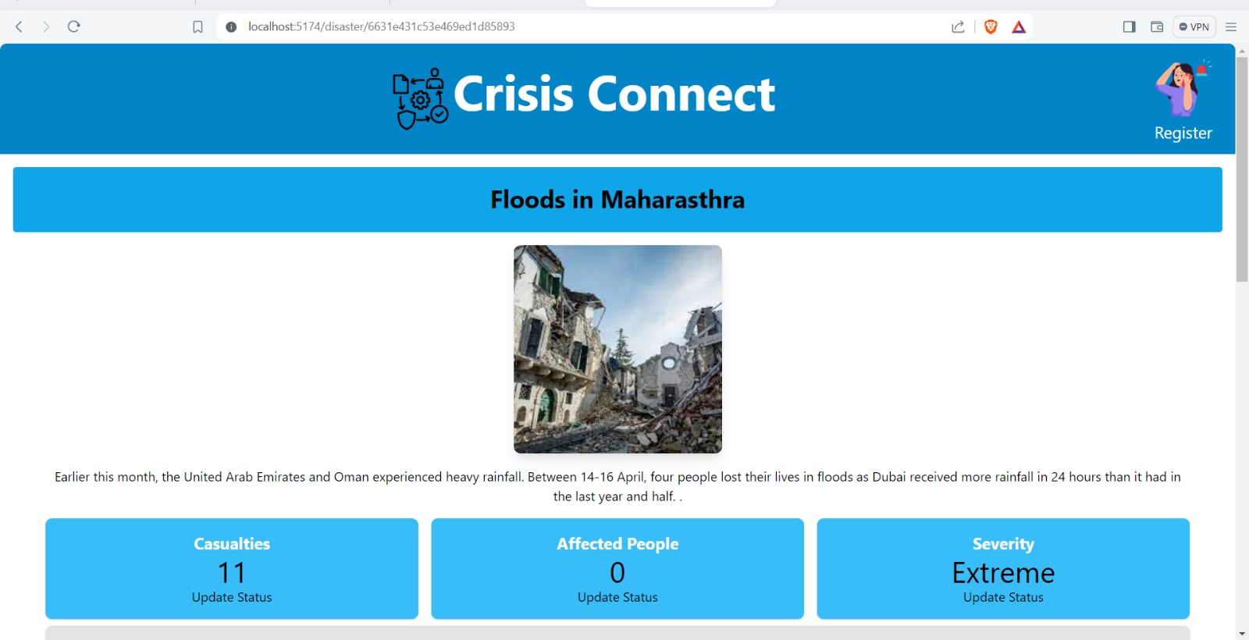

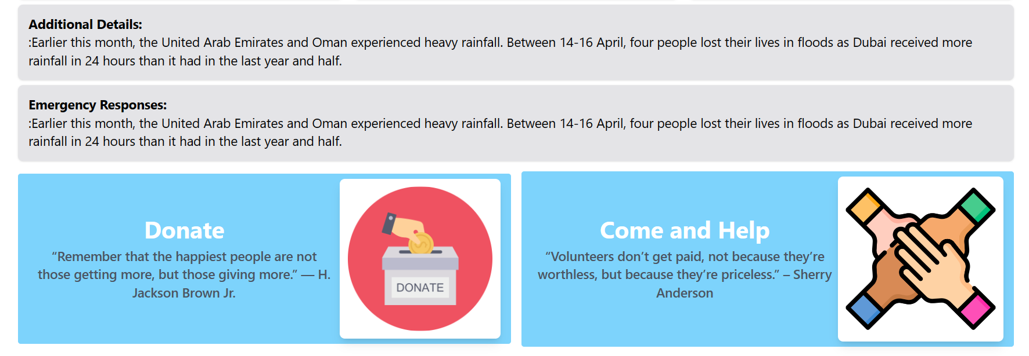

**Fig9:Crisis detail view**

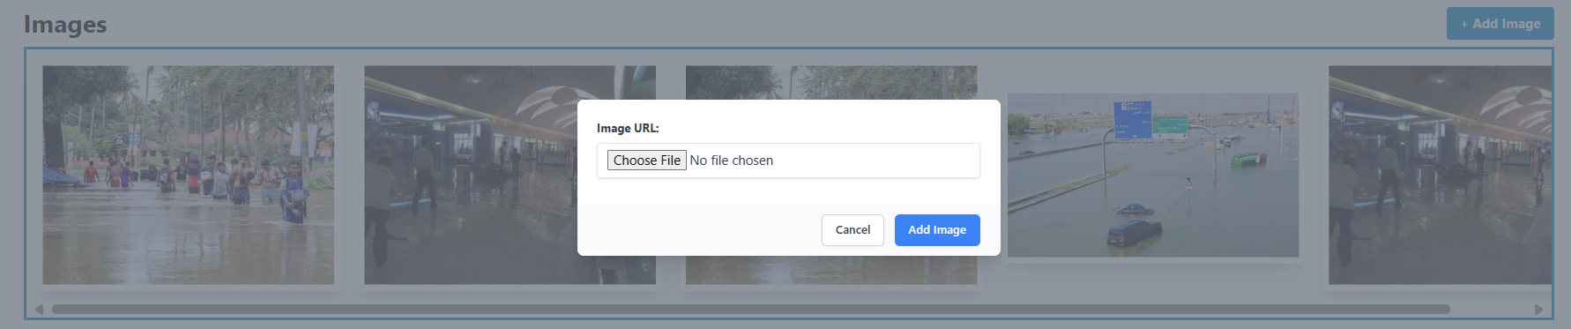

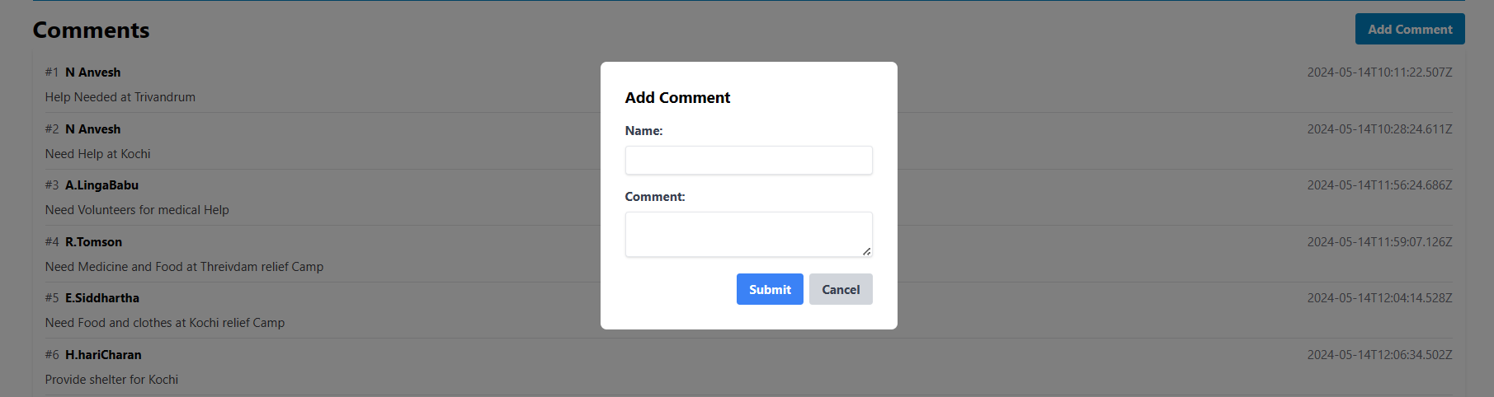

**Fig 10 :Add images, comments**

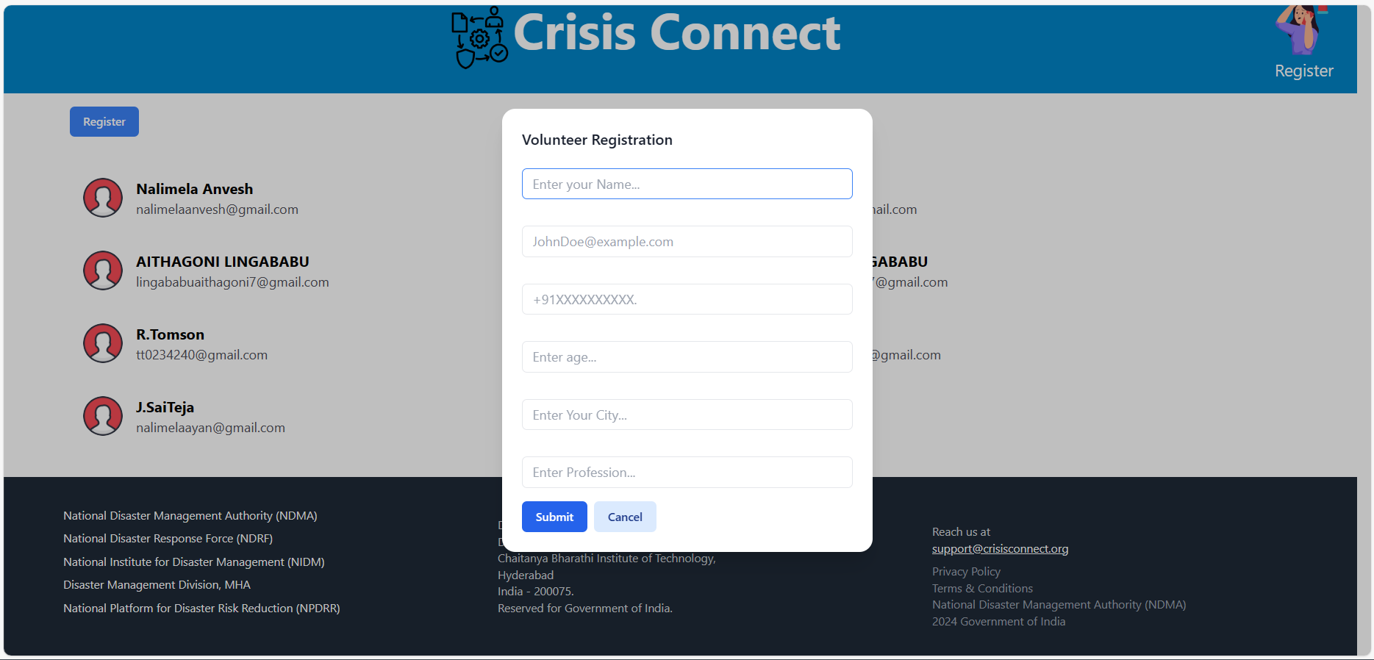

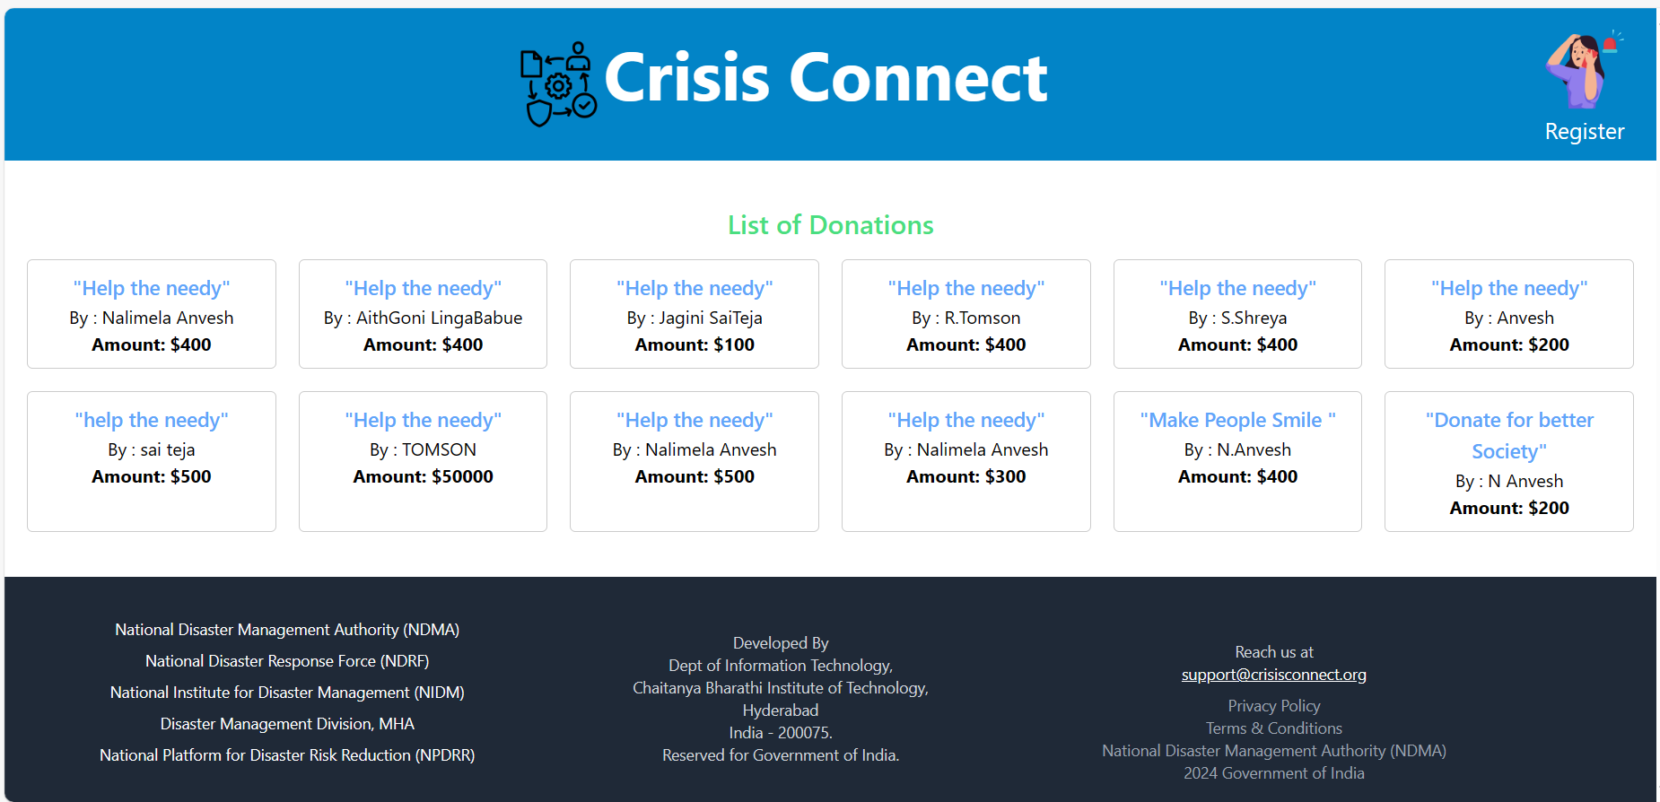**Fig11 : Volunteers and Donotions**

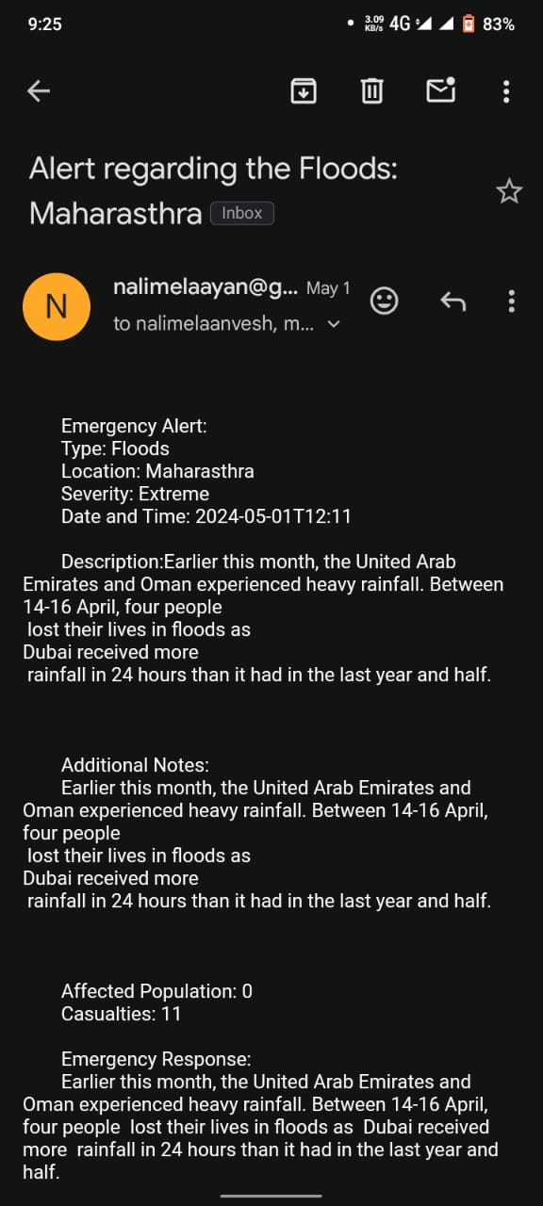

**Fig12:Mail Notification**

**CONCLUSION and FUTURE SCOPE:**

Crisis Connect represents a significant step forward in disaster management by leveraging the power of modern web technologies and community-driven approaches. By integrating functionalities for real-time disaster reporting, volunteer coordination, and fundraising within a single platform, it provides a comprehensive solution that addresses critical needs during emergencies. The user-friendly interface ensures that individuals and organizations can quickly and efficiently contribute to disaster relief efforts, fostering a sense of community and collective responsibility. The use of the MERN stack ensures a scalable, robust, and flexible foundation, making Crisis Connect a reliable tool in times of crisis.

* **Enhanced AI and Machine Learning:** Future iterations of Crisis Connect can incorporate advanced AI and machine learning algorithms to predict disasters, assess damage more accurately, and optimize resource allocation. These technologies can also help in personalizing volunteer and donor experiences by recommending actions based on historical data and user preferences.
* **Mobile Application Development:** Developing mobile applications for both Android and iOS platforms can increase accessibility and ensure that users can report disasters, volunteer, and donate on the go. Mobile push notifications can also provide real-time updates and alerts to users.
* **Integration with Government and NGO Systems:** Establishing partnerships and integrating with governmental and non-governmental organization systems can enhance the platform’s effectiveness. This integration can facilitate better data sharing, resource pooling, and coordinated response efforts.
* **Community Engagement and Training:** Introducing features for community engagement, such as forums, training modules, and educational resources, can empower individuals with the knowledge and skills to respond effectively in disaster situations.

By continuously evolving and incorporating these advancements, Crisis Connect can significantly enhance its capabilities, making it an indispensable tool in the global effort to manage and mitigate the impacts of disasters.

**REFERENCES:**

* FEMA Disaster Management System
* Google Crisis Map
* All Hands and Hearts – Volunteer Coordination Platform
* MongoDB Documentation
* Node.js Official Documentation
* Express.js Official Documentation
* React.js Official Documentation