1. (2 points) State whether each of the following is true or false. If false, explain why.

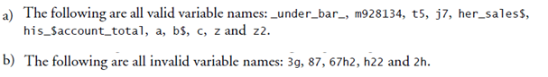

1. True all are valid variable names.
2. False, only h22 is valid because it starts the variable name must always start with a letter, $, or an underscore.