**CL 249 Computational Methods Lab**

**Assignment 7**

Q1. A system of reactors is given below whose dynamics need to be simulated. The mass balance for the first reactor can be written as:

$V_{1}\frac{dc_{1}}{dt}=Q_{01}c_{01}+Q_{31}c_{3}−Q_{12}c_{1}−Q_{15}c_{1}$

or, after substituting of parameters:

$\frac{dc_{1}}{dt}=−0.12c_{1}+0.02c_{3}+1$

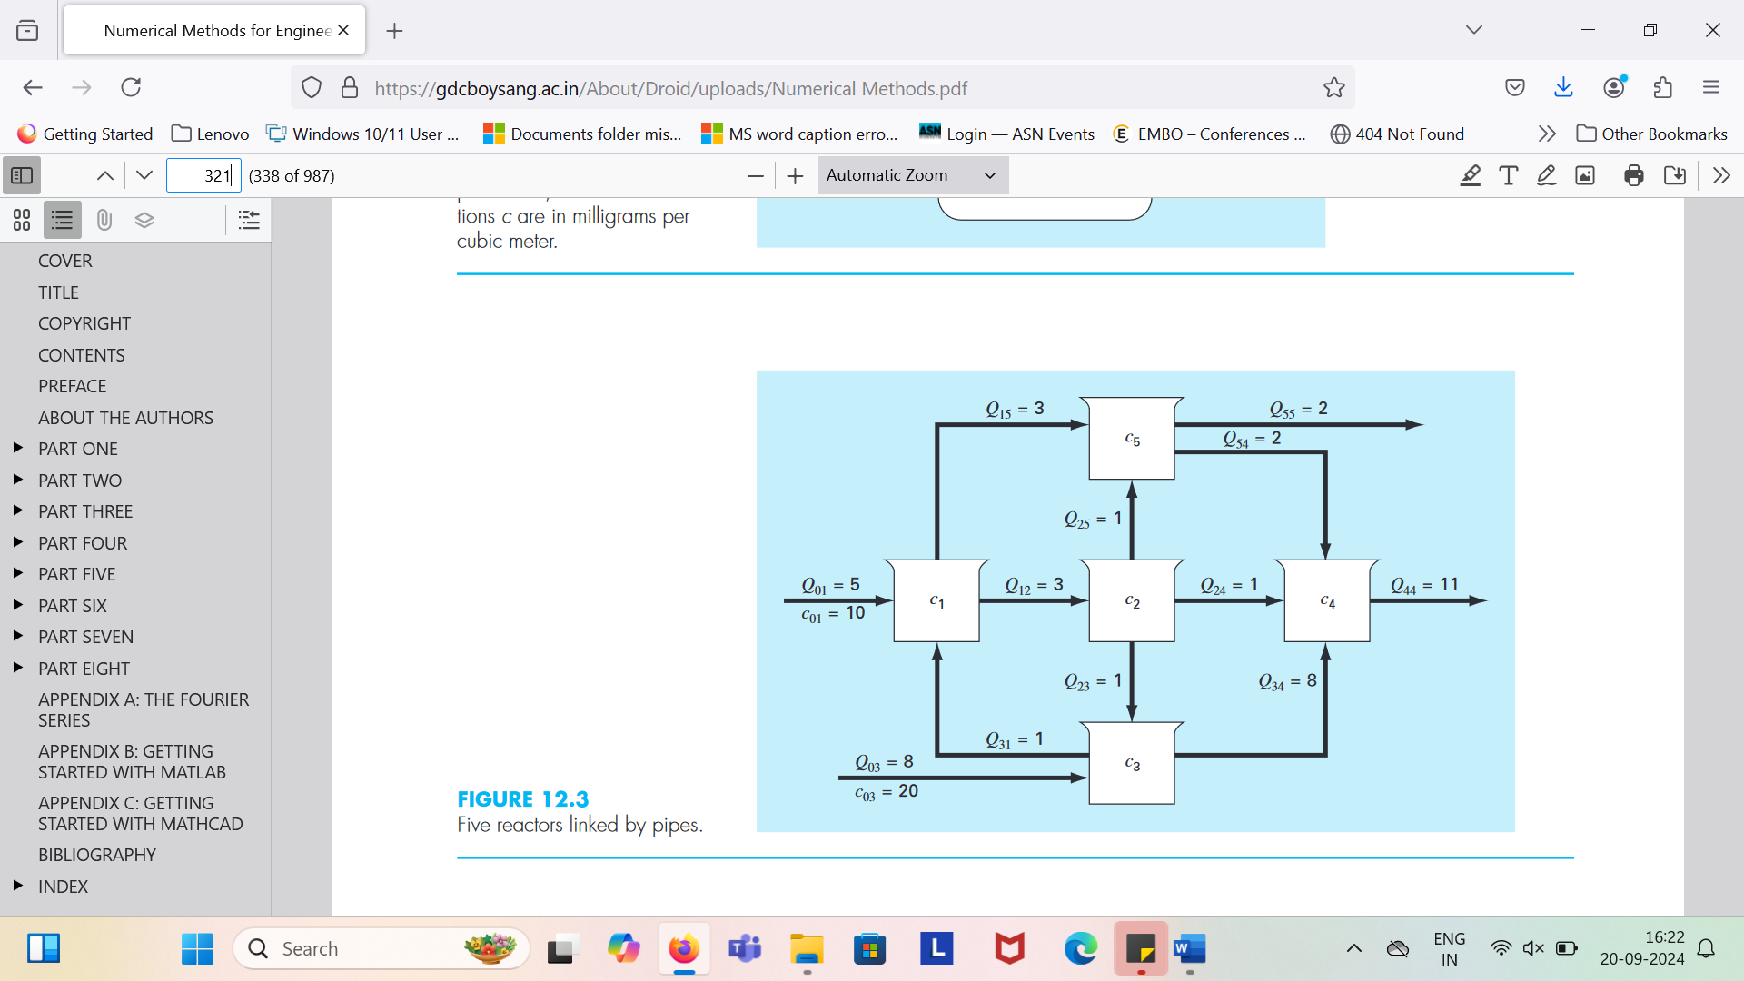

Similarly write the mass balance for the remaining four reactors and then using fourth-order RK method, compute the dynamic response of the network of reactors (that is plot the concentration in the reactors as a function of time).

*V*1 = 50 m3, *V*2 = 20 m3, *V*3 = 40 m3, *V*4 = 80 m3, and *V*5 = 100 m3. Assume that at t=0 all the concentrations in the reactors are at zero. Use h = 0.1.

(Please write down the values obtained for the first two iterations on the paper provided.)

Q2. A python code to solve the following second order differential equations for a damped harmonic oscillator using Heun’s predictor corrector method is given:

+2+ɷ 02 y = A cos(ɷt)

where β=0.1, ɷ0=1.0, A=1.0, ɷ=0.5 and

at t=0, y=0 and v=0.

However some part of the code is missing, which you are supposed to write. Please fill the missing part of the code and submit the python script.