A
Report On
Project-Based Learning (Database Management Systems)
PBL (TCS-503)
File System Management and Simulator
Submitted in partial fulfilment of the requirement for the award of the degree of



BACHELOR OF TECHNOLOGY
In
Computer Science & Engineering
Submitted By:
Ved Kanwal (2361575)
Sarthak Singh (2361486)
Dia Bisht (2361158)
Under the Guidance of
Mr. Aviral Awasthi
Project Supervisor

Ritik Palariya (2361455)

Department of Computer Science & Engineering
Graphic Era Hill University, Bhimtal, Uttarakhand SESSION: 2025-26

CERTIFICATE

The report entitled “Online Ticketing System”, submitted by Ved Kanwal(2361575),Ritik Palariya(2361455), Sarthak Singh(2361486), Dia Bisht(2361158) ,to Graphic Era Hill University, Bhimtal Campus, is hereby certified as a genuine and original piece of academic work.
This report is the result of his independent effort carried out under my continuous guidance and supervision. Throughout the course of this work, the student has demonstrated sincerity, diligence, and a responsible
attitude toward fulfilling the academic requirements prescribed by the university.

The report, as presented, meets the necessary standards for submission in partial fulfillment of the requirements for the award of the degree of Bachelor of Technology in Computer Science and Engineering.

Mr. Aviral Awasthi
Project Supervisor
Department of Computer Science & Engineering Graphic Era Hill University, Bhimtal

Submitted By :
Ved Kanwal
Ritik Palariya
Sarthak Singh
Dia Bisht

Signature Signature
Supervisor Head of the Department

CANDIDATE’S DECLARATION

I hereby declare that the project work entitled “File System Management And Simulator” submitted in partial fulfillment of the requirements for the award of the degree of Bachelor of Technology in Computer Science and Engineering is my original work and has not been submitted previously for the award of any degree, diploma, or other similar titles.
I further declare that this project does not contain any content copied from unauthorized sources and that all contributions and references used have been appropriately cited.

I understand that any violation of academic integrity may lead to disciplinary action by the department.

Submitted by:
Ved Kanwal
Ritik Palariya
Sarthak Singh
Dia Bisht
Semester: 5th Semester
Department: Computer Science and Engineering
Institution: Graphic Era Hill University, Bhimtal Campus

Signature Signature
Supervisor Head of the Department

A file system is the foundation of any operating system that helps in managing various types of data. It helps in managing data by saving files and creating directories, tracking file locations, ensuring proper authentication maintaining the security of the file and much more. However, mostly people learn these concepts theoretically rather than by practical implementation. Performing these concepts practically would help students comprehend these concepts more clearly. This project, “File System Simulator ” aims to cover up that gap and depict how data is being stored or organized, how storage of files and its management is done with the help of directories, how data is fragmented and reorganized within the storage for optimization of the disc space.
This project implements three classical file allocation techniques — Contiguous, Linked, and Indexed and visualizes their effect on disk blocks. OS concepts such as fragmentation, defragmentation and system calls are also covered up in this project.
The project adds on to AI-powered file fragmentation model using SentenceTransformer (MiniLM-L6-v2) and audio-to-text conversion using Whisper AI for MP3 files to be saved and in the storage. It can handle file formats like TXT, PDF, DOCX, SRT, and MP3. The entire application is built using Flask (Python) for backend, SQLite for database, and React.js for frontend.
This project successfully demonstrates the operations performed in file systems in a clear, and interactive manner, making it easy and resourceful for students studying Operating Systems, File Management, and Storage Systems.

z

Chapter No. |  | Description | Page No.
1 |  | Introduction and Problem Statement | 7
2 |  | Background / Literature Survey | 8
3 |  | Objectives | 9
4 |  | Hardware and Software Requirements | 10
5  6  7 |  | System Architecture Design  Highlights  References | 11  12  13

Introduction and Problem Statement

The rapid growth in the data is becoming one of the hot topics of today’s world and requires a look upon it. File systems tells us how data is managed on discs, how memory is managed in the blocks, how file is distributed and stored in various directories, and how fast the changes can be made and viewed in the file.
However, students rarely get to see how the internal functioning of the discs works and how the storage and manipulation in files are done.
This project focuses on building a File System Simulator that demonstrates:
- How files are broken into smaller sections or blocks
- How allocation methods differentiate from each other in their performance
- Why fragmentation happens
- How defragmentation reorders blocks of data into an organised manner to utilize space
- How updateds and logs are maintained
By working on these concepts the user can comprehend how file system works and how disc management and various other concepts are handled.

  - Problem Statement

These concepts are the basic building blocks of the operating system and play a crucial role in the design and working of operating system..
Learners face the following challenges while learning this concepts theoretically rather than practically :
- They are unable to visualize how data is allocated to blocks
- No practical understanding of how OS organizes files
- Lack of understanding of concepts like
- Fragmentation
- Block pointers
- Indexed tables

Existing tools can only show theoretically but not depict how it works on the back.
Therefore, wefullfill it with a web-based visual file system that tells all OS-level storage concepts interactively.

Background/ Literature Survey

4.1 FAT File System
- Uses Linked Allocation for file storage
- High fragmentation rate
- Simple and widely used

4.3 EXT4
- Uses extents (improved contiguous allocation)
- Logs enabled
- Data access is faster

4.4 APFS
- Snapshot-based
- Copy-on-write
- Designed for SSDs

Thus, there exists a gap for modern, interactive OS visualization tools.

Objectives
Primary Objectives
Implementation of Contiguous, Linked, and Indexed Allocation of data in the storage.
Visualization of how data blocks are filled.
Calculate and work on fragmentation.
Show how the data stored is defragmented to optimize.
Secondary Objectives

Maintaining a log file to show operations performed.
Support the storage of different file types (PDF, DOCX, MP3, SRT).
Use Whisper AI for mp4-to-text conversion for storing audio files.
Apply SentenceTransformer to remove duplicate files.

Long-Term Learning Objectives
Help learners understand the concepts of operatinf systems and how files are managed in the disc.
Provide an expandable model for future advancements.

Hardware and Software Requirements

5.1 Hardware Requirements

Dual-core processor or more.

Minumum 4 GB RAM

Disk: 2 GB free space

5.2 Software Requirements

Python 3.10+

Flask Web Framework

SQLite Database

React.js

Node.js

Whisper Module

Sentence Transformer Module

Required Other Python modules

5.1 SYSTEM ARCHITECTURE DESIGN

Presentation Layer
- The frontend is build using simpler react framework.
- It visualizes how memory blocks works and how data is stored.
- We can choose which type of memory allocation method we want to use to store the data.

2. Application Layer (Backend)
- We have used python flask and RESTAPI as a backend.
- Separate sections are created for memory allocation depiction for methods like contiguous , linked and indexed.
- Fragmentation and defraghmentation concepts are used to enhance the performance of the project.
- Created a AI module for detection and removal of duplicate files..

3. Data Layer

- The database stores the files and logs of the updates.
- The file storage system manages the uploads and deletion of the files.
- Designed to be portable so that the project can be run on any device or system easily.

C. Ride Discovery Module (Passenger)
Algorithm:
- Show only rides with available_seats > 0
- Sort by departure time
- Return real-time availability

4. System Workflow
- The project user chooses which allocation method he want to use to store file.
- Frontend then sends a flask request to the backend.
- Backend then stores the file and updates the storage in the disc.
- Each update then gets updated in the frontend.
- User can then see storage updates, fragmentation results, or request defragmentation on files.
- All logs of updates are then stored in the database.

5. Key Features
- Easy access for the choice of memory allocation methods.
- Updates and visualizes the actions performs in real time.
- Supports the conversion from mp3-to-text using AI.

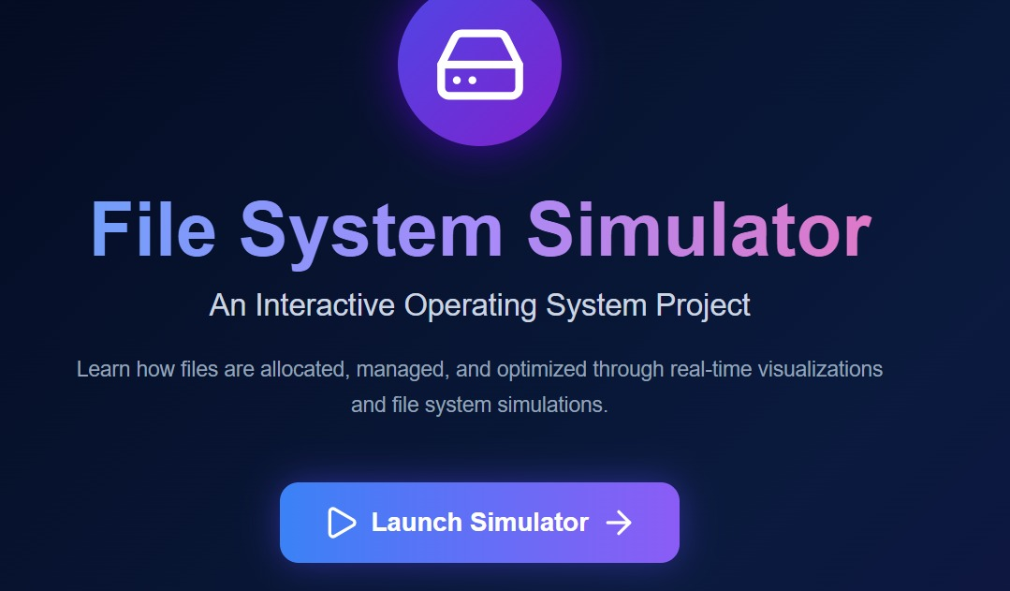

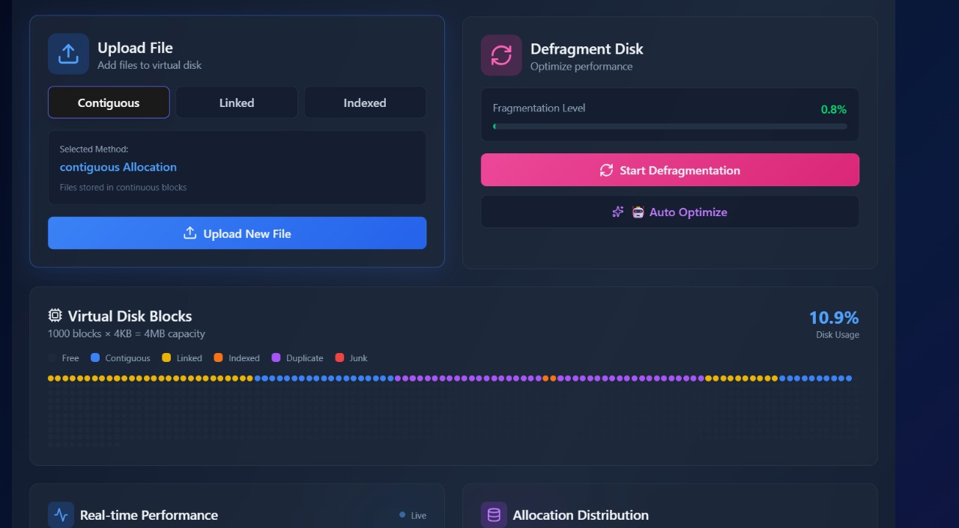

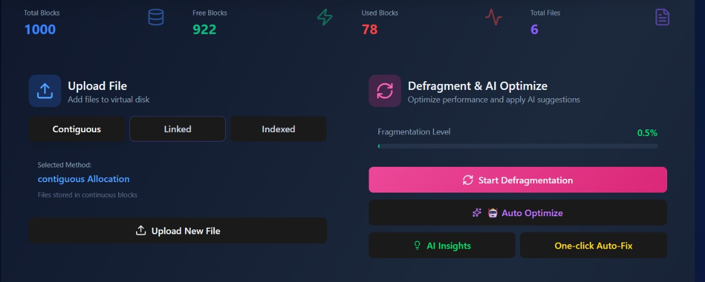

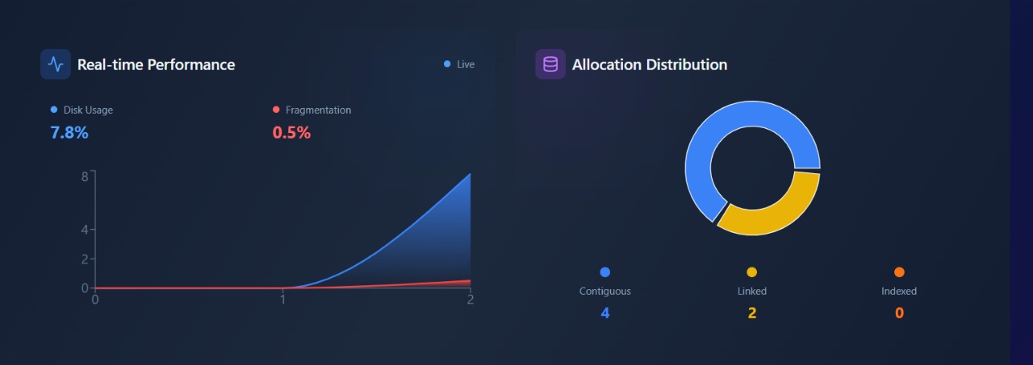

References

- Silberschat Operating System Concepts
- Tanenbaum Modern Operating Systems
- Stallings OS Internals
- Flask Documentation
- SQLite Documentation
- Whisper AI Model
- Sentence Transformer Documentation
- Research papers on file allocation

