**A Minor Project Synopsis**

**on**

**Website of an NGO**

Submitted to Manipal University Jaipur

towards the partial fulfillment for the award of the degree of

**Bachelor of Technology**

**In Information Technology**

By

**Mohit Arora**

**and**

**Aditya Vardhan**

219302293 and 219302384

Section-D

Under the Guidance of

**Dr. Anju Yadav**



**Department of Information Technology**

**School of Information Technology**

**Manipal University Jaipur**

**2022-2023**

**Synopsis**

**1. Introduction**

The project is quite simple, and it has been made using the most common technologies that are used for web development. This has been done to facilitate easy development and maintenance of the website in the future. This has been ensured by following the norms of programming which are generally followed by the programmers.

The website has been kept as simple as possible in terms of design to make it responsive and less clunky. Interactive bits have been added to make the website dynamic / interactive in nature which in turn leads to an easy-to-use experience. Clutter is kept at minimum levels to as keep the interest of the users of the website.

The paradigm of WYWIWYG ( What you want is what get ) has been followed. The site has been made secure. Consistency in design has been kept. A fixed layout has been followed for all the webpages. Also, the website has been made responsive for different screen sizes, devices, technologies, etc.

The website has been optimized for different search engines. A visual hierarchy has been maintained. To ensure minimum discrepancies in the website, the content has been thoroughly checked using the different web testing techniques.

**2. Motivation**

The main motivation for us to build the website is to fulfil our passion of providing the children of weak economic background, free of cost education so that in the future they can sustain themselves and their families and use their education for making this world a better place. Also, the website’s development process in turn we will be able to help us to develop a good skill by learning about web development.

**3. Project Objectives**

To build a responsive and easy to use website with the required functionalities. The website should also be able to collect donations and be able to accept the applications of volunteers.

**4. Methodology/ Planning of work:**

Firstly, we planned the layout and tech-stack of the website.

Then, we started with the designing and development part. We stated with the front-end, and designed with the home-page first so that we have a rough layout of our website.

Then login and signup pages were created. Another page with donation option was created.

After the front-end work was done, we moved to the back-end. Here, login and signup pages were made functional. Proper authentication and authorization were implemented. Donation page was added and made available only after successful login. Functionality for cases such as the user wasn’t signed up and they are trying to login, they are made to go to the signup page and if they were signed up and were entering details at the signup page, they are made to go to the login page we added.

Payment gateway was added with the help of RazorPay Payment Gateway and required API(s).

After the development, the website was tested using the standard web testing procedures for any problems.

All the discrepancies found after the testing were removed.

Flowchart / Gant Chart for the same :-

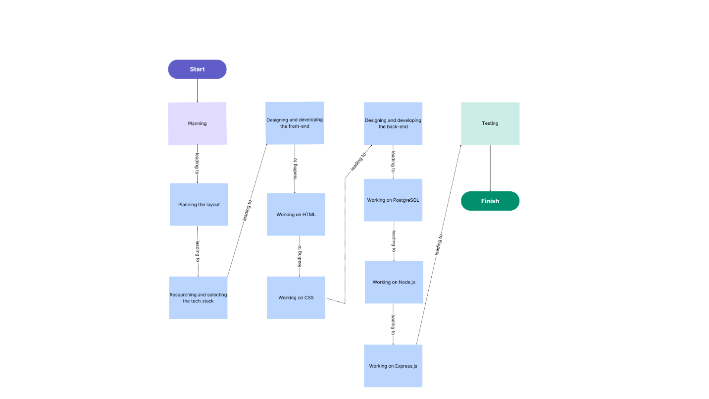

Time-line :-

Week 1 :- Deciding the name of the NGO as well as the website. Also deciding the detailed objectives of both, the website and the NGO.

Week 2-3 :- Researching about and deciding the tech stack and preparing the synopsis.

Week 4-5 :- Developing the front-end.

Week 6-7 :- Developing the presentation for mid-term evaluation.

Week 8-10 :- Developing the back-end.

Week 11 :- Testing the website for any errors.

Week 12-15 :- Adding the functionalities mentioned in the prospect.

Week 16 :- Completing work related to end-term evaluation.

**5. Facilities required for proposed work:**

System requirements ( For developers ) :-

Hardware requirements :-

Processor: Intel Core i5 or AMD Ryzen 5 processor (or equivalent) or higher.

RAM: 8GB of RAM or higher for optimal performance.

Storage: At least 50GB of available storage space for the operating system, development tools, and project files.

Display: Minimum resolution of 1366 x 768 pixels for comfortable viewing and editing.

Software requirements :-

Operating System: Windows 10, macOS, or Linux (Ubuntu, CentOS, or similar distributions).

Web Browser: Latest versions of Google Chrome, Mozilla Firefox, or Microsoft Edge for testing and development.

Code Editor: Any text editor or Integrated Development Environment (IDE) such as Visual Studio Code, Sublime Text, or Atom.

PostgreSQL: Installation of PostgreSQL database server (version 10 or higher) for data storage and management.

Node.js: Latest LTS version of Node.js installed for running JavaScript runtime environment.

NPM (Node Package Manager): Bundled with Node.js installation for managing project dependencies.

Command Line Interface (CLI): Terminal or Command Prompt for running commands and scripts during development and deployment.

Express.js: Installation of Express.js (latest stable version) for building the server-side application logic.

Git: Version control system for managing project files and collaboration (optional but recommended).

System requirements ( For users ) :-

Hardware Requirements:

Device: Desktop, laptop, tablet, or smartphone with modern web browsing capabilities.

Processor: Any modern processor capable of running web browsers efficiently.

RAM: Minimum 4GB of RAM recommended for smooth browsing experience.

Storage: Sufficient storage space for caching website data, although negligible for most users.

Software Requirements:

Web Browser: Latest versions of popular web browsers such as Google Chrome, Mozilla Firefox, Microsoft Edge, Safari, or Opera.

Operating System: Compatible with Windows, macOS, Linux, iOS, or Android operating systems.

Internet Connection: Stable and reliable internet connection with adequate bandwidth for accessing web content.

JavaScript: Enabled in the web browser settings for full functionality of interactive features and dynamic content.

Cookies and Local Storage: Enabled in the web browser settings to facilitate session management and personalized user experience.

Security Software: Up-to-date antivirus and firewall software recommended for enhanced security while browsing the web.

**References**

[1] AkshayaPatra’s website :- https://www.akshayapatra.org/