ASSESSMENT

Q1. WAP to display array elements.

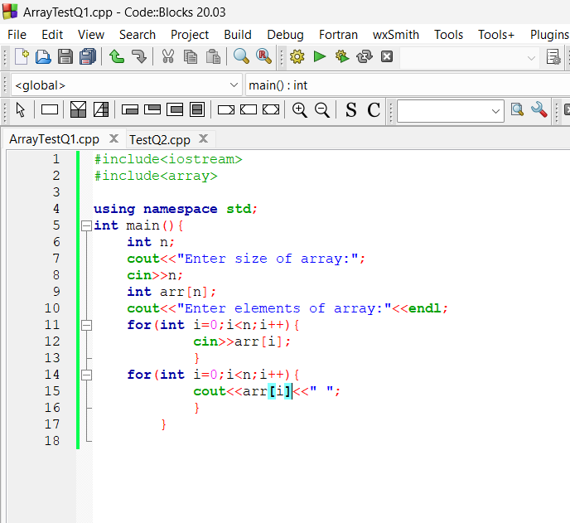

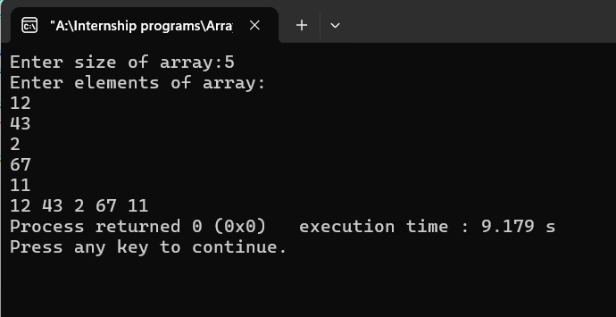

Q2. WAP to print maximum element of the list.

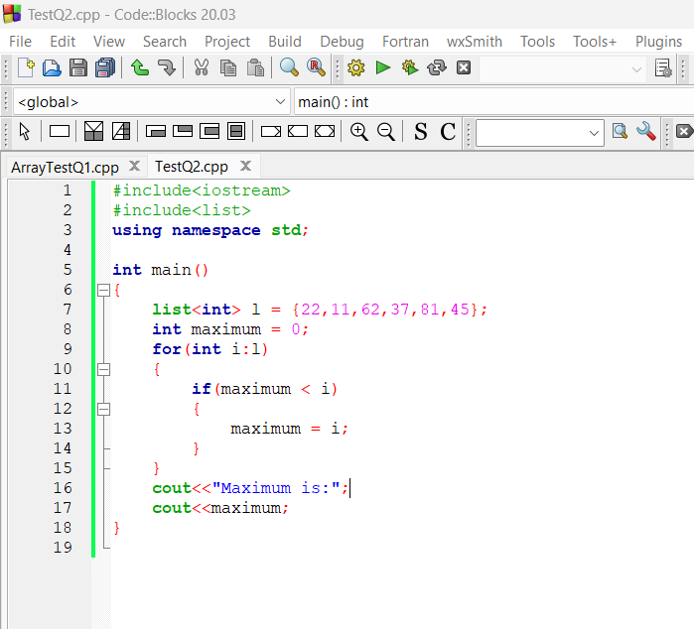

Q3. WAP to find count of 3 Multiples.

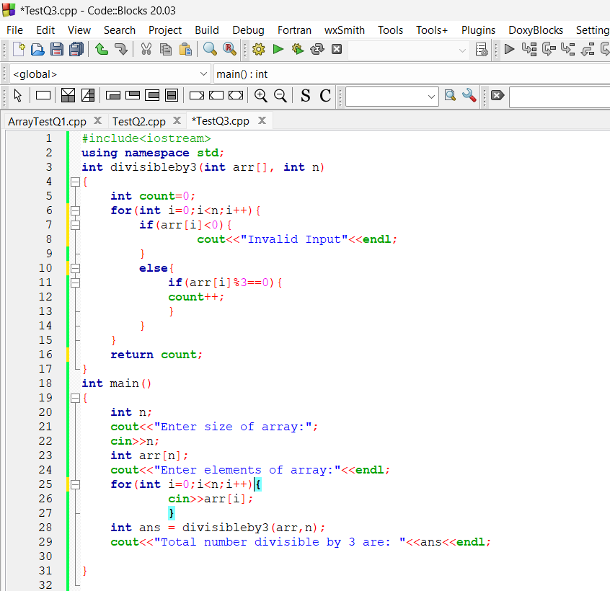

Q4. Two Sum (Leet Code)

