**EXP 1 – FTP Server**

1. Setup following topology :

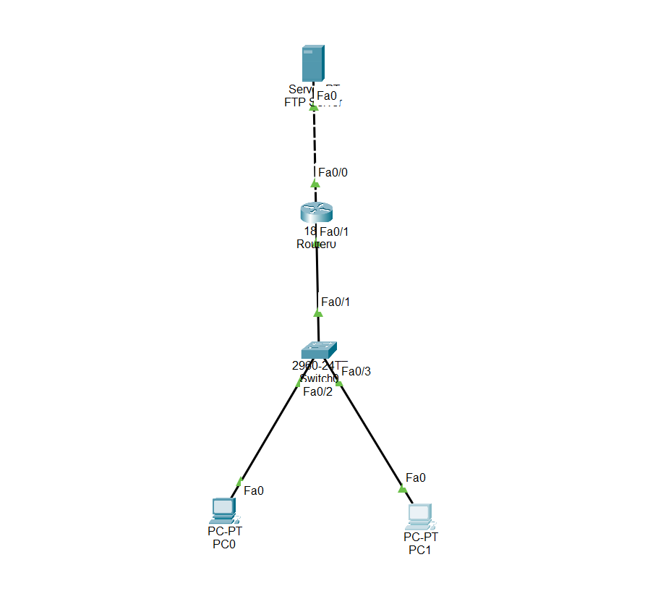

1. Open router -> config -> FastEternet0 (one which is connected to server) , and set its IP address as 10.10.10.1 and turn on port status
2. Again in config -> FastEthernet1 ( which is connected to switch) , and set its ip address as 192.168.0.1 and turn on port status
3. Open PC0 (first PC) and go to Desktop -> set IP address -> set its ip address as 192.168.0.2 and its default gateway as 192.168.0.1
4. For PC1 set ip address as 192.168.0.3 and default gateway as 192.168.0.1
5. Now click on Server and Go to desktop and set ip address as 10.10.10.2 and its default gateway as 10.10.10.1
6. Now click services in server -> FTP -> in username enter any username say admin1 and password say test, below it, select the permissions you want to give such as write read delete rename , list, and click add. And close the window
7. Now go to any PC then go to text editor -> type any text and save it as exp1.txt
8. Now go to PC0, -> Desktop -> test connection to server by using

->Ping 10.10.10.2

Then to upload file on FTP server type ftp along with IP address in cmd

->ftp 10.10.10.2

(enter username and password you set before)

Then you can upload any file , using put command :

**ftp>**put exp1.txt

(file will be uploaded)

Check the uploaded file using following command on same pc

**ftp>** dir

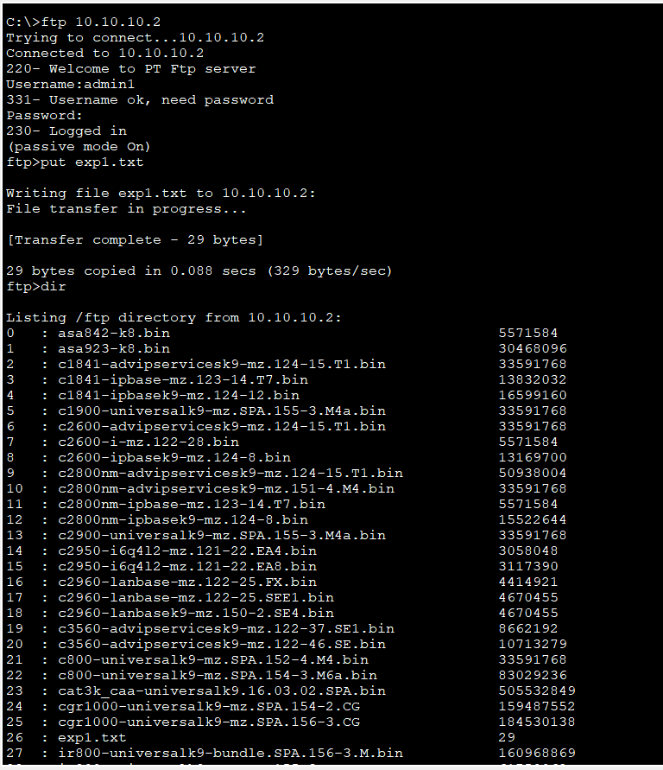

1. Now to download the uploaded file, click on PC1, then cmd, then

->ftp 10.10.10.1

Enter username and password set before

**ftp>**get exp1.txt

**EXPERIMENT 2**

OSPF : https://www.youtube.com/watch?v=som1j7-J6w4

1. Setup following topology:

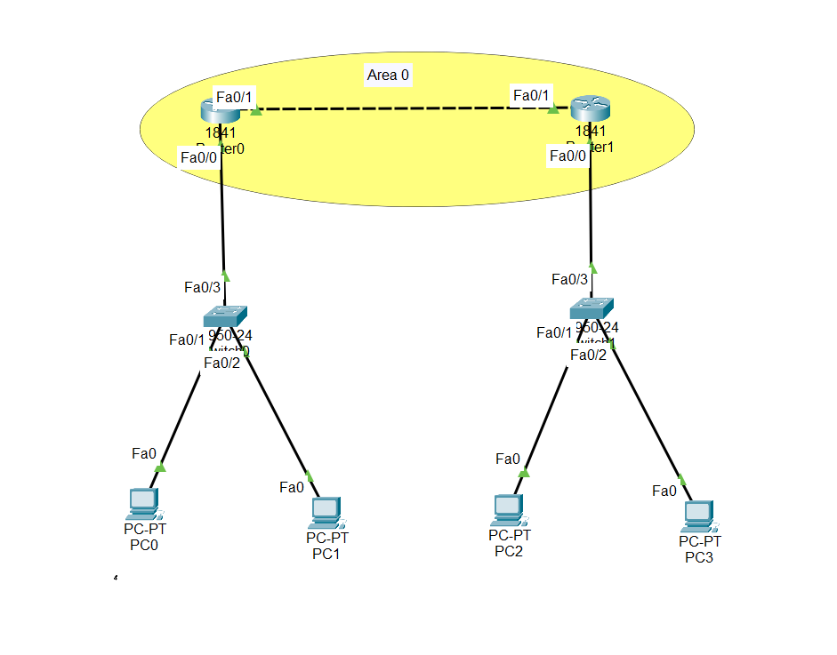

1. Set following ip :

**PCNAME IP Default Gateway**  
 PC0 192.168.1.2 192.168.1.4

PC1 192.168.1.3 192.168.1.4

PC2 192.168.2.2 192.168.2.4

PC3 192.168.2.3 192.168.2.4

1. On routers set ip address in config :

ROUTER INTERFACE IP ADDRESS

R0 FastEt0/0 192.168.1.4 (set port status on)

R0 FastEt0/1 192.168.3.2 (set port status on)

R1 FastEt0/0 192.168.2.4(set port status on )

R3 FastEt0/1 192.168.3.3(set port status on)

1. Open router R0 then go to CLI : (in config of ospf you have to enter network ip address, its area and its wild card mask(opposite of subnet mask)(eg. If subnet is 255.255.255.0 then its wildcard mask will be 0.0.0.255)  
   Router> en

Router# conf t

Router (config)# router ospf 1

Router (config-router)# network 192.168.1.0 0.0.0.255 area 0

Router (config-router)# network 192.168.3.0 0.0.0.255 area 0

Router (config-router)# exit

1. Open router R1:

Router> en

Router# conf t

Router (config)# router ospf 2

Router (config-router)# network 192.168.2.0 0.0.0.255 area 0

Router (config-router)# network 192.168.3.0 0.0.0.255 area 0

Router (config-router)# exit

1. Test connection by sending packets.

EIGRPF : https://www.youtube.com/watch?v=Np_VuQeLS44

1. Setup following topology :

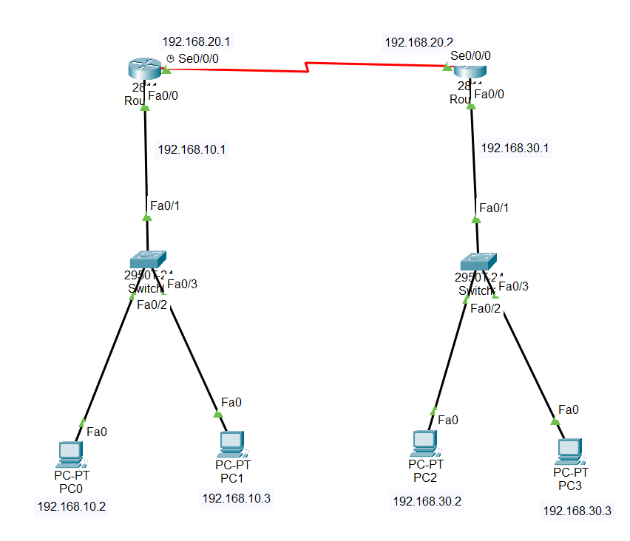

1. On both router , install module WIC-1T, click on router R0 -> Physical -> Zoom In -> find the router switch to turn it off, then on left hand side find WIC-1T module, click on it, it will show module on bottom right, just drag and drop the module (refer youtube video)(don’t forget to turn switch back on )
2. Set following ip :

**PCNAME IP Default Gateway**  
 PC0 192.168.10.2 192.168.10.1

PC1 192.168.10.3 192.168.10.1

PC2 192.168.30.2 192.168.30.1

PC3 192.168.30.3 192.168.30.1

1. On routers set ip address in config :

ROUTER INTERFACE IP ADDRESS

R0 FastEt0/0 192.168.10.1 (set port status on)

R0 Serial0/0/0 192.168.20.1 (set port status on)

R1 FastEt0/0 192.168.30.1(set port status on )

R3 Serial0/0/0 192.168.20.2(set port status on)

1. After config, click on router again -> CLI (Here we just need to add networks attached to the router and their subnet mask instead of wildcard mask)

Router>en

Router# conf t

Router (config)# router eigrp 10

Router (config-router)# network 192.168.10.0 255.255.255.0

Router (config-router)# network 192.168.20.0 255.255.255.0

Router (config-router)# exit

Do the same for router 2

Router>en

Router# conf t

Router (config)# router eigrp 10

Router (config-router)# network 192.168.30.0 255.255.255.0

Router (config-router)# network 192.168.20.0 255.255.255.0

Router (config-router)# exit

1. Test the connection by opening cmd on PC0

**Cmd>**ping 192.168.30.2

If everything is done well, ping will be successful

**DHCP**

1. Setup the following confi :

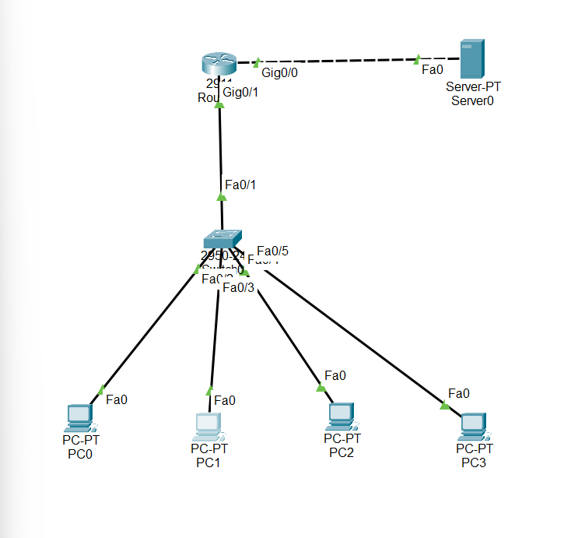

(2911 router, 2950-24 switch)

1. Click on server, go to Desktop -> IP Address -> set ip 10.0.0.2 , default gateway as 10.0.0.1 and DNS Server as 8.8.8.8
2. Click on router -> config -> gigabitEt0/0 -> set ip -> 10.0.0.1
3. gigabitEt0/1 -> set ip -> 20.0.0.1
4. again go to server -> click on services -> DHCP -> and Click on On button to enable the DHCP service
5. Create dhcp pool :

Default gateway : 10.0.0.2

Dns server : 8.8.8.8

Start ip address : 20.0.0.2

Ssubnet : 255.0.0.0

Max users : 200

Click save 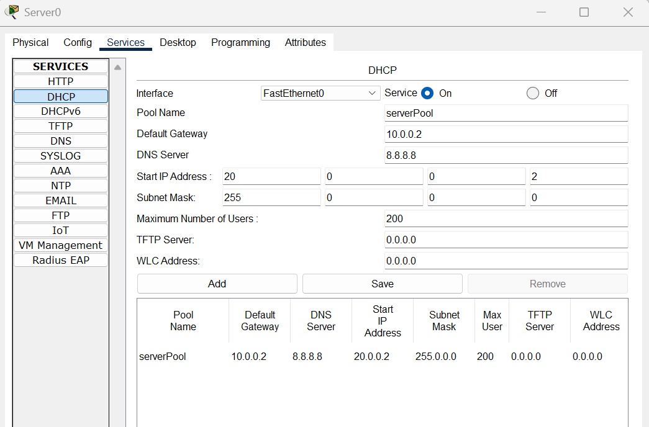

1. Open router -> cli then select gateway of devices

Router (config)# int gig0/1

Router (config)# ip helper-address 10.0.0.2

Exit

Wait and then assign ip

1. Now select any PC -> desktop -> ip -> select option DHCP instead of static

**DNS SERVER**

1. Setup following topology :

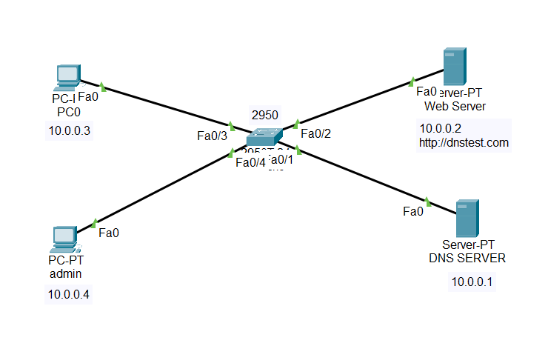

1. Firstly click on the Server1, name it as Web Server, then assign it an ip say 10.0.0.2 subnet 255.0.0.0
2. Then click on server0 , name it as DNS server, this will hold our Domain Name System server, rename it, and assign it an ip 10.0.0.1 subnet 255.0.0.0
3. Now firstly create your webpage : click on Web server -> services -> HTTP

On 5th number you will find index.html file, click on edit on right of file name

-Edit contents of the file to match your site such as : 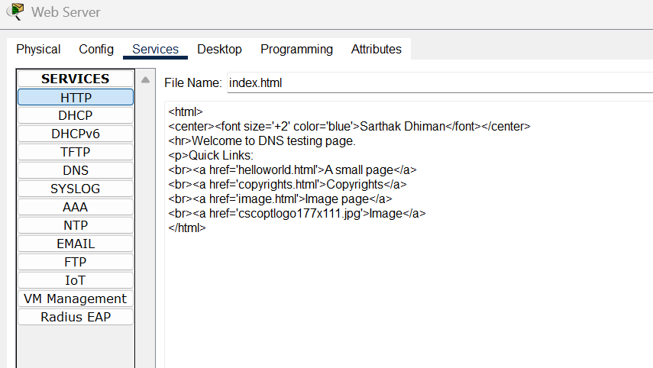

Click on save and close the window

1. To map domain name to ip address , click on DNS server, go to services -> DNS -> Click on ON button to enable DNS

In name enter name of site such as dnstest.com

Address : 10.0.0.2

Click on add

1. Now click on PC0 , set its ip address as 10.0.0.3 subnet 255.0.0.0 and DNS as 10.0.0.1
2. Now in PC0 click on Web browser, in url enter name of site dnstest.com , if dns is successfully implemented it will show contents of index.html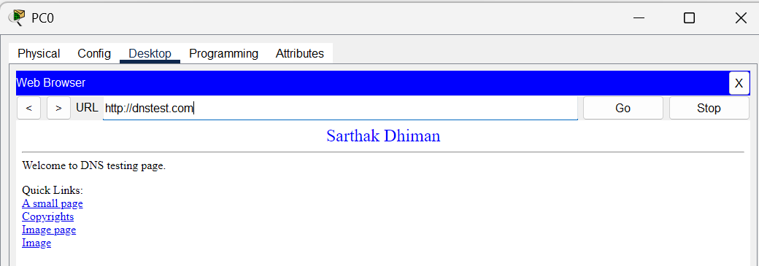
3. Now we will create an admin PC and map its ip to domain name, click on PC1, then name it as admin

Set its ip as 10.0.0.4 subnet 255.0.0.0 and DNS as 10.0.0.1

1. Now go to DNS server, services -> DNS ->

Name : admin

Ip address : 10.0.0.4

Click add

Close window

1. To test if entry is made, go to PC0, desktop -> command prompt :

Ping admin 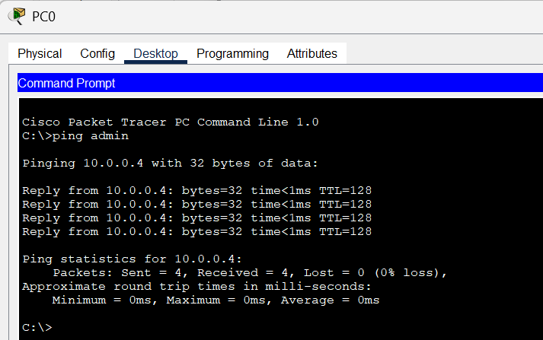

**EXP – 6**

1. **DNS Server service using Server Manager without Delegation**
   * + 1. Open windows server -> then go to **SERVER MANAGER**
       2. In Dashboard -> **ADD ROLES AND FEATURES**
       3. Select **ROLE-BASED or FEATURES-BASED INSTALLATION**
       4. in server roles -> Check the box **DNS Server**, click next
       5. In features click next then click install
       6. After installation, in server manager on top right beside Manage, click on tools and click DNS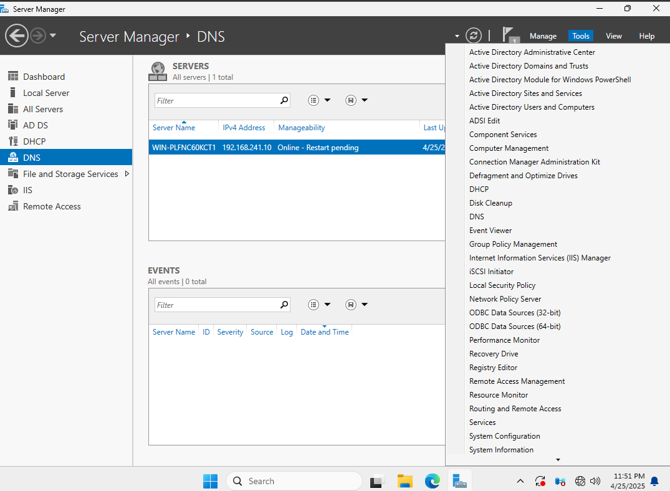
       7. Below DNS there will be server (something like WIN-PLFNCKCT1) , double click on it and right click on **Forward Lookup Zones** and click on **New Zone**

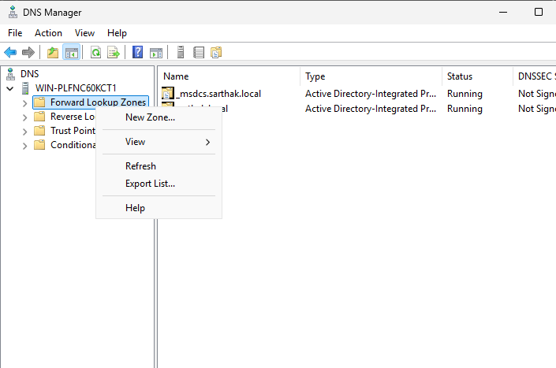

* + - 1. window will appear for New Zone Wizard, click next
      2. Select Zone type : Primary Zone click next, select To all DNS Servers running on domain controllers in this domain
      3. Enter zone name : eg Sarthak.local
      4. Select allow only secure dynamic updates and click next and then finish