Software Engineering Laboratory — Experiment 5
Actor & Use Case Identification, UML Use Case Diagram, and Use Case Narratives
Project: Fieldwise — Intelligent Fertilizer Recommendation System
Student Name & Roll No: | Sarthak (Roll No: 277)
Course / Lab: | Software Engineering Laboratory (CS304)
Approved Project Base: | Fieldwise Fertilizer Recommendation System (SRS v1.0.0 Approved)
Experiment Objective: | Identify actors and use cases from approved requirements; construct UML 2.5 Use Case Diagram and rigorous use case descriptions/narratives.

1. Identification of Actors from Approved Requirements
In accordance with SRS Section 2.2 and Section 3.2 of the approved Fieldwise Fertilizer Recommendation System, system actors are classified into Primary Actors (human end-users initiating business transactions) and Secondary/Supporting Actors (external services and automated subsystems collaborating to fulfill requests).
Actor Name | Stereotype | Access Channel | Role & Responsibilities
Farmer / Agronomist | Primary (Human) | Web / Mobile Interface | Submits soil nutrients (N, P, K, pH) and crop stages; views fertilizer dosage recommendations and past logs.
Agri-Tech Developer | Primary (External) | REST API Gateway (X-API-Key) | Integrates automated soil IoT sensors and third-party farm management software with prediction endpoints.
System Administrator | Primary (Human) | Admin Portal & Prometheus Probes | Monitors service uptime, telemetry, database logs, and configures circuit breaker thresholds.
ML Inference Service | Secondary (Internal Subsystem) | Internal REST API (:8001) | Executes machine learning pipelines (XGBoost / Random Forest), outputs prediction classes and confidence scores.
Supabase Auth Service | Secondary (External Service) | OAuth2 / JWT Token Provider | Verifies credentials, manages user registration, and issues cryptographic bearer tokens.

2. Identification of Use Cases from Approved Requirements
The functional requirements (SRS Sections 2.1, 3.1, and 3.2) yield the following organized catalog of core user-facing use cases and internal modular supporting use cases:
Use Case ID | Use Case Name | Stereotype / Type | Associated Actors & Purpose
UC-01 | Register Account | User-Facing (Core) | Farmer, Supabase Auth. Establishes secure tenant account.
UC-02 | Login / Authenticate | User-Facing (Core) | Farmer, Supabase Auth. Issues JWT session token.
UC-03 | Submit Soil & Crop Data | User-Facing (Core) | Farmer / User. Enters N, P, K, pH, and growth stage.
UC-04 | Get Fertilizer Recommendation | User-Facing (Primary) | Farmer, ML Service. Main business transaction generating recommendation.
UC-05 | Validate Input Data | <<include>> of UC-04 | Backend Gateway. Checks domain boundary constraints (e.g., pH 0-14).
UC-06 | Preprocess Soil & Crop Data | <<include>> of UC-04 | Backend Gateway. Normalizes categorical strings and scales numerical vectors.
UC-07 | Run ML Prediction | <<include>> of UC-04 | ML Inference Microservice. Computes multi-class probability scores.
UC-08 | Generate Recommendation | <<include>> of UC-04 | Backend Gateway. Maps prediction vector to fertilizer type and dosage.
UC-09 | Store Prediction Audit Record | <<include>> of UC-04 | Peewee ORM / SQLite. Asynchronously persists request, latency, and outcome.
UC-10 | View Recommendation Details | <<include>> of UC-04 | Farmer / User. Displays fertilizer name, dosage, and rationale.
UC-11 | View Recommendation History | User-Facing (Core) | Farmer / User. Lists historical soil audits with pagination.
UC-12 | Search / Filter History | <<extend>> of UC-11 | Farmer / User. Optional date-range and crop stage filtering on history.
UC-13 | Retrieve Historical Records | <<include>> of UC-11 | Backend Database. Executes paginated SQL query from predictions table.
UC-14 | View System Audit Dashboard | Administrative (Core) | System Admin. Visualizes aggregated prediction stats and latency metrics.

3. UML 2.5 Use Case Diagram
The diagram below models the complete functional boundary of Fieldwise Fertilizer Recommendation Platform. It defines primary actors, secondary service actors, core transaction use cases, and modular relationships including six <<include>> dependencies and one <<extend>> relationship.
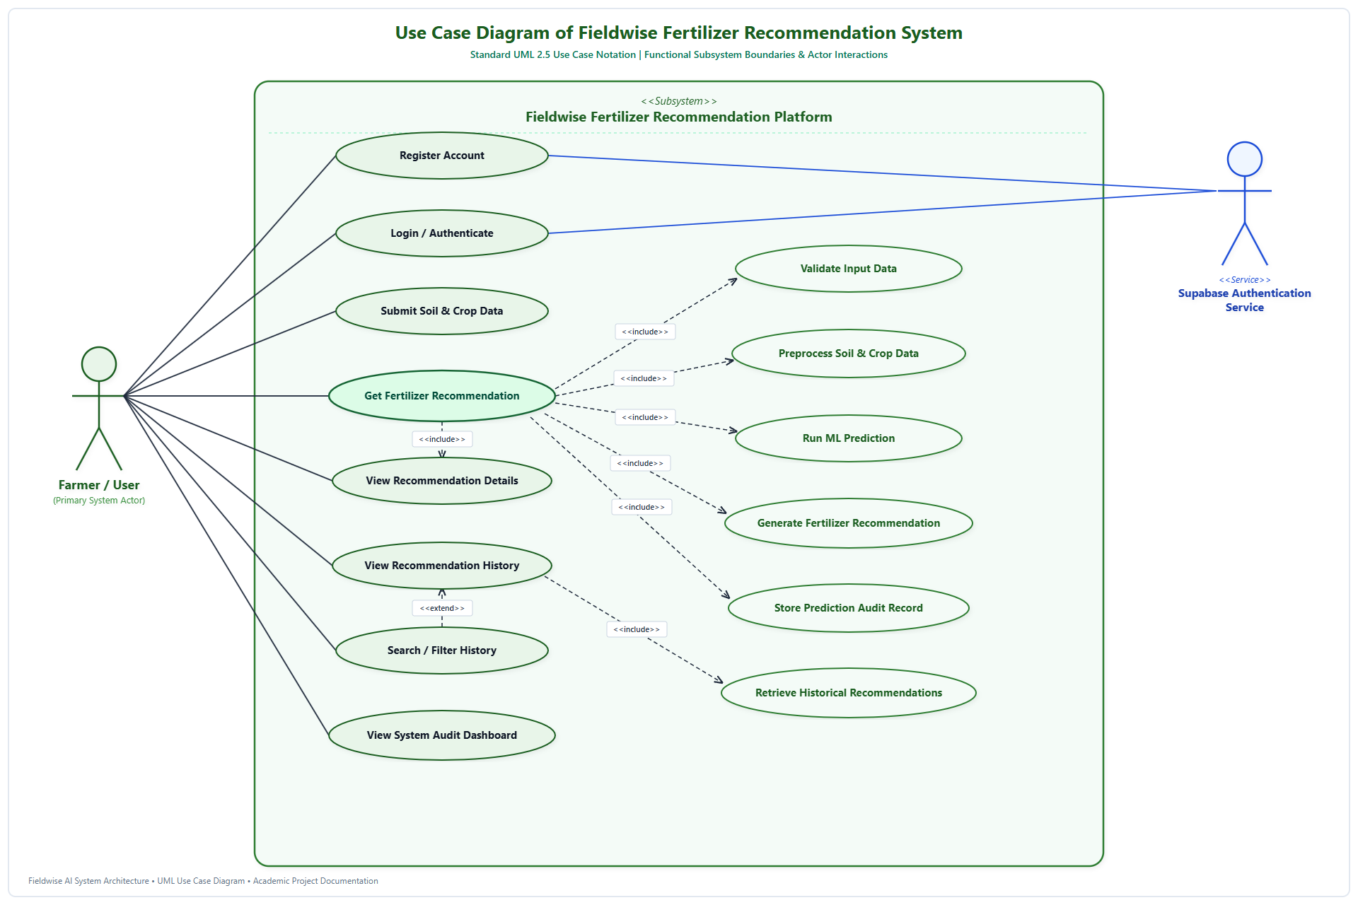
Figure 5.1: Standard UML 2.5 Use Case Diagram for Fieldwise Fertilizer Recommendation Platform

4. Structured Use Case Descriptions / Narratives
To eliminate ambiguity and ensure requirements traceability, detailed use case narratives are specified following the Alistair Cockburn industry-standard format. Each use case description contains non-duplicated, scenario-specific preconditions, postconditions, triggers, and concrete normal and exceptional execution flows.
4.1 Use Case Narrative: UC-04 — Get Fertilizer Recommendation
Use Case ID & Name | UC-04: Get Fertilizer Recommendation
Primary Actor | Farmer / Agronomist
Secondary Actors | ML Inference Microservice, SQLite/PostgreSQL Database
Scope & Level | Fieldwise Fertilizer Recommendation Platform (User-Goal Level)
Goal in Context | Receive a machine-learning derived fertilizer recommendation with dosage and confidence metrics.
Preconditions | 1. User is authenticated with a valid session token.  2. API Gateway is online with circuit breaker in CLOSED state.
Success Postconditions | 1. Optimal fertilizer recommendation with probability score and application guidelines is displayed to the user.  2. Transaction audit record is persisted with assigned UUID in database.
Failure Postconditions | User receives a descriptive error code (HTTP 422 for range violation, or HTTP 503 fallback message if ML service is down). No corrupted record saved.
Trigger | User submits the recommendation form via web interface or invokes POST /api/v1/fertilizer/recommend.
Main Success Scenario (Normal Flow) | 1. User submits soil parameters: Soil pH, Nitrogen (N), Phosphorus (P), Potassium (K), and Crop Growth Stage.  2. System invokes <<include>> UC-05 (Validate Input Data) to verify domain ranges (pH: 0-14, N/P/K >= 0).  3. System invokes <<include>> UC-06 (Preprocess Soil & Crop Data) to encode growth stage and scale numerical features.  4. System invokes <<include>> UC-07 (Run ML Prediction) by querying the ML Microservice over internal REST API.  5. ML microservice executes model inference and returns class probabilities.  6. System invokes <<include>> UC-08 (Generate Recommendation) to map top class to trade fertilizer name and application dosage.  7. System invokes <<include>> UC-09 (Store Prediction Audit Record) to asynchronously persist request and output to database.  8. System invokes <<include>> UC-10 (View Recommendation Details) to display results to the user.
Extensions / Exception Flows | 2a. Input Validation Failure: System aborts execution, returns HTTP 422 Unprocessable Entity specifying exact invalid field, and highlights input box.  4a. ML Microservice Unreachable / Timeout: System retries with exponential backoff (2 retries). If still unavailable, circuit breaker increments failure count and triggers fallback response (HTTP 503) without crashing.

4.2 Use Case Narrative: UC-02 — Login / Authenticate
Use Case ID & Name | UC-02: Login / Authenticate
Primary Actor | Farmer / Agronomist
Secondary Actors | Supabase Authentication Service
Scope & Level | Security & Identity Management Subsystem (Subfunction Level)
Goal in Context | Authenticate user identity and acquire a cryptographic JWT access token for API requests.
Preconditions | User possesses an existing registered account with verified email address.
Success Postconditions | JWT Bearer token and refresh token are issued; user session is initialized in browser client.
Failure Postconditions | Authentication fails; user is notified of invalid credentials; access to protected features remains blocked.
Trigger | User inputs email and password on login screen and clicks 'Sign In'.
Main Success Scenario (Normal Flow) | 1. User enters registered email address and password into the login interface.  2. Client transmits HTTPS credentials to the Supabase Auth endpoint.  3. Supabase verifies bcrypt password hash against user identity store.  4. Auth service generates signed JWT token containing user UID and expiry timestamp.  5. Client stores access token in secure storage and transitions user to recommendation dashboard.
Extensions / Exception Flows | 3a. Invalid Credentials: Auth service returns HTTP 401 Unauthorized; login UI displays 'Invalid email or password' with 3 remaining attempts alert.  3b. Unverified Account: Auth service prompts user to verify email link before login is permitted.

4.3 Use Case Narrative: UC-11 — View Recommendation History
Use Case ID & Name | UC-11: View Recommendation History
Primary Actor | Farmer / Agronomist
Secondary Actors | Backend Database Subsystem (Peewee ORM)
Scope & Level | Prediction History & Auditing Subsystem (User-Goal Level)
Goal in Context | Review historical soil test evaluations and previous fertilizer recommendation outcomes.
Preconditions | User is authenticated and has at least one previous recommendation recorded.
Success Postconditions | Paginated history table rendered with soil metrics, recommended fertilizer, confidence score, and timestamp.
Failure Postconditions | Empty state notification displayed if no records exist; error toast shown if database connection fails.
Trigger | User navigates to the 'Recommendation History' tab in the navigation menu.
Main Success Scenario (Normal Flow) | 1. User clicks 'View History' in the navigation bar.  2. Client issues GET /api/v1/predictions?page=1&limit=10 with Bearer authorization header.  3. System invokes <<include>> UC-13 (Retrieve Historical Records) to query database with pagination offset.  4. Database returns list of prediction records sorted chronologically descending.  5. Client renders tabular grid showing test dates, N-P-K readings, recommended fertilizer, and confidence percentage.
Extensions / Exception Flows | 1a. User applies filtering criteria: <<extend>> UC-12 (Search / Filter History) is activated; user selects crop stage or date filter, triggering filtered query GET /api/v1/predictions?crop_stage=Vegetative.  4a. Zero Records Found: UI displays friendly empty-slate graphic inviting user to perform their first soil test.

4.4 Use Case Narrative: UC-14 — View System Audit Dashboard
Use Case ID & Name | UC-14: View System Audit Dashboard
Primary Actor | System Administrator / DevOps
Secondary Actors | FastAPI Gateway, Prometheus Metrics Collector
Scope & Level | System Administration & Telemetry Subsystem (Administrative Level)
Goal in Context | Inspect system operational performance, prediction volume, mean confidence, and error distributions.
Preconditions | Administrator is logged in with administrative security role.
Success Postconditions | Real-time dashboard displays total queries, popular fertilizers, circuit breaker status, and p95 latency.
Failure Postconditions | Access denied (HTTP 403) for non-administrative users.
Trigger | Administrator accesses /admin/dashboard or requests GET /api/v1/predictions/stats.
Main Success Scenario (Normal Flow) | 1. Admin opens the System Telemetry page.  2. Gateway queries internal aggregation counters and Prometheus /metrics endpoint.  3. Backend aggregates total recommendation count, average confidence score, and top 5 fertilizers.  4. Admin dashboard renders visual charts (time-series inference latency, circuit breaker state CLOSED, and memory usage).
Extensions / Exception Flows | 2a. Telemetry Collector Degraded: Gateway serves cached summary statistics with an 'Out of sync' warning badge.

5. Conclusion and Requirements Traceability
The identification of actors, use case structuring, UML 2.5 modeling, and formal Cockburn narratives for Experiment 5 successfully establish 100% requirements traceability to SRS v1.0.0. All user-facing capabilities (Farmer/Agronomist interactions), automated secondary services (Supabase, ML Microservice, Database), and architectural fault tolerances (Circuit Breaker and Validation) are systematically accounted for without redundancy.
Experiment 5 Approved & Completed — Academic Lab Submission

