**Increment Array Elements** 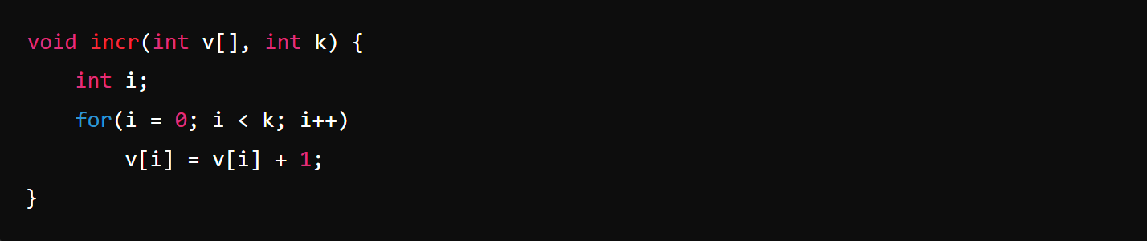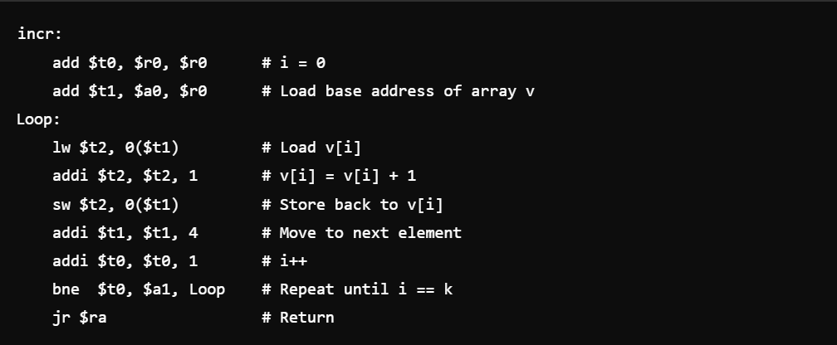

**Swap Two Elements in Array**

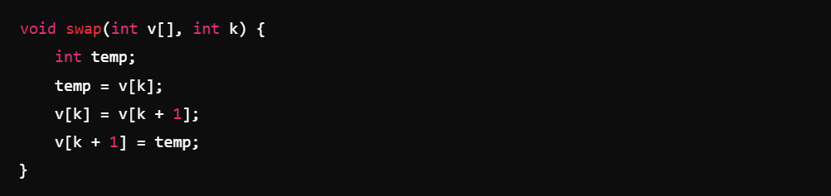

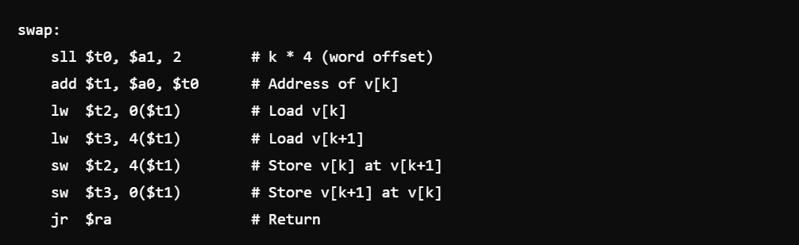

**Sum of Array Elements**