**Sarthak Patil**

College Parking App

Aim: The main objective of this application is to reduce the time required by a student/faculty member to spot a parking area.

Tools Used:

1. [www.invisionapp.com](http://www.invisionapp.com/) (Wireframe)

Navigation through the app:

The user will have to sign up if he is a first-time user. He may log-out of the app anytime he wishes, and log back in.

1. Homepage

Once the user reaches the campus, he/she can open the app and find a suitable parking spot. Let us consider that there are 3 parking areas in the college premises, namely P-Spot 1, P-Spot 2, P-Spot 3.

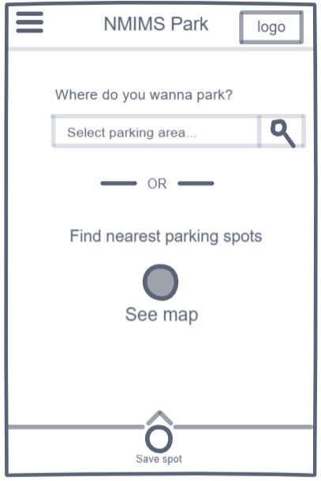

The user can then either select one of the 3 parking spot or just look up for the nearest parking space, depending on his preferences and available time. If the user clicks on the ‘See map’ button, he/she will be asked for their vehicular specification (Elaborated in the next point).

Note- The user can directly reach the empty parking spot and then save the spot by swiping up the ‘Save spot’ icon.

1. Select Vehicle

Once the user starts looking for a parking spot, the app will enquire about their vehicular specification (through an on screen pop-up), meaning if the vehicle is 2-wheeler, Cycle or 4-wheeler.

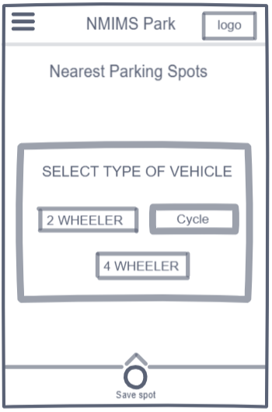

Then based on their vehicle in use, they will be shown the total availability of parking spots.

1. Total Availability

The user will then be provided with the information of all the spots concerning the user’s vehicle. The user can see the total parking spots, and the available/free parking spots here. The availability of each category will be followed by a button called, ‘Get Direction’. This button will take the user to a google map (Further explained in the next point).

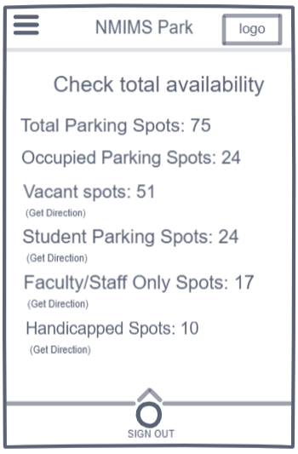

1. Select Spot/Get Direction

This page will show all the free parking slots marked with a red dot. The user can click on any of the dots and the map will lead the user to the location by giving him/her the directions.

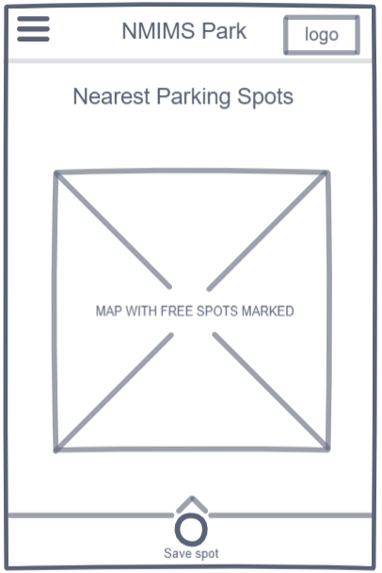

1. Save Spot

Once the user reaches the desired spot, he/she has to swipe up the save spot icon. This will update the database of that spot as ‘occupied’.

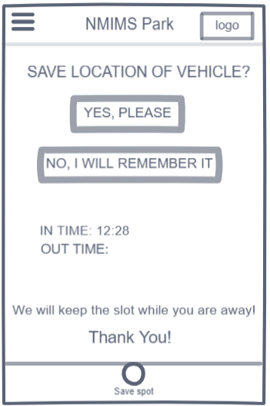

There is an option of saving the location of the vehicle for later reference. The ‘IN TIME’ will be auto-updated the moment the user swipes the save spot icon. The ‘OUT TIME’ will be updated when the user leaves the parking area with the vehicle.

1. Find Your Parking Spot

If the user has saved the location of the vehicle when he parked it, this page will help the user with the directions to the vehicle.

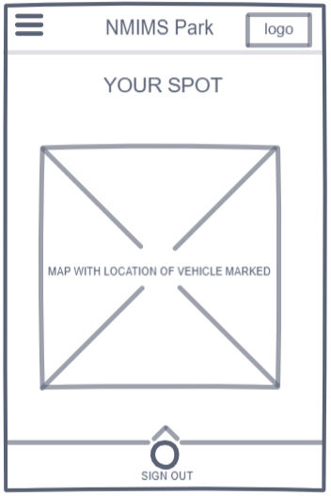

1. Sign Out The Vehicle

Once the user reaches the location of the vehicle, the ‘OUT TIME’ will be auto updated. The user will be asked to rate his experience and provide any feedback(optional).

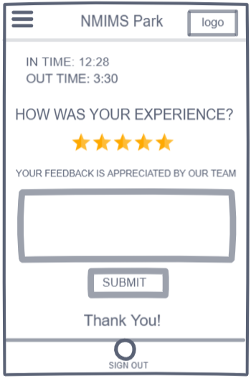

1. Menu

The 3 horizontal lines on the top left corner of the app will provide the user with the drop-down menu.

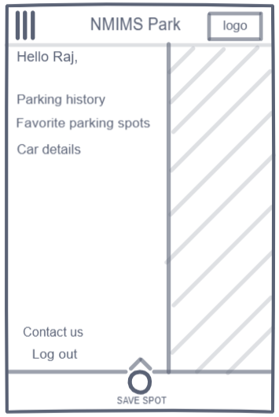

The user can check their parking history, their car details(The user can keep pictures of their driving license and other legal papers saved) and also save parking spots which they always prefer over other spots. The user can log out from the account and contact the company regarding any issues or feedback with the app.