***CASE STUDY***

***IN RELATIONAL DATABASE DESIGN***

***TITLE: ECOMMERCE***

***STUDENTS NAME:* UJJWAL SOHAL, SARTHAK GARG, SEHAJ SINGH, SHIVANKIT SINGH, SPARSH BANSAL, SUSHANT MISHRA.**

***GUIDE***: **Mrs. ADITI MOUDGIL**

**Abstract**

The objective of this thesis is, E-commerce brings convenience for customers as they do not have to leave home and only need to browse websites online, especially for buying the products which are not sold in nearby shops. It could help customers buy a wider range of products and save customers' time. Consumers also gain power through online shopping. One case study “ECOMMERCE” is presented. Input for this case study is taken from its informal specification to a relational schema using entity-relationship modelling and its translation to relational

model, to database schema, to implementation of the database, to interactive SQL querying of the installed database (SQL/ Oracle).

***Functional requirement:***

1. **A**dmin can view details of customers who have not purchased anything.

2. **A**dmin can view the products purchased on a particular date.

3. **A** new user can register on the website.

4. **C**ustomers can filter the product based on the product details.

5. **A** customer can view the total price of the product present in the cart.

6. **A**dmin can start a sale with a certain discount on every product.

***Acknowledgments***

I would like to express my gratitude to all of those who made it possible to complete this thesis, in particular to my supervisor Mrs. Aditi Moudgil, who believed in me and motivated me.

***Contents***:

Abstract........................................................................................... . ......................................

Acknowledgments..................................................................................................................................

Chapter 1:

Introduction..................................................................................... . ............................................

Chapter 2: Name of Case

Study............................................................................................... . ..................................

3.1 Case Study INFORMAL DESCRIPTION

3.2 Terminologies and Symbols of E-R diagram

3.3 case study LOGICAL MODEL (ER Diagram)

3.4 case study Physical schema

3.5 Case Study INTERACTIVE QUERIES

Chapter 3: Conclusion

Bibliography...................................................................................................... 107

***Chapter 1: Introduction***

**· *Database Management Systems*:**

A database management system (or DBMS) is

essentially nothing more than a computerized data keeping system. Users of the system are given facilities to perform several kinds of operations on such a system for either manipulation of the data in the database or the management of the database structure itself.

**· *Relational Database Management System*:** A

relational database is a type of database that stores and provides access to data points that are related to one another. The columns of the table hold attributes of the data, and each record usually has a value for each attribute, making it easy to establish the relationships among data points.

**· *ER Diagram*:**

An Entity–relationship model (ER model) describes the structure of a database with the help of a diagram, which is known as Entity Relationship Diagram (ER Diagram). An ER model is a design or blueprint of a database that can later be implemented as a database. The main components of the E-R model are: entity set and relationship set.

· ***Brief introduction of case study:***

The main purpose to a database is to store information. Have a question about a customer order? Check the database. Want to know a product price? Check the database.

By using a database, a web application can ignore the actual data and focus more on the presentation and behaviour of that data. The end result is that the amount of code and logic in the web application is much smaller and easier to understand.

***Objective of the case study*:**

1. Track Transactions.

2. Organize Product.

3. Provide Structure to your stored data.

***Chapter 2: Name of Case study***

**3.1 *Case study Informal Description*:** The objective of this thesis is, E

commerce brings convenience for customers as they do not have to leave home and only need to browse websites online, especially for buying the products which are not sold in nearby shops. It could help customers buy a wider range of products and save customers' time. Consumers also gain power through online shopping. One case study “ECOMMERCE” is presented. Input for this case study is taken from its informal specification to a relational schema using entity-relationship modelling and its translation to relational model, to database schema, to implementation of the database, to interactive SQL querying of the installed database (SQL/Oracle).

**3.2 *Case study Logical Model*:**

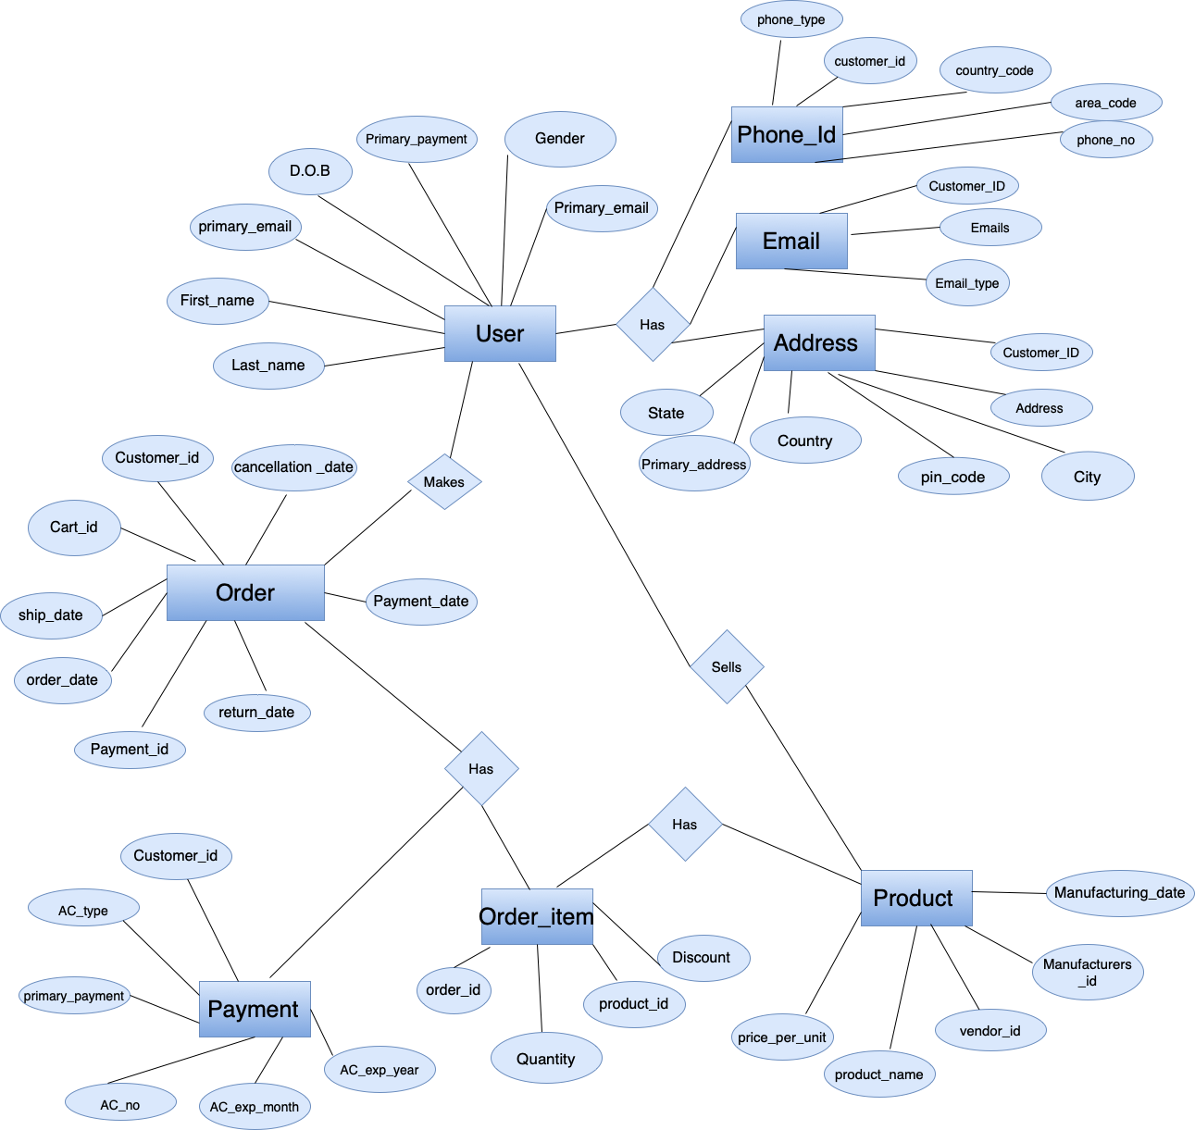

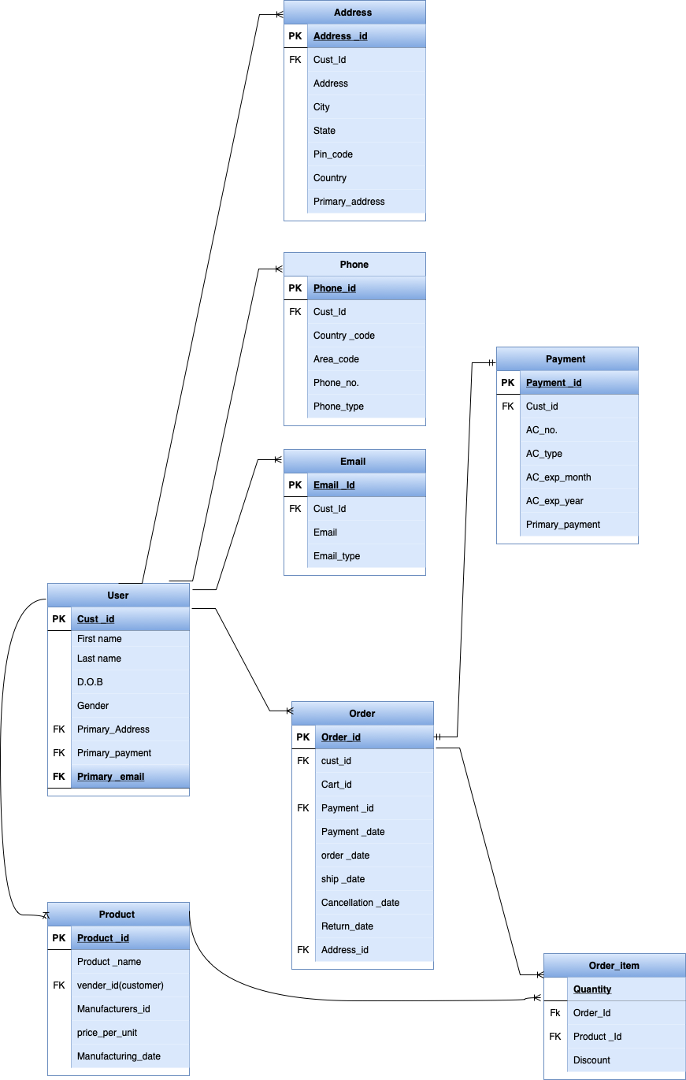

**3.3 *Case Study Physical Model*:**

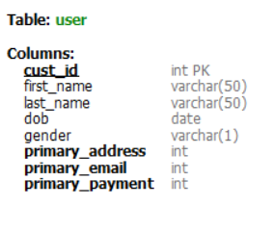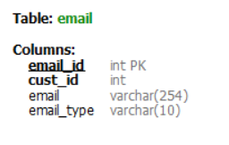

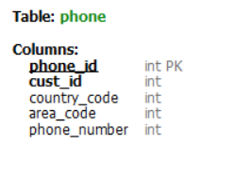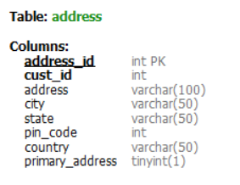

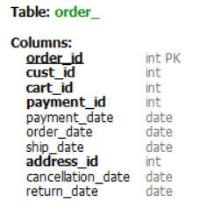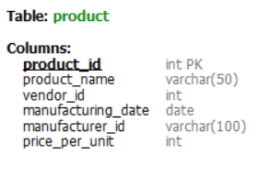

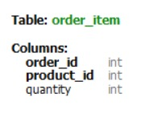 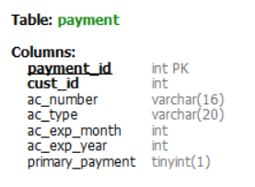

**3.4 *Case Study Interactive Queries:***

**#query1** - *“Product price greater than 10000”*

select * from product where price_per_unit > 10000;

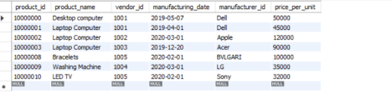

**#query 2** - *“Selecting order where delivery state is Punjab”*

select * from order_ where address_id in (

select address_id from address where state = 'Punjab’);

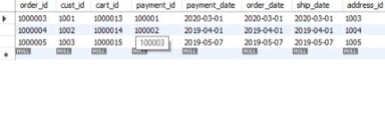

**#query3** – *“Select user’s D.O.B =1987-3-23”*

select * from user where dob = "1987-3-23";



**#query4** - *“Select Product which is sold by Deepak”*

select * from product where vendor_id in (

select cust_id from user where first_name = 'Deepak' );

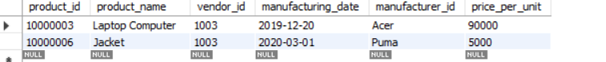

**#query5** – *“Select user who have cancelled an Order”*

select first_name, last_name from user where cust_id in (select cust_id from order_ where cancellation_date is not null );

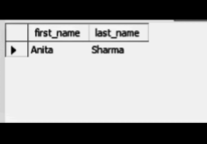

**#query6** - *“Select product name where quantity is >=3 in order item.”*

select product_name from product where product_id in (

select product_id from order_item where quantity >= 3

);

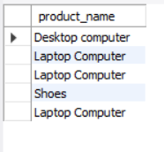

**#query7** – *“Select user who is Male.”*

select first_name, last_name from user where gender='M';

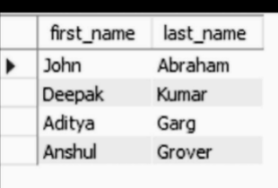

**#query8** - *“How many payments done via visa card.”*

select count(order_id) from order_ where payment_id in (

select payment_id from payment where ac_type = 'Visa'

);

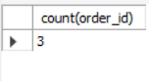

**#query 9** - “*Total payment done via visa card.”*

select sum(price_per_unit) from product where product_id in (

select product_id from order_item where order_id in (

select order_id from order_ where payment_id in (

select payment_id from payment where ac_type = 'Visa'

)

)

);



**#query10** - *“Checking which product user 1001 has bought.”*

select o.cust_id, oI.order_id, p.product_id, p.product_name from

order_item as oI inner join (select * from order_ where cust_id = 1001) as o on oI.order_id = o.order_id

inner join product as p on oI.product_id = p.product_id;

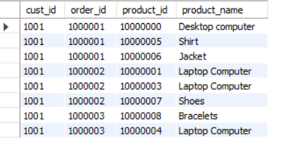 **#query11** – *“Total money spended by user 1001”*

select sum(oI.quantity*p.price_per_unit) from order_item as oI inner join (select * from order_ where cust_id = 1001) as o on oI.order_id = o.order_id inner join product as p on oI.product_id = p.product_id;



***Conclusion and Future Work*: In future if our project proceeds into web development or becomes an app, we will be adding some new features in it which will make it easy for our users to access it.**

**In future when any customer will login into our app/ site, the user will be able to see whether any old /latest products are available or not in the store. If yes, the user can book the product.**

**In future the customer will be able to track the order. brand promise is to deliver the broadest selection of products and services at the lowest prices with minimal hassle.**

**In future customers will be able to know beforehand on which date the product will come back in stock.**

***Bibliography*:**

**1. https://app.diagrams.net/**

**2. https://www.mysql.com/**