📄 PRODUCT REQUIREMENTS DOCUMENT (PRD)

1️⃣ Product Overview
Product Name
Sweta Enterprises Official Website
Product Type
B2B Chemical Manufacturing Website with Admin Dashboard
Objective
Build a professional digital platform that:
- Establishes brand credibility
- Displays chemical product catalog
- Generates verified B2B inquiries
- Allows admin product management
- Is scalable and production-ready

2️⃣ Business Context
Company Profile
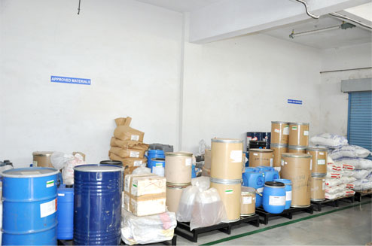
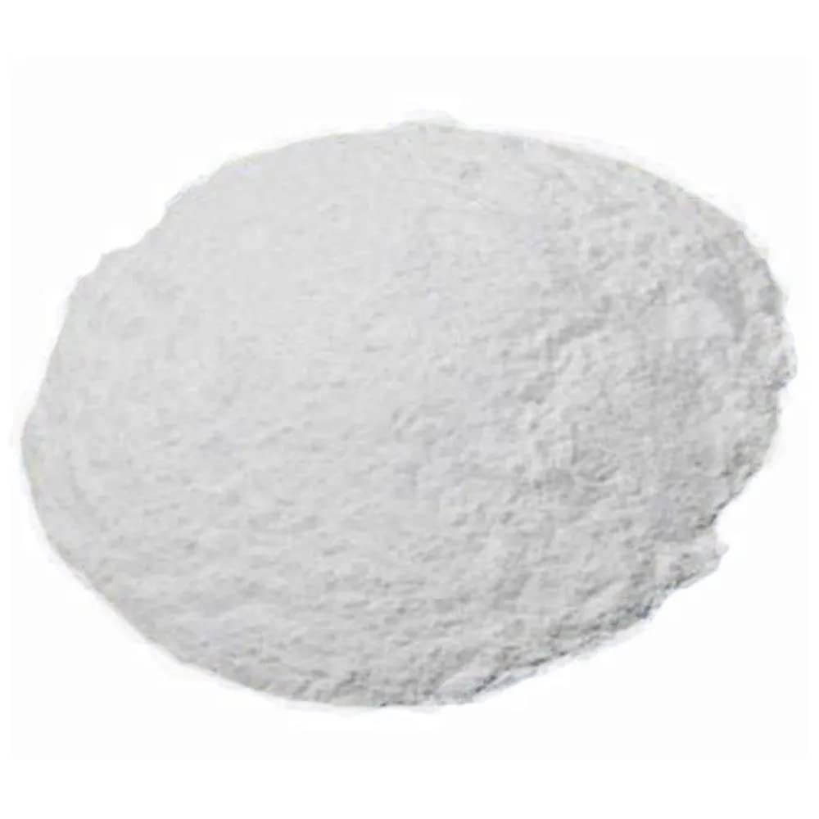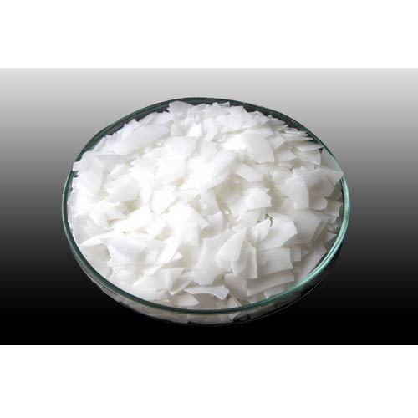

Company Name: Sweta Enterprises
Location: Khanda Colony, Raigad, Maharashtra
GST: 27AHYPC0260H1ZB
Nature of Business: Wholesaler / Distributor
Established: 2017
Employees: Up to 10
Core Product Categories:
- Surfactants
- Emulsifiers
- Pearlizing Agents
- Shampoo / Handwash Bases
- Textile Chemicals

3️⃣ Product Scope
Phase 1: Public Website (MVP)
Phase 2: Admin Panel
Phase 3: Production Deployment

4️⃣ Target Users
🎯 Primary Users
- Cosmetic manufacturers
- Detergent manufacturers
- Textile units
- Chemical distributors
- FMCG small industries
🎯 Secondary Users
- Lab chemical buyers
- Resellers

5️⃣ Business Goals
Goal | KPI
Increase inquiries | +40%
Improve trust | Bounce rate < 40%
Increase product visibility | SEO ranking
Convert visitors to leads | >5% conversion

6️⃣ Functional Requirements

🌐 PUBLIC WEBSITE FEATURES

6.1 Homepage
Sections:
- Hero Section
  - Company tagline
  - CTA: “Request a Quote”
- About Snapshot
  - 2–3 lines about company
  - GST and Experience highlight
- Featured Products
  - 6–8 key products
- Industries Served
  - Cosmetics
  - Home Care
  - Textile
  - Laboratory
- Why Choose Us
  - Quality Assurance
  - Competitive Pricing
  - Bulk Availability
  - Fast Dispatch
- Testimonials
  - Display ratings
- Footer
  - Contact
  - GST
  - Social
  - Quick Links

6.2 Product Listing Page
Route:
/products
Features:
- Search bar
- Category filter
- Grid view
- “Get Quote” button
- Pagination

6.3 Product Detail Page (Dynamic)
Route:
/products/:slug
Each product includes:
- Product name
- Image
- Description
- Applications
- HSN Code
- Chemical category
- Technical Specifications:
  - Purity
  - Packaging
  - Storage
- Download TDS (PDF)
- Inquiry form (pre-filled product)

6.4 Quote Request System
Flow:
- User clicks “Get Best Quote”
- Form opens (modal or page)
- User submits:
Fields:
- Product Name
- Quantity Required
- Company Name
- GST (optional)
- Name
- Email
- Phone
- Message
System Actions:
- Save to database
- Send email to admin
- Show success message

6.5 Contact Page
Features:
- Address
- Embedded Google Map
- Call button
- WhatsApp button
- Inquiry form

6.6 About Page
Sections:
- Company Story
- Vision & Mission
- Business Strengths
- Owner message
- GST Information

🔐 ADMIN PANEL FEATURES

7️⃣ Admin Authentication
- Admin login
- JWT-based authentication
- Protected routes
- Session management

7.1 Admin Dashboard
Displays:
- Total Products
- Total Inquiries
- Recent Inquiries
- Most Requested Product
- Monthly Inquiry Chart

7.2 Product Management
Admin can:
- Add Product
- Edit Product
- Delete Product
- Upload Image
- Upload TDS PDF
- Assign Category
- Set Featured Product

7.3 Inquiry Management
Admin can:
- View inquiries
- Filter by date
- Filter by product
- Mark status:
  - New
  - Contacted
  - Closed
- Export CSV

8️⃣ Database Design

Product Schema
{
name: String,
slug: String,
category: String,
description: String,
hsnCode: String,
applications: [String],
specifications: {
purity: String,
packaging: String,
storage: String
},
featured: Boolean,
image: String,
tdsFile: String,
createdAt: Date
}

Inquiry Schema
{
productId: ObjectId,
quantity: String,
companyName: String,
gst: String,
name: String,
email: String,
phone: String,
message: String,
status: String,
createdAt: Date
}

Admin Schema
{
email: String,
password: String (hashed),
role: "admin"
}

9️⃣ Non-Functional Requirements
Requirement | Target
Load Time | <2 seconds
Mobile Responsive | Yes
Security | HTTPS
Input Validation | Required
SEO Optimized | Meta tags
Accessibility | Basic ARIA
Deployment Ready | Yes

🔟 Technical Architecture

Frontend
- React (Vite)
- Tailwind CSS
- Axios
- React Router
- Framer Motion
Backend
- Node.js
- Express
- MongoDB
- Mongoose
- JWT
- Nodemailer
Storage
- Cloudinary (Images)
- Local or Cloud storage (PDFs)
Deployment
- Frontend → Vercel
- Backend → Render
- MongoDB → Atlas

1️⃣1️⃣ API Structure
Public Routes
GET /api/products
GET /api/products/:slug
POST /api/inquiry
Admin Routes
POST /api/admin/login
POST /api/admin/products
PUT /api/admin/products/:id
DELETE /api/admin/products/:id
GET /api/admin/inquiries
PATCH /api/admin/inquiries/:id

1️⃣2️⃣ Security Requirements
- Password hashing (bcrypt)
- JWT expiration
- Rate limiting
- Input sanitization
- CORS protection

1️⃣3️⃣ SEO Requirements
- Dynamic meta titles
- Structured data for chemicals
- Sitemap.xml
- Robots.txt
- OpenGraph tags

1️⃣4️⃣ Analytics
- Google Analytics integration
- Track:
  - Page views
  - Quote submissions
  - Most visited product

1️⃣5️⃣ Risks & Mitigation
Risk | Solution
Spam inquiries | Add reCAPTCHA
Admin brute force | Rate limit login
File abuse | File size validation
SEO not ranking | Proper keywords

1️⃣6️⃣ Timeline
Week | Task
Week 1 | UI + Frontend Layout
Week 2 | Backend APIs
Week 3 | Admin Panel
Week 4 | Deployment + SEO

1️⃣7️⃣ Deliverables
- Fully responsive website
- Admin dashboard
- Deployed live URL
- Clean GitHub repo
- README documentation
- Architecture diagram

