Trader Performance vs. Market Sentiment
An Analysis of Hyperliquid Trading Behavior Against the Bitcoin Fear & Greed Index
Data Science Take-Home Assignment — PrimeTrade.ai
Prepared July 2026

Executive Summary
This report examines whether Bitcoin market sentiment — as measured by the Fear & Greed Index — is associated with systematic differences in how traders on Hyperliquid behave and perform. The analysis merges 211,224 individual trade executions from 32 accounts across 246 tokens with the daily Fear/Greed classification, covering a trading history from May 2023 through May 2025 (the bulk of activity falls in 2024–2025).
Four patterns stand out:
- Win rates are highest at sentiment extremes, but not symmetrically. Trades closed during Extreme Greed win 89.2% of the time and during Fear 87.3% of the time — both well above the 83.2% overall average. Extreme Fear (76.2%) and plain Greed (76.9%) are the weakest regimes for win rate.
- Activity spikes sharply during fear. Average daily trading volume is roughly 5–7x higher in Fear and Extreme Fear regimes ( 5.3M and 8.2M per day respectively) than in Greed ( 1.5M per day), and traders execute far more orders per day (680–1,529 vs. 261) when the market is fearful.
- Extreme Greed is where the best risk-adjusted trades happen. It combines the highest win rate (89.2%) with the highest average profit per closed trade ($130), while occurring on relatively low volume — suggesting cleaner, more trending conditions rather than panic-driven churn.
- Liquidations and forced deleveraging cluster in Greed, not Fear. All 9 liquidation/auto-deleveraging events in the dataset occurred on Greed-classified days, despite Greed accounting for a minority of trading days — consistent with overconfidence and excess leverage building up during optimistic markets.
Taken together, the data supports a contrarian, sentiment-aware approach: trade size and leverage discipline should tighten during Extreme Fear (high activity, lower win rate) and during Greed (where blow-ups concentrate), while Extreme Greed and Fear windows appear to reward continued participation.

1. Data & Methodology

1.1 Datasets
- Hyperliquid historical trades: 211,224 rows covering account, coin, execution price, size (tokens & USD), side, direction (open/close/liquidation/ADL), closed PnL, fees, and timestamp.
- Bitcoin Fear & Greed Index: daily sentiment classification (Extreme Fear → Extreme Greed) and a 0–100 index value, spanning 2018–2025.

1.2 Processing steps
- Parsed trade timestamps and derived a calendar date key to join with the daily sentiment index (exact-date match — 99.997% of trades matched successfully).
- Collapsed the 5-class sentiment label into a simplified Fear / Neutral / Greed bucket for higher-level comparisons, while retaining the full 5-class breakdown for granular analysis.
- Defined a “close event” as any row with non-zero Closed PnL (i.e., a realized gain or loss), used for win-rate and per-trade PnL statistics. Rows with zero Closed PnL are typically position-opening trades and were excluded from win-rate math but retained for volume/activity metrics.
- Aggregated to daily level (total PnL, total volume, trade count per day) to analyze regime-level behavior independent of any single large trader.

1.3 Scope note
The dataset contains 32 accounts, so account-level findings (Section 4) should be read as illustrative of behavioral variety rather than a statistically representative trader population. Aggregate/regime-level findings (Sections 2–3) are based on the full 211K-row trade log and are more robust.

2. Performance by Market Sentiment

2.1 Win rate and average profitability
Win rate (share of closed trades with positive PnL) and average PnL per closed trade both vary meaningfully by sentiment regime:
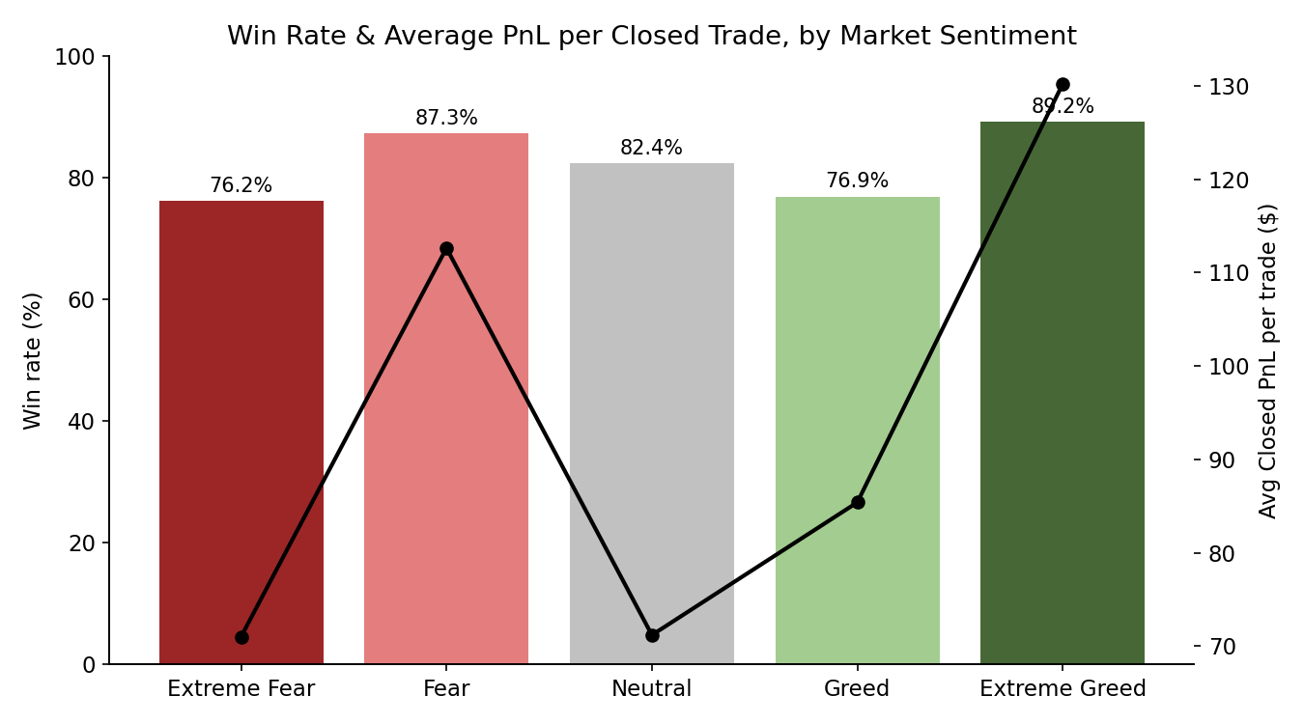
Figure 1. Win rate (bars, left axis) and average PnL per closed trade (line, right axis) by sentiment.
Sentiment | Win Rate | Avg PnL / Close | # Closed Trades
Extreme Greed | 89.2% | $130.21 | 20,853
Fear | 87.3% | $112.63 | 29,808
Neutral | 82.4% | $71.20 | 18,159
Greed | 76.9% | $85.40 | 25,176
Extreme Fear | 76.2% | $71.03 | 10,406

The pattern is not a simple “fear is bad, greed is good” story. Extreme Greed and Fear — arguably the two regimes with the clearest directional conviction in the market — produce the best trader outcomes. Extreme Fear (capitulation) and ordinary Greed (complacency / late-stage rallies) are where outcomes are weakest, plausibly because these are periods of sharper reversals and crowded, one-sided positioning.

2.2 Activity and volume
Trading activity is far from uniform across sentiment regimes. Traders are dramatically more active — in both volume and trade count — when the market is fearful:
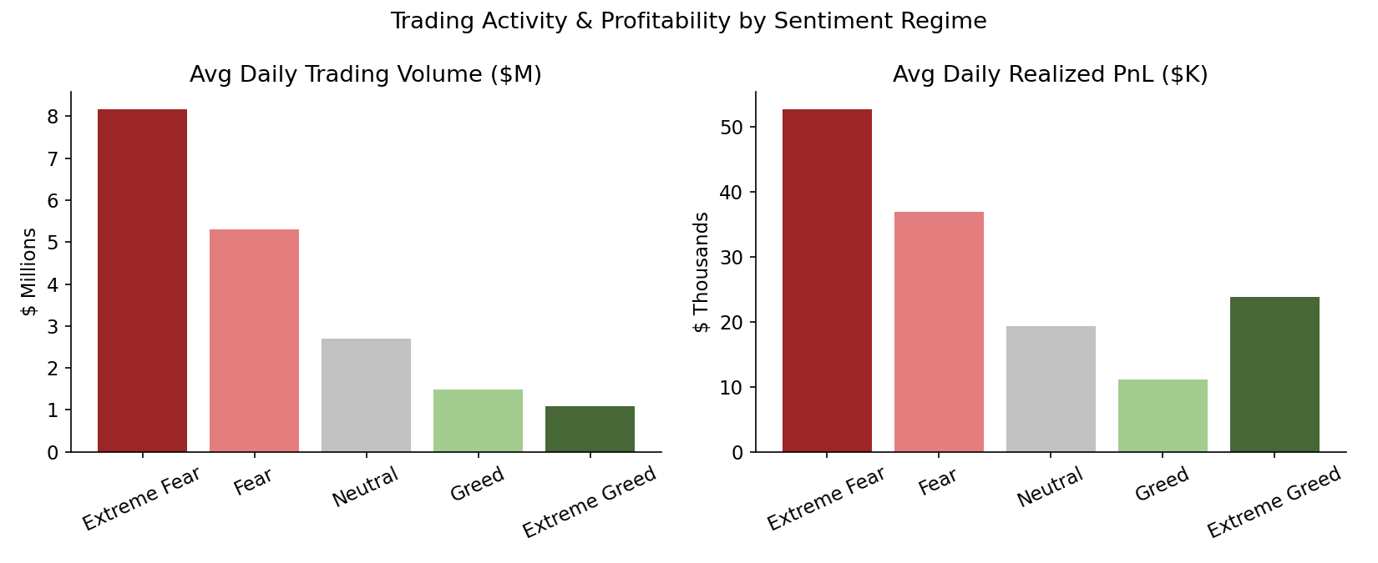
Figure 2. Average daily trading volume and average daily realized PnL, by sentiment regime.
Sentiment | Avg Daily Volume | Avg Trades / Day | Avg Daily PnL | Calendar Days
Extreme Fear | $8.18M | 1,529 | $52,794 | 14
Fear | $5.31M | 680 | $36,892 | 91
Neutral | $2.69M | 562 | $19,297 | 67
Extreme Greed | $1.09M | 351 | $23,817 | 114
Greed | $1.50M | 261 | $11,141 | 193

Extreme Fear days are rare (14 of 479 days in the sample) but disproportionately active — nearly 6x the average daily volume of Greed days. This is consistent with capitulation-style behavior: sharp moves draw high participation (stop-outs, panic exits, and opportunistic entries all at once), even though the win rate during these days is below average.

2.3 Trade sizing
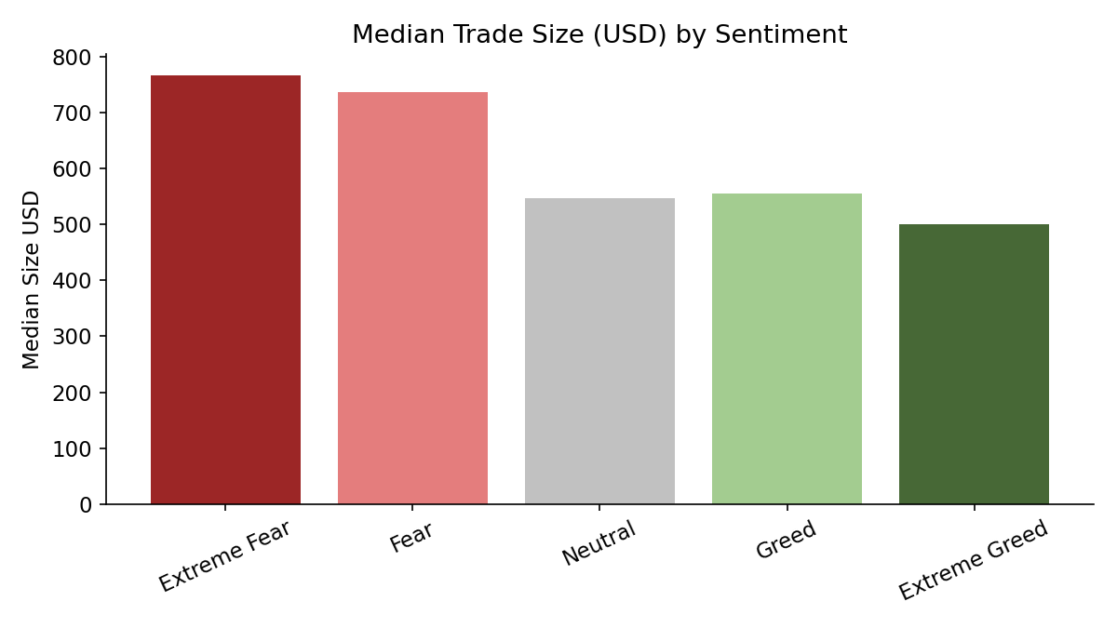
Figure 3. Median trade size (USD) by sentiment.
Median trade size is broadly similar across regimes ($500–$766), indicating traders in this dataset don’t dramatically resize individual orders based on sentiment — the volume differences in Section 2.2 are driven mainly by trade frequency, not order size.

2.4 PnL over time
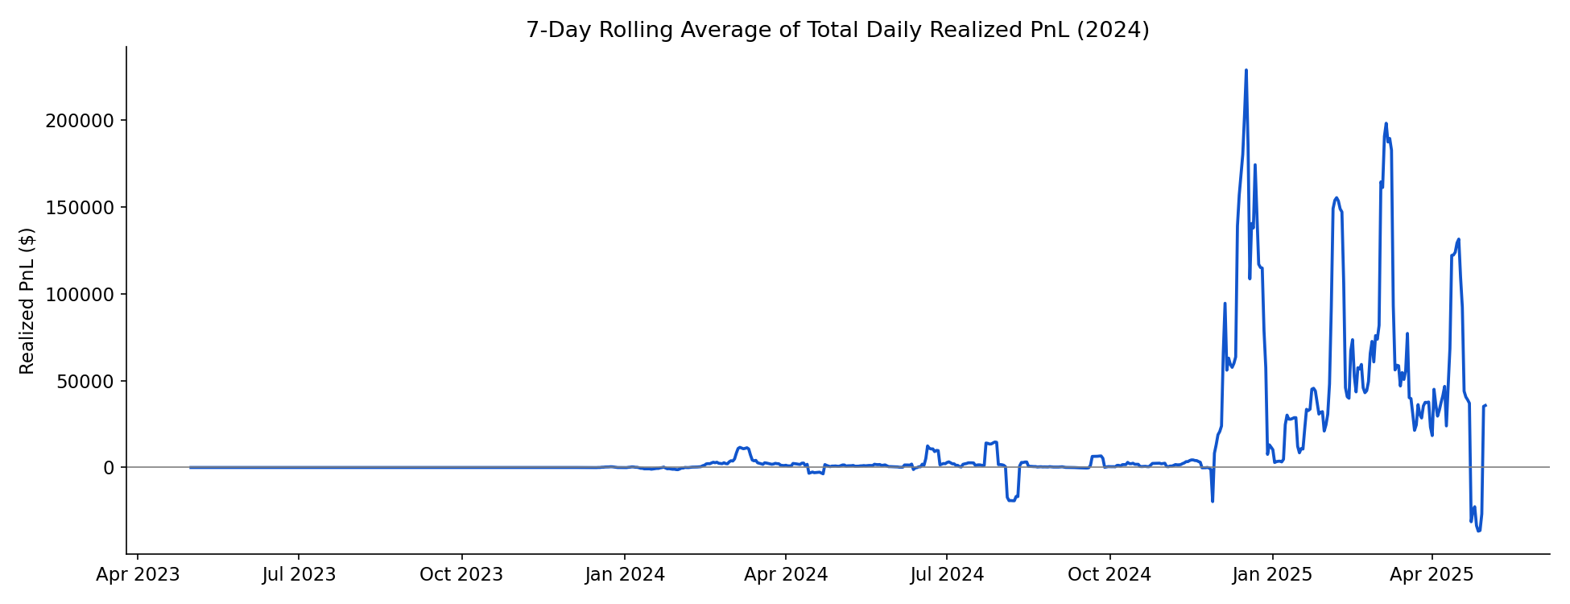
Figure 4. 7-day rolling average of total daily realized PnL across the sample period.
The correlation between the raw Fear/Greed index value (0–100) and daily realized PnL is weakly negative (r ≈ −0.08), and the correlation with daily volume is more clearly negative (r ≈ −0.26) — confirming quantitatively that lower sentiment readings (more fear) are associated with higher trading activity, and mildly with higher profitability.

3. Risk Events: Liquidations & Auto-Deleveraging
The dataset contains 9 forced-risk events (liquidations and auto-deleveraging). All 9 occurred on days classified as Greed — none during Fear, Extreme Fear, Extreme Greed, or Neutral days. With Greed accounting for only about 40% of calendar days in the sample, this concentration is notable.
A plausible interpretation: rallies during “Greed” (as opposed to euphoric “Extreme Greed” blow-off tops) are where traders are most likely to add leverage into a market that then reverses or chops, triggering forced closes. This is a useful, low-noise signal for risk management: leverage limits and margin buffers could reasonably be tightened specifically during Greed-labeled conditions, not just during Fear as intuition might suggest.

4. Coin- and Account-Level Variation

4.1 Coins behave differently across regimes
Realized PnL by coin is highly regime-dependent. For example, in this dataset ETH and HYPE were profitable across every sentiment regime including Extreme Fear, while more speculative tokens (e.g., FARTCOIN, and the anonymized “@107” market) swung from large gains in Extreme Greed to losses in Extreme Fear — consistent with higher-beta, sentiment-sensitive assets amplifying regime effects.

4.2 Traders are not uniform
Looking at the ten highest-volume accounts, average PnL by sentiment bucket varies by trader: some accounts perform best in Fear, others in Greed, and a couple are consistently positive across all regimes while others are consistently marginal. This indicates sentiment is one useful factor among several — not a variable that overrides individual strategy or skill — and supports treating sentiment as a position-sizing/risk overlay rather than a standalone signal.

5. Strategic Recommendations
- 1. Use sentiment as a risk-sizing overlay, not a directional signal on its own. Win rate and profitability differences across regimes are real but moderate (roughly 10–15 percentage points of win rate) — large enough to inform position sizing and leverage limits, not large enough to justify a binary “only trade in Regime X” rule.
- 2. Tighten leverage/margin buffers specifically during Greed (not just Fear). This is the regime where all observed forced-liquidation events occurred, likely reflecting overconfidence and leverage build-up ahead of reversals.
- 3. Expect — and prepare operationally for — activity surges during Fear and Extreme Fear. Volume and trade counts rise 5–7x versus Greed conditions; execution infrastructure, slippage assumptions, and risk monitoring should scale accordingly during these windows.
- 4. Treat Extreme Greed as a higher-quality trending regime. It shows the best combination of win rate and average PnL per trade, on relatively controlled volume — a profile more consistent with clean trends than panic-driven churn.
- 5. Layer in asset-level sentiment sensitivity. Higher-beta / narrative-driven tokens amplify sentiment regime effects far more than large-cap assets like BTC and ETH; sentiment-based risk adjustments should be more aggressive for these tokens specifically.

6. Limitations
- Only 32 accounts are represented; account-level conclusions (Section 4.2) are illustrative, not statistically generalizable to the broader trader population.
- Daily sentiment classification is a blunt instrument — it doesn’t capture intraday sentiment shifts, and trades are matched to sentiment by calendar date only.
- “Closed PnL” reflects realized outcomes only; open, unrealized positions at the end of the sample are not captured in the win-rate calculation.
- Correlation results (Section 2.4) are associational; the analysis does not establish that sentiment causes the observed behavior, only that the two are related.

7. Conclusion
Market sentiment, as captured by the Fear & Greed Index, is a meaningful but secondary factor in trader outcomes on Hyperliquid. The clearest, most actionable finding is behavioral rather than purely about profitability: traders are far more active during fear, and risk events cluster during greed — which argues for a sentiment-aware risk framework (leverage limits, margin buffers, execution capacity) layered on top of — not in place of — existing trading strategy.

