Business Problem
In recent years, City Hotel and Resort Hotel are facing the problem of high cancellation rates. Each hotel is now dealing with several issues as a result, including fewer revenue and less than ideal hotel room use. Consequently, the goal here is to reduce the cancelation rates so that efficiency in generating hotel revenue is increased.
Assumptions
1. No unusual occurrences between 2015 and 2017 will have a substantial impact on the data used.
2. The information is still current and can be used to analyze a hotel’s possible plans in an efficient manner.
3. The hotel is not using any of the suggested solutions.
4. The biggest factor affecting the income is booking cancellations.
5. Cancellations result in vacant rooms for the booked length of time
6. Clients make hotel reservations the same year they make cancelations.

Research Question
1. What are the variables that affect hotel reservation cancellations?
2. How can we reduce the hotel cancellations?
3. How will hotels be assisted in making pricing and promotional decisions?

Hypothesis
1. More cancellations occur when the prices are higher
2. When the waiting list is longer the customers tend to cancel more frequently
3. Most of the clients are coming from offline travel agents to make their reservations.
Dataset Link: https://www.kaggle.com/datasets/mojtaba142/hotel-booking
Analysis and Findings:
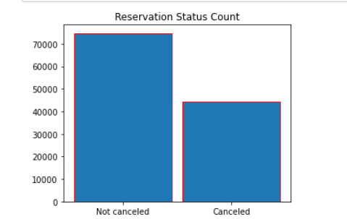
The above plot reveals that the reservations cancelled is almost half of the reservations that are not cancelled.
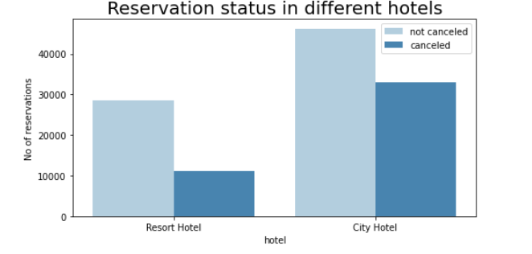In the above graph we see that cancellations are higher for city hotels as compared to resort hotels. Also, the bookings in city hotels is much higher than that of resort hotels. This might be because resort hotels are much more expensive than city hotels.

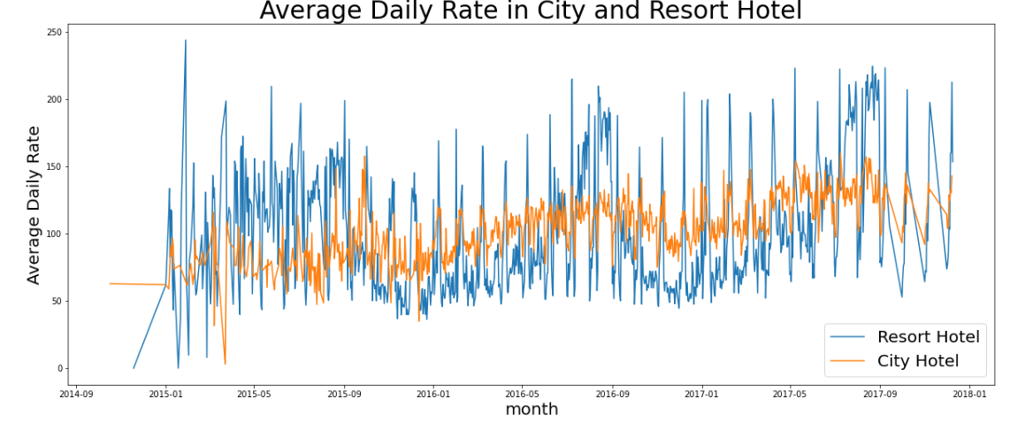

The above line graph indicates the average daily rates for resort and city hotels between the period starting January 2015 to January 2018. We can see that the data is inconsistent over certain periods. The data is consistent from January 2016 to September 2017. The line graph shows that the average daily rates of resort hotels are consistently higher than the city hotels.
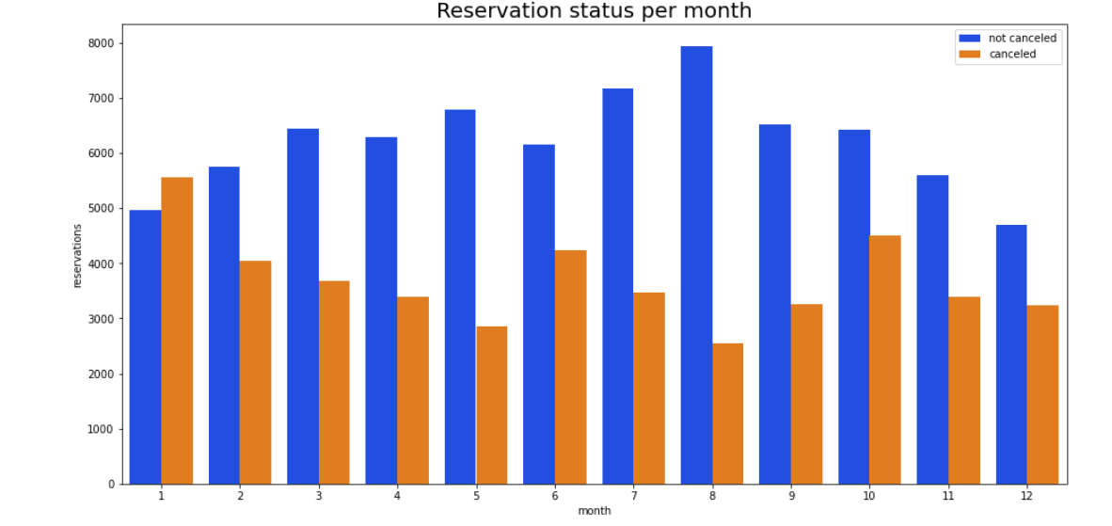
The above grouped bar graph of both the city and resort hotels is for the reservations for that month. The above graph shows that the highest bookings and the lowest cancellations are in the month of August. The highest cancellations are in the month of January.

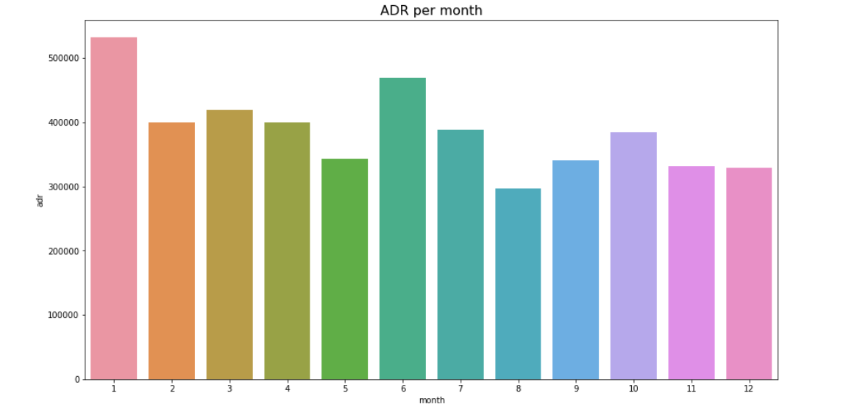
The bar graph above shows the highest average daily rates and the lowest average daily rates in the months of the year. Highest is in January and lowest is in August.

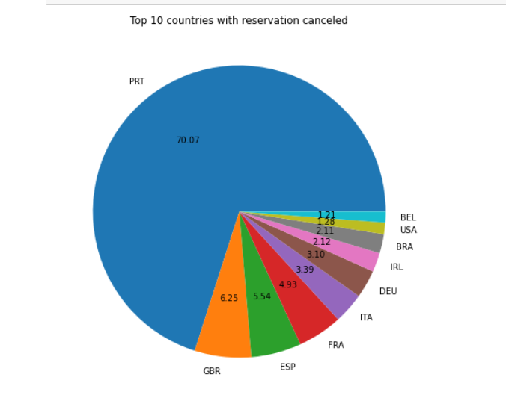
We see that Portugal has recorded the highest number of cancellations.

We also check from where the maximum reservations are coming from. Maximum reservations are from online at 47%. Offline reservations are at 20%. Only 10% of the clients come through direct reservations.
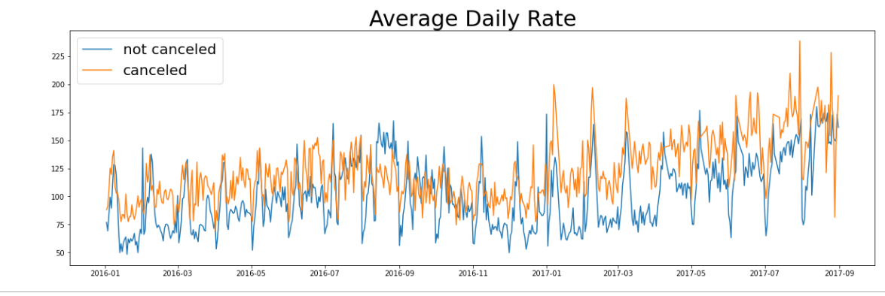

From the above graph we can see that when the average daily rate is high then the cancellation rates are also higher.
Suggestions
1. Cancellation rates are heavily dependent on the prices. To prevent cancellations of reservations, hotels should work on their pricing strategies and should try to lower the rates for specific hotels and locations. They should also think about providing discounts to customers especially in the months where the cancellation rates are higher.
2. Hotels can start some marketing campaigns with a reasonable amount especially in January to increase their revenue as the cancellation is the highest in this month.
3. Hotels in Portugal should improve their hotel quality as well as service so that their cancellation rates might come down.

