VANILLAWARP – Peer 2 Peer File Transfer System
Name: Sarthak Deodhar | Branch: TY-CSE-A
Roll No: 1262240166 [27] | Subject: Java Programming

1. Project Overview
What is VanillaWarp?
VanillaWarp is a hybrid, zero-trust peer-to-peer (P2P) file-sharing platform. It allows devices to securely transfer multi-gigabyte files directly between each other without storing the payload on a central cloud server.
Why was it built?
Traditional file sharing relies on cloud middlemen, which introduces privacy risks, file size limits, and bandwidth throttling. Furthermore, in enterprise or university environments with strict AP Isolation (Client Isolation), local sharing is often blocked. VanillaWarp was built to bypass these bottlenecks, utilizing local Wi-Fi hotspots and WebRTC to unleash raw device-to-device speeds while maintaining absolute cryptographic security.
Who is it for?
It is designed for users who need a secure, high-speed, and lightweight solution to move large amounts of data between devices (e.g., from an ASUS ROG laptop to a Vivo mobile device) without downloading external software.
Where does it operate?
The system operates entirely within the browser on the client side, while the lightweight backend server can be hosted locally or exposed to the public internet via an automated SSH tunneling daemon.
When is data encrypted?
Data is encrypted end-to-end. The encryption keys are derived locally on the devices before the transfer begins, ensuring that even the signaling server cannot intercept or read the files.
How does it work?
It separates the architecture into two planes. The Java backend acts purely as a "Control Plane" to match users and exchange connection details (SDP offers/answers). The JavaScript frontend acts as the "Data Plane," utilizing the WebRTC protocol to build a direct bridge between the sender and receiver.

2. System Architecture
- The Frontend (Data Plane): A Single Page Application (SPA) built with vanilla HTML, CSS (Glassmorphism UI), and JavaScript. It handles file chunking, AES-256-GCM encryption via the Web Crypto API, and peer-to-peer streaming via WebRTC Data Channels.
- The Backend (Control Plane): A native Java server utilizing com.sun.net.httpserver that manages room states, enforces IP rate-limiting, handles SSH tunneling, and logs telemetry to an embedded SQLite database.
- Development Lifecycle
Phase 1: The Signaling Engine
The first step was establishing a way for two devices to find each other. We built a lightweight REST API in Java. When a sender creates a room, the server generates a 6-character room code and waits for the receiver to query that code.
Phase 2: Network Traversal & WebRTC
Once the devices locate each other, they exchange SDP (Session Description Protocol) offers. We configured the system to use Cloudflare STUN servers. By intentionally stripping out heavy TURN servers, we forced the application to prioritize local network bridges (like Windows Mobile Hotspots), allowing the system to completely bypass Carrier Grade NAT (CGNAT) and college network AP Isolation.
Phase 3: Cryptography & Zero-Trust
Security was implemented using the Web Crypto API. The 6-character room code combined with a random 16-byte salt is passed through PBKDF2 (100,000 iterations) to derive an AES-256-GCM key. The file is then sliced into chunks, and each chunk is encrypted with a unique Initialization Vector (IV) before transmission.
Phase 4: Optimization (Turbo Mode & Handshakes)
During testing, we encountered WebRTC buffer overflows and browser UI crashes. To solve this, we implemented:
- Turbo Mode: A dynamic chunking system that scales between 60KB (for strict mobile compatibility) and 250KB (to maximize desktop-to-desktop LAN throughput).
- Cryptographic Handshake: A FILE_READY signal ensuring the sender completely pauses data transmission until the receiver has resolved their file system permissions.
- 500ms Rolling Telemetry: A mathematical throttle on the UI thread to calculate true live speeds without crashing the browser's DOM.

4. Java Implementation in Detail
Java serves as the robust orchestration layer for VanillaWarp. We intentionally avoided heavy frameworks like Spring Boot to demonstrate a deep understanding of core Java networking and concurrency.
- Native HTTP Server: We implemented com.sun.net.httpserver.HttpServer on port 8080. Custom classes implementing the HttpHandler interface (CreateRoomHandler, OfferHandler, AnswerHandler) route incoming HTTP traffic and serve JSON responses.
- Concurrency & Thread Safety: The server uses Executors.newCachedThreadPool() to handle concurrent incoming requests without blocking. Active room states and rate-limiting trackers are stored in ConcurrentHashMap instances, guaranteeing thread-safe, O(1) memory lookups.
- Embedded Database (JDBC): Telemetry is handled via SQLite. The initDatabase() method creates a table if it doesn't exist, and the server uses PreparedStatement logic to safely insert the client's IP and room code upon creation, eliminating SQL injection risks.
- Process Orchestration (SSH Daemon): To expose the local Java server to the internet, we utilized Java's ProcessBuilder. A background daemon thread launches an SSH command (ssh -R 80:localhost:8080 localhost.run), intercepts the standard output stream, parses the dynamically assigned public HTTPS URL, and exposes it via an API endpoint.
- Automated Garbage Collection: A ScheduledExecutorService runs a cleanup thread every 60 seconds, sweeping the ConcurrentHashMap to purge room configurations older than one hour, preventing memory leaks.
- Browser-Accessible Admin API: A dedicated endpoint (/api/admin/stats) securely outputs the active room count and server telemetry as a JSON payload for real-time monitoring.

5. System Interfaces
- Figure 1: The Splash Screen & UI Initialization
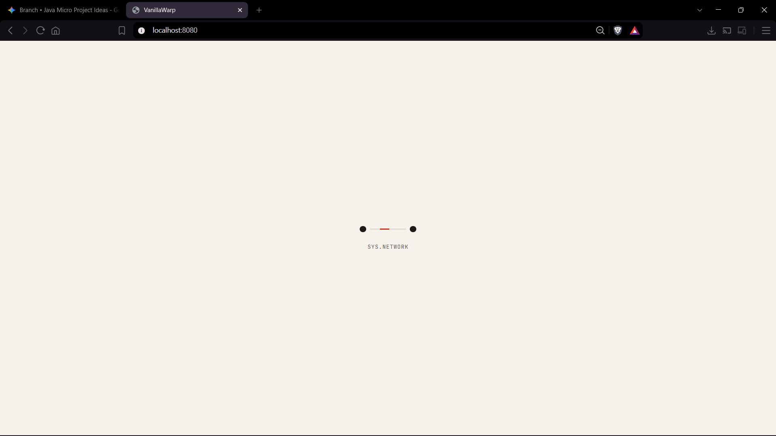

- Figure 2: Room Creation & Turbo Mode
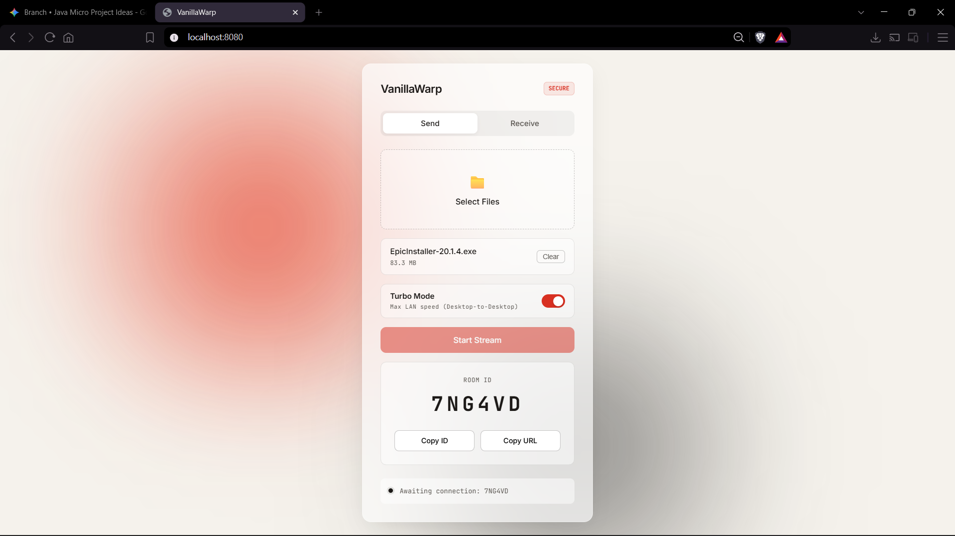

- Figure 3: Live Telemetry & Transfer
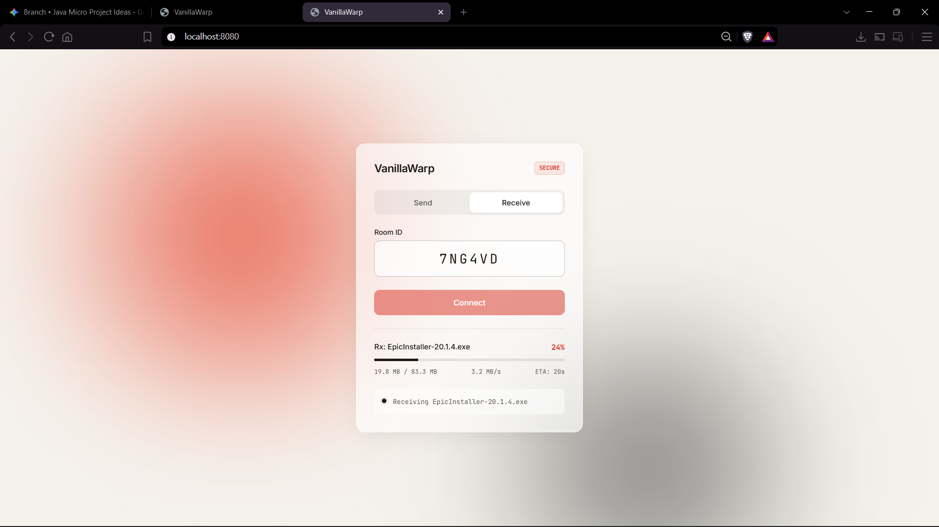

- Figure 4: Java Server Console & Tunneling
