SIR M. VISVESVARAYA INSTITUTE OF TECHNOLOGY, BENGALURU
Department of Electronics and Communication Engineering

Assignment Report

Magnitude, Phase and Intelligibility of Speech
Zero-phase and random-phase reconstruction, phase scrambling, and STOI of speech in NOISEX-92 noise

Submitted by
Sarthak Tripathi
USN: 1MV23EC096

October 2026

Abstract
This report looks at what the magnitude and the phase of the short-time Fourier transform (STFT) each contribute to a speech signal. A 9.9 s clean utterance from LibriSpeech was analysed with a 32 ms Hann window and an 8 ms hop. Rebuilding the signal from the magnitude with zero phase gave a buzzy, robotic voice, and rebuilding it with a random phase gave a rough, noisy one, yet both stayed largely intelligible (STOI 0.839 and 0.871). A real signal is guaranteed when the phase is odd-symmetric in every frame, and infinitely many such phases exist. Random phase made the speech unintelligible only when the frame was made about one second long (ESTOI 0.072), and such speech could be recovered only when the magnitude or the random phase itself was kept. The experiments were repeated with NOISEX-92 white, babble and machine-gun noise at −2 to 10 dB SNR. A band-pass filter did not improve STOI in any of the fifteen noisy conditions.

1. Introduction
Most speech processing is done on the STFT, where every time-frequency point has a magnitude and a phase. Classical enhancement methods change only the magnitude and keep the noisy phase, on the assumption that the ear is not very sensitive to phase. Oppenheim and Lim [2] showed that this is not true in general, and listening tests [3], [4] found that the answer depends on the length of the analysis window.
The assignment tests these ideas on a real recording. The signal is rebuilt from its magnitude alone and from a random phase, the condition for a modified spectrum to give a real signal is worked out, the speech is made unintelligible by scrambling its phase and then recovered, and intelligibility is measured with STOI in clean and noisy conditions, with and without a band-pass filter. Section 2 describes the data and the choices made, Section 3 answers the questions in order, Section 4 describes the code and its tests, and Section 5 gives the conclusions. The code, the executed notebook and all results are in the GitHub repository github.com/Sarthak261-rgb/speech-phase-stoi.

2. Data and Method

2.1 Speech and noise
The recording is utterance 1272-128104-0003 from the LibriSpeech dev-clean set [10], read by a male speaker: “He has grave doubts whether Sir Frederick Leighton's work is really Greek after all and can discover in it but little of rocky Ithaca.” It lasts 9.9 s and is stored losslessly at 16 kHz with 16-bit samples. The pauses are about 47 dB below the speech, so there is very little background noise. A public studio recording was used instead of a phone recording for two reasons: STOI needs a clean reference, and anyone can download the same file and repeat the work.
White, babble and machine-gun noise were taken from the NOISEX-92 folder of the speechdnn/Noises repository [11] and resampled to 16 kHz. The machine-gun file was recorded at 8 kHz, so it has no energy above 4 kHz. For each noise one 9.9 s segment was picked with a fixed random seed and used at all five SNRs, so that the SNR conditions differ only in noise level. The SNR is measured over the whole utterance.

2.2 Analysis settings
Table 1 lists the settings and the reason for each. Two of them need a short explanation. First, the FFT keeps all N bins, a two-sided spectrum. Library STFTs based on the real FFT keep only the positive frequencies, and their inverse always returns a real signal; that would hide the question asked in Part 3. Second, the inverse STFT is the least-squares method of Griffin and Lim [1]:
y[n] = Σ_{m} w[n − mH] y_{m}[n − mH] / Σ_{m} w²[n − mH], y_{m} = IDFT of frame m (1)
For an unchanged STFT it returns the original signal exactly (the error is 2×10⁻¹⁶). For a modified STFT it returns the signal whose STFT is closest to the modified one, and its output is complex if the modified spectrum is not conjugate-symmetric.
Table 1: Analysis settings and the reason for each choice.
Setting | Value | Reason
Window | Hann, N = 512 (32 ms) | speech is nearly stationary over 20 to 40 ms; bins 31.25 Hz apart separate harmonics 116 Hz apart; low side lobes
Hop | H = 128 (8 ms), 75% overlap | the squared windows add to a constant, so the inverse is stable; the fourfold redundancy is also what makes phase recovery possible in Part 5
FFT | two-sided, N = 512 | keeps the symmetry studied in Parts 3 and 4 visible
Inverse STFT | least-squares [1] | correct inverse for a modified STFT
Random phase | uniform on [−π, π), fixed seed | no preferred phase; repeatable
Scrambler frame | 1.024 s, 75% overlap | chosen from the sweep in Section 3.5
Phase recovery | fast Griffin–Lim [7], 200 iterations | standard method; settled within 200 iterations in every run
Band-pass filter | Butterworth (order 4 per edge), forward-backward | flat pass band; no phase distortion or delay
Intelligibility | STOI [8] and ESTOI [9] | STOI is required; ESTOI copes better with fluctuating noise and falls to about 0 for unintelligible speech

2.3 Measures
STOI compares the band envelopes of a processed signal with those of the clean signal in 15 third-octave bands between 150 Hz and about 4 kHz, over 384 ms segments [8]. It is close to 1 for intact speech, but because of its normalisation an unrelated speech-like sound still scores around 0.35 to 0.4; ESTOI [9] does not have this floor. The clean recording is always the reference. To describe changes that STOI does not see, the waveform correlation r with the original and the spectral convergence SC (the relative error between the STFT magnitude of the result and MG) are also given.

3. Results and Discussion

3.1 Recording, STFT magnitude and phase (Parts 1 and 2)
Use a voice recording of about 10 s with minimal background noise. Take its STFT and plot the magnitude (MG) and the phase (PH) separately.
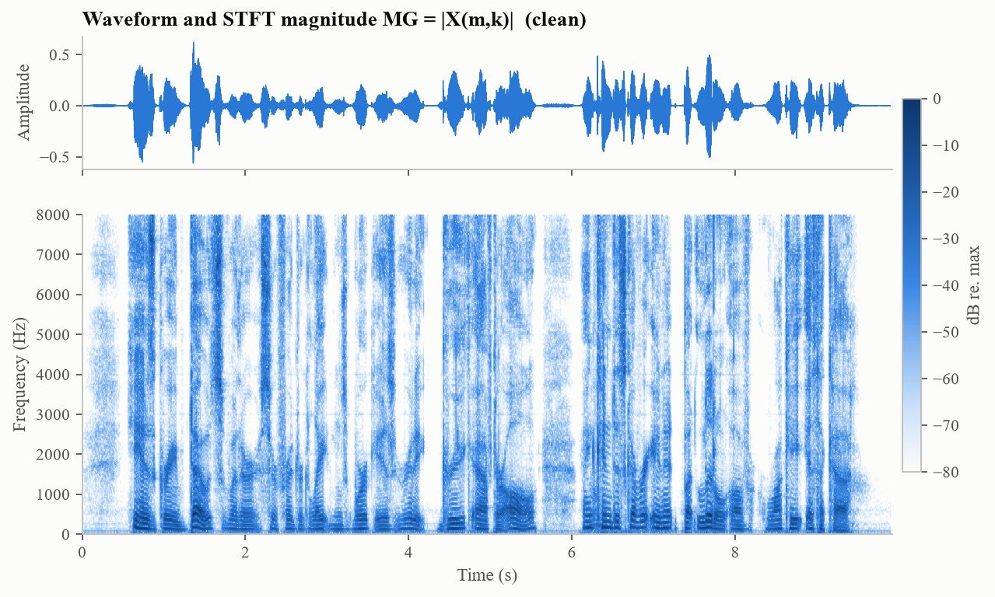
Figure 1: Waveform and STFT magnitude MG of the recording (dB relative to the maximum).
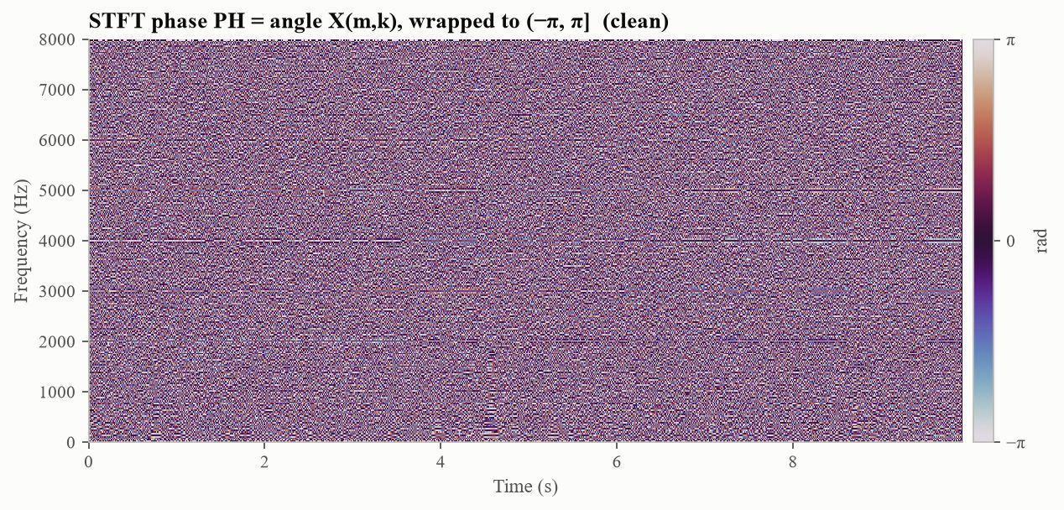
Figure 2: STFT phase PH, wrapped to (−π, π]. The colour scale is cyclic, so −π and π have the same colour.
MG (Figure 1) shows the speech clearly: harmonics as thin horizontal lines, formants as darker bands, fricatives above 4 kHz, and the pauses between words. PH (Figure 2) looks like random noise. The phase is not actually random: for a steady tone it advances by 2πkH/N = πk/2 radians per hop, so every bin wraps around ±π at a different rate and the plot shows mostly the wrapping. Its rate of change over time, the instantaneous frequency, does follow the harmonics (see the notebook). In every frame MG is symmetric and PH antisymmetric about bin N/2, as expected for a real signal. This is used in Part 4.

3.2 Magnitude only, zero phase: sig1 (Part 3)
Using only the magnitude (zero phase), do the inverse transform and call the result sig1. How does it differ from the original, and why?
sig1 was computed with Eq. (1) from MG alone, with every phase set to zero. It is real, it follows the spectral envelope of the original, and it is still mostly intelligible (STOI 0.839, ESTOI 0.731). It sounds like a buzzy, monotone, robotic voice, and its waveform has almost nothing in common with the original (r = 0.040, Table 2).
The reason is that with zero phase every frame turns into a short symmetric pulse at the start of the frame. All the cosine components of the frame are in phase at n = 0 and add up there (Figure 3). Three things follow. The timing inside each 32 ms frame, where the glottal pulses and onsets were, is lost. The pulses repeat every hop of 8 ms, so sig1 is excited at f_{s}/H = 125 Hz instead of at the speaker's own varying pitch (median 116 Hz); its spectrum becomes a comb with lines at multiples of 125 Hz (Figure 4), and the autocorrelation at a lag of 8 ms rises from 0.31 to 0.86. Finally, because the pulse falls at the edge of the frame, where the Hann window is zero, most of it is removed in the overlap-add, and sig1 is 13.8 dB quieter than the original.
Zero phase therefore depends on where the time origin of a frame is taken. Taking it at the centre of the window (sig1c) puts the pulse at the peak of the window: the loss drops to 2.0 dB and STOI rises to 0.945, but the 125 Hz buzz remains.
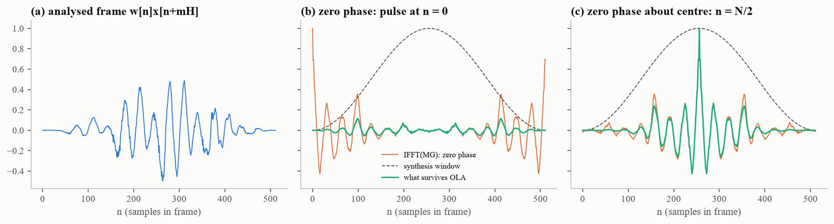
Figure 3: One voiced frame. (a) Original frame. (b) Inverse DFT of its magnitude with zero phase, a pulse at n = 0, and the small part that survives the synthesis window (green). (c) Zero phase about the window centre puts the pulse at n = N/2.
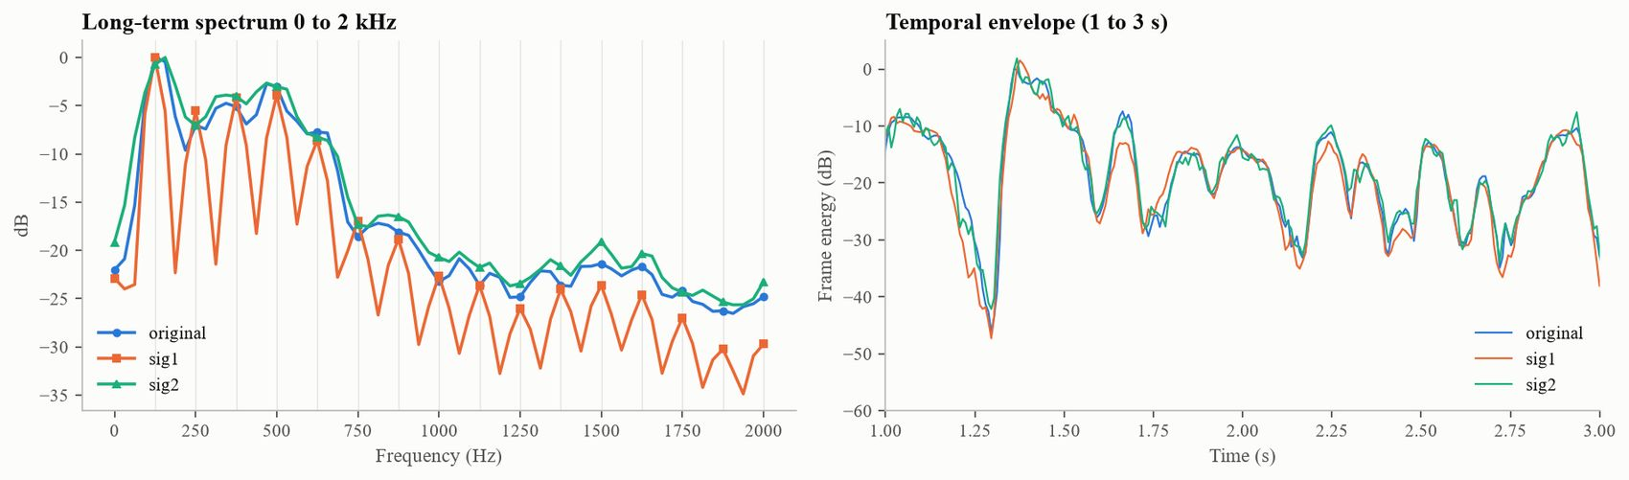
Figure 4: Left: long-term spectrum up to 2 kHz, grey lines every 125 Hz. sig1 is a comb at multiples of 125 Hz, sig2 follows the original. Right: frame energy; both keep the syllable rhythm of the original.

3.3 Random phase PH1: sig2 (Part 3)
Create an array PH1 of the same size as PH and use MG and PH1 to obtain sig2. Is a real-valued sig2 possible? How does sig2 differ from the original, and from sig1?

Is a real sig2 possible?
When PH1 is filled with independent random values for all 512 × 1241 entries, sig2 comes out complex, with 51.7% of its energy in the imaginary part. A signal is real only if its spectrum satisfies X[N − k] = X*[k]. MG already meets the magnitude part of this condition, so PH1 must satisfy PH1[N − k] = −PH1[k], and an unrestricted random array almost never does. A real sig2 is therefore possible: it is guaranteed when PH1 has this symmetry in every frame (Section 3.4). With such a PH1 the largest imaginary value is 7.5×10⁻¹⁷, which is rounding error. Taking the real part of the complex sig2 also gives a real signal, but it scales the magnitude by a random factor and loses another 2.6 dB (−8.9 dB against −6.3 dB). Below, sig2 means the real signal obtained with a symmetric random PH1.

sig2 compared with the original
Inside each frame the harmonics now add with random phases, so each frame becomes a burst of noise with the right spectral shape. sig2 sounds rough and hoarse, and its waveform is uncorrelated with the original (r = 0.011). It is 6.3 dB weaker. This agrees with a simple argument: a random-phase spectrogram is not the STFT of any signal, and the inverse STFT keeps only the part that is consistent, which for a random phase is about H/N = 1/4 of the energy (−6.0 dB). The rest is lost, so the harmonics are blurred and onsets are spread over up to one frame (SC = 0.562). STOI is still 0.871, because at 32 ms the magnitude carries the formant movements and the syllable rhythm on which intelligibility depends [3], [4].

sig1 compared with sig2
The two signals have exactly the same magnitude and differ only in phase. Zero phase is the same in every frame, so the frames line up and sig1 is a periodic pulse train (kurtosis 22.7, autocorrelation at 8 ms 0.86). Random phase changes from frame to frame, so sig2 is noise-like (kurtosis 12.9, autocorrelation 0.05). sig1 has an artificial 125 Hz comb in its spectrum, sig2 a smooth but blurred one. Their STOI values are close (0.839 and 0.871), yet they sound completely different: one is buzzy and robotic, the other rough and noisy.
Table 2: sig1 and sig2 compared with the original recording.
Signal | Energy (dB) | r | SC | Kurtosis | Autocorr. at 8 ms | STOI | ESTOI
Original | 0.000 | 1.000 | 0.000 | 10.731 | 0.306 | 1.000 | 1.000
sig1 (zero phase) | −13.788 | 0.040 | 0.693 | 22.683 | 0.857 | 0.839 | 0.731
sig1c (zero phase, centred) | −1.969 | 0.045 | 0.596 | 22.883 | 0.959 | 0.945 | 0.889
Re{sig2}, unrestricted PH1 | −8.900 | −0.046 | 0.578 | – | – | 0.870 | 0.776
sig2, symmetric PH1 | −6.266 | 0.011 | 0.562 | 12.917 | 0.052 | 0.871 | 0.774

3.4 Phase pattern that gives a real sig2 (Part 4)
Is there a pattern in PH1 that ensures a real-valued sig2? How many such patterns are possible?
Yes. sig2 is guaranteed to be real if, in every frame m, the phase is odd about N/2 and the DC and Nyquist bins are real:
PH1(m, N − k) = −PH1(m, k) (mod 2π), k = 1, ..., N/2 − 1 (2)
PH1(m, 0) and PH1(m, N/2) ∈ {0, π} (3)
Wherever MG is non-zero, these conditions are necessary and sufficient for the inverse DFT of each frame to be real, and the overlap-add of real frames is then real. Table 3 checks them numerically. Zero phase, a linear phase (a pure delay) and symmetric random phases all give imaginary parts at the 10⁻¹⁶ level. A symmetric phase with arbitrary DC and Nyquist values, a symmetric phase plus a constant π/4, an even phase and an unrestricted phase all give complex signals.
Table 3: Is sig2 real? Random patterns were tried 20 times each.
PH1 pattern | Trials | Imaginary energy / total | Max |Im| | Real?
zero phase (PH1 = 0) | 1 | 1.3e−31 | 6.9e−17 | Yes
linear phase (pure delay, −2πkd/N) | 1 | 5.2e−28 | 3.6e−15 | Yes
odd random, DC and Nyquist in {0, π} | 20 | 2.7e−32 | 9.6e−17 | Yes
odd random, DC and Nyquist arbitrary | 20 | 2.7e−04 | 0.00974 | No
odd random + constant π/4 | 20 | 0.5 | 0.319 | No
even random (wrong symmetry) | 20 | 0.5 | 0.367 | No
unconstrained i.i.d. uniform | 20 | 0.494 | 0.362 | No

As for the number of patterns: in each frame the 255 phases of bins 1 to N/2 − 1 can take any value, the other half is then fixed by Eq. (2), and the DC and Nyquist bins have two choices each. Since the phases are continuous, the number of valid patterns is infinite. Even if each phase could only be 0 or π there would be 4·2²⁵⁵ ≈ 10⁷⁷ patterns per frame, and about 10^{96,010} for the 1241 frames of this recording. Familiar examples are zero phase, a linear phase, the original phase PH, and the phase of the DFT of any real sequence. Different patterns can still give the same sig2, because the inverse STFT discards part of the spectrogram.

3.5 Unintelligible speech and its recovery (Part 5)
Create an unintelligible version of every speech signal using an odd but random phase, and ask others to recover the original.
At 32 ms, random phase does not make speech unintelligible (STOI 0.871 above). Figure 5 shows what happens as the frame gets longer, with the hop kept at a quarter of the frame. STOI falls from 0.877 at 16 ms to 0.361 at 2 s, and ESTOI from 0.777 to 0.006. Most of the drop happens between about 128 and 512 ms, roughly the length of a syllable: once a frame covers several syllables, random phase smears them together. For long frames the magnitude alone no longer carries the intelligibility; earlier studies found that the phase then does [2], [4]. A frame of 1.024 s was chosen for the scrambler. It gives STOI 0.396 and ESTOI 0.072, which is unintelligible. Scrambled versions were made for the clean recording and for all fifteen noisy signals.
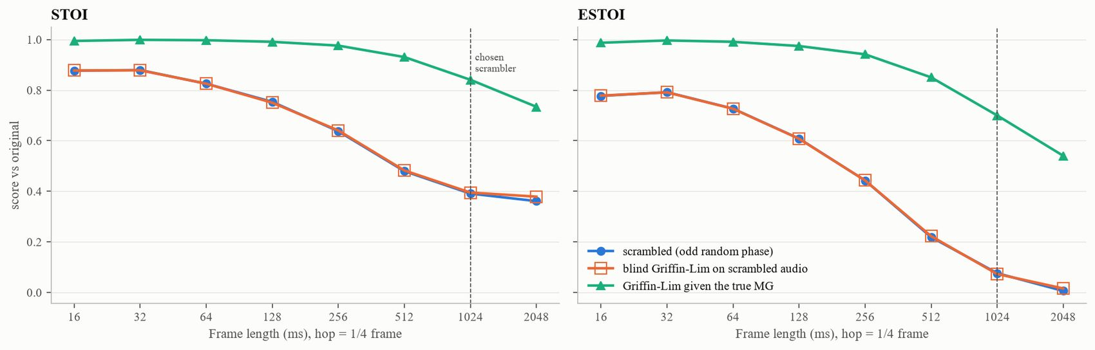
Figure 5: Effect of frame length. Blue: random-phase version. Orange: blind Griffin–Lim recovery from it, which lies on the blue curve. Green: Griffin–Lim given the true magnitude.
Recovering the original was tried in three ways (Table 4, Figure 6).
Blind recovery. Only the scrambled file is available. Fast Griffin–Lim was run for 200 iterations on its magnitude. It converged, but STOI stayed at 0.395. This cannot work: the scrambled signal is itself a perfect solution for its own magnitude, and the original phase was thrown away, not hidden. Even the original magnitude can no longer be read from the scrambled file (SC = 0.535).
Recovery with the magnitude. If the true 32 ms magnitude is sent along with the file, Griffin–Lim rebuilds the speech almost perfectly (STOI 0.999), since a redundant STFT magnitude in general fixes the signal up to its sign [5], [6]. The waveform is not identical (SNR about 0 dB) because the sign of separate speech segments cannot be decided, which does not affect STOI.
Recovery with a key. Instead of replacing the phase, an odd random phase K, generated from a secret number, is added to the phase of non-overlapping 1.024 s frames. The result is real, because the sum of two odd phases is odd, and just as unintelligible (STOI 0.357, ESTOI −0.003). Whoever has the key subtracts K and gets the original back exactly (STOI 1.000). The frames must not overlap, otherwise neighbouring keys mix and the recovery is only approximate.
Phase scrambling is therefore reversible only if extra information is kept: the magnitude or the random phase itself. The scrambled files of all sixteen signals and a script for the three recovery methods (recover.py) are in the repository, so others can try to recover the speech.
Table 4: Scrambling and recovery of the clean recording.
Signal | STOI | ESTOI
Scrambled (phase replaced) | 0.396 | 0.072
Blind Griffin–Lim | 0.395 | 0.061
Griffin–Lim with true magnitude | 0.999 | 0.998
Scrambled with key | 0.357 | −0.003
Descrambled with key | 1.000 | 1.000

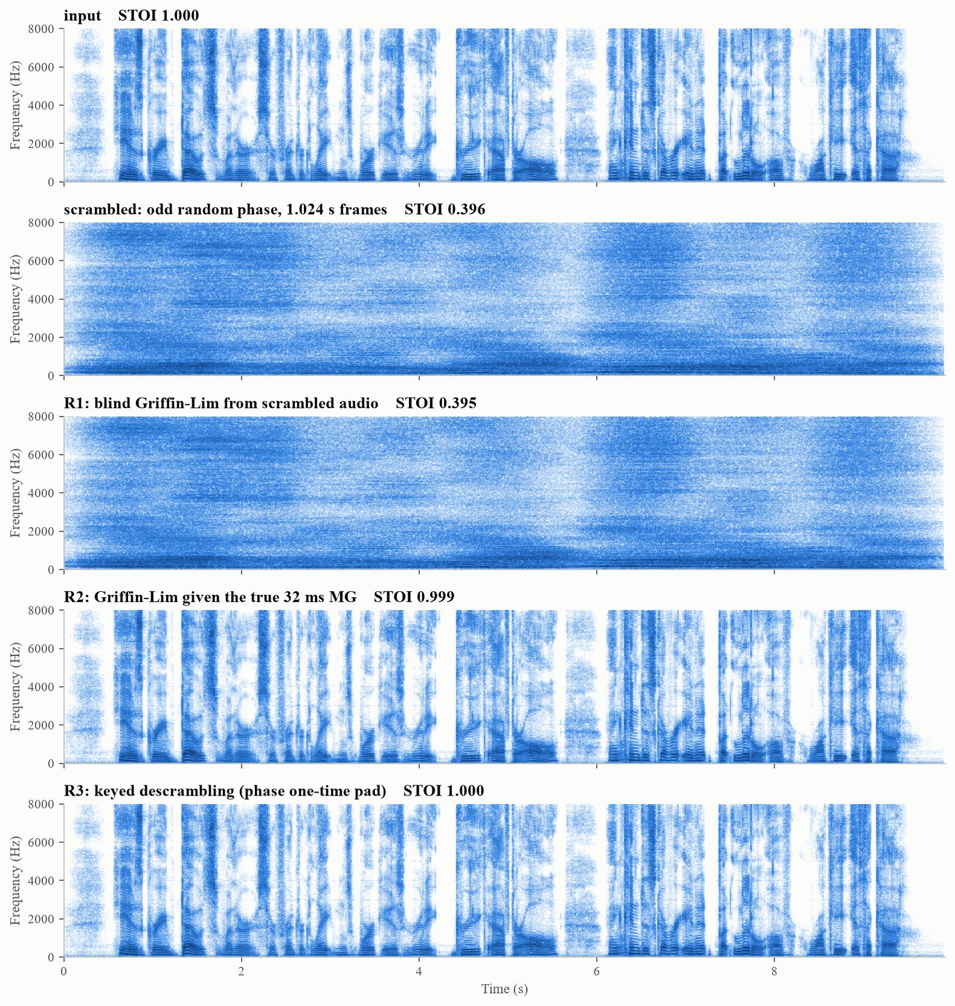
Figure 6: Spectrograms of the original, the scrambled signal and the three recovery attempts.

3.6 Noise, STOI and band-pass filtering (Part 6)
Add white, machine-gun and babble noise from NOISEX-92 at −2, 0, 2, 5 and 10 dB SNR and compute STOI. Repeat Parts 2 to 5 for each noise. Apply a band-pass filter, compare STOI for each noise and comment on the filter design and the scores.

STOI of the noisy speech
Table 5: STOI and ESTOI of the noisy speech.
SNR (dB) | White STOI | White ESTOI | Babble STOI | Babble ESTOI | Machine-gun STOI | Machine-gun ESTOI
−2 | 0.676 | 0.375 | 0.587 | 0.276 | 0.796 | 0.669
0 | 0.712 | 0.423 | 0.638 | 0.339 | 0.827 | 0.711
2 | 0.747 | 0.472 | 0.690 | 0.405 | 0.856 | 0.750
5 | 0.798 | 0.546 | 0.765 | 0.506 | 0.894 | 0.801
10 | 0.872 | 0.670 | 0.869 | 0.669 | 0.942 | 0.872

STOI rises with SNR for all three noises (Table 5). At the same SNR babble is the most harmful (mean STOI 0.710), then white noise (0.761), then machine-gun noise (0.863). Babble is itself speech, so it overlaps the target in both frequency and rhythm. White noise covers the weak high-frequency consonants. Machine-gun noise comes in bursts with near-silent gaps in between, where the speech is heard clearly, and it has no energy above 4 kHz.

Parts 2 to 5 for the noisy signals
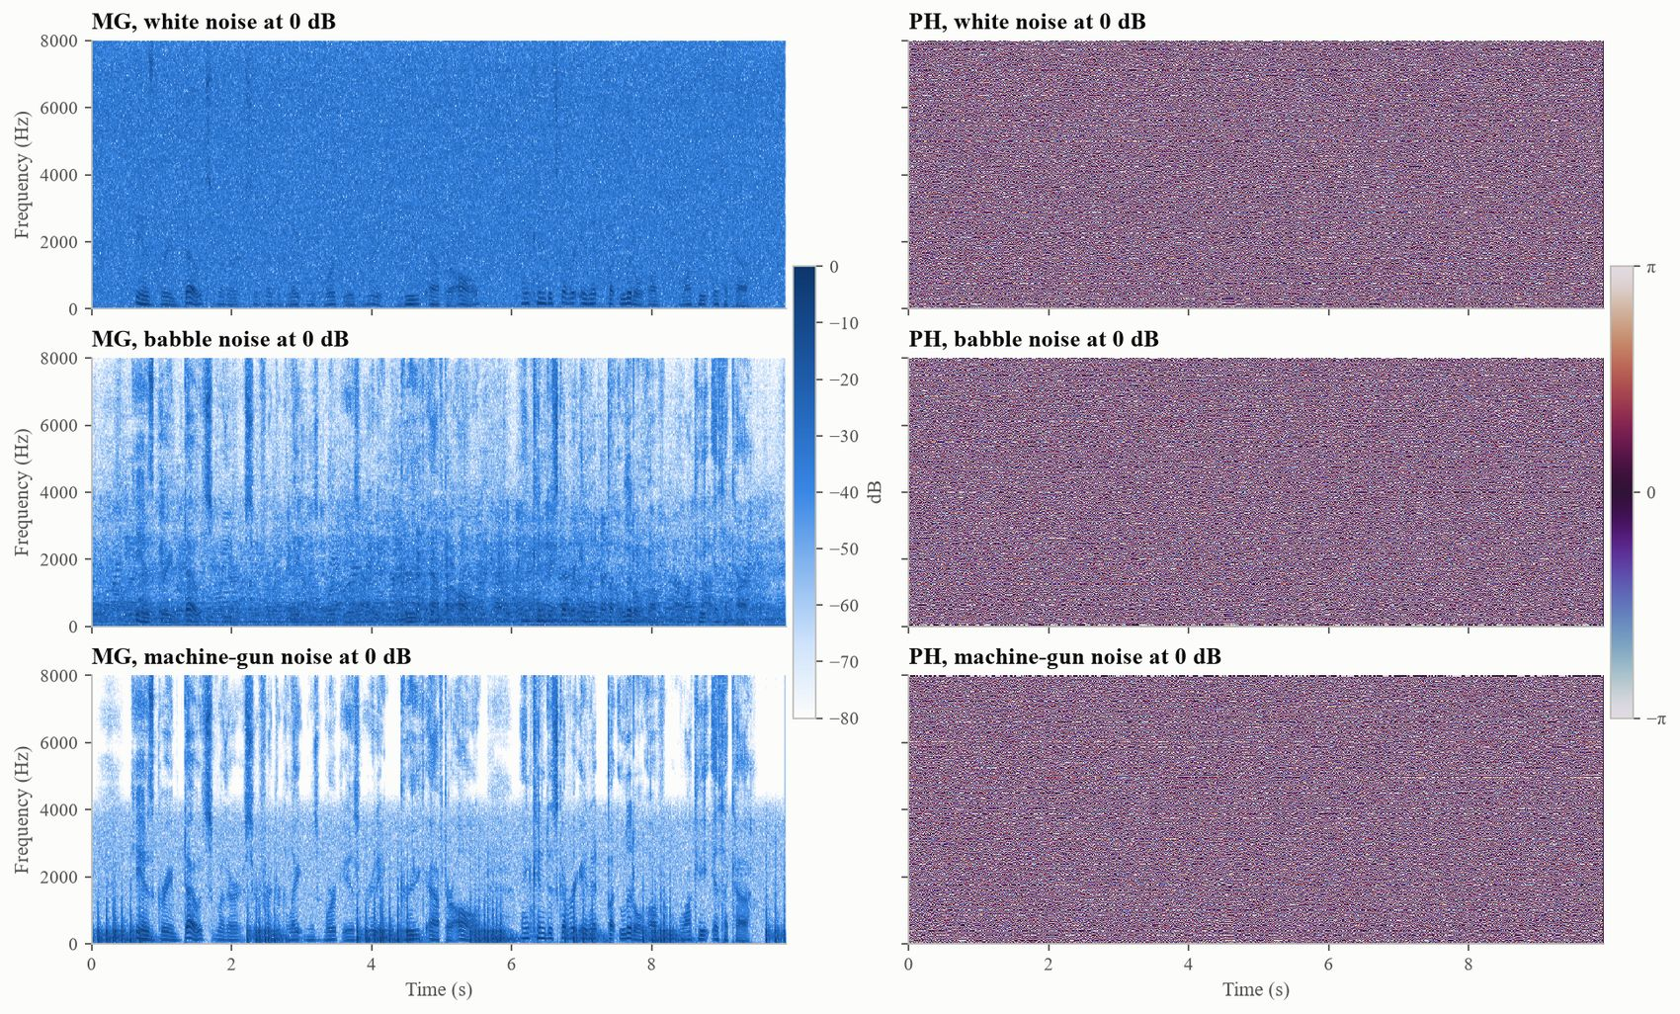
Figure 7: MG and PH of the three noisy signals at 0 dB SNR (all SNRs are in the notebook).
The STFT plots of the noisy signals (Figure 7) show the noise filling the pauses and the high frequencies of MG; in those places PH is simply the phase of the noise. The answers to Parts 3 and 4 do not change: an unrestricted PH1 gives a complex sig2 (50.2 to 51.5% imaginary energy) and a symmetric PH1 a real one. sig1 and sig2 lower STOI further, by 0.074 to 0.143 compared with the noisy input, since changing the phase cannot separate speech from noise. Scrambling makes every noisy signal unintelligible (STOI 0.376 to 0.396), blind recovery fails in every case, and recovery with the magnitude or with the key gives back the noisy signal, not the clean one (Table 6).
Table 6: STOI after each operation of Parts 3 and 5 for every noisy signal. Blind, Magnitude and Key are the three recovery methods.
Noise | SNR | Noisy | sig1 | sig2 | Scrambled | Blind | Magnitude | Key
white | −2 | 0.676 | 0.576 | 0.579 | 0.378 | 0.371 | 0.676 | 0.676
white | 0 | 0.712 | 0.602 | 0.608 | 0.380 | 0.376 | 0.711 | 0.712
white | 2 | 0.747 | 0.629 | 0.636 | 0.381 | 0.380 | 0.748 | 0.747
white | 5 | 0.798 | 0.669 | 0.678 | 0.384 | 0.382 | 0.798 | 0.798
white | 10 | 0.872 | 0.729 | 0.743 | 0.390 | 0.388 | 0.872 | 0.872
babble | −2 | 0.587 | 0.505 | 0.513 | 0.376 | 0.377 | 0.586 | 0.587
babble | 0 | 0.638 | 0.545 | 0.556 | 0.379 | 0.374 | 0.638 | 0.638
babble | 2 | 0.690 | 0.586 | 0.599 | 0.383 | 0.371 | 0.688 | 0.690
babble | 5 | 0.765 | 0.646 | 0.663 | 0.388 | 0.374 | 0.764 | 0.765
babble | 10 | 0.869 | 0.730 | 0.752 | 0.395 | 0.389 | 0.867 | 0.869
machine-gun | −2 | 0.796 | 0.713 | 0.702 | 0.381 | 0.371 | 0.795 | 0.796
machine-gun | 0 | 0.827 | 0.736 | 0.728 | 0.385 | 0.376 | 0.826 | 0.827
machine-gun | 2 | 0.856 | 0.756 | 0.751 | 0.388 | 0.379 | 0.855 | 0.856
machine-gun | 5 | 0.894 | 0.781 | 0.782 | 0.392 | 0.391 | 0.893 | 0.894
machine-gun | 10 | 0.942 | 0.809 | 0.820 | 0.396 | 0.387 | 0.942 | 0.942

Band-pass filter: design
Three filters were compared. BPF-T passes 300 to 3400 Hz, the usual telephone band [12]. BPF-S passes 120 to 4500 Hz; it was chosen so that all 15 STOI bands (133 Hz to 4.3 kHz) lie inside its pass band while the noise above them is still removed. Both are 4th-order Butterworth filters, chosen because their pass band is flat, and both are applied forward and backward so that there is no phase distortion or delay. An ideal brick-wall version of BPF-T and an oracle Wiener filter, which uses the true speech and noise spectra and is not a band-pass filter, were added for comparison.
Table 7: STOI with and without band-pass filtering, and the change in overall SNR caused by BPF-T.
Noise | SNR | Noisy | BPF-T | BPF-S | Brick-wall | Wiener | SNR gain, BPF-T (dB)
white | −2 | 0.676 | 0.619 | 0.667 | 0.597 | 0.954 | 1.256
white | 0 | 0.712 | 0.653 | 0.704 | 0.626 | 0.960 | 1.256
white | 2 | 0.747 | 0.686 | 0.740 | 0.654 | 0.965 | 1.256
white | 5 | 0.798 | 0.735 | 0.792 | 0.697 | 0.973 | 1.256
white | 10 | 0.872 | 0.809 | 0.868 | 0.764 | 0.982 | 1.256
babble | −2 | 0.587 | 0.553 | 0.582 | 0.528 | 0.936 | −0.679
babble | 0 | 0.638 | 0.600 | 0.633 | 0.574 | 0.944 | −0.679
babble | 2 | 0.690 | 0.648 | 0.684 | 0.621 | 0.953 | −0.679
babble | 5 | 0.765 | 0.716 | 0.758 | 0.686 | 0.964 | −0.679
babble | 10 | 0.869 | 0.811 | 0.862 | 0.773 | 0.979 | −0.679
machine-gun | −2 | 0.796 | 0.757 | 0.790 | 0.732 | 0.968 | 4.463
machine-gun | 0 | 0.827 | 0.786 | 0.821 | 0.758 | 0.973 | 4.463
machine-gun | 2 | 0.856 | 0.812 | 0.850 | 0.781 | 0.978 | 4.463
machine-gun | 5 | 0.894 | 0.847 | 0.888 | 0.811 | 0.983 | 4.463
machine-gun | 10 | 0.942 | 0.890 | 0.936 | 0.848 | 0.990 | 4.463

Band-pass filter: results
No band-pass filter improved STOI for any noise or SNR (Table 7). On average BPF-T lowered STOI by 0.050, BPF-S by 0.006 and the brick-wall filter by 0.081, even though BPF-T raised the overall SNR by up to 4.5 dB for machine-gun noise and 1.3 dB for white noise. For babble the overall SNR even fell (−0.7 dB), because babble has the same spectrum as speech. The Wiener filter, in contrast, raised STOI by 0.048 to 0.349.
The reason is that a fixed filter multiplies speech and noise at each frequency by the same gain. Inside its pass band the SNR of each STOI band does not change (largest change 0.03 dB), and STOI's normalisation cancels the gain itself, so the per-band scores in the pass band are identical with and without the filter (Figure 8). The only effect on STOI comes from the bands the filter removes. Once a band is attenuated by tens of decibels, STOI measures leakage from neighbouring bands there instead of speech, and the score of that band falls; even for clean speech the 150 Hz band drops to 0.66 after BPF-T. With 15 equally weighted bands, losing three or four costs about 0.04 to 0.06, which matches the results. Further checks on clean speech show that the phase of the filter does not matter to STOI (causal Butterworth 0.974, zero-phase filter with the same magnitude 0.975); what matters is how sharply the bands outside the pass band are cut (forward-backward 0.939, 511-tap FIR 0.908, brick-wall 0.886).
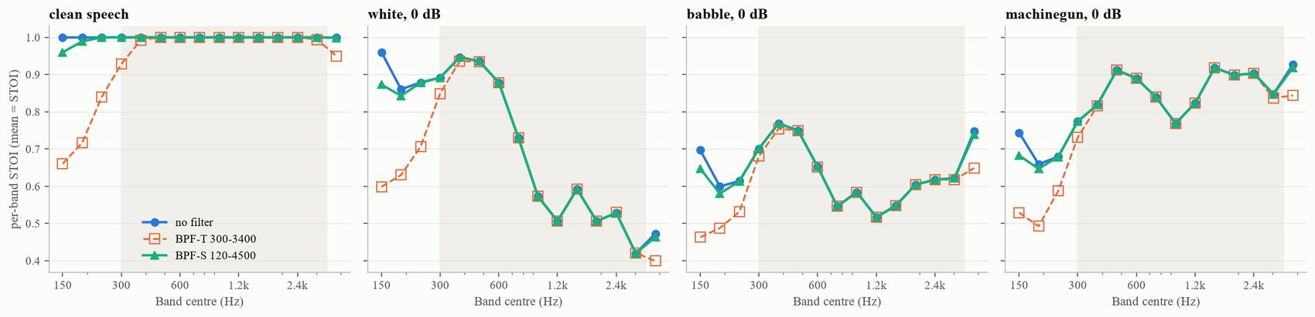
Figure 8: STOI split into its 15 bands, for clean speech and the three noises at 0 dB. Inside the 300 to 3400 Hz pass band (grey) the curves with and without the filter coincide.

Comment on the filter design
For STOI, a band-pass filter should be at least as wide as the band STOI uses, about 120 Hz to 4.5 kHz. Inside that band the type of filter and its phase hardly matter, and a zero-phase Butterworth is a safe choice. A narrower filter such as the telephone band raises the overall SNR but costs intelligibility, and the sharper its edges, the larger the loss. A fixed filter cannot remove noise that lies inside the speech band; that needs a gain that changes with time and frequency, as the Wiener result shows.

4. Code and Testing
All processing was written in Python with NumPy, SciPy and pystoi. The STFT, its inverse, the phase generators, Griffin–Lim and the filters were written directly rather than taken from a library, so that each step could be checked. The repository contains phaselab.py (signal processing), experiments.py (one function per part), run_all.py (runs everything), recover.py (the recovery exercise), the executed notebook and the tests (github.com/Sarthak261-rgb/speech-phase-stoi).
65 automated tests (pytest) check the properties that the results depend on. Table 8 summarises them; all of them pass. They run 97% of the lines of phaselab.py and 88% of recover.py. The code also passes the Ruff linter without warnings. Every random value uses a fixed seed: a fresh copy of the repository was run from scratch and reproduced every result table to within rounding error (largest difference 2×10⁻¹⁴).
Table 8: Automated tests.
Area | Tests | What is checked | Result
STFT and inverse | 9 | exact reconstruction for every window size used; two-sided output; conjugate symmetry of a real signal; constant window overlap; complex output for a non-symmetric input | all passed
Parts 3 and 4: phase | 12 | symmetric phase gives a real signal (5 seeds); unrestricted, wrong-DC, offset and even phases give complex signals; zero-phase frame is even; 125 Hz buzz; the 1/4 energy rule | all passed
Part 5: recovery | 6 | key restores the signal exactly and a wrong key does not; magnitudes are kept; scrambled speech is unintelligible; the scrambled signal is a Griffin–Lim fixed point; recovery from the true magnitude works | all passed
Part 6: noise, STOI, filters | 18 | noise added at exactly the target SNR; STOI equals 1 for identical signals, ignores gain and falls with noise; per-band STOI matches pystoi; filter gains, delays and band SNRs | all passed
Part 1: data | 5 | recording length, sampling rate and noise floor; noise files present at 16 kHz | all passed
Files and tools | 15 | wav saving, loading and resampling; metric sanity checks; input validation; recover.py run end to end in all three modes | all passed

5. Conclusion
The magnitude and the phase of the STFT carry different information, and the frame length decides which one matters more. With the usual 32 ms frames the magnitude carries most of the intelligibility, while the phase carries the pitch and the fine timing that make speech sound natural. With frames of about one second the magnitude alone is no longer enough, and randomising the phase destroys the speech. A phase used for reconstruction should be odd-symmetric to guarantee a real result. Intelligibility in noise cannot be improved with a fixed band-pass filter, because the filter does not change the signal-to-noise ratio inside the bands that matter.
The answers to the individual parts are:
1. sig1 (zero phase) is a buzzy, monotone voice pitched at the 125 Hz frame rate; its waveform is unrelated to the original, but STOI is 0.839.
2. An unrestricted random PH1 gives a complex sig2. With a symmetric PH1, sig2 is real, rough and noise-like, about 6 dB weaker, with STOI 0.871. sig1 and sig2 differ only in phase coherence.
3. A real sig2 is guaranteed when PH1(N − k) = −PH1(k), with the DC and Nyquist phases equal to 0 or π; infinitely many such patterns exist.
4. Random phase makes speech unintelligible only with frames of about 1 s (ESTOI 0.072). Blind recovery is impossible; recovery works with the true magnitude (STOI 0.999) or exactly with a key.
5. Babble is the most damaging noise at equal SNR and machine-gun noise the least. The phase experiments behave the same way with noise, and recovery can at best return the noisy signal.
6. No band-pass filter improved STOI. The telephone band lowered it by 0.050 on average; a 120 to 4500 Hz filter left it almost unchanged.
The study used one utterance from one speaker and objective measures only; a few more speakers and a short listening test would make the conclusions stronger.

References
[1] D. W. Griffin and J. S. Lim, “Signal estimation from modified short-time Fourier transform,” IEEE Trans. ASSP, vol. 32, no. 2, pp. 236–243, 1984.
[2] A. V. Oppenheim and J. S. Lim, “The importance of phase in signals,” Proc. IEEE, vol. 69, no. 5, pp. 529–541, 1981.
[3] K. K. Paliwal and L. D. Alsteris, “On the usefulness of STFT phase spectrum in human listening tests,” Speech Communication, vol. 45, no. 2, pp. 153–170, 2005.
[4] M. Kazama, S. Gotoh, M. Tohyama and T. Houtgast, “On the significance of phase in the short term Fourier spectrum for speech intelligibility,” J. Acoust. Soc. Am., vol. 127, no. 3, pp. 1432–1439, 2010.
[5] S. H. Nawab, T. F. Quatieri and J. S. Lim, “Signal reconstruction from short-time Fourier transform magnitude,” IEEE Trans. ASSP, vol. 31, no. 4, pp. 986–998, 1983.
[6] R. Balan, P. Casazza and D. Edidin, “On signal reconstruction without phase,” Appl. Comput. Harmon. Anal., vol. 20, no. 3, pp. 345–356, 2006.
[7] N. Perraudin, P. Balazs and P. L. Søndergaard, “A fast Griffin–Lim algorithm,” Proc. IEEE WASPAA, 2013.
[8] C. H. Taal, R. C. Hendriks, R. Heusdens and J. Jensen, “An algorithm for intelligibility prediction of time–frequency weighted noisy speech,” IEEE Trans. ASLP, vol. 19, no. 7, pp. 2125–2136, 2011.
[9] J. Jensen and C. H. Taal, “An algorithm for predicting the intelligibility of speech masked by modulated noise maskers,” IEEE/ACM Trans. ASLP, vol. 24, no. 11, pp. 2009–2022, 2016.
[10] V. Panayotov, G. Chen, D. Povey and S. Khudanpur, “LibriSpeech: an ASR corpus based on public domain audio books,” Proc. IEEE ICASSP, 2015.
[11] A. Varga and H. J. M. Steeneken, “Assessment for automatic speech recognition II: NOISEX-92,” Speech Communication, vol. 12, no. 3, pp. 247–251, 1993.
[12] ITU-T Recommendation G.712, Transmission performance characteristics of pulse code modulation channels, 2001.

