Cluster: ACOM

TRIBHUVAN UNIVERSITY
INSTITUTE OF ENGINEERING
PULCHOWK CAMPUS

Fault Detection And Bit-Error Rate Diagnostics In Optical Wireless
Links Using Edge-AI

Submitted by
Sarthak Bhattarai (PUL080BEI038)
Sheshadri Shikhar Bandyopadhyay (PUL080BEI040)
Suprabh Dhakal (PUL080BEI043)

A
BE MINOR PROJECT REPORT
SUBMITTED TO THE DEPARTMENT OF ELECTRONICS & COMPUTER ENGINEERING IN PARTIAL FULFILLMENT OF THE REQUIREMENTS FOR THE DEGREE OF BACHELOR OF ENGINEERING IN
ELECTRONICS, COMMUNICATION & INFORMATION ENGINEERING

DEPARTMENT OF ELECTRONICS & COMPUTER ENGINEERING
LALITPUR, NEPAL

AUGUST, 2026

Declaration of Authorship

This is to certify that the minor project entitled “Fault Detection And Bit-Error Rate Diagnostics In Optical Wireless Links Using Edge-AI” submitted for the degree of Bachelor of Engineering in Electronics, Communication and Information Engineering comprises our original work and no part of this work has been used for the award of another course or degree. We declare that this work is our own. If any part of the work is not our own, we have indicated it by acknowledging the source of that part or those part of the work with proper citations.

Name of the Student Signature
Sarthak Bhattarai
Sheshadri Shikhar Bandyopadhyay
Suprabh Dhakal

Date: August 27, 2026
TRIBHUVAN UNIVERSITY
INSTITUTE OF ENGINEERING
PULCHOWK CAMPUS
DEPARTMENT OF ELECTRONICS & COMPUTER ENGINEERING
The undersigned certify that they have read, and recommended to the Institute of Engineering for acceptance, a minor project entitled “Fault Detection And Bit-Error Rate Diagnostics In Optical Wireless Links Using Edge-AI” submitted by Sarthak Bhattarai(PUL080BEI038), Sheshadri Shikhar Bandyopadhyay(PUL080BEI040), and Suprabh Dhakal(PUL080BEI043) in partial fulfillment of the requirements for the degree of Bachelor of Engineering in Electronics, Communication & Information Engineering.

________________________________________
Supervisor, Jitendra Kumar Manandhar
Assistant Professor,
Department of Electronics & Computer Engineering
Pulchowk Campus, IOE, TU
_____________________________________________
Internal Examiner,
Department of Electronics & Computer Engineering
Pulchowk Campus, IOE, TU
_____________________________________________
Head of Department, Prof. Dr. Ram Krishna Maharjan
Department of Electronics & Computer Engineering,
Pulchowk Campus, IOE, TU

Date: August 27, 2026

Copyright
The authors have agreed that the library, Department of Electronics & Computer Engineering, Pulchowk Campus, Institute of Engineering may make this project report freely available for inspection. Moreover, the authors have agreed that permission for extensive copying of this report for scholarly purpose may be granted by the professor(s) who supervised the work recorded herein or, in their absence, by the Head of the Department wherein the project was done. It is understood that the recognition will be given to the author of this report and to the Department of Electronics & Computer Engineering, Pulchowk Campus, and Institute of Engineering in any use of the material of this project. Copying or publication or the other use of this report for financial gain without approval of the Department of Electronics & Computer Engineering, Pulchowk Campus, Institute of Engineering and authors’ written permission is prohibited.
Request for permission to copy or to make any other use of the material in this report in whole or in part should be addressed to:

Head of Department
Department of Electronics & Computer Engineering
Pulchowk Campus
Pulchowk, Lalitpur
Nepal

Abstract

Optical Wireless Communication (OWC) systems enable high-bandwidth wireless data transmission but are sensitive to factors such as physical obstruction, transmitter–receiver misalignment, optical attenuation, and ambient light interference. Identifying these conditions is important for assessing the quality of an optical link and detecting link degradation. This project presents an embedded diagnostic framework that uses Edge-AI to classify OWC link conditions locally on a low-power microcontroller. The system uses measured physical-layer and signal-quality parameters, including bit error rate and optical signal characteristics, as inputs to a compact, quantized neural network. The model classifies the link into four conditions: normal transmission, optical filter attenuation, ambient light interference, and severe physical obstruction or misalignment. The trained model is deployed directly on the microcontroller, allowing link-condition assessment to be performed locally without relying on cloud-based or external processing. Experimental evaluation shows that the proposed approach can classify the considered link conditions with low computational overhead, demonstrating the feasibility of lightweight Edge-AI for local OWC link monitoring and fault diagnosis.

Acknowledgement

We would like to express our sincere gratitude to the Department of Electronics and Computer Engineering, IOE Pulchowk Campus, for providing us with the opportunity to undertake this minor project as a part of our academic curriculum. The project provided us with an opportunity to apply the knowledge and skills gained throughout our coursework to a practical problem.
We would like to express our appreciation to our project supervisor, Asst. Prof. Jitendra Kumar Manandhar, for his guidance and feedback during the course of this project. His supervision helped us in carrying out the project and completing the work within the required academic framework.
We would also like to express our appreciation to the project management team, including the IC Chairs, Asst. Prof. Bikal Adhikari and Asst. Prof. Anila Kansakar, for their coordination and support throughout the course of this project.
Finally, we extend our gratitude to all faculty members, friends, and well-wishers who provided their assistance and support in various ways during the course of this work.

Table of Contents
Declaration of Authorship ii
Page Of Approval iii
Copyright iv
Abstract v
Acknowledgements vi
Contents vii
List of Figures ix
List of Tables x
List of Abbreviations xi
1 Introduction 1
1.1 Background ……………………...……………….………………………………………..1
1.2 Problem Statement…………………………………………………………………………1
1.3 Objectives………………………………………………………………………………….1
1.3.1 General Objectives…………………………………………………………….1
1.3.2 Specific Objectives…………………………………………………………….2
1.4 Rationale…………………...………………………………………………………………2
1.5 Scope……………………………………………………………………………………… 2
1.6 Limitations…………………………………………………………………………………3
2 Literature Review 4
2.1 Review of Related Theories………………………………………………………………..4
2.1.1 Optical Wireless Communication and OOK…………………………………4
2.1.2 NRZ-L Line Coding……………………………………………………………4
2.1.3 Bit Error Rate and Optical Link Quality………………………………………4
2.1.4 Signal Quality and Ambient Light……………………………………………...5
2.1.5 TinyML for Edge-Based Diagnostics…………………………………………..5
2.2 Review of Related Works…………………………………………………………………..6
2.3 Gap Analysis……………………………………………………………………………….7
3 Methodology 8
3.1 Research Design and Approach……………………………………………………………8
3.2 System Architecture and Overall Framework……………………………………………...8
3.3 Mathematical Modeling…………………………………………………………………..10
3.3.1Optical Data Representation…………………………………………………..10
3.3.2 Bit Error Rate…………………………………………………………………10
3.3.3 Received Signal Voltage……………………………………………………...11
3.3.4 Ambient-Light Measurement…………………………………………………11
3.3.5 Signal-to-Noise Ratio………………………………………………………...12
3.3.6 Diagnostic Feature Vector……………………………………………………12
3.4 Algorithms Used………………………………………………………………………….12
3.4.1 Optical Transmission Algorithm……………………………………………12
3.4.2 Synchronization Algorithm…………………………………………………13
3.4.3 Bit Recovery Algorithm…………………………………………………….13
3.4.4 BER Calculation Algorithm…………………………………………………..14
3.4.5 Telemetry and Feature Extraction…………………………………………….14
3.4.6 Classification Algorithm……………………………………………………14
3.5 Dataset Preparation and Data Acquisition………………………………………………...15
3.6 Experimental Setup……………………………………………………………………….16
3.7 Evaluation Metrics………………………………………………………………………17
3.7.1 Communication Metrics ……………………………………………………17
3.7.2 Classification Metrics………………………………………………………...17
3.8 Validation Strategy ………………………………………………………………………18
4 Implementation 19
4.1 Hardware Implementation………………………………………………………………19
4.1.1 Transmitter Hardware………………………………………………………19
4.1.2 Receiver Hardware…………………………………………………………...20
4.2 Communication Firmware Implementation………………………………………………20
4.2.1 Transmitter Firmware...………………………………………………………21
4.2.2 Receiver Firmware……………………………………………………………21
4.2.3 Synchronization Implementation……………………………………………22
4.2.4 Bit Sampling and Majority Voting……………………………………………22
4.3 Telemetry and Feature Extraction Implementation……………………………………….23
4.3.1 Ambient-Light Measurement…………………………………………………23
4.3.2 Signal Voltage Calculation…………………………………………………...23
4.3.3 BER Calculation ……………………………………………………………23
4.3.4 SNR Calculation ……………………………………………………………24
4.3.5 Feature Vector Formation ……………………………………………………24
4.4 Dataset Construction and Preprocessing …………………………………………………24
4.4.1 Dataset Class Distribution ………………………………………………….25
4.4.2 Feature Distribution …………………………………………………………25
4.4.3 Data Preprocessing …………………………………………………………...26
4.5 Machine-Learning Model Implementation ………………………………………………26
4.5.1 Model Input and Output………………………………………………………26
4.5.2 Model Training……………………………………………………………….27
4.6 Edge-AI Deployment……………………………………………………………………28
4.6.1 Model Conversion and Quantization………………………………………….28
4.6.2 TensorFlow Lite Micro Integration…………………………………………28
4.7 Integrated System Operation ……………………………………………………………..29
5 Results and Discussion 30
5.1 Results……………………………………………………………………………………30
5.1.1 Communication Performance………………………………………………...30
5.1.2 Machine-Learning Classification Performance………………………………30
5.1.3 Edge-AI Deployment Results………………………………………………...31
5.2 Discussion ………………………………………………………………………………..32
5.3 Comparative Analysis ……………………………………………………………………32
6 Conclusions and Recommendations 33
6.1 Conclusions………………………………………………………………………………33
6.2 Recommendations and Future Enhancements ……………………………………………34
References 35

List of Figures

Figure 1. Complete System Overview………………………………………………………. 9
Figure 2. Implemented transmitter circuit ………………………………………………19
Figure 3. Implemented receiver circuit. ………..…………………………………...………..20
Figure 4. Distribution of observations among the four optical-link diagnostic classes……….25
Figure 5. Distribution of the diagnostic features obtained from the optical-link dataset……25
Figure 6. Training and validation Loss/Accuracy………………………………………….27
Figure 7. Diagnostic Performance and Confidence on Test Data…………………………..27
Figure 8. Conversion and quantization process for embedded deployment of the diagnostic model…………………………………………………………………………………………28
Figure 9. Aggregate confidence heatmap for after-deployment performance ……………….31

List of Tables

Table 1. Transmitter Firmware Parameters ………………………………………………..21
Table 2. Output Diagnostic Classes ……………………………………………...………….24
Abbreviations

ADC Analog-to-Digital Converter
BER Bit Error Rate
ESP32 Espressif 32-bit Microcontroller
GPIO General-Purpose Input/Output
LiFi Light Fidelity
LOS Line-of-Sight
NPN Negative-Positive-Negative
NRZ-L Non-Return-to-Zero Level
OOK On-Off Keying
OWC Optical Wireless Communication
SNR Signal-to-Noise Ratio
TinyML Tiny Machine Learning
VLC Visible Light Communication

Chapter 1. Introduction
- Background
Optical Wireless Communication (OWC) utilizes light waves to transmit data, offering significant advantages over traditional radio-frequency systems, including high-bandwidth capabilities, immunity to electromagnetic interference, and enhanced security. However, the reliability of OWC is heavily dependent on maintaining a clear Line-of-Sight (LOS) and is inherently sensitive to environmental variables. Factors such as physical obstructions, transmitter-receiver misalignments, optical attenuation, and ambient light interference can severely degrade signal integrity. To assess link quality, communication systems monitor physical-layer metrics like Bit Error Rate (BER), Signal-to-Noise Ratio (SNR), and voltage levels. Concurrently, the emergence of Edge-AI, specifically the deployment of lightweight machine learning models on low-power microcontrollers, has opened new avenues for processing these diagnostic metrics locally, eliminating the need for continuous cloud connectivity or external computation.

- Problem Statement
Real-world OWC links frequently suffer from signal degradation due to unpredictable environmental and physical disruptions. Traditional diagnostic systems often offload the analysis of physical-layer metrics to external computing systems or cloud infrastructure. This approach introduces processing latency, consumes additional transmission bandwidth, and reduces the autonomy of the communication node. Consequently, there is a critical need for a self-contained, embedded diagnostic framework capable of instantly evaluating signal parameters to classify the severity and type of link degradation directly at the receiver node, without relying on external infrastructure.

- Objectives

- General Objectives
The primary objective of this project is to develop and deploy an embedded diagnostic framework utilizing Edge-AI to locally monitor, detect, and classify fault conditions in an Optical Wireless Communication link on a low-power microcontroller.

- Specific Objectives
- To implement a functional optical wireless communication link using a low-power microcontroller to enable reliable digital data transmission and signal recovery.
- To extract key physical-layer and signal-quality features—specifically Signal Voltage, Bit-Error Rate (BER), Signal-to-Noise Ratio (SNR), and Ambient Light levels—from the received optical signal.
- To train, quantize, and deploy a compact TensorFlow Lite Micro neural network on the receiver node to classify the link into four distinct conditions: normal transmission, optical filter attenuation, ambient light interference, and severe physical obstruction/misalignment.
- Rationale
Performing fault classification locally at the edge significantly reduces diagnostic latency and conserves network bandwidth by keeping data processing on the device. By integrating a lightweight neural network directly onto the receiver hardware, the system can provide immediate, autonomous feedback regarding link integrity. This approach not only proves the feasibility of running machine learning on resource-constrained microcontrollers but also serves as a foundational step toward developing resilient, self-adapting optical wireless networks that can dynamically respond to environmental changes.

- Scope
This project encompasses the hardware configuration, software development, and machine learning pipeline required for an on-device OWC diagnostic system. The scope includes designing the transmitter and receiver circuits using an ESP32-S3 microcontroller, developing the ADC sampling and signal recovery logic, creating a feature extraction mechanism, and deploying a quantized predictive model. The system is designed to classify four specific operational states and utilizes dynamic threshold overrides to ensure deterministic performance during extreme signal degradation.

- Limitations
- Data Rate Constraints: The communication speed is inherently restricted by the sampling rate limits of the microcontroller's ADC and the processing overhead required for the 5-sample majority voting and real-time feature extraction.
- Classification Scope: The diagnostic model is trained to identify only four predefined link conditions; unmodeled environmental anomalies may not be accurately classified.
- Diagnostic vs. Corrective: The current framework focuses strictly on fault detection and classification (diagnostics) and does not autonomously physically realign or correct the link hardware upon detecting a fault.

Chapter 2. Literature Review
- Review of Related Theories

2.1.1 Optical Wireless Communication and OOK
Optical Wireless Communication (OWC) refers to the transmission of information through free-space optical signals rather than radio-frequency waves. A typical OWC system consists of an optical transmitter, an optical propagation channel, and a photodetector-based receiver. Optical communication offers advantages such as immunity to electromagnetic interference and high spatial reuse. However, directed optical links are sensitive to line-of-sight alignment, physical obstruction, and changes in ambient illumination, which can affect the received signal and communication reliability.
On-Off Keying (OOK) is a simple intensity modulation technique used in optical communication. In OOK, a logical '1' is represented by the optical source being ON, while a logical '0' is represented by the source being OFF. Its simple implementation makes OOK suitable for low-cost embedded optical communication systems. In the developed system, the laser is directly switched between these two optical states according to the transmitted binary data.

2.1.2 NRZ-L Line Coding
Non-Return-to-Zero Level (NRZ-L) is a line-coding technique in which each binary bit is represented by a constant signal level throughout its bit duration. Unlike return-to-zero schemes, the signal does not return to a reference level within each bit interval. In a binary optical link, one signal level can represent a logical '1', while another represents a logical '0'.
NRZ-L provides a simple method for transmitting binary data with low encoding and decoding complexity. In the developed system, a logical '1' is represented by keeping the laser ON for the complete bit period, while a logical '0' is represented by keeping it OFF. Each bit occupies a fixed duration of 1ms, corresponding to a nominal data rate of 1000 bit/s. The receiver samples the corresponding electrical signal and determines the received bit using a threshold-based decision.

2.1.3 Bit Error Rate and Optical Link Quality
Bit Error Rate (BER) is a fundamental measure of the reliability of a digital communication system. It is defined as the ratio of incorrectly received bits to the total number of transmitted bits. In an optical wireless link, BER can be affected by received signal strength, transmitter-receiver alignment, optical attenuation, physical obstruction, and environmental interference. An increase in BER therefore indicates degradation in communication quality. However, BER alone does not necessarily identify the physical cause of degradation. Combining BER with other signal characteristics provides additional information for distinguishing different operating conditions of an optical link.
In this project, BER is calculated by comparing the known transmitted bit sequence with the sequence recovered by the receiver. The resulting BER is used as one of the features for assessing and classifying the condition of the optical link.

2.1.4 Signal Quality and Ambient Light
Signal-to-Noise Ratio (SNR) is a measure of the strength of a desired signal relative to the noise present in the received signal. A higher SNR generally indicates that the desired signal can be distinguished more reliably from unwanted variations.
Ambient light is an important factor in optical wireless communication because the photodetector responds to both the transmitted optical signal and surrounding optical radiation. Changes in ambient illumination can therefore alter the receiver baseline and affect the detection of transmitted data. Optical attenuation and obstruction can similarly reduce the received signal level.
In the developed system, signal voltage, BER, SNR, and ambient light level are used as complementary indicators of link condition. These parameters provide information about both communication performance and the physical conditions affecting the received optical signal.

2.1.5 TinyML for Edge-Based Diagnostics
Tiny Machine Learning (TinyML) enables lightweight machine-learning models to operate directly on resource-constrained embedded devices such as microcontrollers. Local inference reduces the need to transmit data to an external processing system and allows diagnostic decisions to be generated directly at the edge.
Machine-learning models can be trained to identify patterns in measured communication and environmental parameters. In the developed system, signal voltage, BER, SNR, and ambient light level are used as input features to a compact neural-network classifier. The trained model is quantized and deployed directly on the receiver microcontroller, allowing the optical-link condition to be classified locally. This approach integrates communication monitoring with embedded intelligence, enabling the receiver to provide information about the condition of the optical link rather than simply recovering the transmitted data.
- Review of Related Works
Khan and Nisar presented an overview of Visible Light Communication VLC systems, discussing the architecture, applications, modulation techniques, and challenges associated with optical wireless communication. The study highlighted the advantages of VLC over conventional RF communication, while also identifying practical limitations such as line-of-sight dependency, interference, and channel variability [1].
Purnita and Mondal investigated the application of machine learning techniques in DCO-OFDM based LiFi systems. Their work demonstrated that machine learning algorithms can be used to analyze optical communication parameters and improve system performance under varying channel conditions. The study shows the potential of datadriven approaches for optimization of optical wireless links [2].
Sejan et al. presented a comprehensive survey on MIMO Visible Light Communication systems, including recent developments involving machine learning techniques. The study discussed challenges such as optical channel variation, receiver alignment issues, and the requirement for intelligent adaptation mechanisms to improve communication reliability [3].
Salman et al. explored a machine learning-based approach for adaptive transmission in indoor LiFi systems. Their work utilized machine learning models for predicting transmission-related parameters and improving system performance under changing channel conditions. The study demonstrates the application of machine learning for intelligent optimization of optical communication systems [4].
The reviewed works demonstrate significant progress in optical wireless communication and machine learning-assisted optimization. However, existing studies mainly focus on improving transmission efficiency, adaptive modulation, or communication performance. Limited research has been explored on deploying lightweight machine learning models for real-time monitoring and classification of optical link conditions using physical-layer parameters such as BER and received signal characteristics.

2.3 Gap Analysis
Existing research on Optical Wireless Communication has mainly focused on improving transmission performance, increasing data rates, and optimizing communication under varying channel conditions. Machine learning has also been applied for channel analysis, adaptive transmission, and communication performance optimization.
However, comparatively less attention has been given to real-time diagnosis of the underlying causes of optical link degradation. Conventional systems can indicate poor communication through parameters such as BER or received signal level, but do not necessarily distinguish between conditions such as attenuation, ambient light interference, obstruction, and misalignment.
This project addresses this gap by combining BER, signal voltage, SNR, and ambient light level as diagnostic features and deploying a lightweight machine-learning model directly on the receiver. The resulting system enables local classification of predefined optical link conditions without relying on external processing.

Chapter 3. Methodology

3.1 Research Design and Approach
An experimental and hardware-oriented research approach was adopted for the development of the optical wireless communication and diagnostic system. The methodology was designed to integrate optical data transmission, receiver-side signal analysis, dataset generation, machine learning, and embedded inference into a single experimental framework.
The work was carried out in successive stages. First, a point-to-point free-space optical communication link was established using a laser-based transmitter and photodiode-based receiver. The receiver was then equipped with signal-processing procedures capable of recovering the transmitted data and extracting parameters describing the quality of the optical link.
Controlled changes were subsequently introduced into the optical path and surrounding optical environment. Measurements obtained under these conditions were labelled according to the corresponding operating condition and used to construct a custom dataset. The resulting dataset was processed and used for supervised machine-learning development.
Finally, the trained diagnostic model was converted for embedded execution and integrated with the receiver-side processing pipeline. The completed system was evaluated at both the communication level and the diagnostic level.
The methodology therefore considers the optical link and the diagnostic system as a unified experimental platform rather than treating communication and machine learning as independent components.

3.2 System Architecture and Overall Framework
The developed system consists of a transmitter node, a free-space optical channel, and a receiver node with integrated diagnostic capability.
The transmitter converts a known digital payload into an intensity-modulated optical signal. The optical signal propagates through a free-space line-of-sight channel and is detected at the receiver by a photodetector. The resulting electrical signal is conditioned before digital acquisition.
At the receiver, two forms of processing are performed. The first is communication processing, through which the transmitted payload is recovered and communication reliability is quantified. The second is diagnostic processing, through which signal and channel characteristics are extracted and supplied to the machine-learning model.
Four features are used for diagnostic classification:
- received signal voltage,
- Bit Error Rate (BER),
- Signal-to-Noise Ratio (SNR), and
- ambient-light level.
These features represent complementary aspects of the optical link. Received signal voltage describes the strength of the detected optical signal, BER represents communication reliability, SNR represents the relationship between the received signal and background variation, and ambient-light level represents the surrounding optical environment.
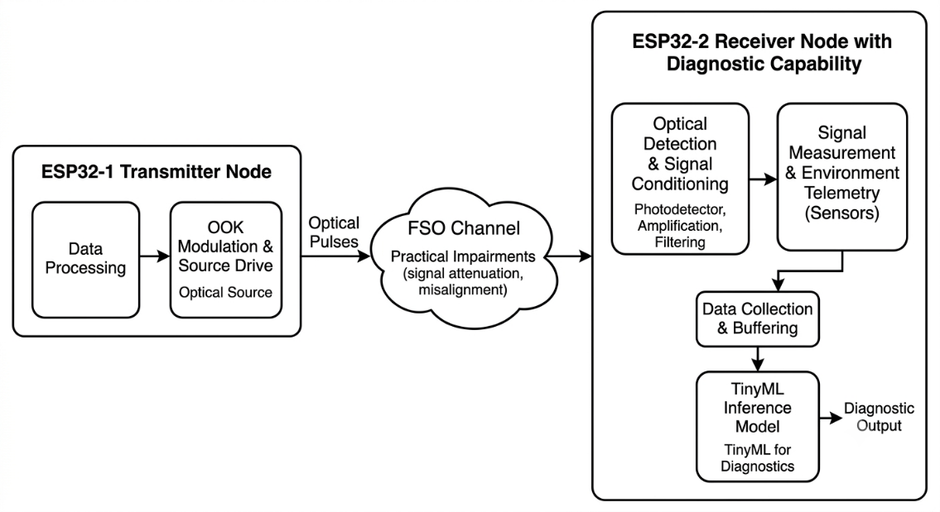
The resulting feature vector is supplied to a supervised classification model. The model produces a diagnostic class corresponding to the operating condition of the optical link.

Figure 1.Complete System Overview

3.3 Mathematical Modeling
Mathematical modeling was used to define the communication parameters and the features used for optical-link diagnosis.

3.3.1 Optical Data Representation
On-Off Keying (OOK) is used as the intensity-modulation technique for optical transmission. In OOK, the optical source assumes one of two states according to the transmitted binary information. A logical one is represented by the presence of the optical signal, while a logical zero is represented by its absence.
Non-Return-to-Zero Level (NRZ-L) is used as the line-coding scheme. Each binary bit is represented by a constant optical level throughout its bit interval. NRZ-L was selected because of its simplicity and low implementation overhead. It permits direct generation of the optical data sequence through microcontroller timing and allows the receiver to recover the transmitted bits through threshold-based signal detection. It also provides a simple baseline for evaluating the optical channel and calculating BER before introducing more complex line-coding or error-control techniques.
Manchester encoding was initially considered during development. However, its requirement for accurate half-bit timing introduced additional synchronization complexity in the prototype. NRZ-L was therefore retained as the final line-coding approach because each bit is represented by a single fixed-duration optical state.
The relationship between bit rate and bit duration is expressed as $R_{b}=\frac{1}{T_{b}}............ (i)$
where R_{b} is the bit rate and T_{b} is the duration of one bit.

3.3.2 Bit Error Rate
Bit Error Rate is used to quantify the reliability of the optical communication link. Since the transmitted payload is known, the recovered bit sequence can be compared directly with the expected sequence.
BER is defined as $BER=\frac{N_{e}}{N_{t}}....................(ii)$
where N_{e} is the number of incorrectly recovered bits and N_{t} is the total number of transmitted bits.
A BER value of zero indicates that all evaluated bits were recovered correctly, whereas increasing BER indicates increasing communication degradation. BER is used as both a communication-performance metric and a diagnostic feature. Its inclusion in the feature vector allows the classifier to consider the effect of a physical link condition on actual communication reliability.

3.3.3 Received Signal Voltage
The optical signal detected by the photodiode is converted into an electrical signal and subsequently sampled by the receiver. The received signal level is determined from the acquired measurements.
The effective signal component can be represented as $S={\overline{X}}_{signal}-{\overline{X}}_{\text{ambient}}..................(iii)$
where $X_{\text{signal}}$ is the mean received signal measurement and ${\overline{X}}_{\text{ambient}}$ is the mean background measurement. The measured ADC quantity is subsequently converted to voltage according to the ADC configuration of the receiver.

3.3.4 Ambient-Light Measurement
Ambient illumination contributes to the background signal detected by the photodiode. Its influence is therefore considered separately from the received optical signal.
The ambient-light level is estimated during a period in which the optical transmitter is not actively transmitting. If N samples are obtained during this interval, the mean ambient level is calculated as $L_{\text{ambient}}=\frac{1}{N}\sum_{i=1}^{N}{X_{i ....................(iv)}}$
where X_{i} represents the individual background measurements.
The ambient-light feature provides information about the optical environment surrounding the receiver and is particularly useful for distinguishing environmental interference from other causes of link degradation.

3.3.5 Signal-to-Noise Ratio
SNR is used to characterize the relationship between the received optical signal and the variation present in the background measurement.
The standard deviation of the background measurements is used as an estimate of the noise component: $σ_{n}=\sqrt{\frac{1}{N-1}\sum_{i=1}^{N}{{\left(X_{i}-\overline{X}\right)}^{2}}}..............(v)$
The SNR is then expressed in decibels as $SNR=\text{dB}=20\log_{10}\left(\frac{S}{σ_{n}}\right)$…………(vi)
where S represents the effective received signal component and σn represents the measured background variation.

3.3.6 Diagnostic Feature Vector
The four selected measurements are combined into a feature vector for supervised classification: [ V_{signal} BER SNR_{dB} L_{ambient}]^{T}………………(vii)
The feature vector combines information from both the physical optical layer and the communication layer. This is important because a single measurement may not uniquely identify the cause of a degraded link. Combining signal strength, communication errors, noise characteristics, and environmental illumination provides a more comprehensive representation of the link condition.

3.4 Algorithms Used
The methodology employs algorithms for optical transmission, synchronization, bit recovery, telemetry extraction, and link-condition classification. This section describes their functional principles. Specific firmware parameters and implementation values are reserved for Chapter 4.

3.4.1 Optical Transmission Algorithm
A predefined transmission sequence is used rather than continuous payload transmission. A synchronization event is generated before the payload to provide a temporal reference for the receiver, followed by a guard interval separating synchronization from data.
The payload is represented in binary form and transmitted using NRZ-L. A logical one corresponds to the optical source being active, while a logical zero corresponds to the optical source being inactive.
The use of a known payload also permits direct comparison between transmitted and recovered data, which is necessary for BER calculation.
The synchronization duration, guard interval, bit duration, and transmitter GPIO configuration are implementation parameters and are presented in Chapter 4.

3.4.2 Synchronization Algorithm
Reliable payload recovery requires the receiver to determine the beginning of a transmission. A synchronization procedure is therefore used to identify a distinctive optical event preceding the payload.
The receiver monitors the conditioned optical signal and determines whether the observed signal satisfies the synchronization condition. Once a valid synchronization event has been identified, the receiver establishes the corresponding temporal reference and proceeds to payload recovery.
The synchronization procedure reduces the dependence on manually aligned transmitter and receiver timing and provides a repeatable starting point for bit sampling.

3.4.3 Bit Recovery Algorithm
Following synchronization, the received waveform is sampled during each bit interval. The individual samples are converted into binary decisions using a signal-level threshold.
Multiple measurements are considered within a bit interval rather than relying on a single measurement. Majority voting is then used to determine the recovered bit. This approach reduces the influence of isolated fluctuations or noise affecting an individual sample.
The sampling count, sampling locations, and threshold value are properties of the final receiver firmware and are documented in Chapter 4.

3.4.4 BER Calculation Algorithm
The known transmitted payload provides a reference for determining whether each recovered bit is correct. The recovered sequence is compared with the expected sequence and the number of mismatches is accumulated.
After the complete payload has been processed, the accumulated error count and total number of evaluated bits are used to calculate BER according to the mathematical definition given in Section 3.3.2. This procedure permits BER to be calculated directly at the receiver without requiring an external measurement system.

3.4.5 Telemetry and Feature Extraction
The receiver extracts four diagnostic features from the communication and optical measurements: received signal voltage, BER, SNR, and ambient-light level.
Received signal voltage is obtained from the conditioned photodiode measurement. BER is obtained from comparison of the recovered payload with the known transmitted payload. Ambient-light level is obtained from background measurements, while SNR is derived from the relationship between the received signal and background variation. The four measurements are combined into the feature vector defined in Section 3.3.6.

3.4.6 Classification Algorithm
The diagnostic problem is formulated as a supervised multiclass classification problem. Each acquired observation consists of the four-feature vector together with a label representing the physical condition under which the observation was obtained.
The final classification problem consists of four classes:
- Class 0: Normal Condition
- Class 1: Optical Filter Attenuation
- Class 2: High Ambient Light
- Class 3: Severe Obstruction / Misalignment
These categories were finalized after the experimental development rather than being treated as fixed categories from the original proposal.
The trained classifier maps the feature vector to the most likely diagnostic class. The model-development and embedded-deployment procedures are described separately in Chapter 4.

3.5 Dataset Preparation and Data Acquisition
A custom dataset was generated from the developed optical wireless communication system. The use of a hardware-generated dataset ensures that the observations reflect the characteristics of the actual transmitter, optical channel, receiver electronics, signal conditioning, and digital processing chain.
The original proposal considered several possible operating conditions, including normal line-of-sight communication, alignment variation, partial obstruction, complete interruption, and changes in surrounding environmental conditions. During development, these conditions were refined into the four final diagnostic classes listed in Section 3.4.6.
For each observation, the optical link was operated under a controlled condition. A known payload was transmitted, the receiver acquired and processed the optical signal, and the resulting telemetry was recorded. The corresponding physical condition was assigned as the class label.
The final feature set consists of:
- Signal Voltage
- BER
- SNR
- Ambient Light
A known fixed text payload is transmitted so that the recovered data can be directly compared with the expected payload for BER calculation.
The collected observations are stored in structured tabular form and subsequently prepared for machine-learning development.

3.6 Experimental Setup
The experiment was designed to evaluate the response of the optical link under controlled variations in the transmission path and optical environment.
A directed free-space optical path was established between the laser transmitter and the photodiode receiver. A reference operating condition was first established under normal line-of-sight alignment. Additional conditions were then introduced individually to alter the optical characteristics of the link.
The final experimental conditions are:

Normal Condition: The transmitter and receiver are maintained under the intended optical alignment without deliberate attenuation, obstruction, or additional ambient-light interference.

Optical Filter Attenuation: An optical filter is introduced into the optical path to attenuate the received optical signal while retaining the transmission path.

High Ambient Light: The optical environment surrounding the receiver is modified to increase background illumination and thereby alter the photodetector response.

Severe Obstruction / Misalignment: A substantial obstruction or misalignment is introduced into the optical path to significantly reduce the received optical signal and degrade communication performance.
The same general measurement procedure is followed for each condition. A known payload is transmitted, the receiver recovers the payload, communication metrics are calculated, and the four diagnostic features are recorded.
Maintaining the same measurement procedure across conditions ensures that changes in the resulting dataset are primarily associated with the imposed optical condition rather than changes in the acquisition methodology.

3.7 Evaluation Metrics
The evaluation framework considers both the communication performance of the optical link and the classification performance of the diagnostic model.

3.7.1 Communication Metrics

Bit Error Rate: BER is used as the principal measure of digital communication reliability. A lower BER indicates more accurate recovery of the transmitted payload.

Received Signal Voltage: Received signal voltage is used to quantify the electrical representation of the optical signal at the receiver. Changes in this feature are useful for assessing attenuation, obstruction, and alignment-related effects.

Signal-to-Noise Ratio: SNR provides a measure of the received signal relative to background variation. It is used to assess the quality of the received optical signal under different experimental conditions.

Ambient-Light Level: Ambient-light level represents the background optical environment experienced by the photodetector. It provides additional information for distinguishing environmental illumination from other forms of optical-link degradation.

3.7.2 Classification Metrics
The diagnostic classifier is evaluated using accuracy, precision, recall, and F1-score.
Overall accuracy is defined as $Accuracy=\frac{N_{\text{correct}}}{N_{\text{total}}}...............(viii)$
Precision is defined as $Precision=\frac{TP}{TP+FP} ..........(ix)$
Recall is defined as $Recall=\frac{TP}{TP+FN} ................(x)$

The F1-score is given by $F_{1}=2\frac{Precision×Recall}{Precision+Recall}$………..(xi)
where TP, FP, and FN denote true-positive, false-positive, and false-negative predictions, respectively. A confusion matrix is additionally used to examine the distribution of correct and incorrect predictions among the four diagnostic classes. The actual metric values are presented in Chapter 5.

3.8 Validation Strategy
Validation was performed at multiple levels to determine whether the individual components and the complete system operated as intended.
First, the communication link was validated by comparing transmitted and recovered payloads and calculating BER. This established whether the optical link could reliably recover the known payload under the tested conditions.
Second, the extracted features were examined under the different experimental conditions. This was used to determine whether the selected measurements exhibited meaningful changes when the optical link was attenuated, exposed to increased ambient illumination, or substantially obstructed or misaligned.
Third, the machine-learning model was evaluated using the prepared dataset. Training and validation data were used during model development, while independent evaluation data were used to assess classification performance. Accuracy, precision, recall, F1-score, and the confusion matrix were selected as the principal classification measures.
Finally, the trained model was deployed on the receiver and evaluated as part of the complete optical communication system. This final stage verified whether the same measurements used during model development could be generated by the receiver and processed locally to produce a diagnostic classification.

Chapter 4. Implementation

4.1 Hardware Implementation
The optical wireless communication system was implemented using separate transmitter and receiver nodes. The transmitter generates the optical data signal, while the receiver detects and conditions the optical signal before performing digital acquisition, communication analysis, feature extraction, and embedded classification.
The final implementation uses an ESP32-based transmitter and an ESP32-S3-based receiver. The optical transmitter is a 650 nm laser module, while a BPW34 PIN photodiode is used for optical detection. A transistor switching stage is used to drive the laser, and an LM358-based analog circuit is used to condition the photodiode output.

4.1.1 Transmitter Hardware
The transmitter consists of an ESP32 microcontroller, an HW-493 laser module, a 2N2222 NPN transistor, and a 1 kΩ base resistor.
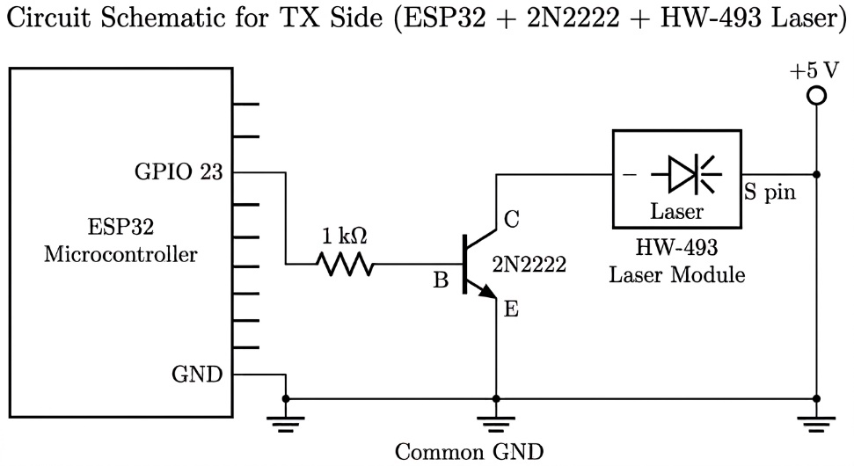
The laser is not driven directly from the ESP32 GPIO. Instead, GPIO 23 is connected through the 1 kΩ resistor to the base of the 2N2222 transistor. The transistor emitter is connected to the common ground, while the collector is connected to the negative terminal of the laser module. The positive terminal of the laser module is connected to the 5 V supply. The transmitter supply and ESP32 share a common ground.

Figure 2: Implemented transmitter circuit.

4.1.2 Receiver Hardware
The receiver consists of a BPW34 photodiode, LM358 operational amplifier, feedback and decoupling components, and an ESP32-S3 microcontroller.
The BPW34 cathode is connected to the +3.3 volts supply and the anode is connected to the inverting input of the LM358. The non-inverting input is connected to ground. The LM358 is powered from the +3.3 volts supply, with its ground connected to the common system ground.
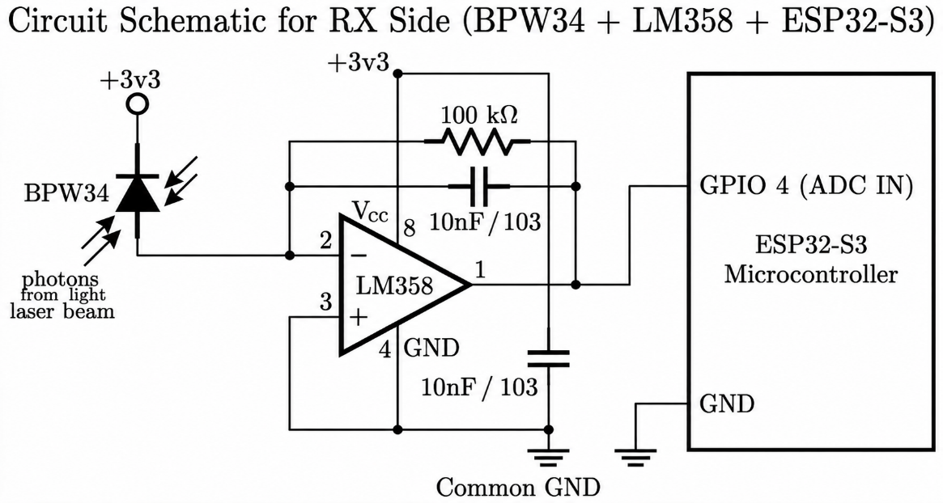
A 100 kΩ resistor is connected between the LM358 output and its inverting input. One 103 capacitor is used for supply decoupling, while another 103 capacitor is connected across the amplifier feedback path. The conditioned output from the first LM358 channel is connected to GPIO 4 of the ESP32-S3 for ADC acquisition.

Figure 3: Implemented receiver circuit

4.2 Communication Firmware Implementation
The final communication firmware differs from the original proposal. The DHT22 sensor was removed from the communication system, and a known fixed text payload is now used. The earlier 500 bps and 5000-bit deterministic-sequence configurations were also replaced by a 1000 bps known-text implementation.
The transmitter and receiver implement OOK using NRZ-L representation. This permits the optical source to be directly controlled according to the binary payload.

4.2.1 Transmitter Firmware
Table 1: Transmitter Firmware Parameters
Parameter | Value
Controller | ESP32
Laser control | GPIO 23
Modulation | OOK
Line coding | NRZ-L
Bit rate | 1000 bit/s
Bit duration | 1 ms
Synchronization pulse | 100 ms
Guard interval | 20 ms
Payload | Known fixed text

During transmission, each bit is maintained at its corresponding optical state for the complete bit interval. A logical one activates the laser, while a logical zero deactivates it.
The known payload is retained at the receiver as the reference sequence required for BER calculation.

4.2.2 Receiver Firmware
The receiver firmware is implemented on the ESP32-S3 and uses GPIO 4 as the ADC input from the LM358 output. The ADC is used to acquire the conditioned photodiode signal. The receiver first establishes the background optical level and subsequently monitors the signal for the synchronization event. Once synchronization has been detected, the payload-recovery procedure is initiated.
The receiver firmware performs the following functions:
- ADC acquisition
- ambient-light measurement
- synchronization detection
- payload sampling
- threshold-based bit decisions
- majority-vote bit recovery
- BER calculation
- signal and noise measurement
- feature-vector preparation
- machine-learning inference
- diagnostic output
The communication-processing and diagnostic-processing stages are executed on the receiver rather than being dependent on an external computer.

4.2.3 Synchronization Implementation
The synchronization pulse is used to provide a deterministic temporal reference before payload reception. The receiver monitors the ADC signal for the expected synchronization event. A candidate synchronization event is evaluated against the configured detection criterion before payload reception is initiated.
Once the synchronization event has been accepted, the receiver accounts for the separation between synchronization and payload before beginning bit recovery. This implementation avoids requiring the transmitter and receiver to begin their payload timing simultaneously.

4.2.4 Bit Sampling and Majority Voting
The receiver uses multiple ADC samples within each bit interval. Each sample is compared with the configured signal-detection threshold to determine whether it represents an optical HIGH or LOW. The final bit decision is obtained using majority voting. A majority of HIGH decisions results in a logical one, while a majority of LOW decisions results in a logical zero.
The finalized receiver implementation uses five samples per bit. The samples are distributed across the central 60 percent of the 1 ms bit interval, spanning from 200 µs to 800 µs from the start of the bit, rather than being taken at its boundaries. This reduces sensitivity to transitions and isolated ADC fluctuations. Each sample is compared against a fixed detection threshold of 1700 ADC counts, and the bit value is decided by majority vote among the five samples.

4.3 Telemetry and Feature Extraction Implementation
The receiver generates four features for the diagnostic model: signal voltage, BER, SNR, and ambient-light level. These quantities are generated from the same optical communication cycle used for payload recovery, eliminating the need for separate diagnostic sensing hardware.

4.3.1 Ambient-Light Measurement
Ambient light is measured during a transmitter-OFF interval. ADC measurements collected during this interval represent the background optical level at the photodiode. The average of these measurements is used as the ambient-light feature. Variation among the measurements is also retained as an estimate of background noise.
The use of the transmitter-OFF interval allows the same photodetection hardware to characterize the surrounding optical environment without requiring a separate ambient-light sensor.

4.3.2 Signal Voltage Calculation
The receiver obtains ADC measurements from the LM358 output. The measured ADC values are converted into voltage using the ADC conversion relationship adopted by the firmware. The received signal level is determined from the measured optical signal while accounting for the ambient baseline. The resulting signal voltage is stored as the first element of the diagnostic feature vector.

4.3.3 BER Calculation
The known fixed payload provides the expected bit sequence for receiver-side verification. Each recovered bit is compared with the corresponding bit in the expected payload.
An error counter is incremented whenever the recovered bit differs from the expected bit. After the payload has been completely processed, the accumulated error count is divided by the total number of evaluated bits to obtain BER. This approach is particularly suitable for the developed testbed because the payload is intentionally fixed and known, allowing BER to be obtained directly through comparison against the expected text without requiring an external reference measurement.

4.3.4 SNR Calculation
The receiver estimates the signal component from the received measurement relative to the ambient baseline. The variation of the ambient measurements is used as the noise estimate.
The resulting signal-to-noise ratio is expressed in decibels and included as the third diagnostic feature. The calculation follows the mathematical formulation presented in Chapter 3. Chapter 4 specifies only the measurement procedure and firmware implementation rather than redefining the underlying mathematical model.

4.3.5 Feature Vector Formation
Once communication and signal processing have been completed, the receiver forms the four-element feature vector: $x=\left[V_{\text{signal}},BER,SNR_{\text{dB}},L_{\text{ambient}}\right]$
The feature vector is subsequently subjected to the same preprocessing used during model development before being passed to the embedded classifier.

4.4 Dataset Construction and Preprocessing
The dataset was generated directly from the developed hardware under controlled optical-link conditions. Each recorded observation contains the four diagnostic features and its corresponding class label.
The final classes are:
Table 2: Output Diagnostic Classes
Class | Condition
0 | Normal Condition
1 | Optical Filter Attenuation
2 | High Ambient Light
3 | Severe Obstruction / Misalignment

4.4.1 Dataset Class Distribution
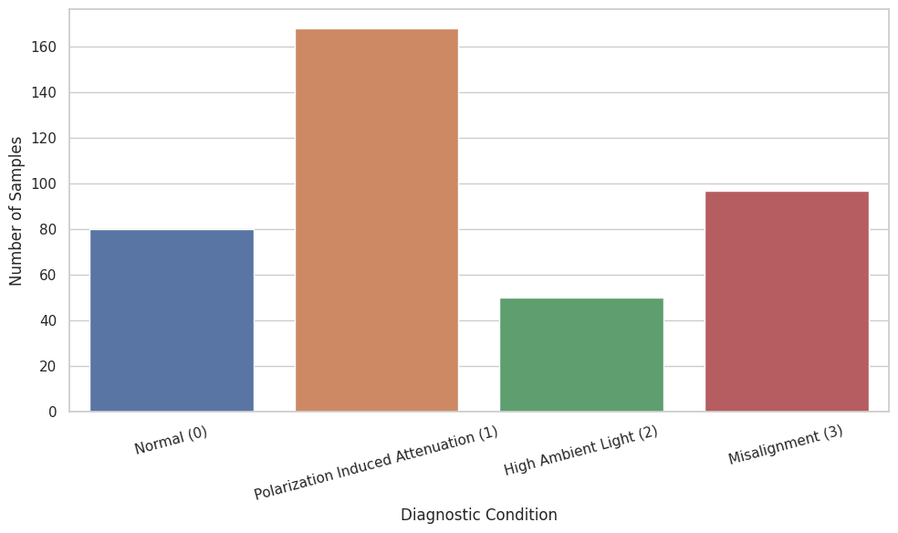
The collected observations were organized according to the four experimental classes. The class distribution was examined before model training to determine the representation of each operating condition in the dataset.

Figure 4: Distribution of observations among the four optical-link diagnostic classes

4.4.2 Feature Distribution
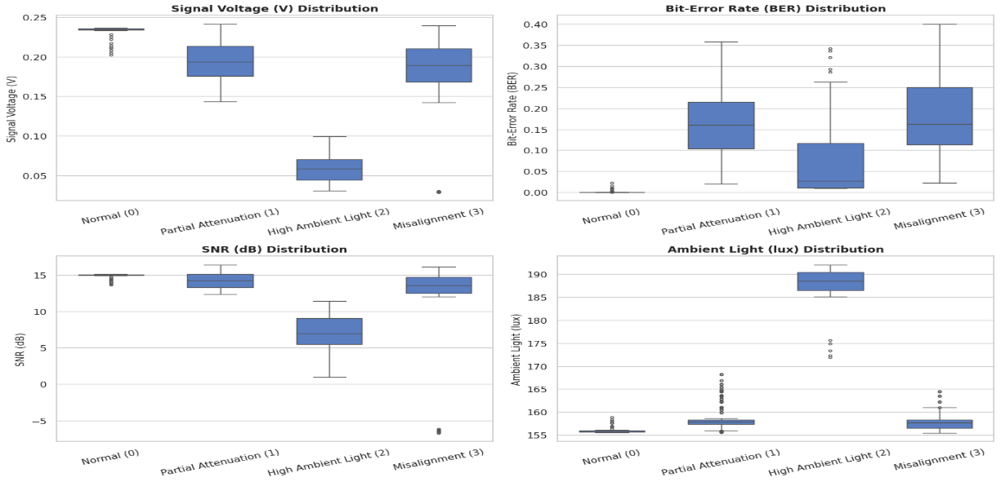
The distributions of signal voltage, BER, SNR, and ambient-light level were examined to characterize the collected data before model development. Since these features represent different physical quantities, their numerical ranges and distributions are not expected to be identical. Examination of their distributions provides an initial assessment of the variation captured by the dataset and helps identify whether the experimental conditions produced distinguishable feature patterns.

Figure 5: Distribution of the diagnostic features obtained from the optical-link dataset.

4.4.3 Data Preprocessing
The four features have different physical units and numerical ranges. Feature preprocessing was therefore performed before model training to provide a consistent numerical representation.
The preprocessing parameters obtained from the training data were retained and applied consistently to validation, testing, and embedded inference data. This prevents the preprocessing operation from introducing information from the evaluation data into the training stage. The class labels were retained separately from the feature values and used as supervised learning targets.

4.5 Machine-Learning Model Implementation
The diagnostic task was implemented as a four-class supervised classification problem using the four telemetry features as model inputs. The deployed model is a compact TensorFlow Lite Micro neural network. The model was trained using the prepared dataset and subsequently converted into a representation suitable for execution on the ESP32-S3.

4.5.1 Model Input and Output
The model receives four input features:
- Signal Voltage
- BER
- SNR
- Ambient Light
The model produces four output classes corresponding to the experimental conditions. The output therefore represents the estimated probability or confidence associated with each diagnostic condition. The final diagnostic decision is obtained from the model output corresponding to the selected class. The use of four inputs directly reflects the feature set defined during the system methodology. The four-class output corresponds to the finalized experimental categories rather than the tentative classes specified in the original proposal.

4.5.2 Model Training
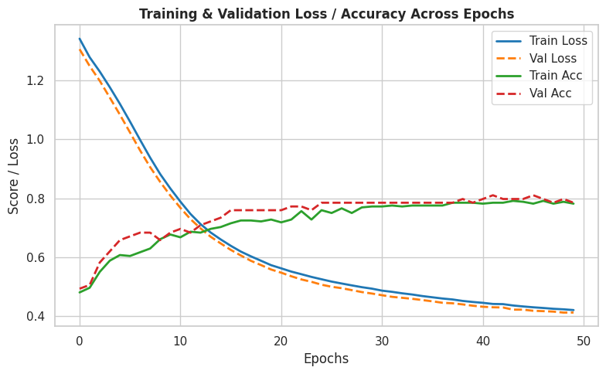
The prepared dataset was used to train the neural-network classifier. The dataset was divided according to the adopted training, validation, and testing strategy. During training, model performance was monitored using accuracy and loss. Training accuracy indicates the model's ability to fit the training observations, while validation accuracy provides an indication of performance on observations not directly used for parameter optimization.
Figure 6: Training and validation Loss/Accuracy
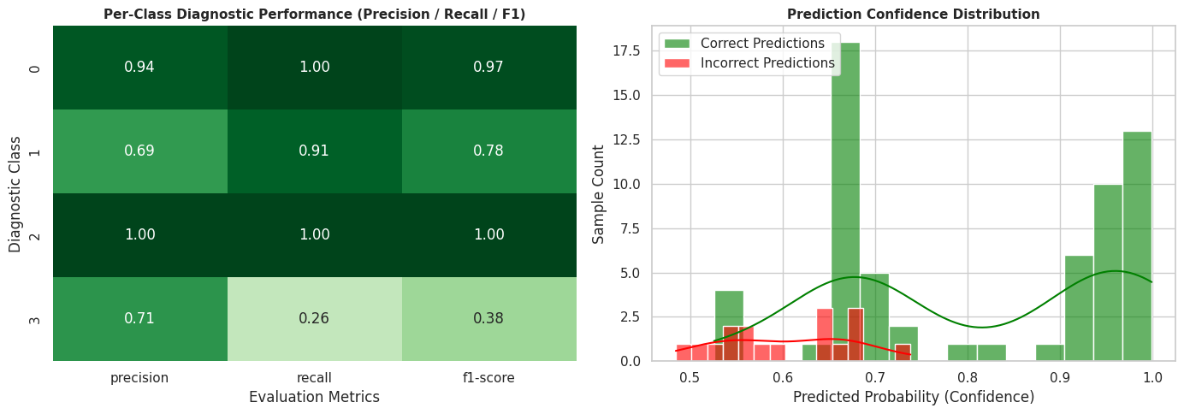
Figure 7: Diagnostic Performance and Confidence on Test Data

4.6 Edge-AI Deployment
After model training, the classifier was prepared for execution on the receiver microcontroller. This converts the diagnostic system from an offline model-development process into an embedded inference system. The final objective is for the receiver to obtain the four telemetry features, preprocess them, perform inference locally, and produce the diagnostic class without relying on an external computer.

4.6.1 Model Conversion and Quantization
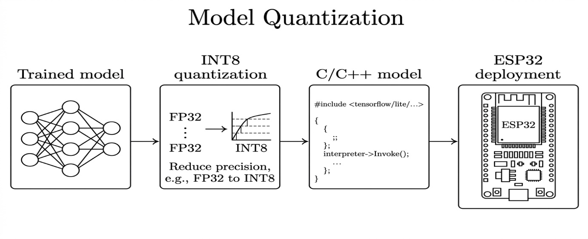
The trained neural network was converted into a TensorFlow Lite representation suitable for embedded inference. Quantization was applied to reduce the computational and memory requirements of the model and to make it suitable for execution within the constraints of the receiver microcontroller.
Figure 8: Conversion and quantization process for embedded deployment of the diagnostic model

4.6.2 TensorFlow Lite Micro Integration
The converted model was incorporated into the receiver firmware using TensorFlow Lite Micro. The receiver initializes the embedded model and allocates the memory required for inference. Following a completed communication cycle, the extracted feature vector is preprocessed and supplied to the model. The resulting model outputs correspond to the four diagnostic classes, from which the predicted operating condition is determined.
The diagnostic process is therefore performed directly on the ESP32-S3. The receiver does not need to transmit the feature vector to a separate computer for classification.

4.7 Integrated System Operation
The completed implementation integrates the optical communication, telemetry extraction, dataset-derived classification model, and embedded inference into a single receiver-side processing chain.
The transmitter begins each communication cycle with the synchronization sequence and subsequently transmits the known payload. The receiver detects the synchronization event, establishes the timing reference, and recovers the payload through ADC sampling and majority-vote decisions.
After payload recovery, the receiver calculates BER and obtains the signal-voltage, SNR, and ambient-light measurements. These four quantities are prepared in the format expected by the embedded classifier.
The preprocessed feature vector is then supplied to the TensorFlow Lite Micro model. The model produces the four-class diagnostic output, which is reported by the receiver.
This implementation allows the communication and diagnostic functions to operate on the same receiver hardware. The communication subsystem provides the data needed for link-quality measurement, while the diagnostic subsystem interprets the resulting measurements to identify the operating condition.
The detailed quantitative performance of the communication system and the classification model is presented in Chapter 5.

Chapter 5. Results and Discussion
5.1 Results
5.1.1 Communication Performance
The developed optical wireless link was evaluated under the four experimental conditions defined in Chapter 3. Under normal line-of-sight conditions, the system consistently achieved a Bit Error Rate of zero, with representative signal voltage and SNR values of approximately 0.12 V and 10.5 dB respectively. As the optical path was progressively degraded through the introduction of attenuation, ambient light interference, and physical obstruction, the measured signal voltage and SNR were observed to decrease while the BER increased correspondingly. Under severe obstruction and misalignment conditions, representative BER values exceeding 0.35 were recorded, accompanied by SNR values as low as negative 20 dB. In the most extreme obstruction scenario, the receiver was unable to recover a valid synchronization pulse, resulting in continuous ambient sampling without payload decoding. This behaviour is discussed further in Section 5.2.
5.1.2 Machine-Learning Classification Performance
The lightweight neural network classifier was trained on the four diagnostic features and achieved a test accuracy of 78.48 percent prior to quantization. For comparison, a Random Forest classifier trained on the same feature set achieved a test accuracy of 77.22 percent, indicating that the compact neural-network architecture performed comparably to a conventional ensemble method while remaining suitable for embedded deployment.
Following conversion to a fully quantized INT8 TensorFlow Lite representation, the classifier achieved a test accuracy of 74.68 percent, corresponding to an accuracy reduction of approximately 3.8 percentage points relative to the floating-point baseline. The quantized model occupied 3.32 kilobytes of memory, confirming its suitability for deployment within the resource constraints of the ESP32-S3 receiver.
The confusion matrix and per-class precision, recall, and F1-score obtained for the quantized model indicate that classification performance was strongest for the normal and severely obstructed conditions, which correspond to the most distinct combinations of BER and signal voltage. Comparatively greater confusion was observed between the optical filter attenuation and high ambient light classes, reflecting the overlapping influence of these two conditions on the received signal voltage and ambient light feature.
5.1.3 Edge-AI Deployment Results
The quantized model was deployed to the receiver ESP32-S3 node and evaluated using the integrated communication and inference pipeline described in Chapter 4. Diagnostic output was assessed by observing classification performance across representative optical link conditions rather than by an exhaustive trial count, in keeping with the evaluation strategy adopted for this stage of the project.
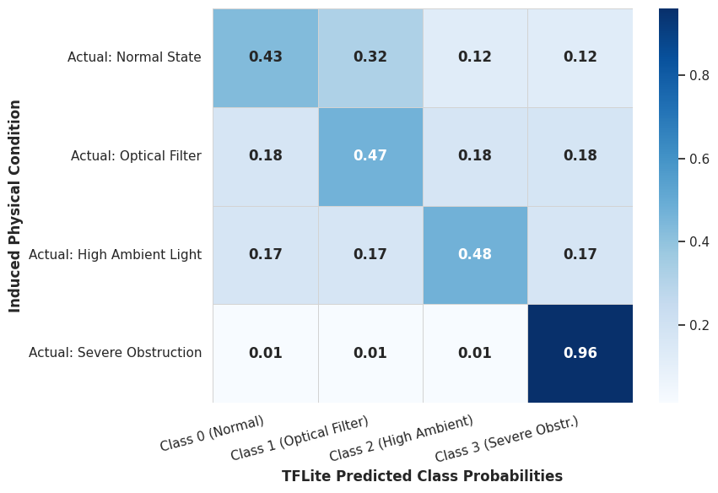
Under normal, unobstructed conditions, the receiver consistently reported Class 0 with a high confidence value, reflecting the deterministic override rule applied at low BER and adequate signal voltage. Under conditions of optical filter attenuation, the receiver correctly identified reduced signal voltage while BER remained at zero, and the trained neural network produced the corresponding classification without requiring the override mechanism. Under severe obstruction and misalignment conditions, BER values and negative SNR values consistent with signal loss triggered the low-signal override rule, resulting in a high-confidence Class 3 classification. In the most severe obstruction case, where the optical path was fully blocked, the receiver was unable to acquire synchronization at all, and no diagnostic classification could be produced. This outcome is treated as a boundary condition of the current system rather than a classification failure and is addressed further in Section 5.2.

Figure 9: Aggregate confidence heatmap for after-deployment performance
5.2 Discussion
The results demonstrate that the developed system is capable of both recovering transmitted data over the optical wireless link and classifying the condition of that link using an embedded machine-learning model. The comparable performance of the compact neural network relative to the Random Forest baseline indicates that the selected features, namely signal voltage, BER, SNR, and ambient light level, provide sufficient discriminative information for the classification task even with a minimal model architecture.
The reduction in accuracy following INT8 quantization is consistent with expected behaviour when converting a floating-point model to a fixed-point representation, and the resulting 3.32 kilobyte model size confirms that the accuracy loss is an acceptable trade-off for enabling on-device inference within the memory constraints of the receiver microcontroller.
The inability of the receiver to produce a diagnostic classification under complete optical blockage highlights a limitation of the current synchronization-dependent architecture. Because feature extraction and classification depend on successful reception of the payload, conditions that prevent synchronization entirely fall outside the scope of the four defined diagnostic classes. This is consistent with the limitation identified in Chapter 1 regarding the diagnostic, rather than corrective, scope of the system.
5.3 Comparative Analysis
The three evaluated approaches, namely the Random Forest baseline, the floating-point neural network, and the quantized INT8 neural network, achieved test accuracies of 77.22 percent, 78.48 percent, and 74.68 percent respectively. While the Random Forest model offered slightly lower accuracy than the floating-point neural network, it does not readily support the quantization and embedded deployment pathway used in this project. The neural-network approach was therefore selected for final deployment, as it provided both competitive accuracy and a direct route to compact, quantized execution on the ESP32-S3 receiver, consistent with the TinyML-based methodology defined in Chapter 3.

Chapter 6. Conclusions and Recommendations
6.1 Conclusions
This project presented the design and implementation of an autonomous optical wireless communication testbed with an integrated Edge-AI diagnostic framework. A point-to-point free-space optical link was implemented using NRZ-L line coding, with the receiver performing majority-vote bit recovery and concurrent extraction of physical-layer diagnostic features, namely signal voltage, Bit Error Rate, Signal-to-Noise Ratio, and ambient light level.
A custom dataset was constructed from the developed hardware under four controlled operating conditions, namely normal transmission, optical filter attenuation, high ambient light, and severe obstruction or misalignment. A lightweight neural-network classifier was trained on this dataset, achieving a floating-point test accuracy of 78.48 percent, and was subsequently converted into a fully quantized INT8 TensorFlow Lite Micro model occupying 3.32 kilobytes. The quantized model was successfully deployed and executed directly on the receiver ESP32-S3 microcontroller, enabling real-time link-condition diagnosis without reliance on external computation.
Hardware evaluation confirmed that the integrated system was able to recover the transmitted payload, compute the required diagnostic features, and classify the resulting link condition using the embedded model, with deterministic override rules improving reliability under extreme signal conditions. These results confirm the feasibility of combining physical-layer optical wireless communication with embedded machine-learning inference to produce a self-diagnosing, low-cost optical link, meeting the objectives defined in Chapter 1.

6.2 Recommendations and Future Enhancements
Based on the outcomes of this project, the following enhancements are recommended for future work:
- The current dataset, while sufficient to demonstrate feasibility, is relatively limited in size. Collection of a larger and more diverse dataset across a wider range of environmental conditions is recommended to improve classifier generalization and reduce reliance on deterministic override rules.
- The present system is unable to produce a diagnostic output under complete loss of synchronization. Future implementations could incorporate a fifth diagnostic category, or a separate lightweight signal-presence detector, to explicitly identify and report complete link failure.
- The current line-coding scheme, NRZ-L, was selected for its simplicity. Future work could investigate more bandwidth-efficient or error-resilient line-coding and modulation schemes, provided that transmitter-receiver timing synchronization can be maintained across differing hardware platforms.
- The diagnostic framework currently operates in a purely passive capacity. A natural extension of this work would be the introduction of corrective mechanisms, such as automated alignment adjustment or adaptive transmission power control, in response to the diagnosed link condition.
- Expansion of the feature set, for example through the inclusion of temporal or statistical variation in the received signal, may further improve the separability of the optical filter attenuation and high ambient light classes, which exhibited comparatively greater classification confusion in the present system.

References

[1] A. Khan and M. Nisar, “Visible Light Communication: Applications, Architecture, Standardization and Future Directions,” Wireless Networks, vol. 24, pp. 1–20, 2018.
[2] K. S. Purnita and M. R. H. Mondal, “Machine Learning for DCO-OFDM Based LiFi,” PLOS ONE, vol. 16, no. 11, 2021.
[3] M. A. S. Sejan, M. H. Rahman, M. A. Aziz, D. S. Kim, Y. H. You, and H. K. Song, “A Comprehensive Survey on MIMO Visible Light Communication: Current Research, Machine Learning and Future Trends,” Sensors, vol. 23, no. 2, p. 739, 2023.
[4] M. T. Salman, D. R. Siddle, and A. G. Udu, “Machine Learning Approach to Predict the DC Bias for Adaptive OFDM Transmission in Indoor Li-Fi Applications,” IEEE Access, vol. 13, pp. 9627–9641, 2025.
[5] P. Warden and D. Situnayake, “TinyML: Machine Learning with TensorFlow Lite on Arduino and Ultra-Low-Power Microcontrollers,” O’Reilly Media, 2019.
[6] TensorFlow, "Post-training quantization," Google AI Edge Documentation. [Online]. Available: https://ai.google.dev/edge/litert/conversion/tensorflow/quantization/post_training_quantization. Accessed: Aug. 26, 2026.
[7] TensorFlow, "TensorFlow Lite for Microcontrollers," tflite-micro GitHub Repository. [Online]. Available: https://github.com/tensorflow/tflite-micro. Accessed: Aug. 26, 2026.
[8] Espressif Systems, "Analog to Digital Converter (ADC)," ESP-IDF Programming Guide. [Online]. Available: https://docs.espressif.com/projects/esp-idf/en/stable/esp32/api-reference/peripherals/adc.html. Accessed: Aug. 26, 2026.

