**DEVOPS PBL**

NAME- Sarthak Bhangade

PRN:- 2124UDSM1084

SET 4

**Q1]**

**Create a new Git repository locally, add a Java file (HelloWorld.java), commit it, and push it to**

**your GitHub repository.**

**Expected Output: Code and commit visible on GitHub.**

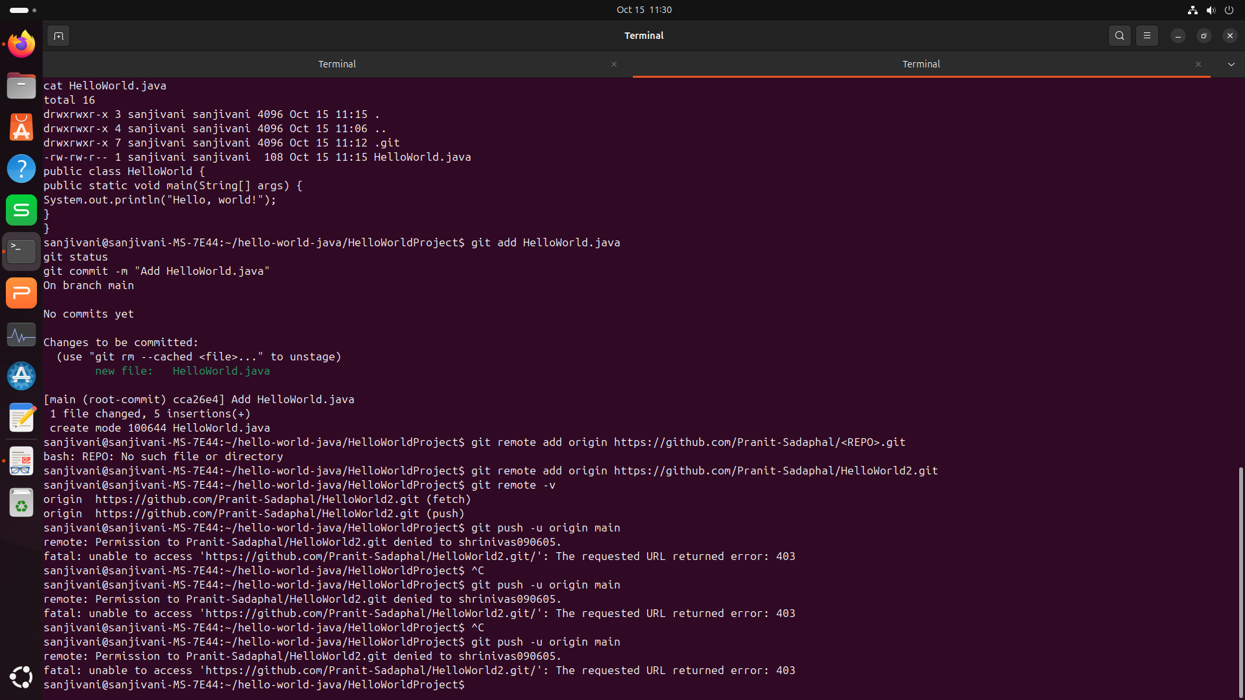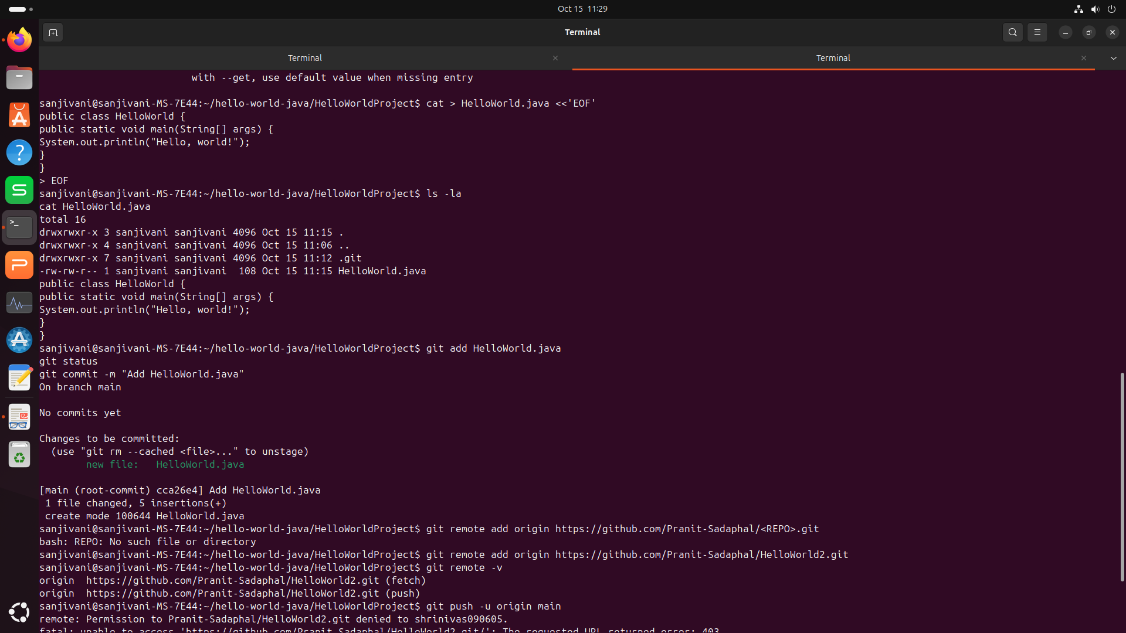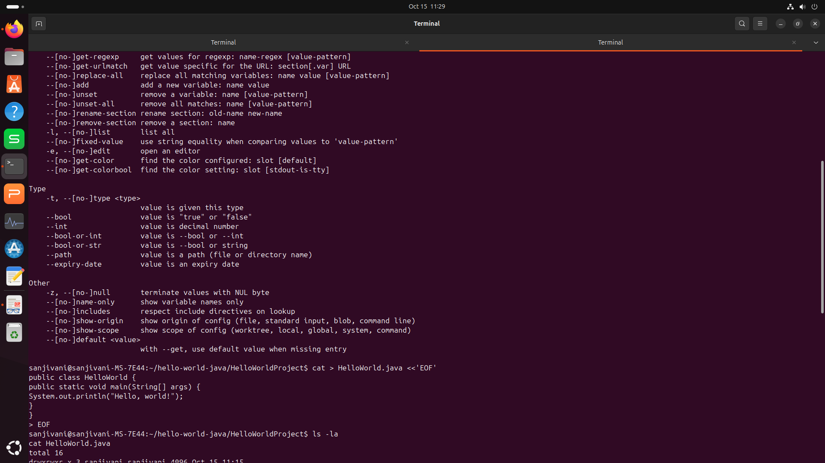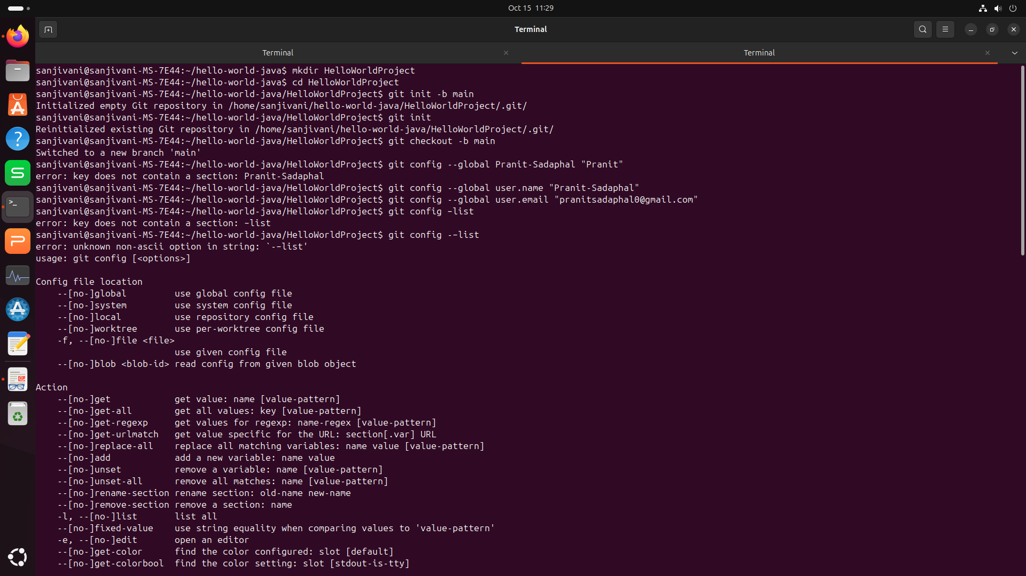

**OUTPUT:-**

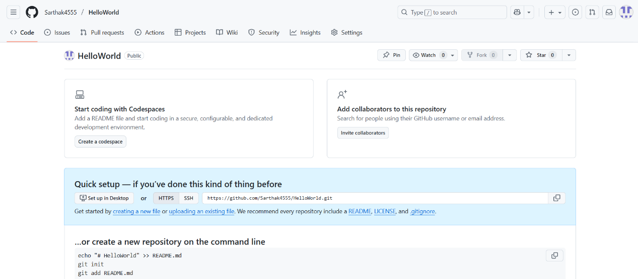

**Q2]**

**Create a simple Maven project using the command line and build it using mvn clean**

**package.**

**Expected Output: Successful build with .jar file in target folder.**

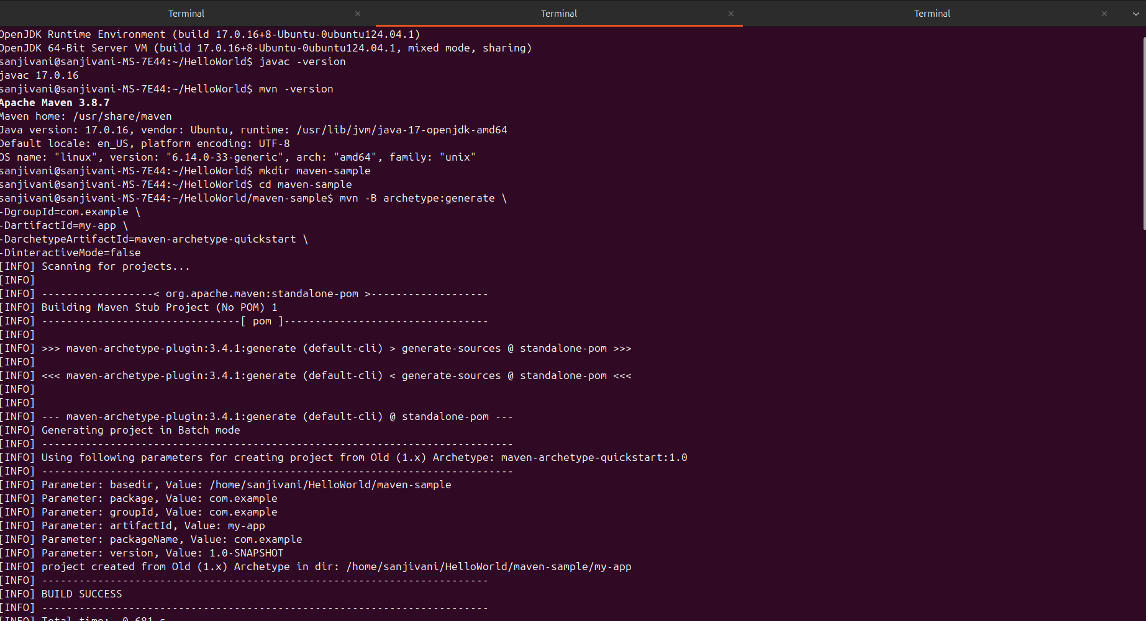

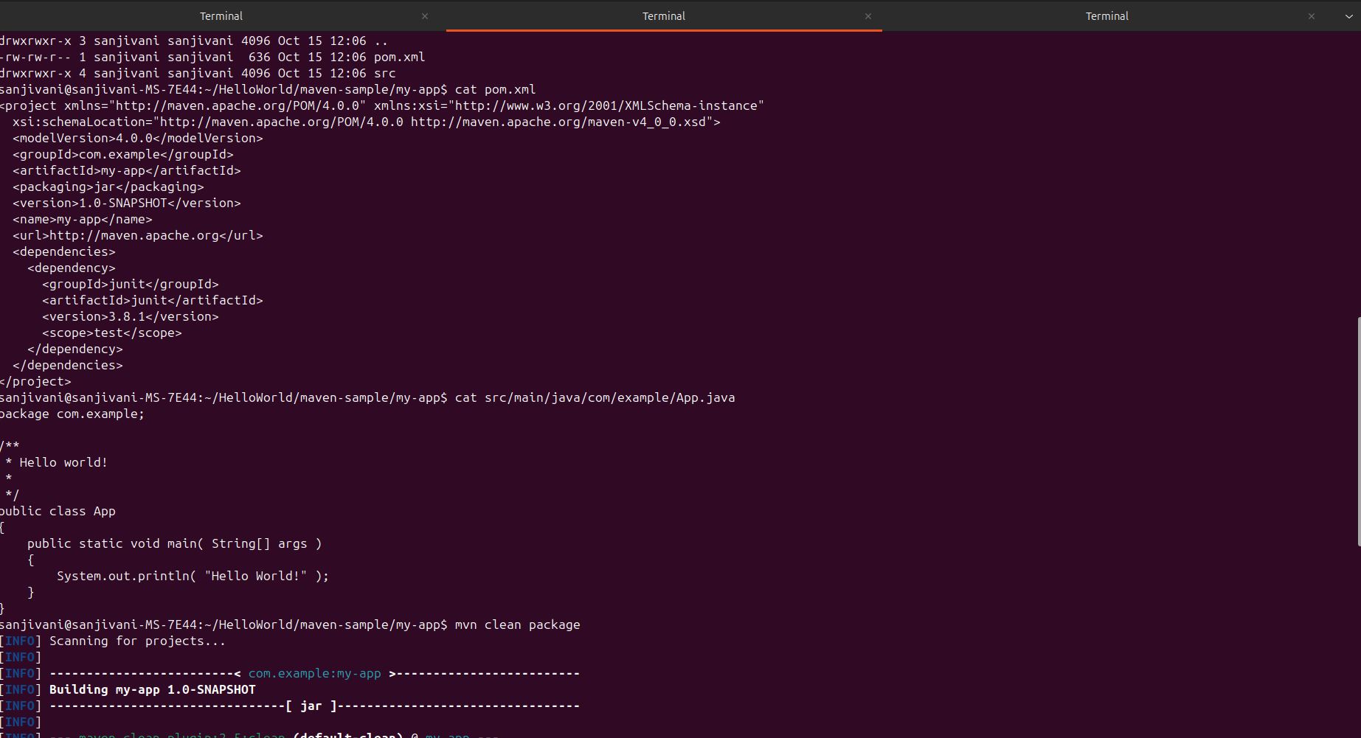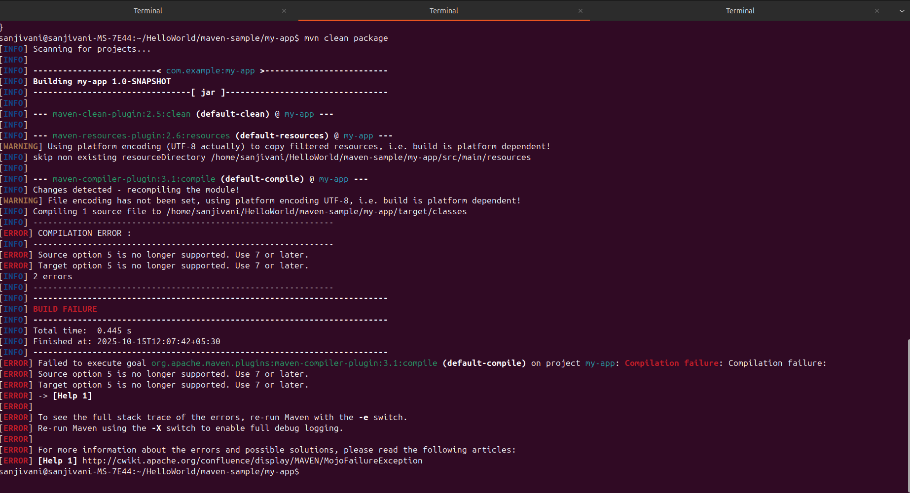

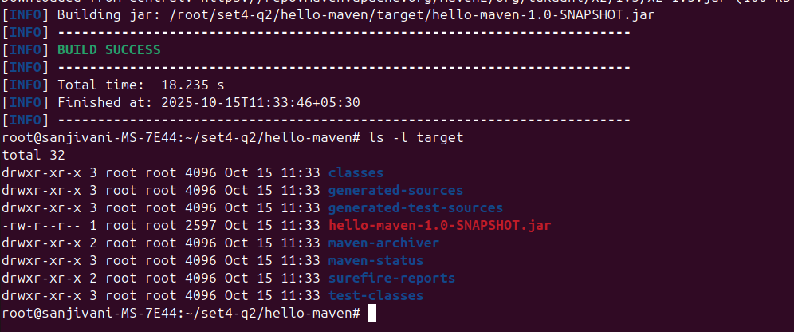

**Q3]**

**Create a Dockerfile for your Maven project and build a Docker image using the command**

**line.**

**Expected Output: Docker image visible in docker images.**

