**Subject code :-IT5016**

**Flowchart and pseudocode**

**Assignment :- 1**

Student Name :- Modi Sarthak Alpeshkumar

Student Id :- 20240193

Due Date:- 29/07/2024

**Inroduction :-**

To commence with the pros and cons of Flowchart and pseudocode. As we all know that flowchart and pseudocode play vital role in software and web development.

Flowchart :- It is a simple method to clarify any process and make it easier to under stand for both user and developer.

Pseudocode :- Pseudocode is a technique to represent code in a understandable language.

In this assignment I have elaborated flowchart and pseudocode of famous and tasty Indian recipe, Samosa.

**Flowchart of samosa recipe :-**

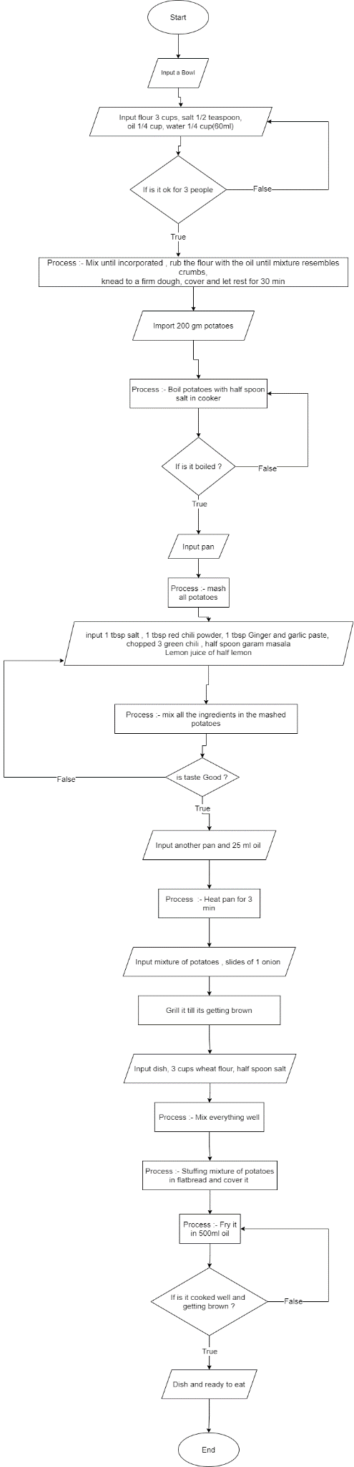

**Pseudocode of samosa recipe :-**

Start

     # Import all ingredients For Dough

     input"3 cups flour, salt 1/2 teaspoon, oil 1/4 cup, water1/4 cup(60ml)"

        if is it enough for 3 people

            Continue Process

         else

                input ingredients

     # Prepare dough

     Mix ingredients until in coporated then

     Rub the flour with oil until mixture resembles crumbs

     knead to firm dough

     cover and let rest for 30 minutes

     # Import ingredients for potatoes mixture

    input"200 gm potatoes"

     Boil Potatoes with half spoon salt for 10 minutes in cooker

     if is it Boiled perfectly

        Continue Process

      else

        import potatoes

      input pan,

      separate all peels from boiled potatoes in a pan

      mash all potatoes

      input "1 tbsp salt, 1 tbsp red chili powder, 1 tbsp Ginger and Garlic paste"

      input "chopped 3 green chili, half spoon garam masala, Lemon juice of half lemon"

       mix all the ingredients in the mashed potatoes

       if is taste good

            input pan , 25ml oil

        else

            import ingredients as per taste

         heat pan for 3 mintues

         input mixture of potatoes, slides of 1 onion

         grill it till its getting Brown

         input dish,3cups wheat flour , half spoon salt

         stuffing mixture of potatoes in flatbread and cover it

         fry it in 500 ml oil

         if is it cooked well and getting brown

                input dish and ready for eat

          else

                   Fry samosas again

        dish and serve samosas with tomato sauce

End