GoSharpener Progress Report
%%%school_name%%% - %%%report_period%%%
Empowering Students Through Purposeful Action, SDG Education & Leadership

- Student Engagement & Orientation
  - A comprehensive Student & Teachers Orientation was successfully conducted to introduce the GoSharpener platform, SDG-based learning pathways, and leadership opportunities. Participation was enthusiastic, laying the foundation for deeper involvement in sustainability education.

- Completed Learning Sessions – Powered by Global Experts
%%%#sessions%%%
- %%%session_title%%%:
Grades: %%%grades%%% Summary:
%%%summary%%%
SDG Aligned:

  - %%%number%%%: %%%name%%%

%%%/sessions%%%
%%%#show_dates_req%%%
- Dates Requirement
We are planning to conduct next Knowledge Sessions on %%%req_session_names%%% in the month of %%%req_month%%%. Requesting school to share the available dates for scheduling the sessions.
%%%/show_dates_req%%%

- Launch of SHARP Action Club
We propose to launch the SHARP Action Club as a dedicated student-led initiative that will drive sustainability projects and SDG awareness across grades. The club will encourage peer-driven learning, collaborative leadership, and structured reporting of real impact.

- Activation Percentage
Activation from %%%report_period%%%: %%%activation_pct%%% %

- Conclusion
%%%school_name%%% continues to stand out as a flagship partner for GoSharpener, actively fostering a generation of students ready to lead in sustainability, social innovation, and future-ready careers.
We express our sincere gratitude to the principal and school leadership for their ongoing trust and support.

- Glimpse of the events:

%%%#sessions%%%
- %%%session_title%%%:
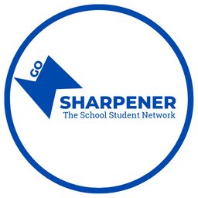

%%%session_title%%%
%%%/sessions%%%

