Assignment 2 :

Instance B :

1. Downloaded Tomcat version 9.0.105 in/home/ec2-user/ directory
2. Directory apache-tomcat-9.0.105 permission – 777

-------------------------------------------------------------------------------------------------------------------------------

Instance A :

1. Installed Java 17
2. Deployed Jenkins on Tomcat server
3. Set installation of maven-3.9.9 in Jenkins tools

Installed Jenkins as a service

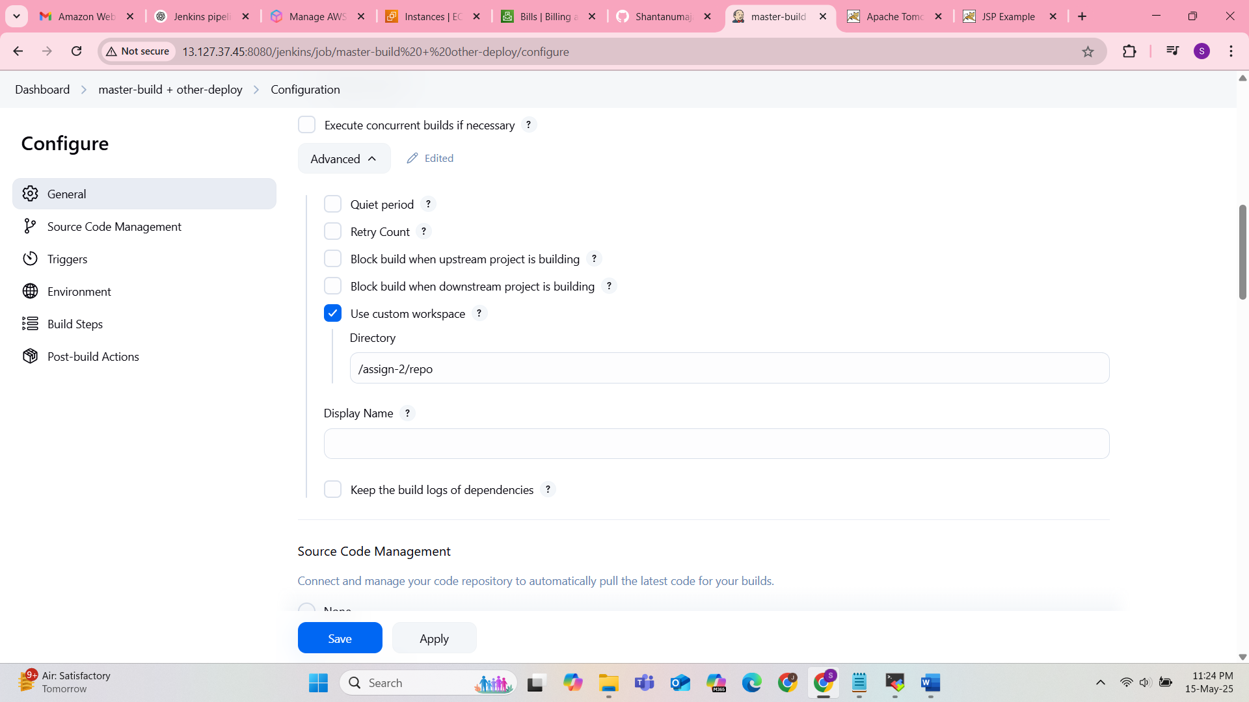

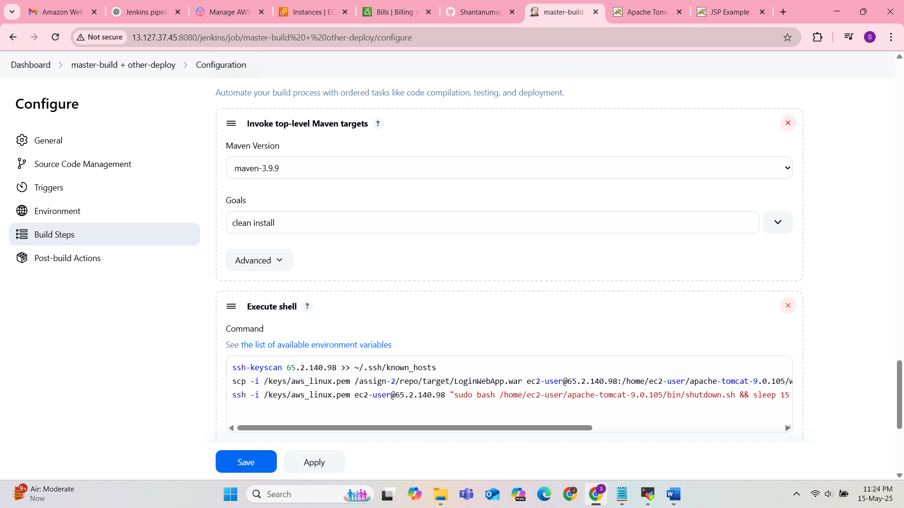

ssh-keyscan 65.2.140.98 >> ~/.ssh/known_hosts

scp -i /keys/aws_linux.pem /assign-2/repo/target/LoginWebApp.war ec2-user@65.2.140.98:/home/ec2-user/apache-tomcat-9.0.105/webapps/

ssh -i /keys/aws_linux.pem ec2-user@65.2.140.98 "sudo bash /home/ec2-user/apache-tomcat-9.0.105/bin/shutdown.sh && sleep 15 && sudo bash /home/ec2-user/apache-tomcat-9.0.105/bin/startup.sh"

