Assignment 5 :

Build on master + deploy on slave

Job -1 : git clone & build project

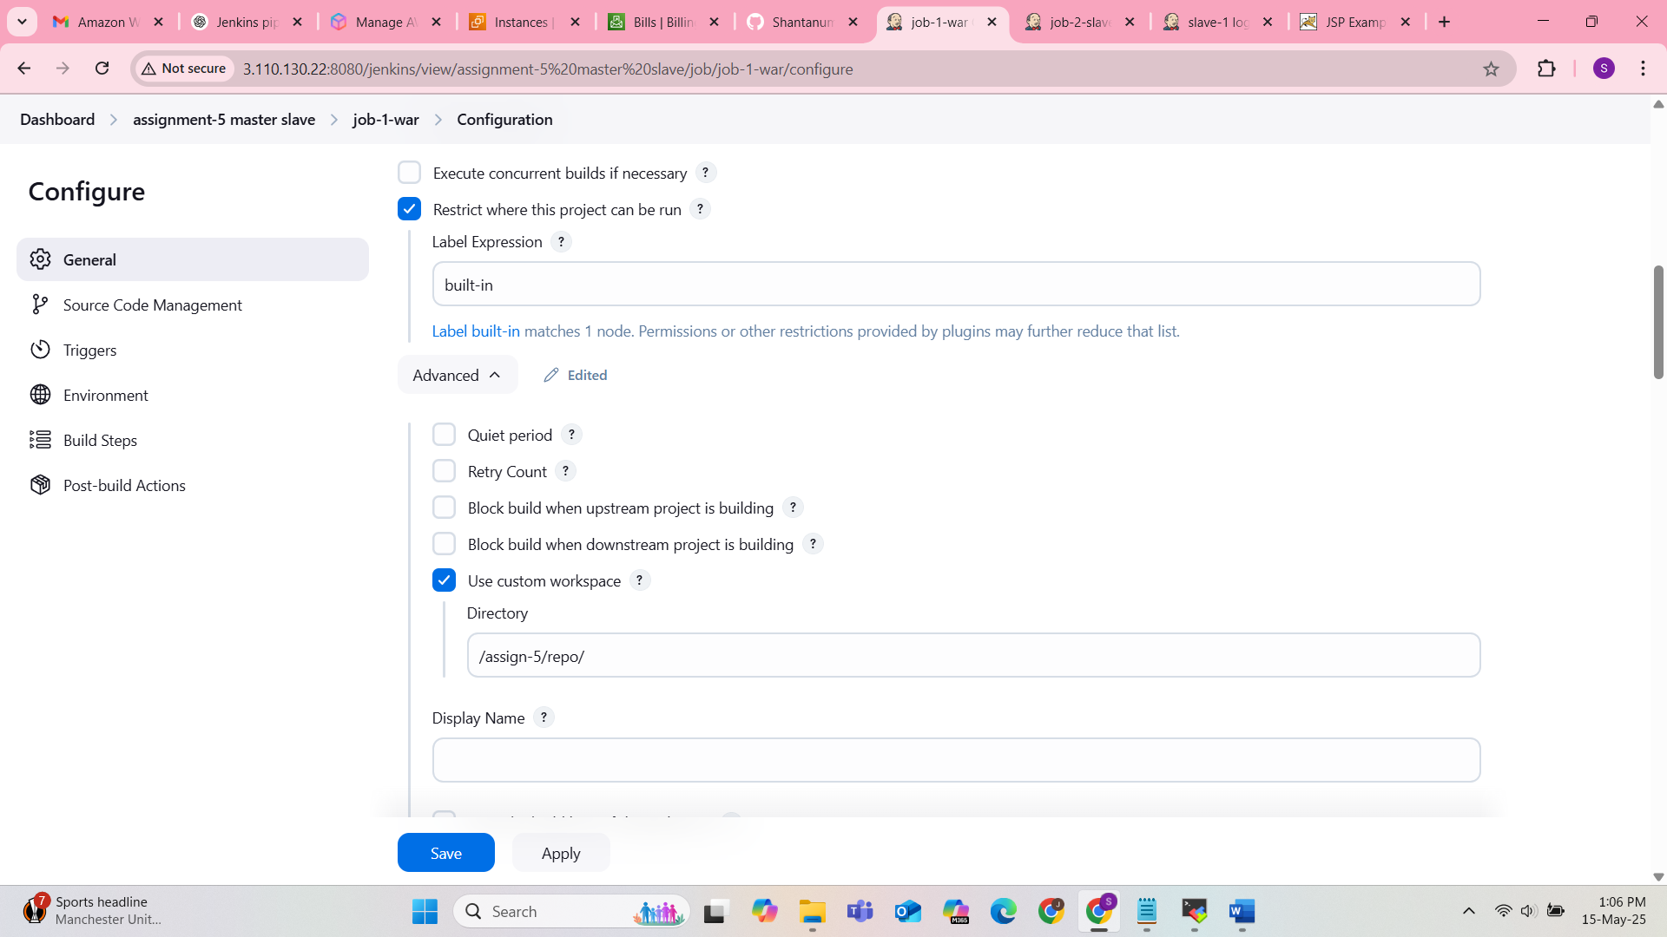

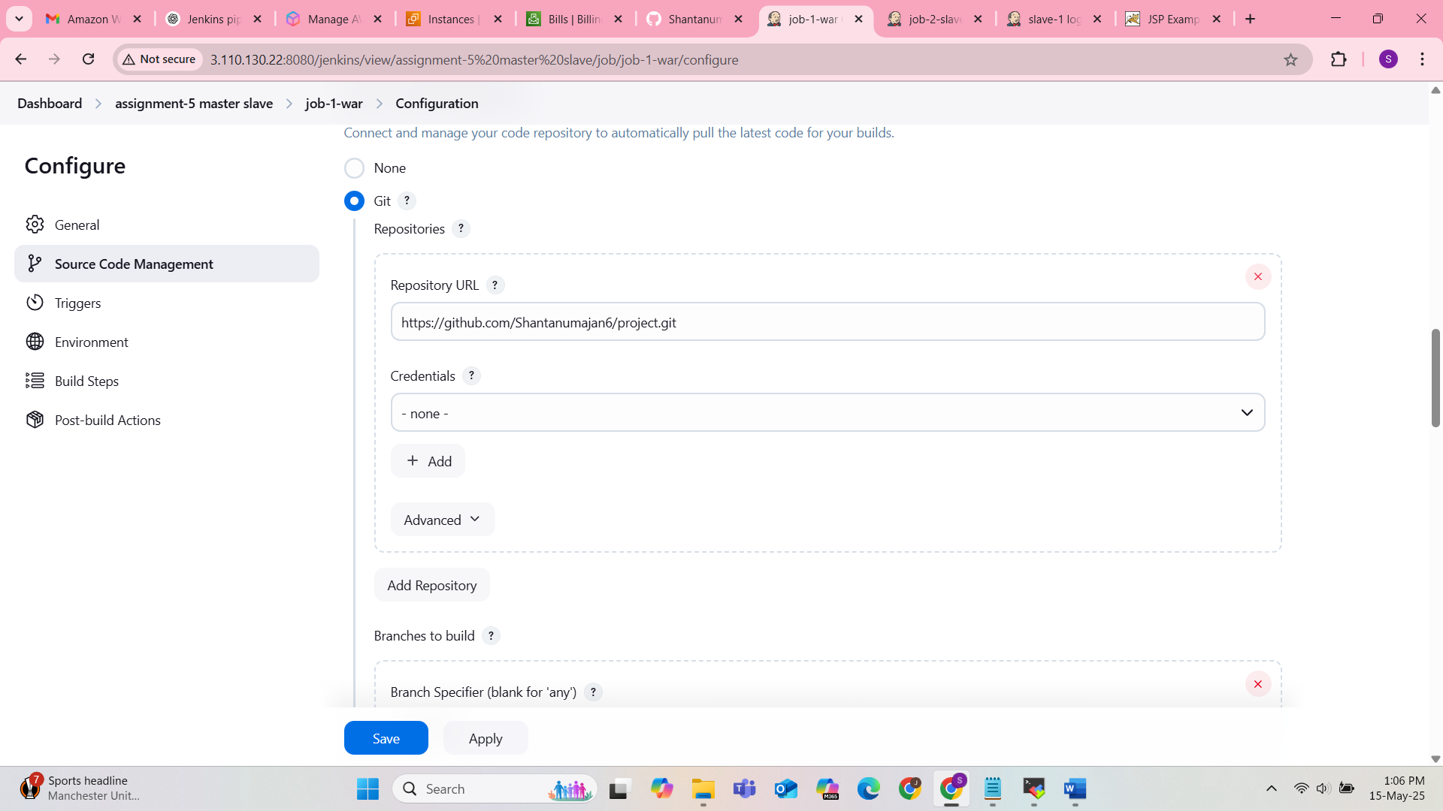

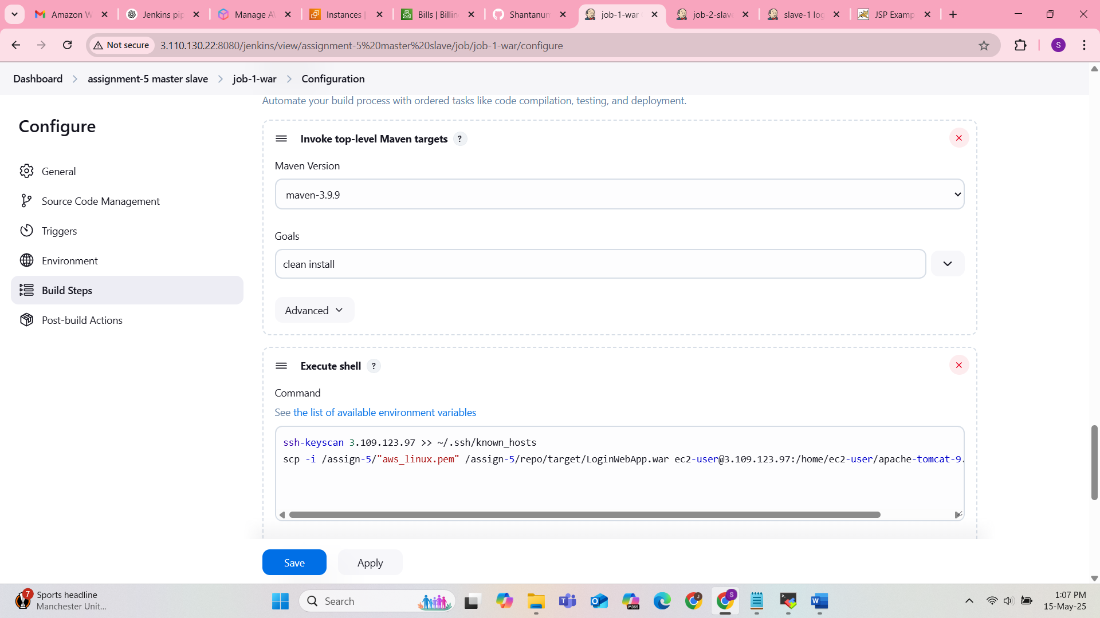

ssh-keyscan 3.109.123.97 >> ~/.ssh/known_hosts

scp -i /assign-5/"aws_linux.pem" /assign-5/repo/target/LoginWebApp.war [ec2-user@3.109.123.97:/home/ec2-user/apache-tomcat-9.0.105/webapps](mailto:ec2-user@3.109.123.97:/home/ec2-user/apache-tomcat-9.0.105/webapps)

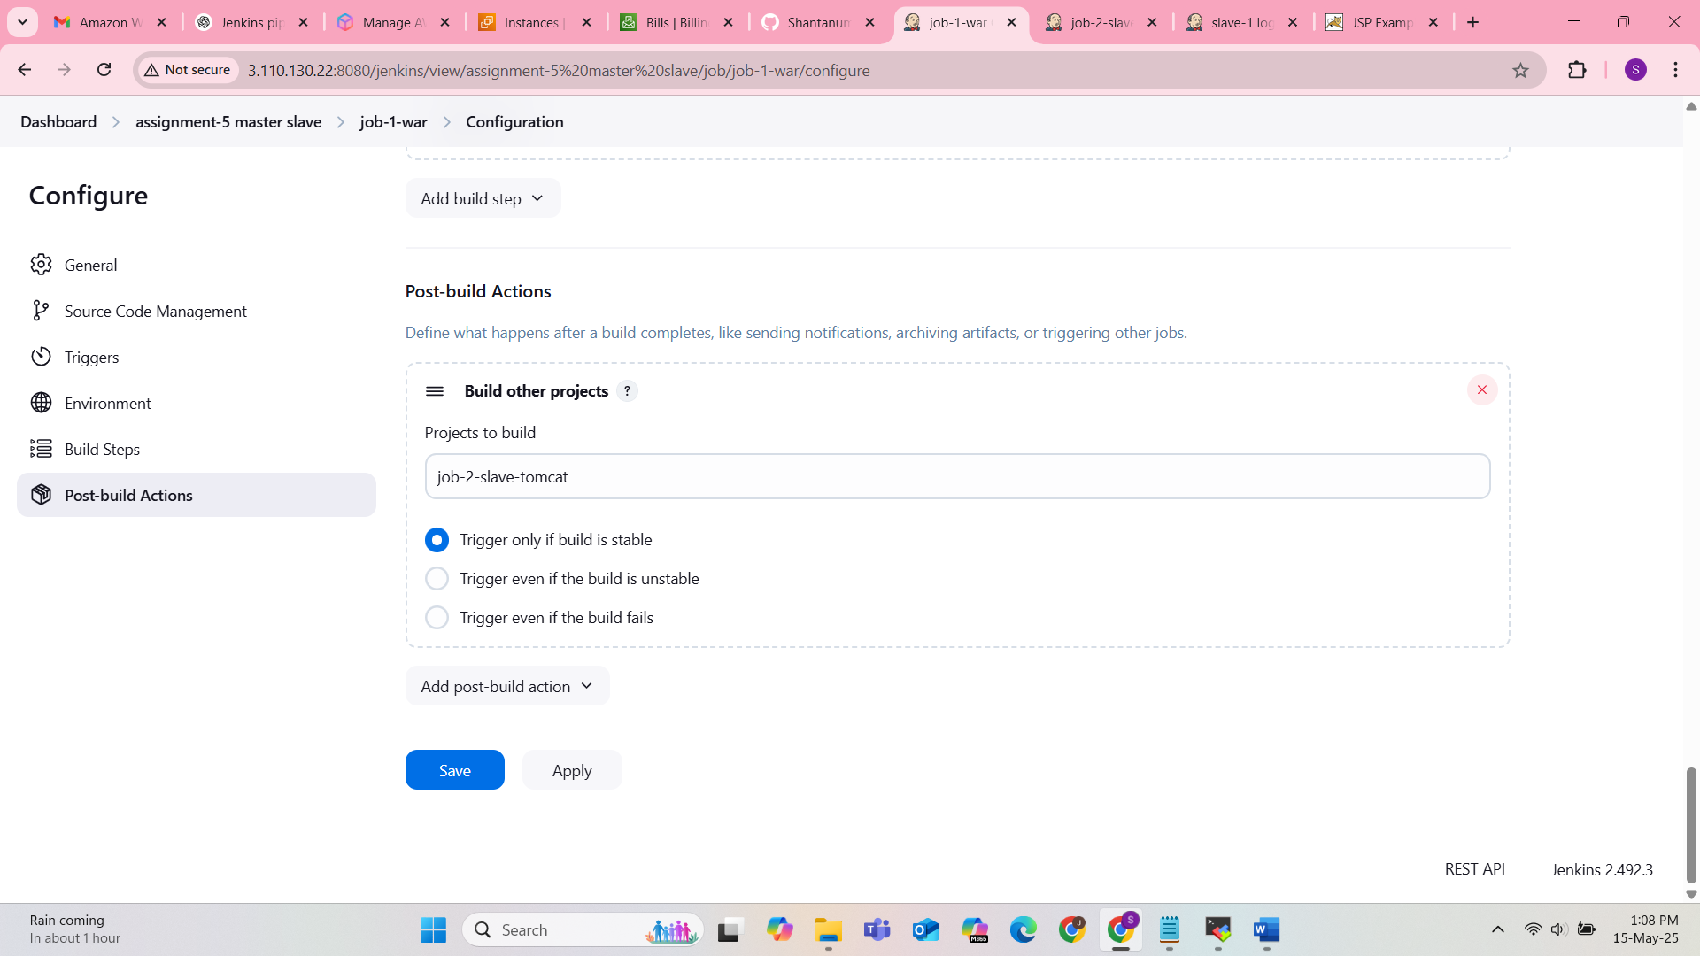

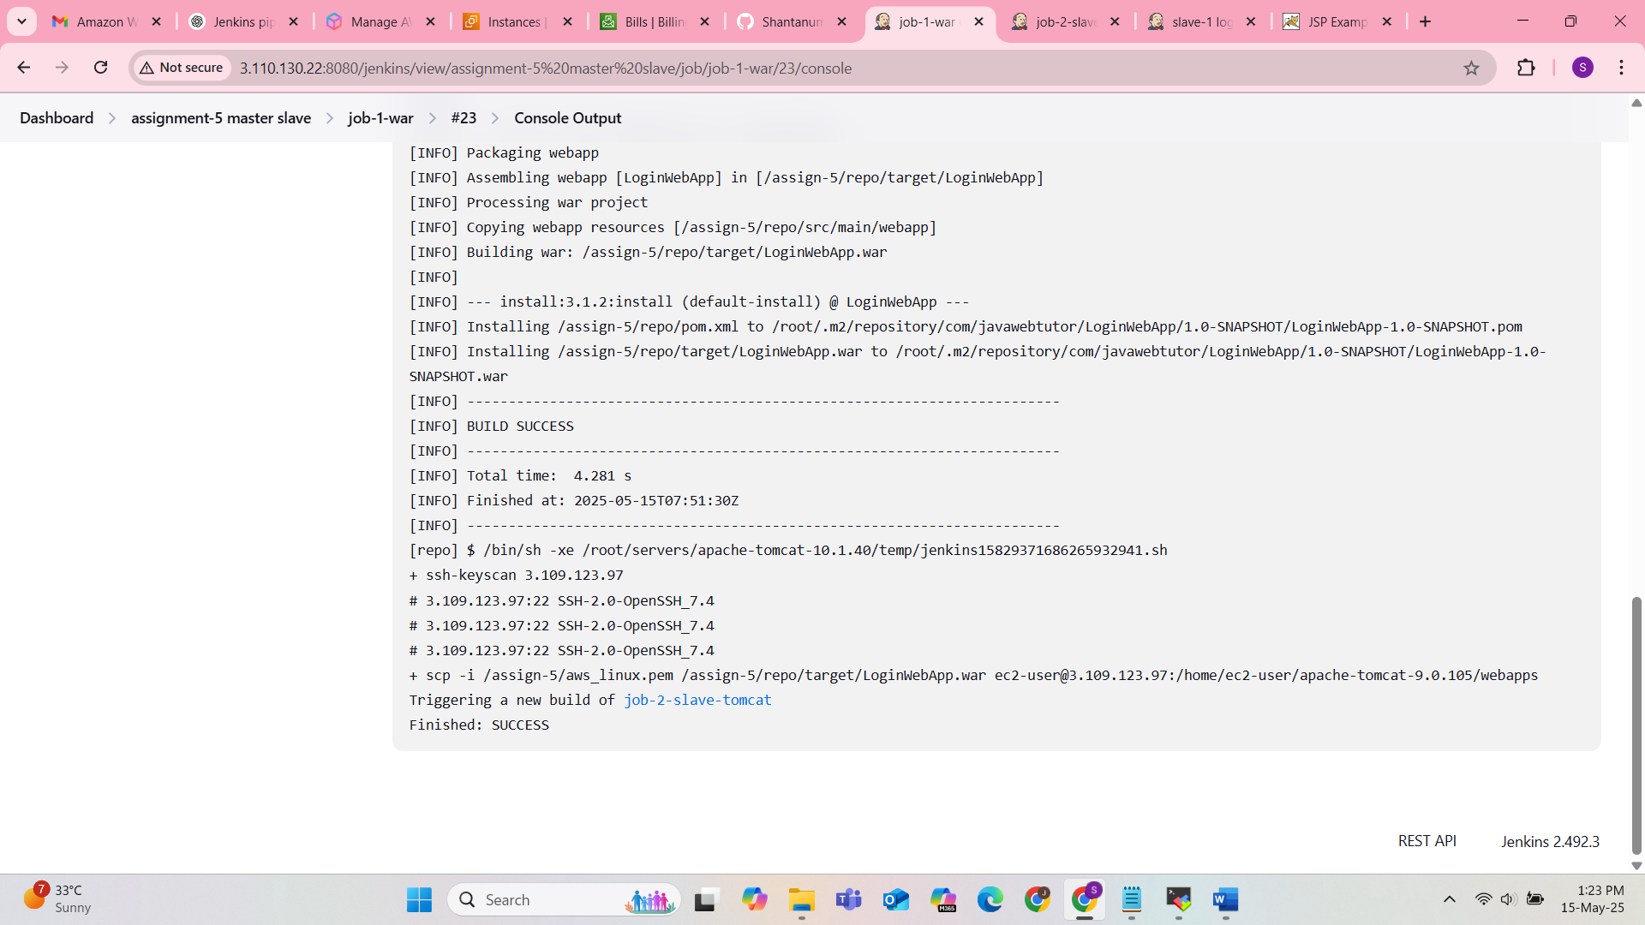

Job – 2 : Deploy on tomcat

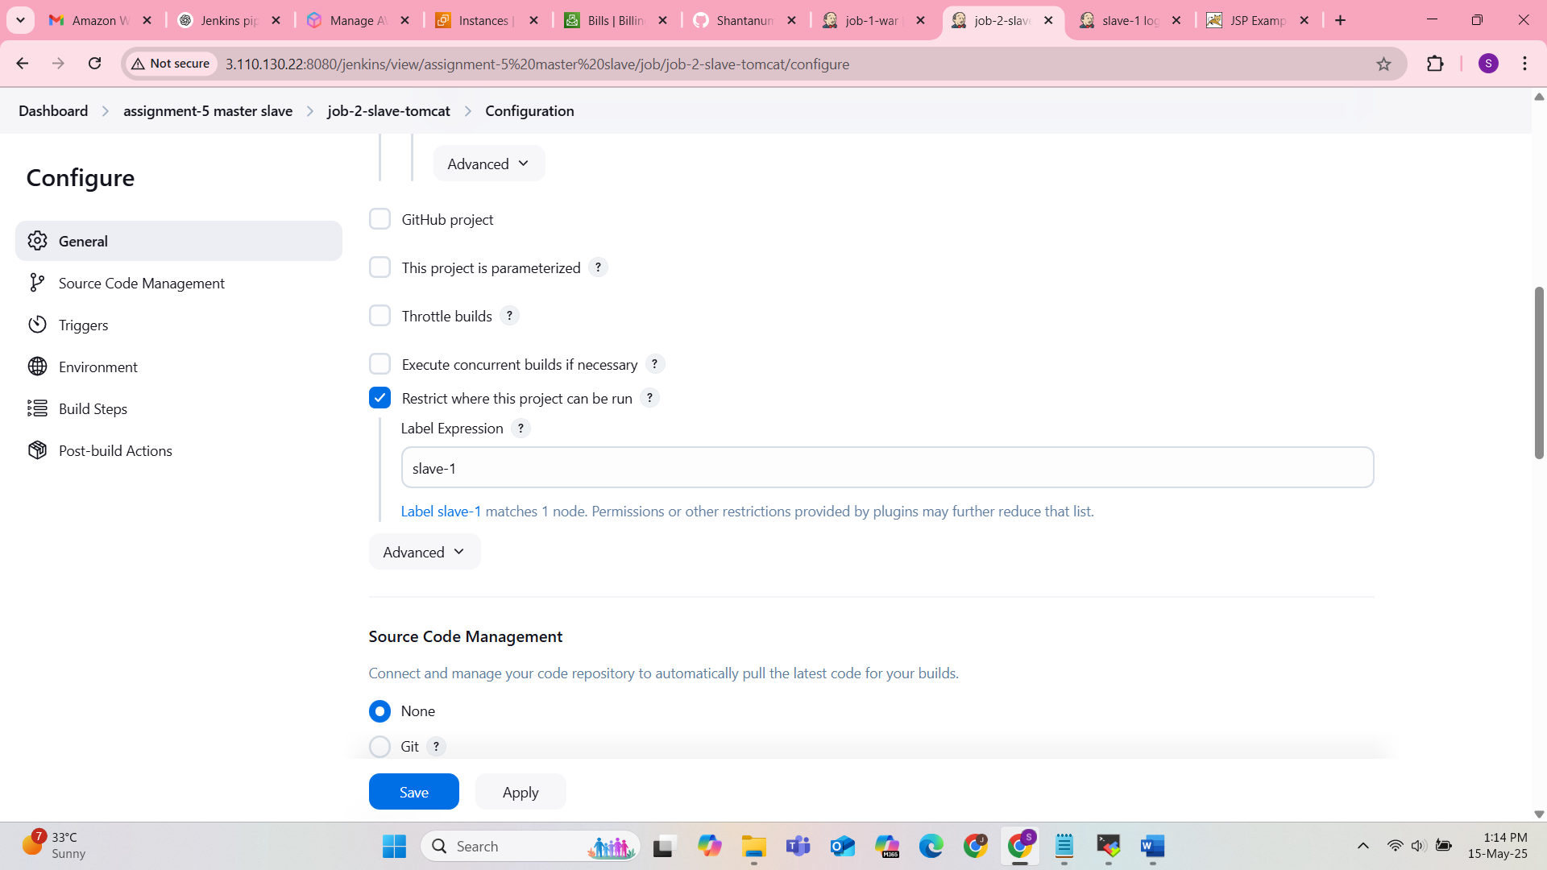

Sleep 20 sec

After running Shutdown.sh & Startup.sh simultaneously, tomcat is not getting started

|| true ---- if server is not running then it will throw error but script will be kept running

