Docker Assignment – 1

1 github repo – 3 branches 2025Q1, 2025Q2, 2025Q3

On Jenkins Master

Deploy index.html web-page in each branch on 3 httpd image containers which will be accessed at port number 80, 90, 8001 on ec2 instance

Method 1 : 1 Declarative pipeline

pipeline {

agent {

label "built-in"

}

stages {

stage("docker-install") {

steps {

sh '''

yum install docker -y

systemctl start docker

docker pull httpd

'''

}

}

stage("git-2025Q1") {

steps {

dir("/docker-asign-1/2025Q1/"){

git url : "https://github.com/SarthakAJ/docker-repo-1.git",

branch : "2025Q1"

sh '''

docker run -dp 80:80 --name 2025Q1 httpd

docker cp index.html 2025Q1:/usr/local/apache2/htdocs/

docker exec 2025Q1 chmod -R 777 /usr/local/apache2/htdocs/

'''

}

}

}

stage("git-2025Q2") {

steps {

dir("/docker-asign-1/2025Q2/") {

git url : "https://github.com/SarthakAJ/docker-repo-1.git",

branch : "2025Q2"

sh '''

docker run -dp 90:80 --name 2025Q2 httpd

docker cp index.html 2025Q2:/usr/local/apache2/htdocs/

docker exec 2025Q2 chmod -R 777 /usr/local/apache2/htdocs/

'''

}

}

}

stage("git-2025Q3") {

steps {

dir("/docker-asign-1/2025Q3/") {

git url : "https://github.com/SarthakAJ/docker-repo-1.git",

branch : "2025Q3"

sh '''

docker run -dp 8001:80 --name 2025Q3 httpd

docker cp index.html 2025Q3:/usr/local/apache2/htdocs/

docker exec 2025Q3 chmod -R 777 /usr/local/apache2/htdocs/

'''

}

}

}

}

}

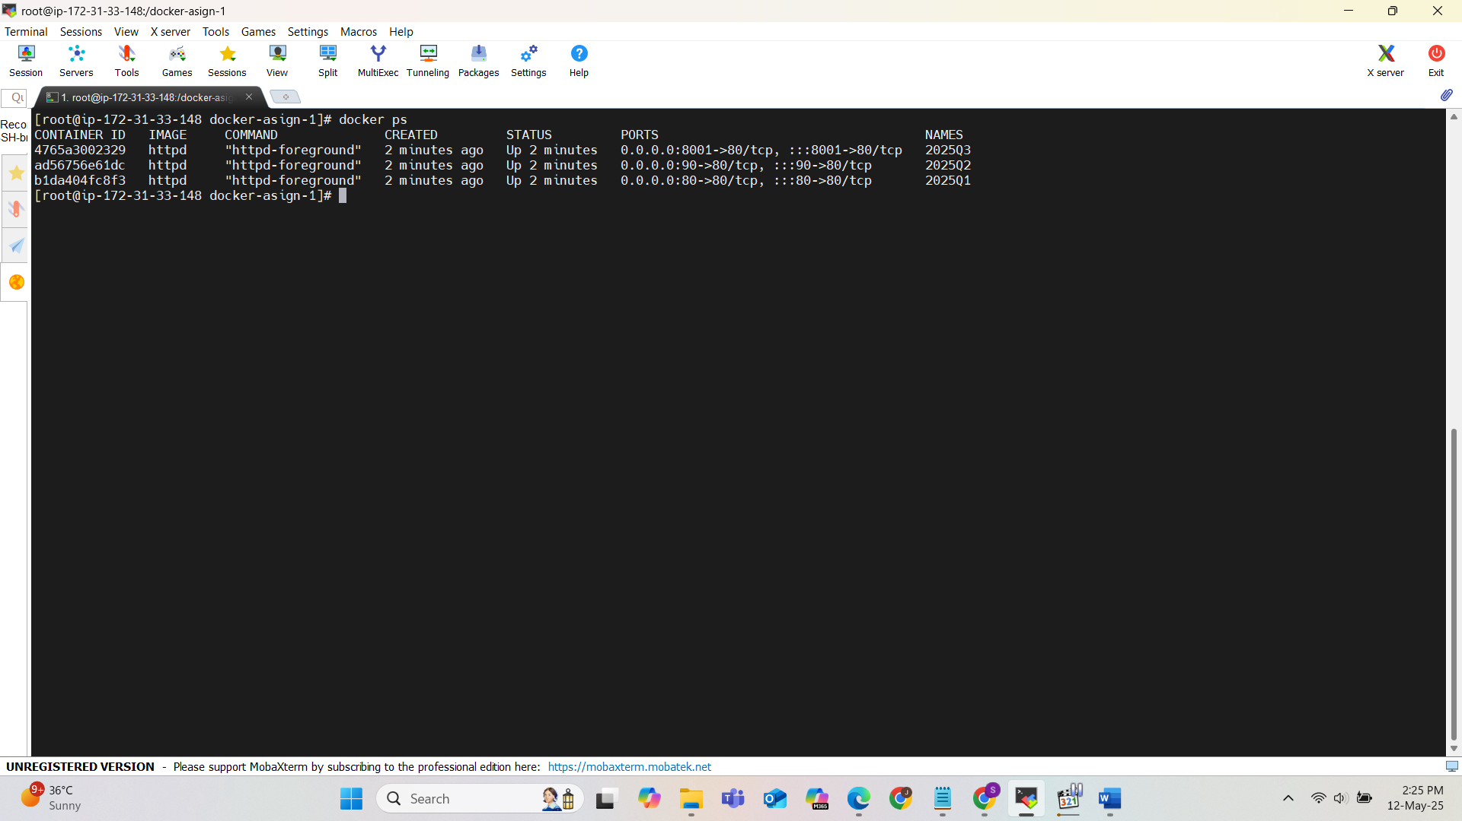

Container 1 : port 80:80

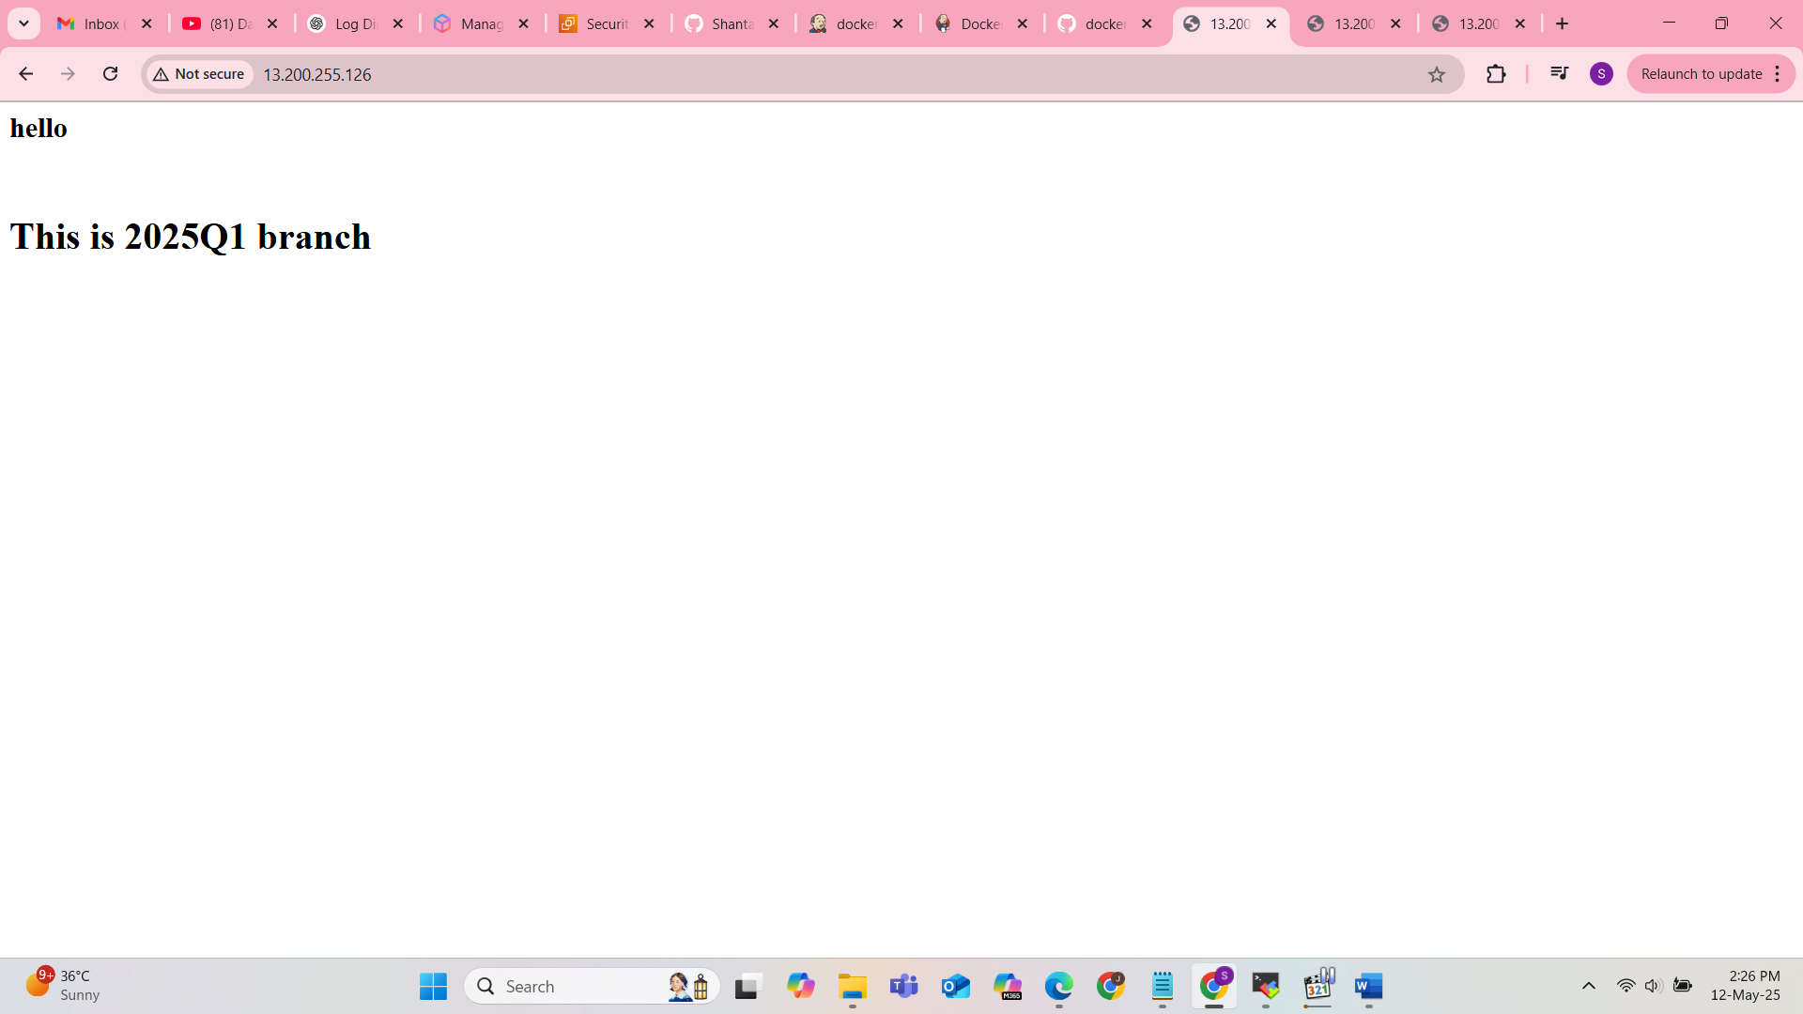

Container 2 : port 90:80

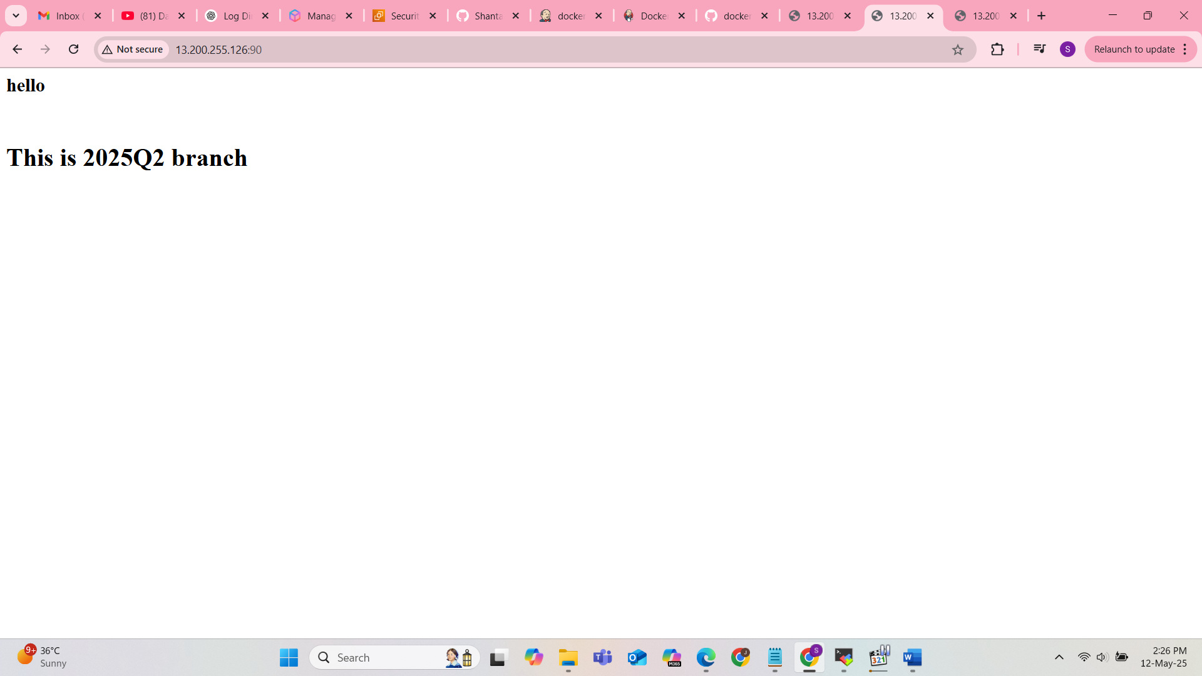

Container 3 : port 8001:80

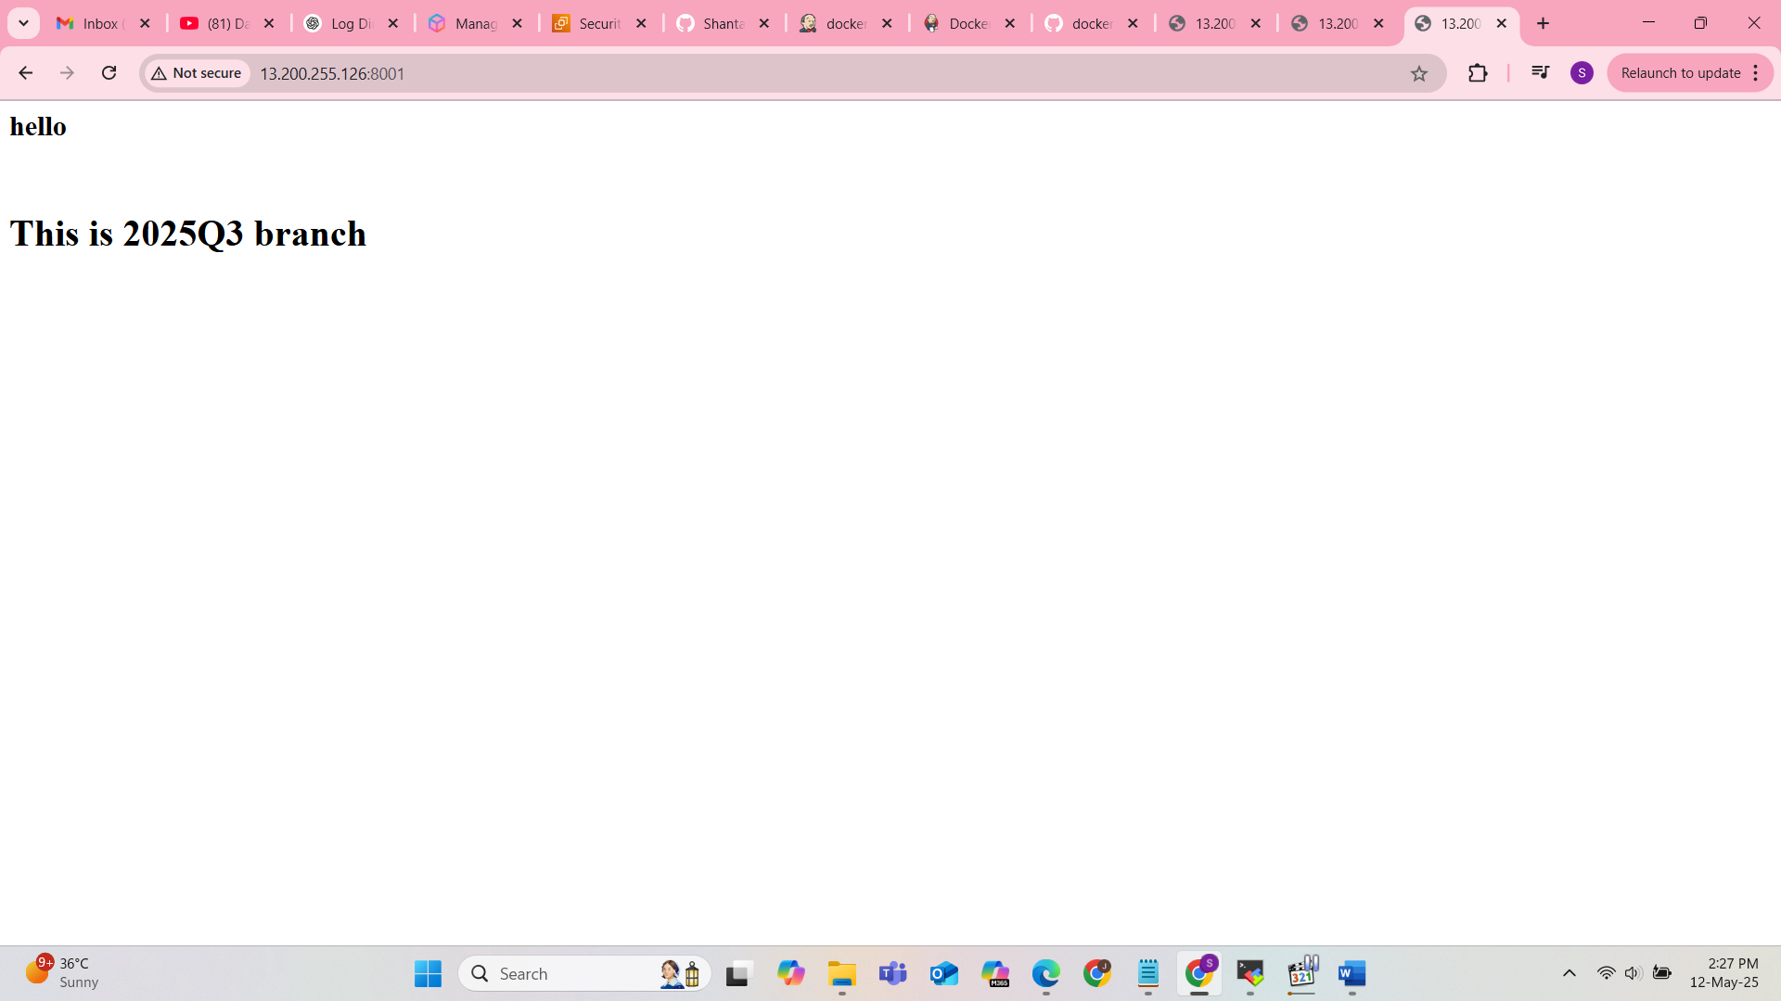

Method 2 : Multibranch pipeline   
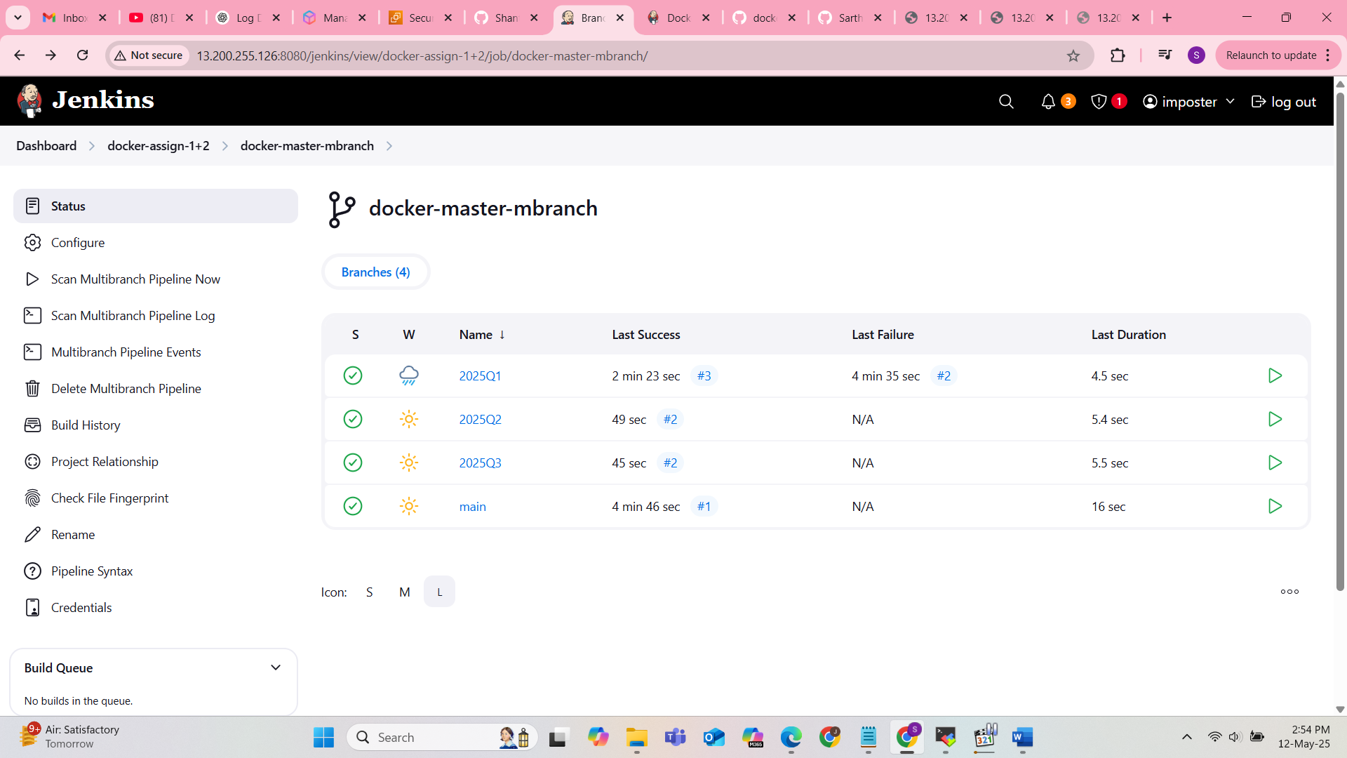

Branch 1 : 2025Q1

pipeline {

agent {

label "built-in"

}

stages {

// stage("docker-install") {

// steps {

// sh '''

// yum install docker -y

// systemctl start docker

// docker pull httpd

// '''

// }

// }

stage("git-2025Q1") {

steps {

dir("/docker-asign-1/2025Q1/"){

git url : "https://github.com/SarthakAJ/docker-repo-1.git",

branch : "2025Q1"

sh '''

docker run -dp 80:80 --name 2025Q1 httpd

docker cp index.html 2025Q1:/usr/local/apache2/htdocs/

docker exec 2025Q1 chmod -R 777 /usr/local/apache2/htdocs/

'''

}

}

}

}

}

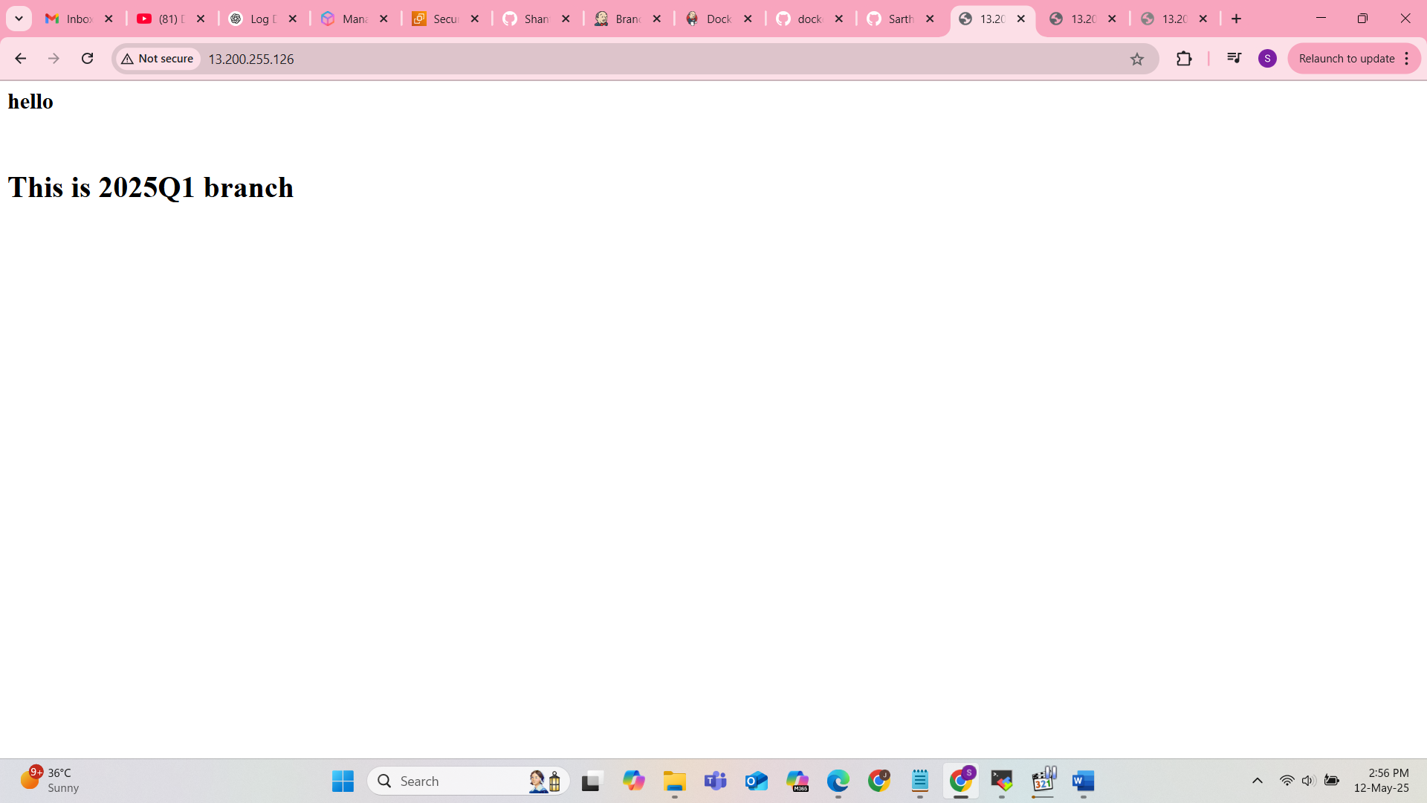

Branch 2 :

pipeline {

agent {

label "built-in"

}

stages {

// stage("docker-install") {

// steps {

// sh '''

// yum install docker -y

// systemctl start docker

// docker pull httpd

// '''

// }

// }

stage("git-2025Q2") {

steps {

dir("/docker-asign-1/2025Q2/"){

git url : "https://github.com/SarthakAJ/docker-repo-1.git",

branch : "2025Q2"

sh '''

docker run -dp 90:80 --name 2025Q2 httpd

docker cp index.html 2025Q2:/usr/local/apache2/htdocs/

docker exec 2025Q2 chmod -R 777 /usr/local/apache2/htdocs/

'''

}

}

}

}

}

