Instance B :

1. Downloaded Tomcat version 10.1.40 in root directory
2. Directory apache-tomcat-10.1.40 permission – 777

-------------------------------------------------------------------------------------------------------------------------------

Instance A :

1. Installed Java 17
2. Installed Jenkins as a service

.m2 in /var/lib/Jenkins

Cloned repo in /var.lib/Jenkins/workspace/job_name

1. Created aws_linux.pem : permissions 400 in root dir (pem for ssh in instance B)

**Error 1** :

permission denied ---read permission is given to root but read permission is supposed to be given to jenkins as user because .pem file will accessed by Jenkins if is accessed in Jenkins shell

**Solution** :

aws_linux.pem file moved to /machine-keys/

permission – 004

**Error 2 :**

Host key verification failed. lost connection --- means that SSH is **refusing to connect** to the remote server because it cannot verify the server's **host key fingerprint**. This is a security feature of SSH to prevent **man-in-the-middle attacks**.

**Solution :**

Add IP of remote device in .ssh/known_hosts file in Jenkins home dir because Jenkins will be accessing it

ssh-keyscan 13.233.229.125 >> /var/lib/jenkins/.ssh/known_hosts

1. After creating build in git cloned repo copy that war file to remote machine(instance B)

scp -i /machine-keys/aws_linux.pem /var/lib/jenkins/workspace/"Creating war file"/target/LoginWebApp.war [ec2-user@13.233.229.125:/root/servers/apache-tomcat-10.1.40/webapps](mailto:ec2-user@13.233.229.125:/root/servers/apache-tomcat-10.1.40/webapps)

**Error :**

Permission denied ---- cannot move file in root directory without root admin

**Solution :**

scp -i /machine-keys/aws_linux.pem /var/lib/jenkins/workspace/"Creating war file"/target/LoginWebApp.war [ec2-user@13.233.229.125:/home/ec2-user/](mailto:ec2-user@13.233.229.125:/home/ec2-user/)

Copy file in ec2-user directory

1. Deploy war file on tomcat server on instance B

Tasks to do

--- need to do ssh in instance B

--- move war file to tomcat home dir in root

--- install java (if not pre-installed on instance B) --- required for tomcat server

--- start/restart tomcat server

**Solution :**

**Start the server**

ssh -i /machine-keys/aws_linux.pem ec2-user@13.233.229.125 "sudo yum install java-17-amazon-corretto-devel.x86_64 -y && sudo mv /home/ec2-user/LoginWebApp.war /root/servers/apache-tomcat-10.1.40/webapps/ && sudo bash /root/servers/apache-tomcat-10.1.40/bin/startup.sh"

**Re-Start the server**

ssh -i /machine-keys/aws_linux.pem ec2-user@13.233.229.125 "sudo yum install java-17-amazon-corretto-devel.x86_64 -y && sudo mv /home/ec2-user/LoginWebApp.war /root/servers/apache-tomcat-10.1.40/webapps/ && sudo bash /root/servers/apache-tomcat-10.1.40/bin/shutdown.sh && sleep 5 && sudo bash /root/servers/apache-tomcat-10.1.40/bin/startup.sh "

1. Jenkins + Maven on Instance A

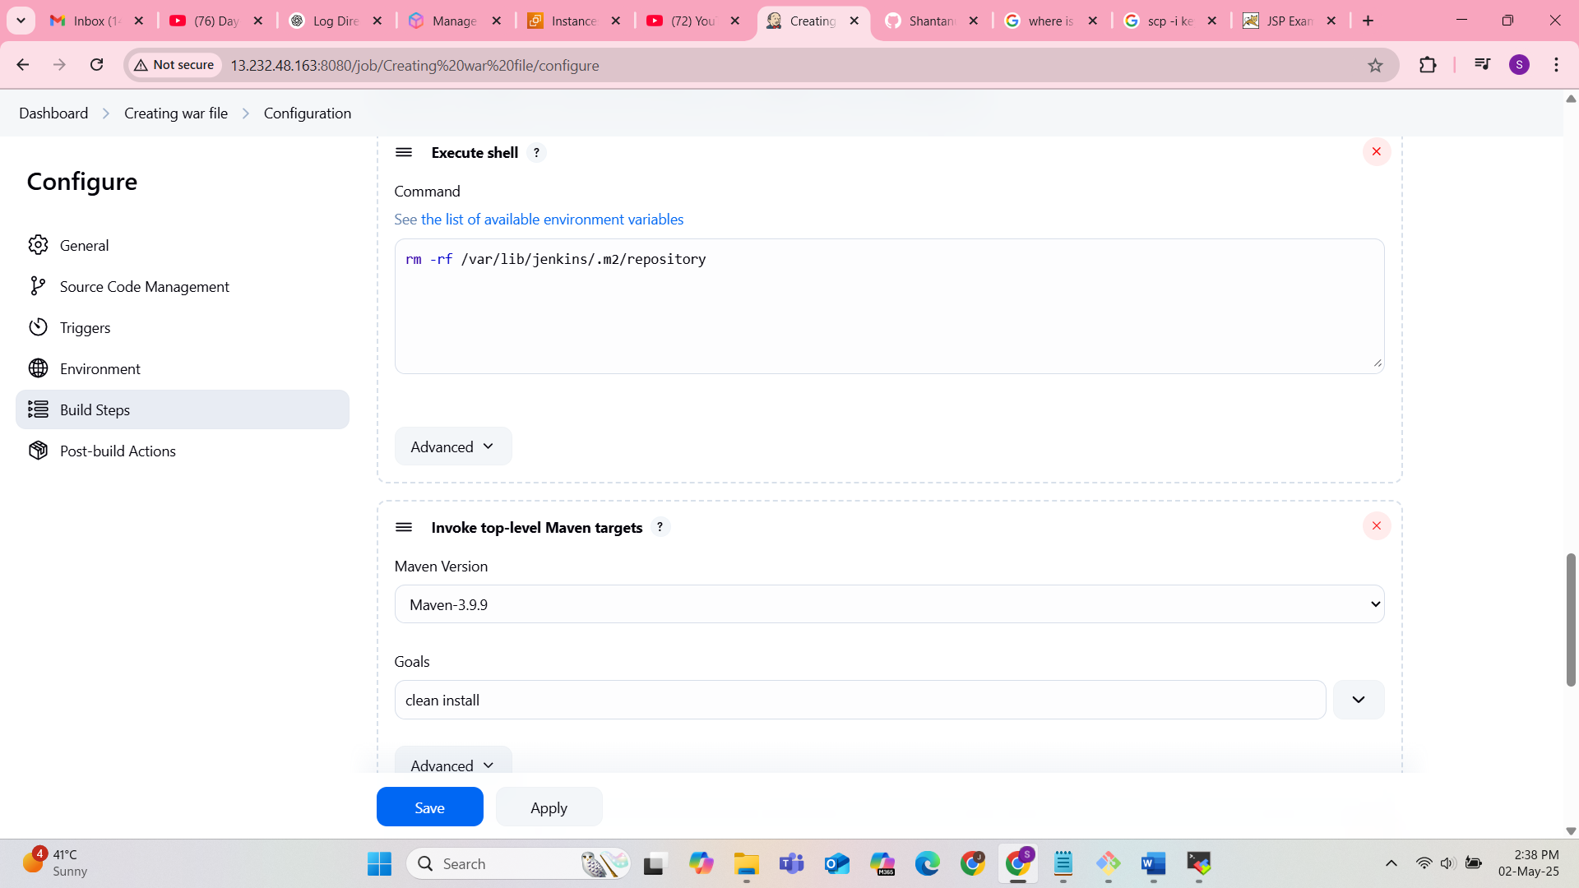

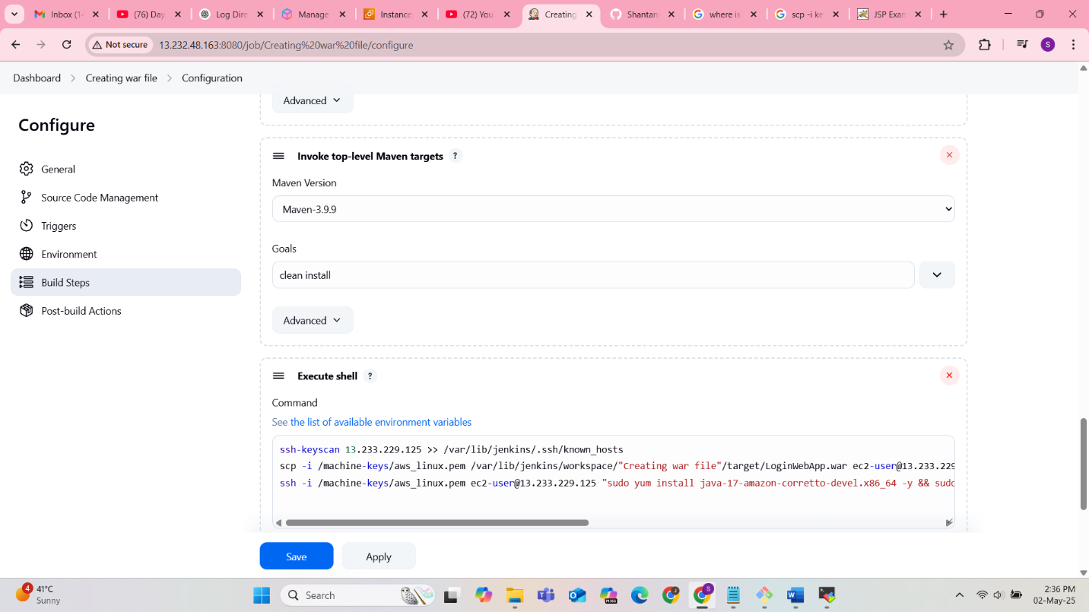

1. Deployed on Instance B

