Assignment : 9

3 GitHub Repo with master branch, dev branch, qa branch

3 jobs to being triggered by github commits and deploy/replace webpage from latest commited repo.

Pipeline 1 : master branch

pipeline {

agent {

label {

label "built-in"

customWorkspace "/assg-3/repo-1"

}

}

stages {

stage("install-httpd") {

steps {

sh "yum install httpd -y"

sh "systemctl start httpd"

}

}

stage ("git-clone") {

steps {

git branch:'master',

url:"https://github.com/SarthakAJ/assign-3-repo-1.git"

}

}

stage ("deploy-httpd") {

steps {

sh "cp index.html /var/www/html/"

sh "chmod -R 777 /var/www/html/"

}

}

}

}

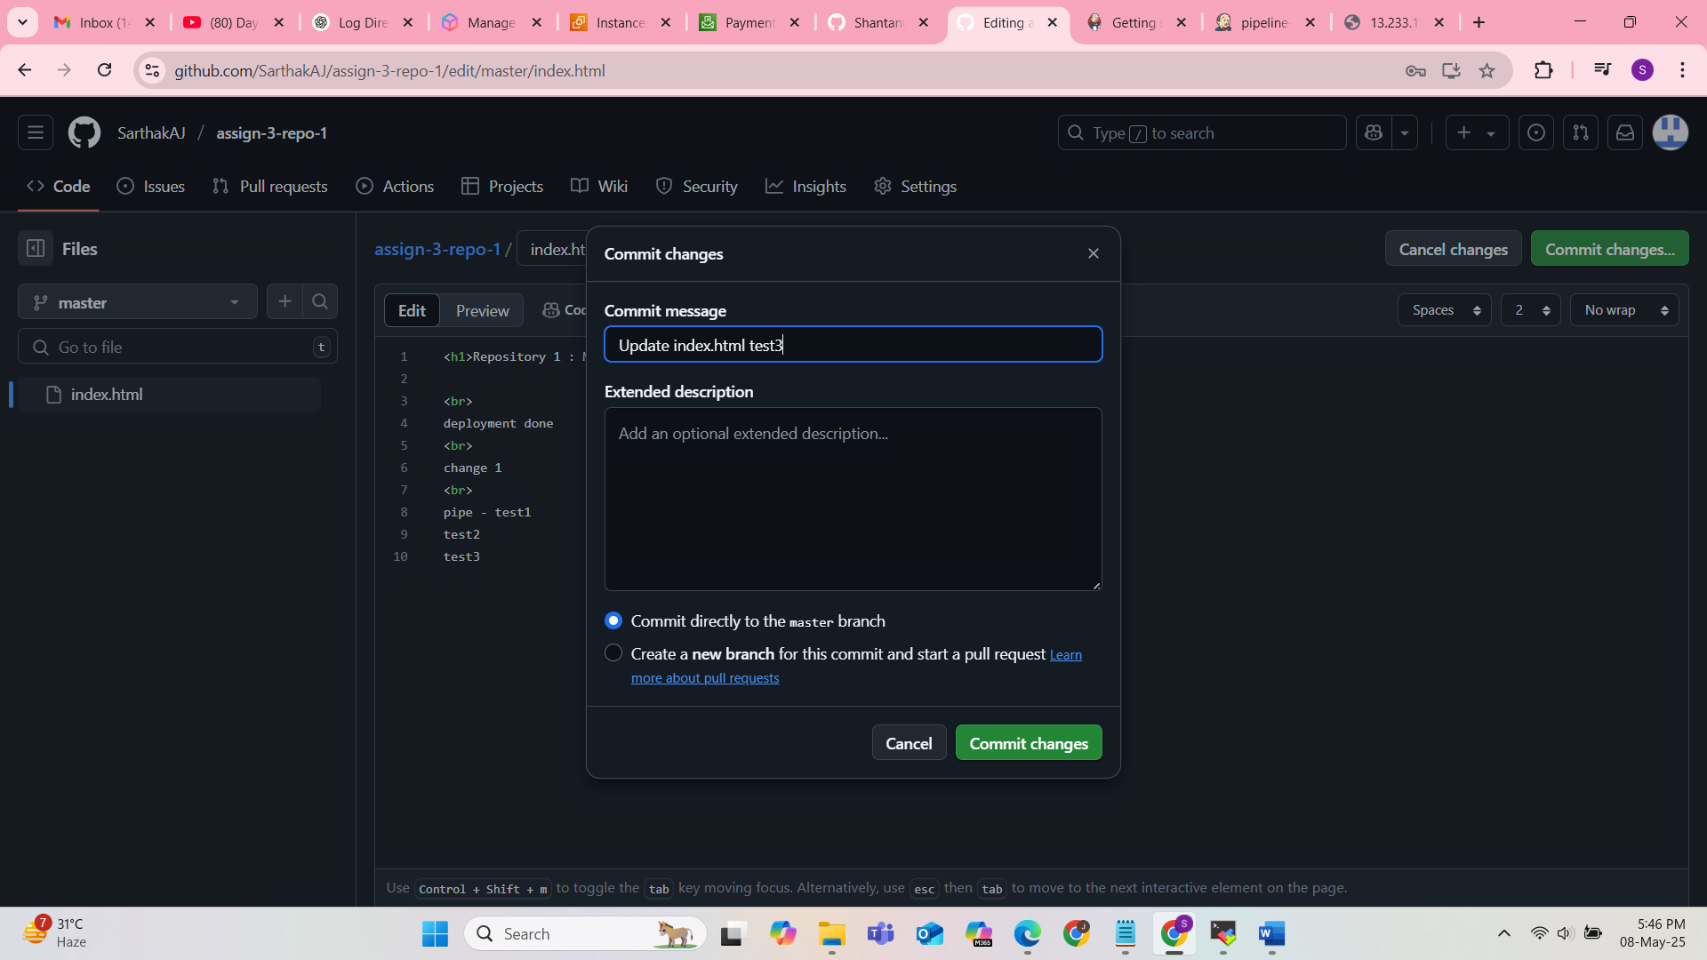

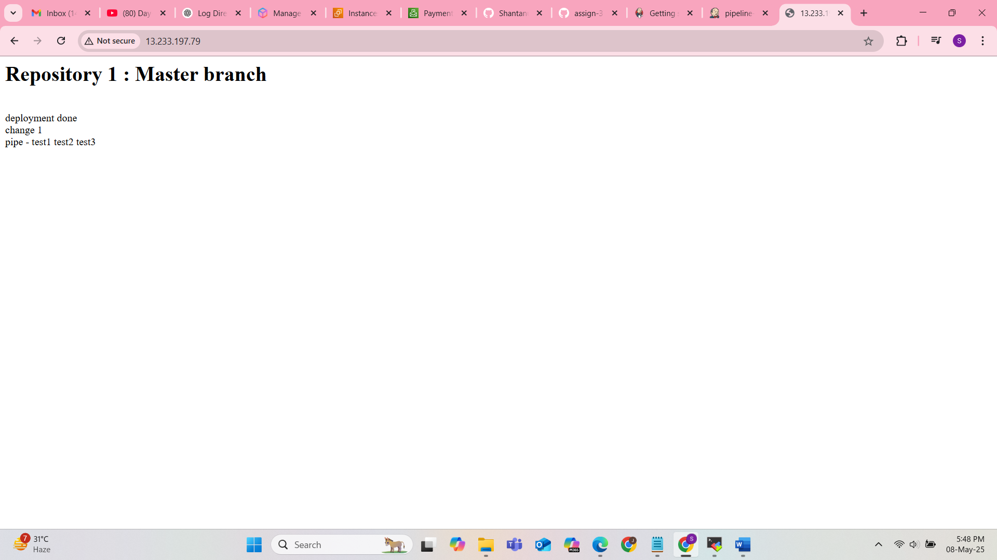

Pipeline – 2 – Repo – 2 – branch – dev

pipeline {

agent {

label {

label "built-in"

customWorkspace "/assg-3/repo-2"

}

}

stages {

stage ("git-clone") {

steps {

git branch:"dev",

url:"https://github.com/SarthakAJ/assign-3-repo-2.git"

}

}

stage ("web-page-deploy") {

steps {

sh "rm -rf /var/www/html/index\*"

sh "cp index.html /var/www/html/"

sh "chmod -R 777 /var/www/html/"

}

}

}

}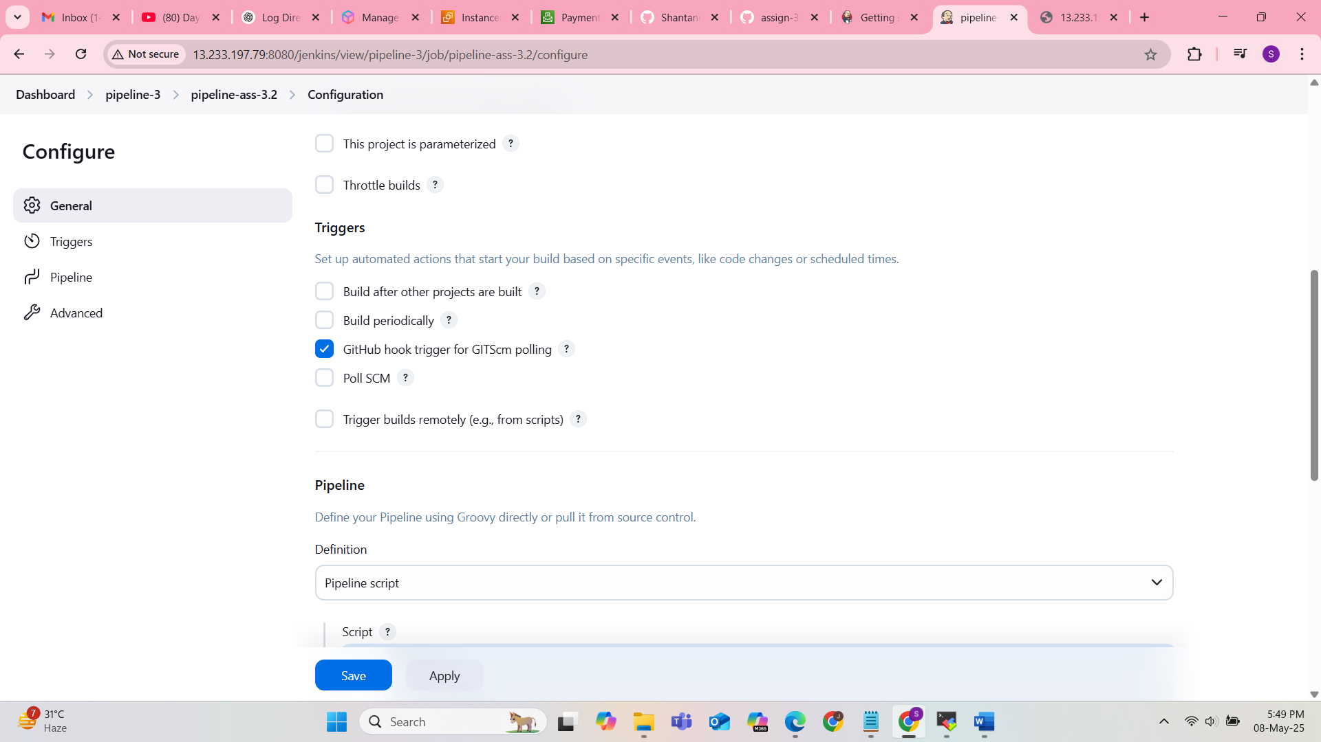

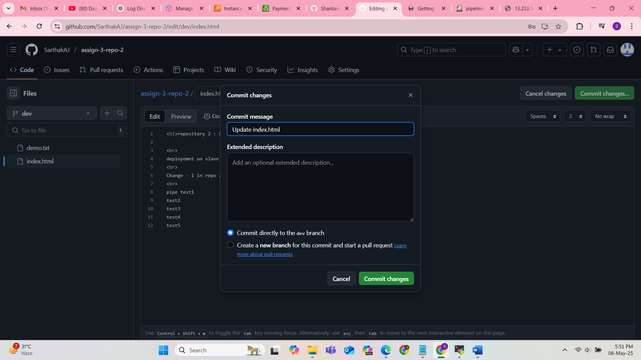

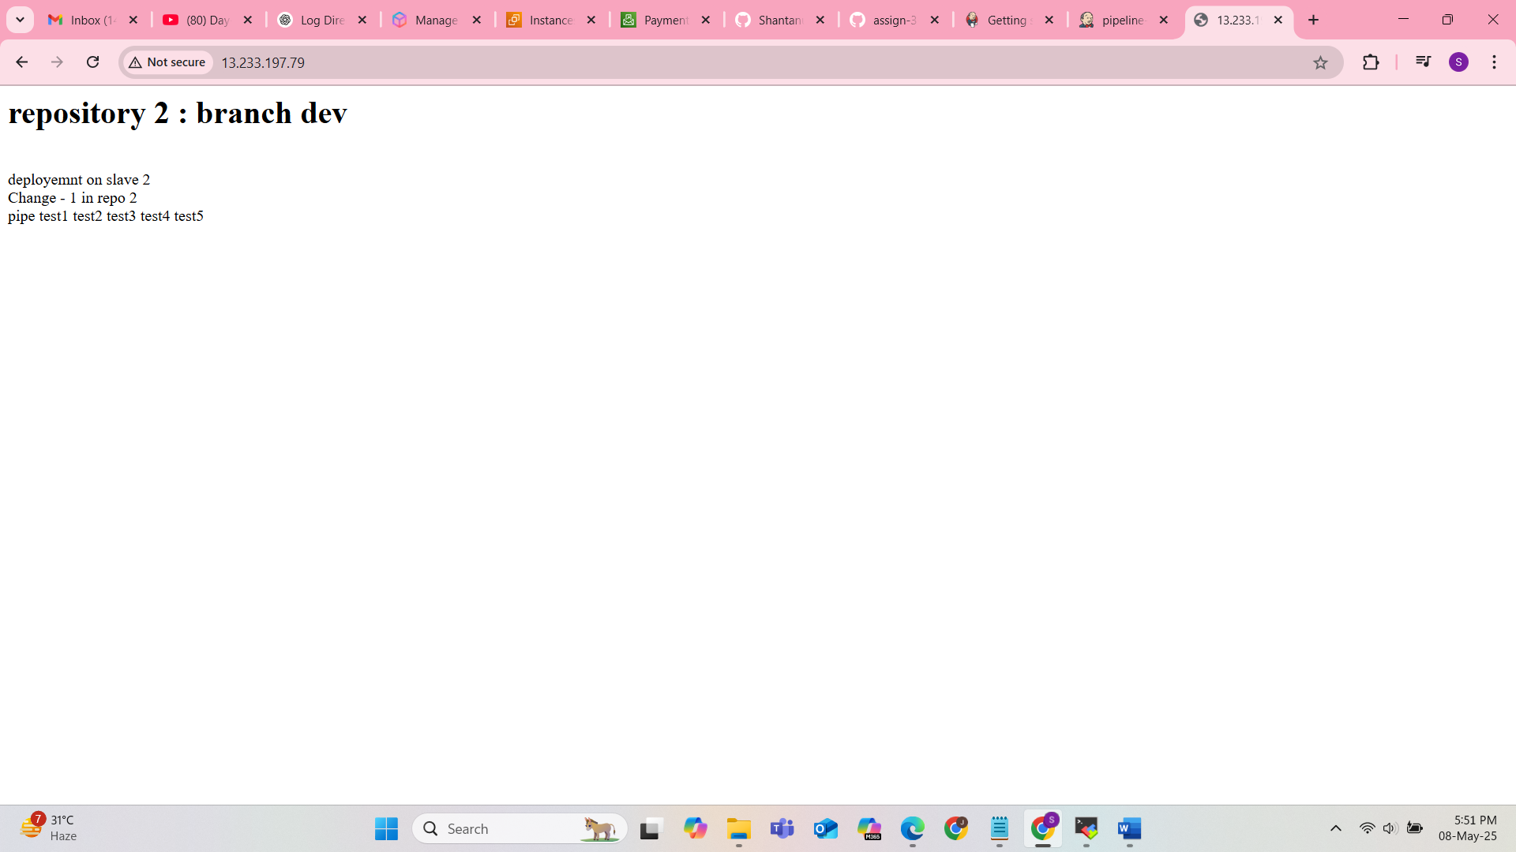

Pipeline – 3 – repo – 3 – branch – qa

pipeline {

agent {

label {

label "built-in"

customWorkspace "/assg-3/repo-3/"

}

}

stages {

stage ("install-httpd") {

steps {

sh "yum install httpd -y"

sh "systemctl start httpd"

}

}

stage ("git-clone") {

steps {

git branch : "qa",

url : "https://github.com/SarthakAJ/assign-3-repo-3.git"

}

}

stage ("httpd-deploy") {

steps {

sh "rm -rf /var/www/httpd/"

sh "cp index.html /var/www/html/"

sh "chmod -R 777 /var/www/html"

}

}

}

}

