Assignment 3 :

3 Github Repositories : branch 1. master, 2. dev, 3. qa

3 jobs to be triggered on new commits in each repo & respective index.html file is supposed to be synced in httpd home dir

Configurations done :

1. Setup Github API on Jenkins to be by github-webhooks after commits on all repositories
2. Create 3 jobs for each repo
3. Set custom workspace as /root/repo-1 or repo-2 or repo-3 in each job
4. Set github url with required branch as \*/branch or branch and beahaviour can be add to get check out at local branch so head at out local repo on instance will point to a latest commit in specified branch otherwise head will not point to nothing and commit will not be pushed to remote repo

---- git branch

\* (HEAD detached at f915bf3)

1. Copy index.html file from local repo to /var/www/html/

Add read permission for others(jenkins) – 644

Job 1 :

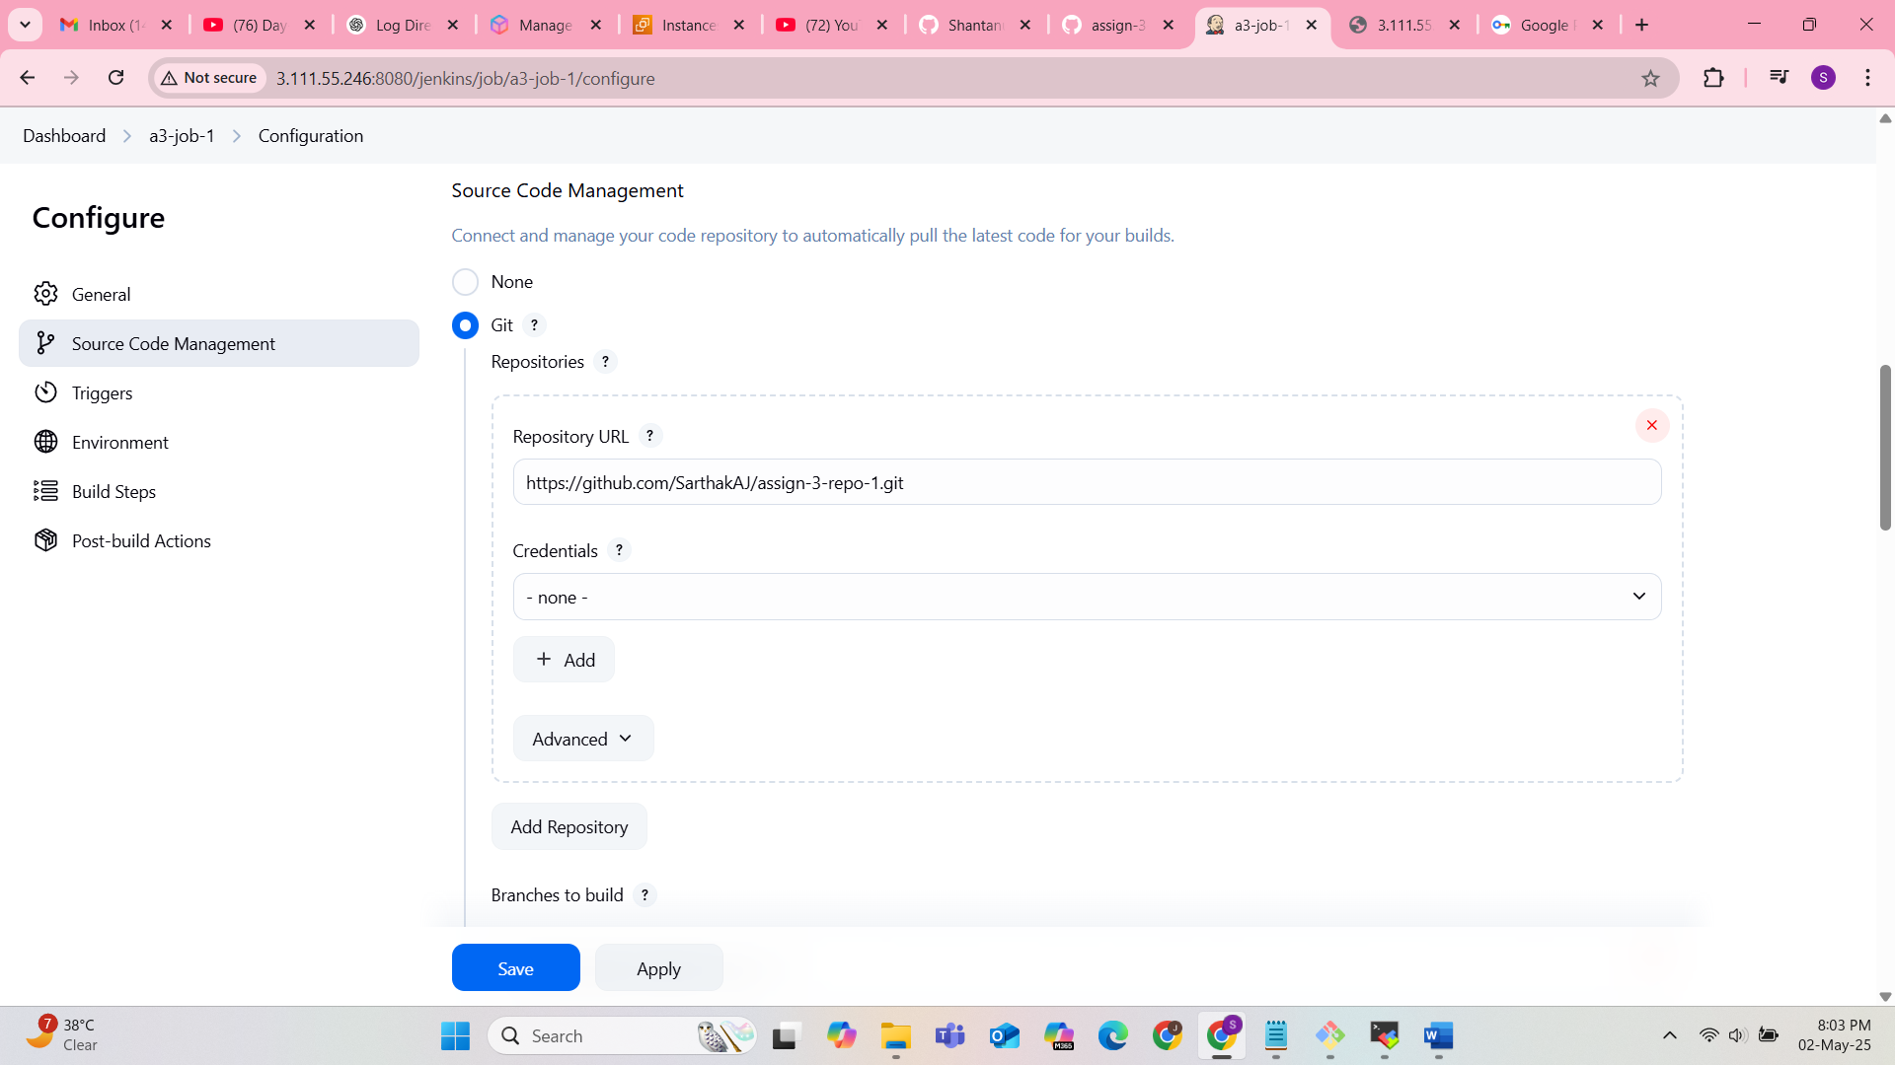

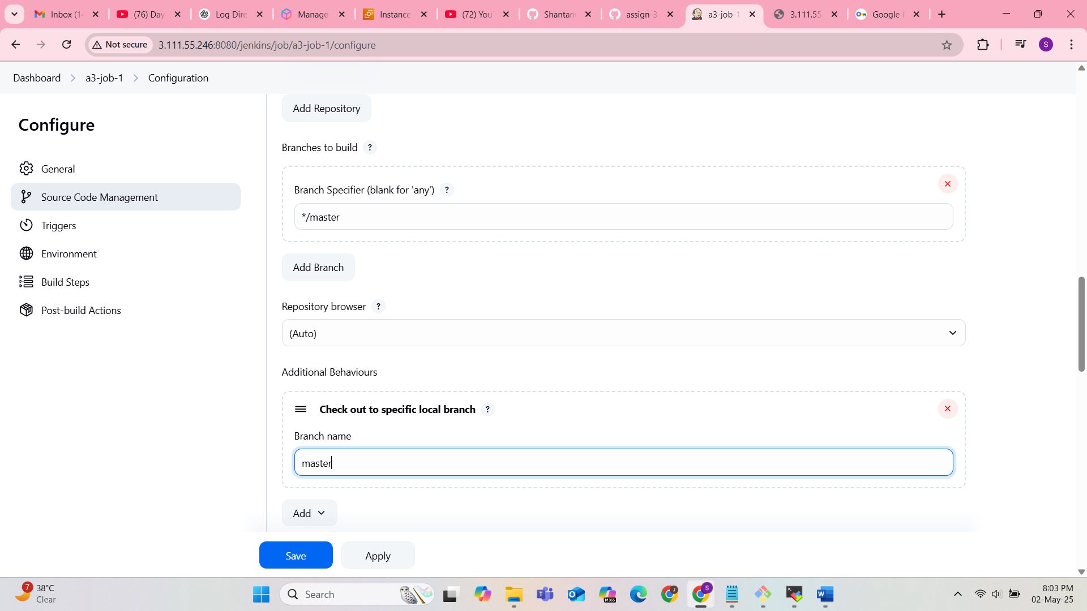

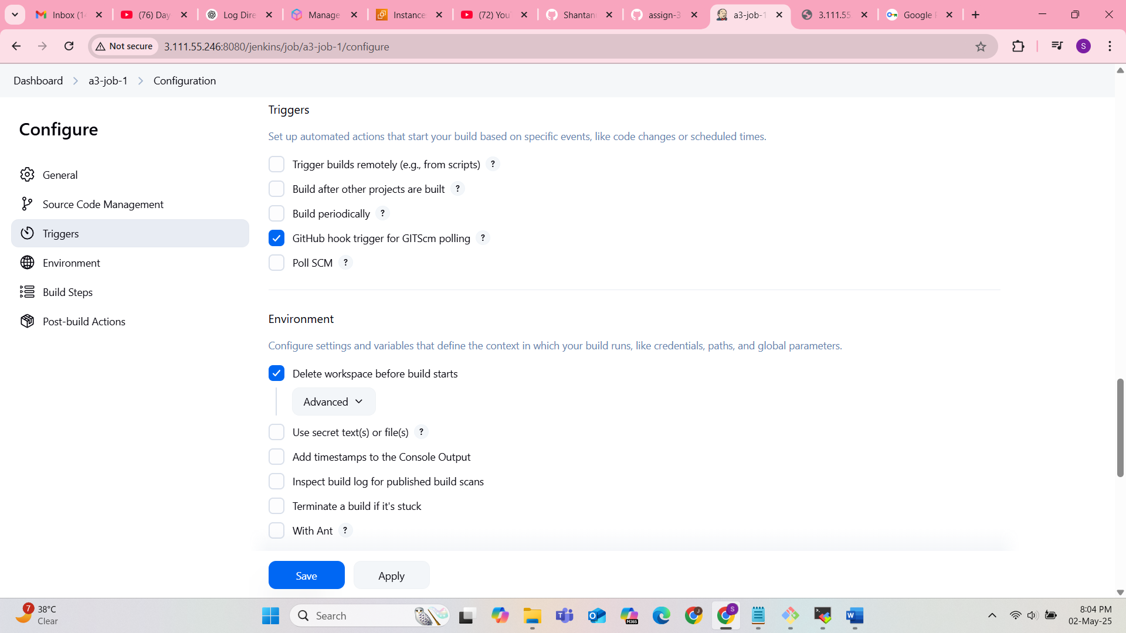

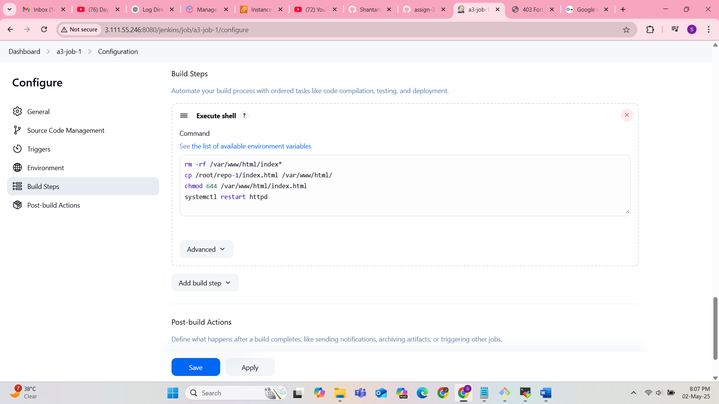

Git repo 1:

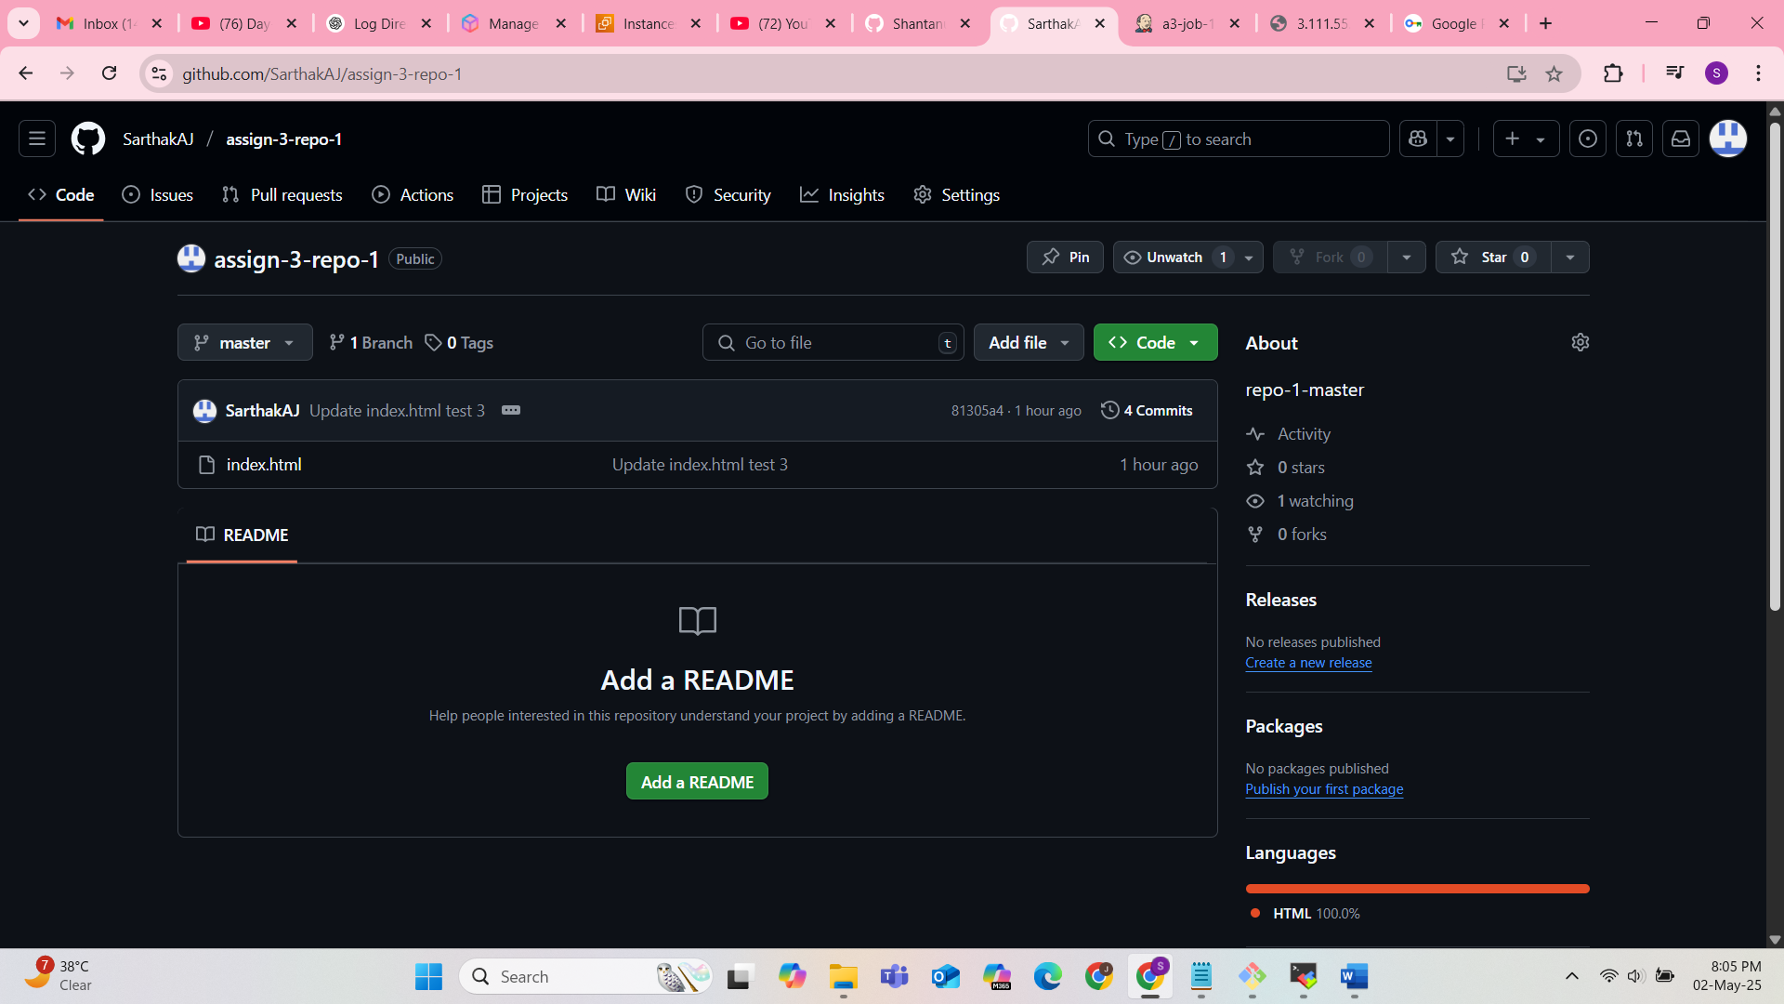

Output :

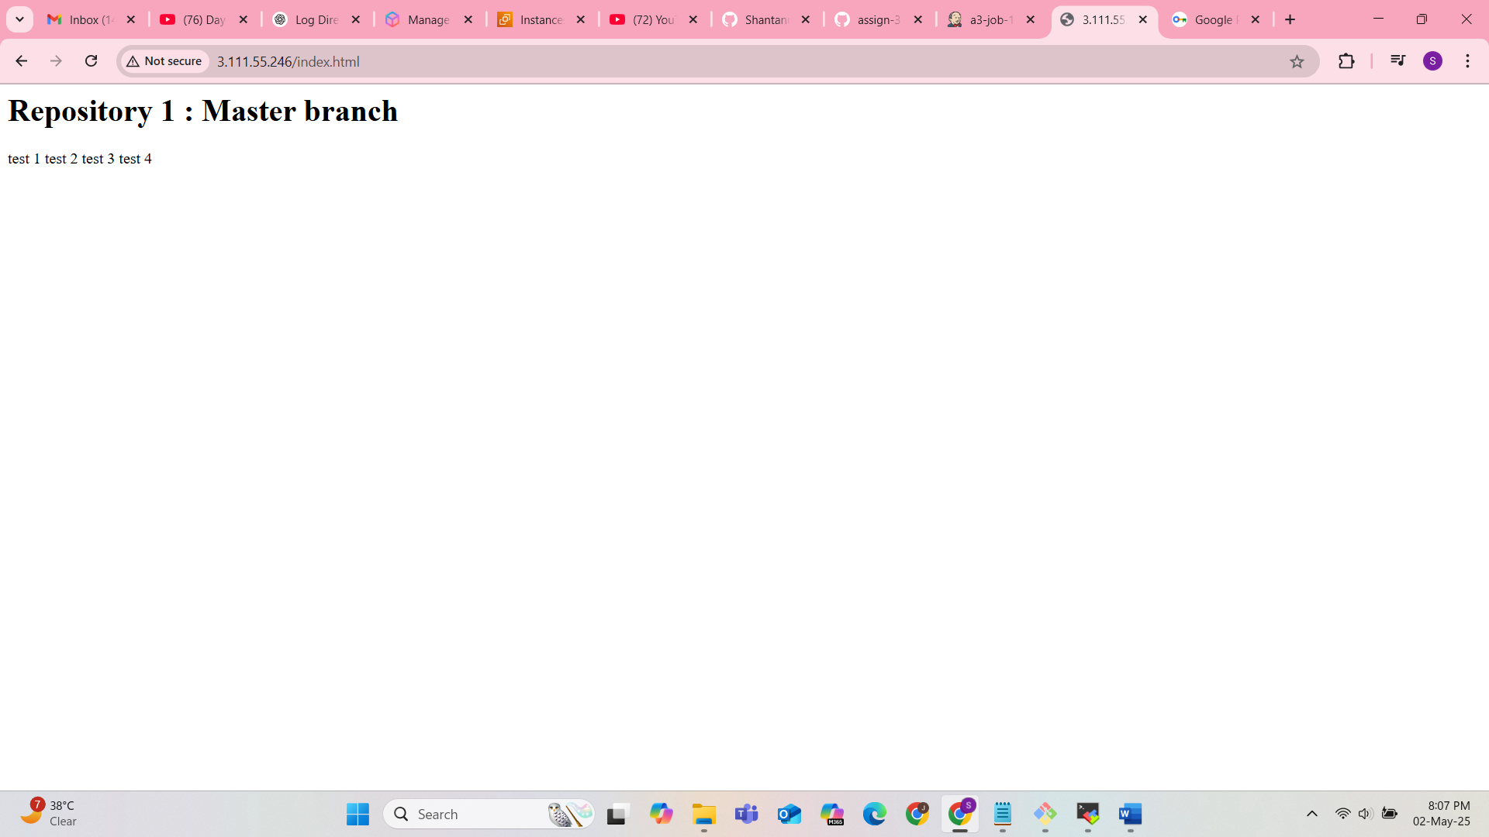

Repo -2

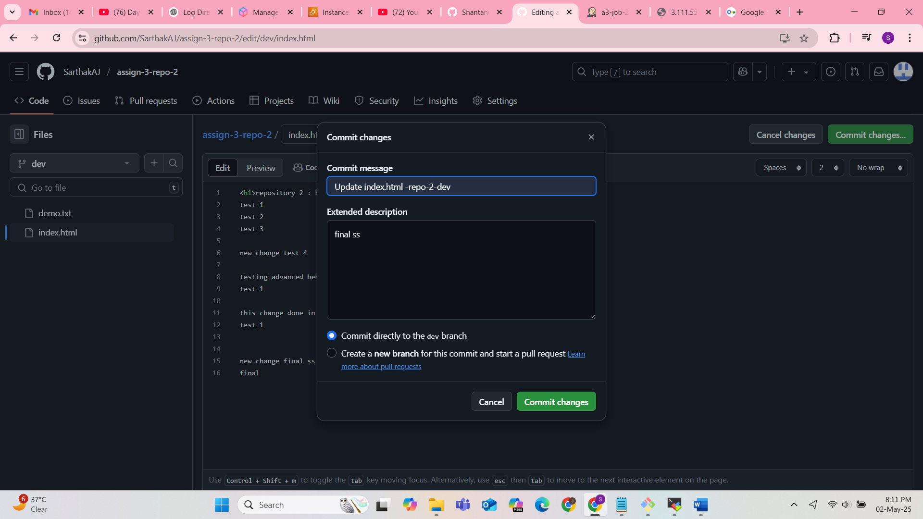

Job triggered

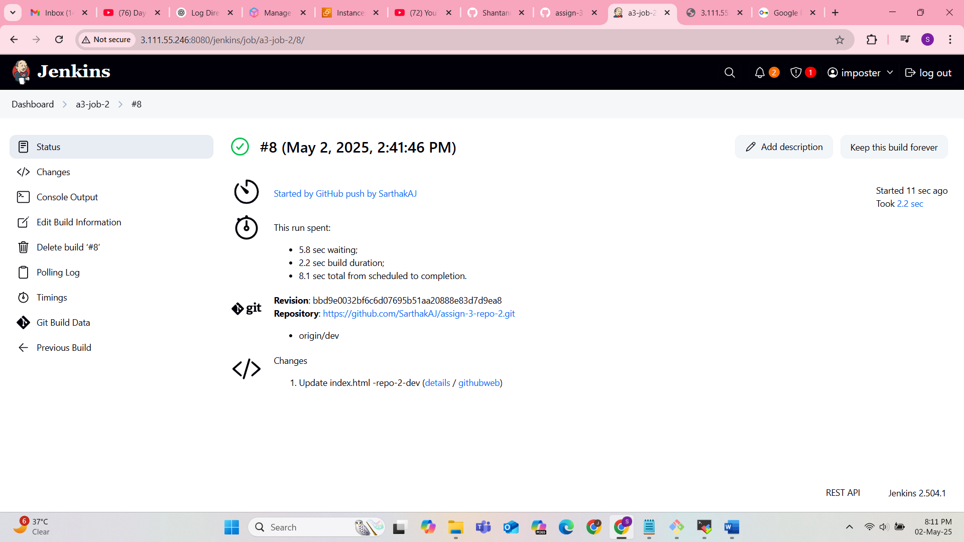

Output

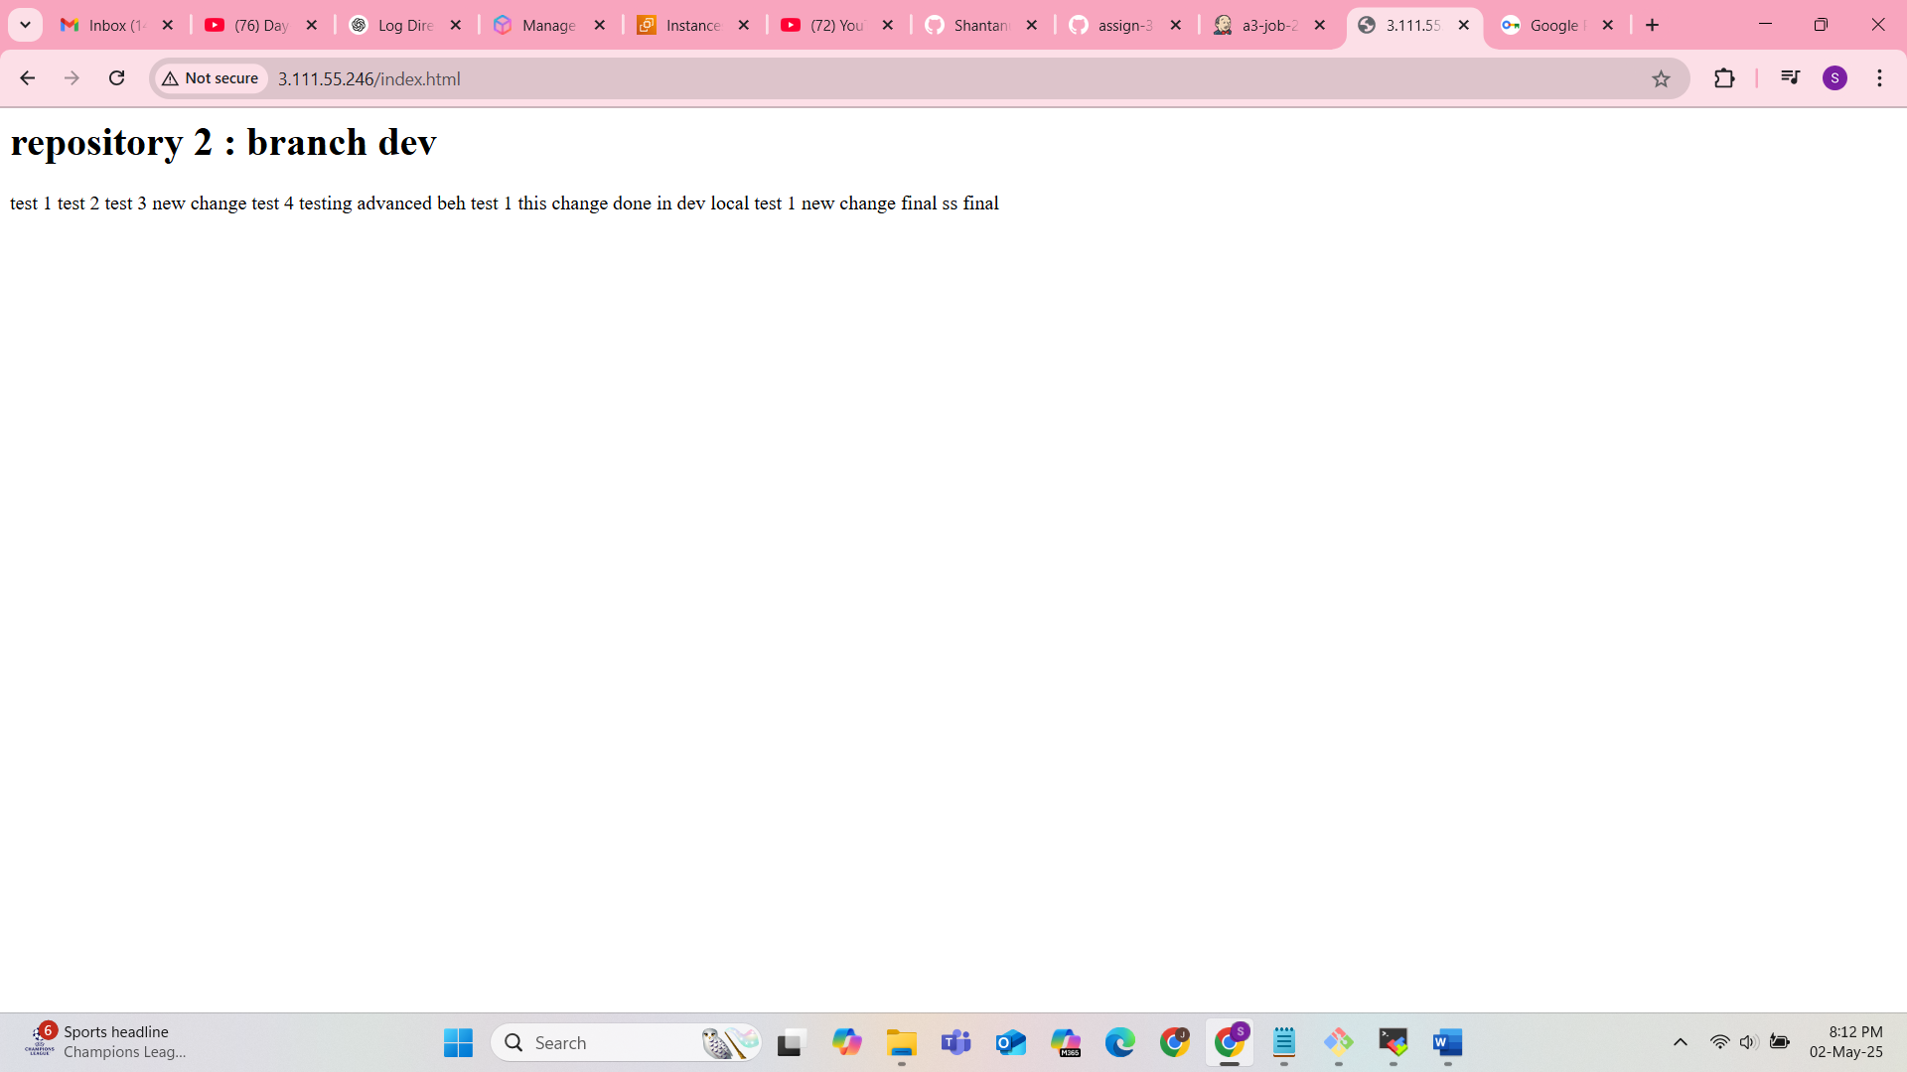

Repo - 3 :

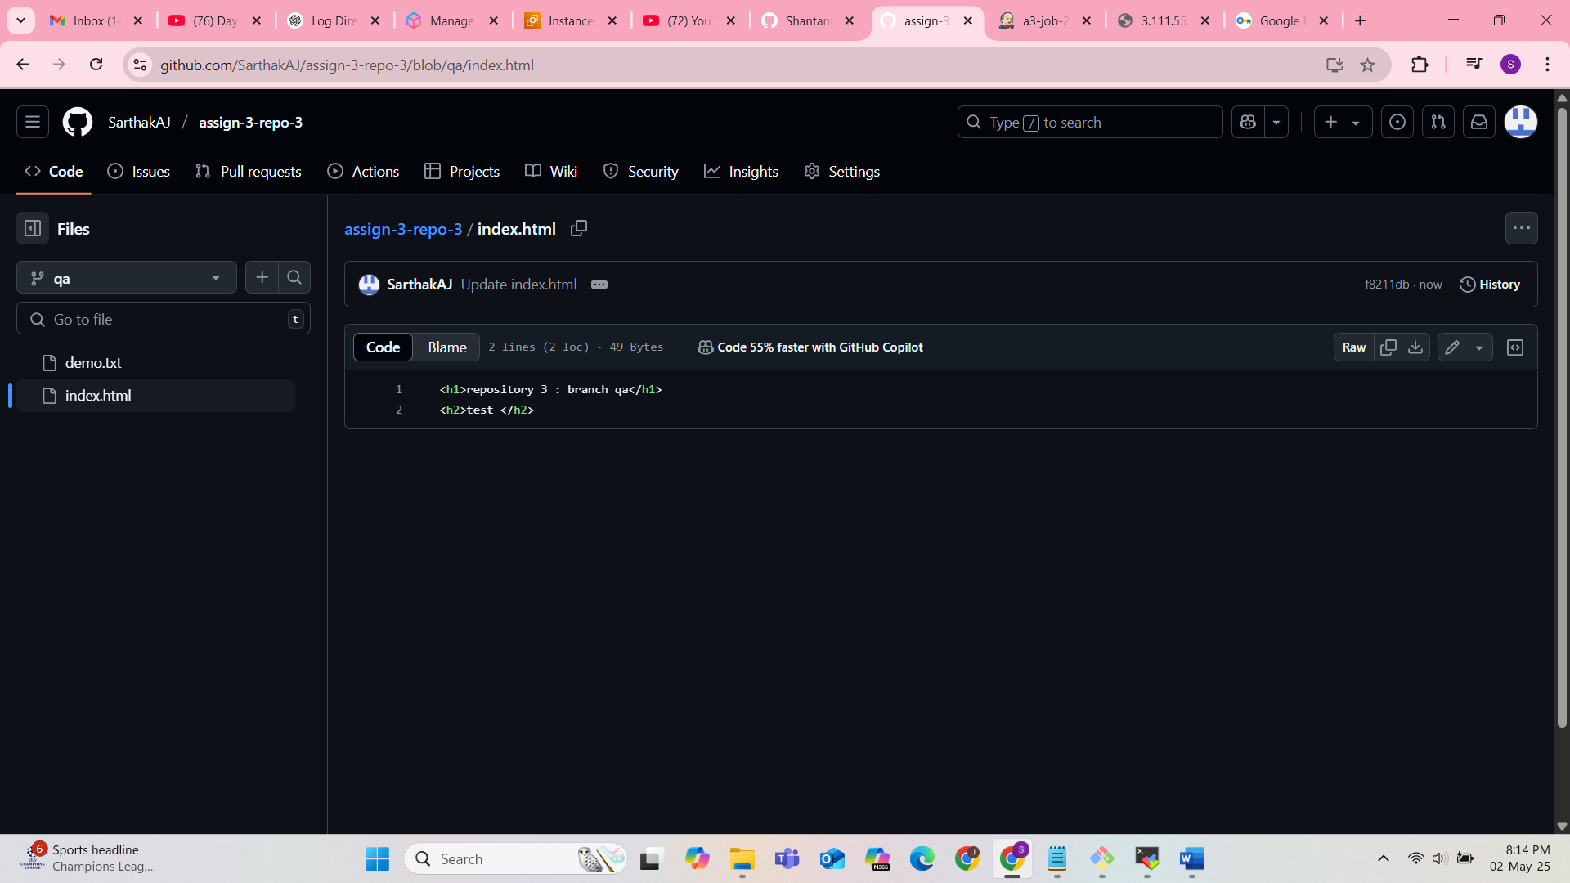

Output :

