Assignment : 10

3 Github repos with master, dev, qa branch

Create 3 slave devices for each repository

Create 2 jobs for each slave devices. 1 for installing httpd server and start it. 2nd for triggering build after commit in index.html file

**Pipeline – 1 – repo – 1 – slave – 1 : installing httpd**

pipeline {

agent {

label "apple"

}

stages {

stage("install-httpd") {

steps {

sh "sudo yum install httpd -y"

sh "sudo systemctl start httpd"

}

}

stage ("deploy-httpd-build") {

steps {

build "assg-4-p2-deploy"

}

}

}

}

**Pipeline – 2 – repo – 1 – slave – 1 : getting triggered after commit**

Enabled : GitHub hook trigger for GITScm polling

pipeline {

agent {

label {

label "apple"

customWorkspace "assg-4/repo-1/"

}

}

stages {

stage("git-clone") {

steps {

git branch:"master",

url:"https://github.com/SarthakAJ/assign-3-repo-1.git"

}

}

stage("deploy-httpd") {

steps {

sh "cp index.html /var/www/html/"

sh "sudo chmod -R 777 /var/www/html/"

sh "sudo systemctl restart httpd"

}

}

}

}

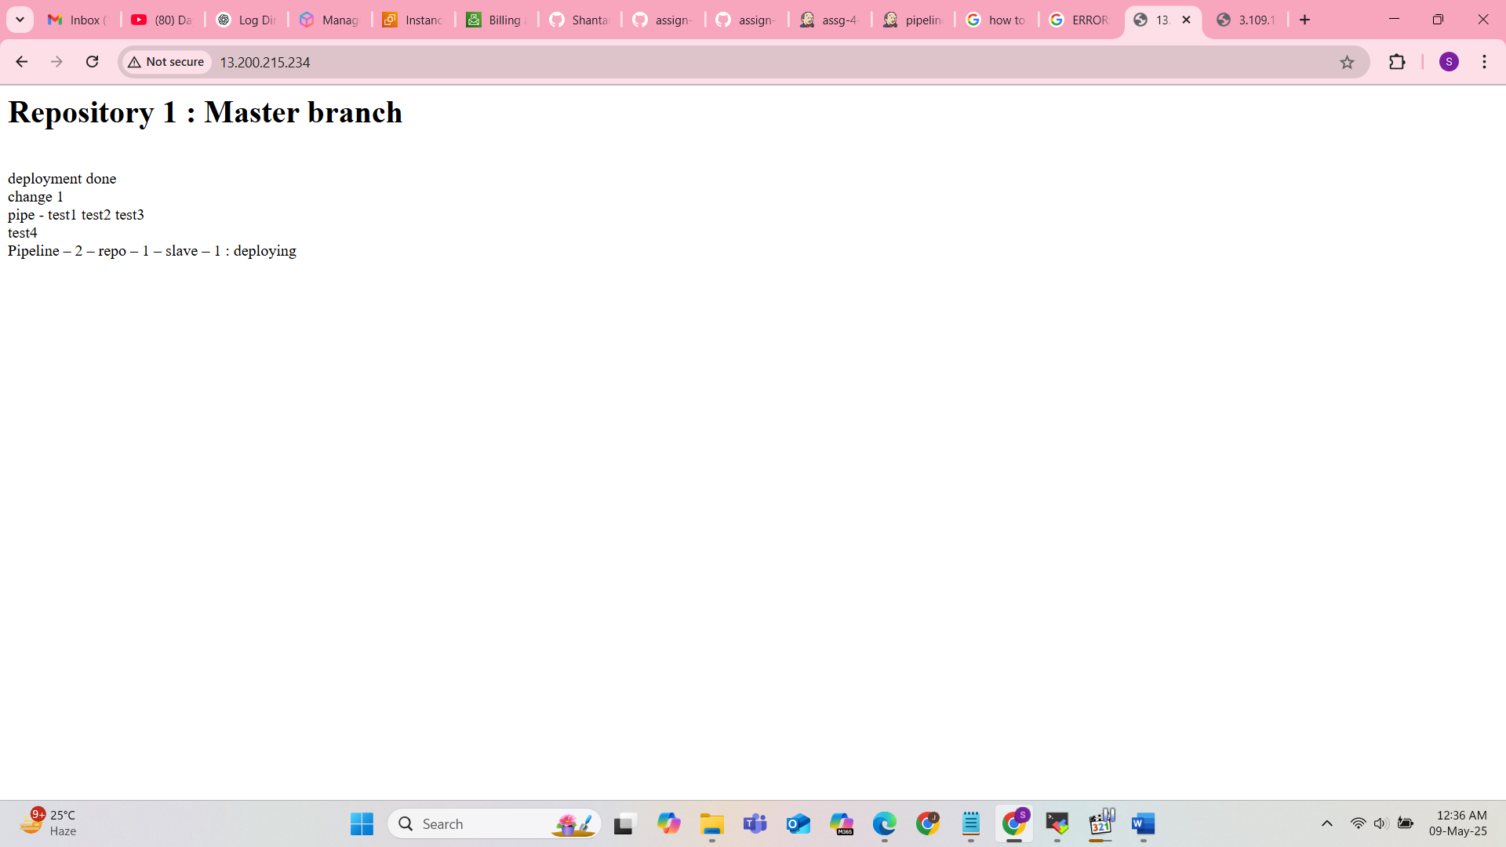

**Pipeline – 1 – repo – 2 – slave – 2 : installing httpd**

pipeline {

agent {

label "banana"

}

stages {

stage("install-httpd") {

steps {

sh "sudo yum install httpd -y"

sh "sudo systemctl start httpd"

}

}

stage ("deploy-httpd-build") {

steps {

build "assg-4-p2-deploy-slave-2"

}

}

}

}

**Pipeline – 2 – repo – 2 – slave – 2 : getting triggered after commit**

Enabled : GitHub hook trigger for GITScm polling

pipeline {

agent {

label {

label "banana"

customWorkspace "assg-4/repo-2/"

}

}

stages {

stage("git-clone") {

steps {

git branch:"master",

url:"https://github.com/SarthakAJ/assign-3-repo-2.git"

}

}

stage("deploy-httpd") {

steps {

sh "cp index.html /var/www/html/"

sh "sudo chmod -R 777 /var/www/html/"

sh "sudo systemctl restart httpd"

}

}

}

}

