Assignment : 12

Build and deploy in slave device

**Pipelilne 1 for installations – JAVA, Tomcat 10**

pipeline {

agent {

label{

label "apple"

customWorkspace "assign-12/"

}

}

stages {

stage ("JAVA"){

steps {sh "sudo yum install java-17-amazon-corretto-devel.x86_64 -y"}

}

stage("tomcat") {

steps {

dir("servers/") {

sh "sudo rm -rf *"

sh 'wget "https://dlcdn.apache.org/tomcat/tomcat-10/v10.1.40/bin/apache-tomcat-10.1.40.zip"'

sh "unzip apache-tomcat-10.1.40.zip"

sh "rm -rf apache-tomcat-10.1.40.zip"

sh "chmod -R 777 apache-tomcat-10.1.40"

sh "sudo bash apache-tomcat-10.1.40/bin/startup.sh"

}

}

}

}

}

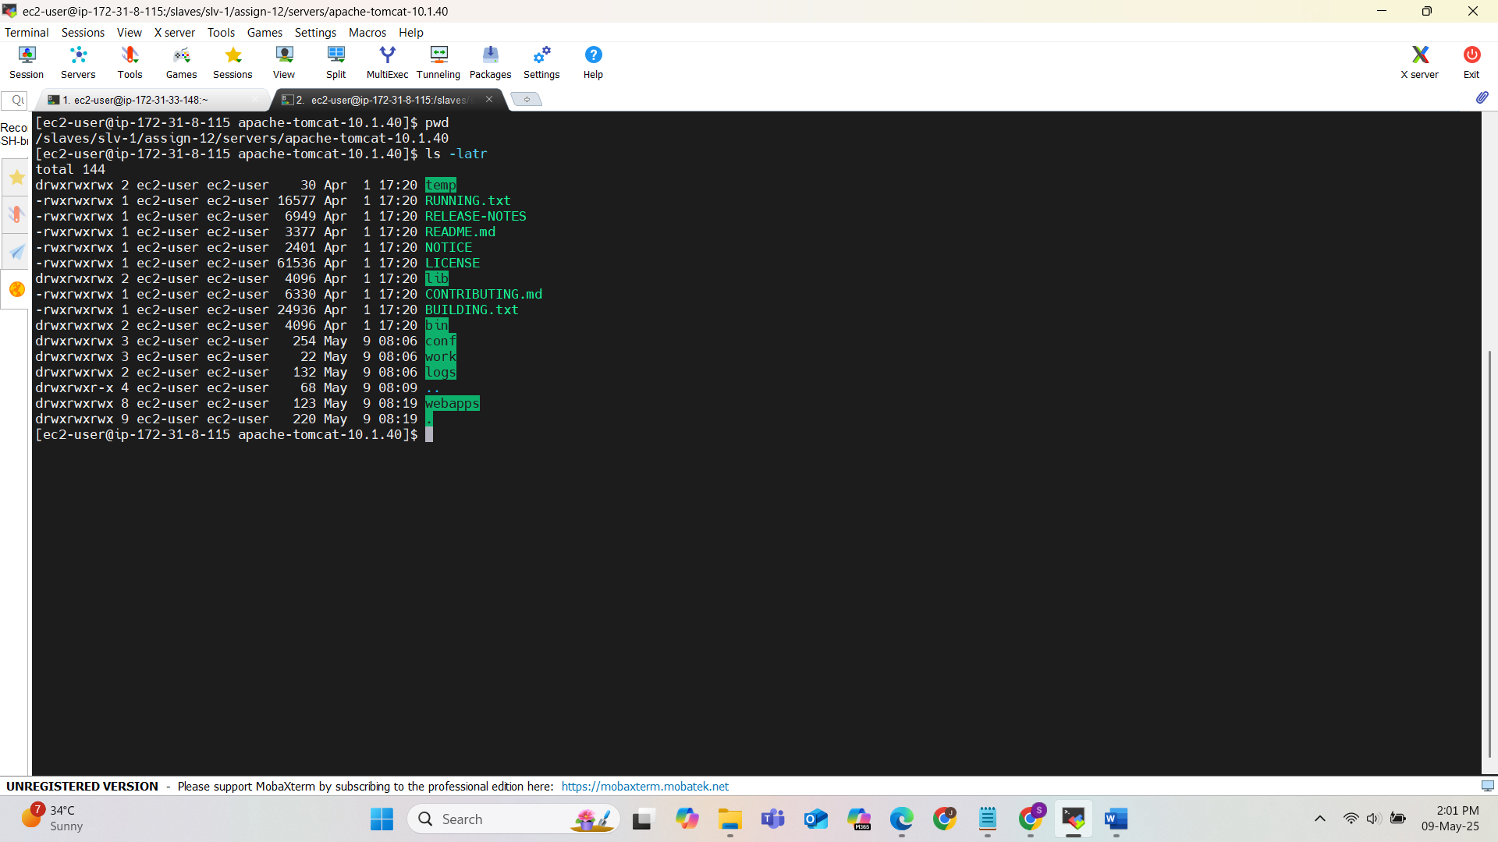

**Jenkins as ec2-user

**Pipelilne 2 for deploying**

pipeline {

agent {

label {

label "apple"

customWorkspace "assign-12/build"

}

}

environment {

MAVEN_HOME = tool 'maven-3.9.9'

PATH = "$MAVEN_HOME/bin:$env.PATH"

}

stages {

stage ("Github-project") {

steps {

git branch : "master",

url : "https://github.com/Shantanumajan6/project.git"

}

}

stage("Build-project") {

steps {

// sh "rm -rf /home/ec2-user/.m2/repository/"

// withMaven (maven : "maven-3.9.9") {

sh "mvn clean install"

// }

}

}

stage("Deploy-on-tomcat") {

steps {

dir("../servers/apache-tomcat-10.1.40/") {

sh "cp ../../build/target/LoginWebApp.war webapps/"

sh "sudo bash bin/shutdown.sh"

sh "sudo bash bin/startup.sh"

}

}

}

}

}

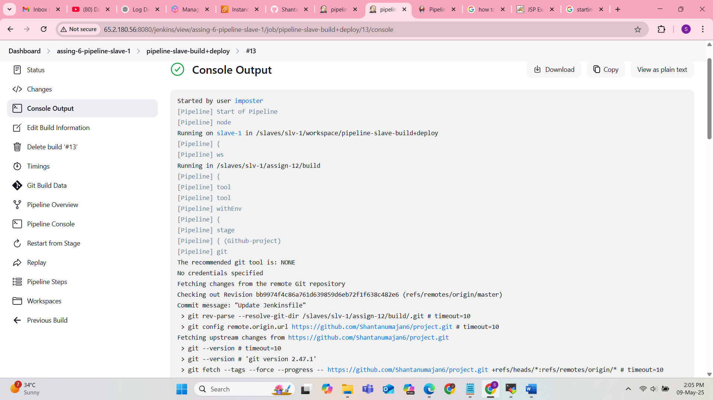

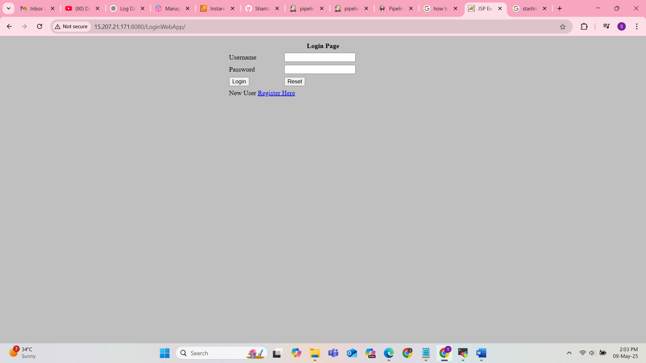

**environment block : setting environment variable for using tool maven configured in Jenkins tool