Assignment 6 :

Build & deploy on slave device

Slave device : slave-2 = label – banana

Job – 1 to install tomcat server with post build action of build & deploy war file on tomcat server

Custom workspace = /project/servers

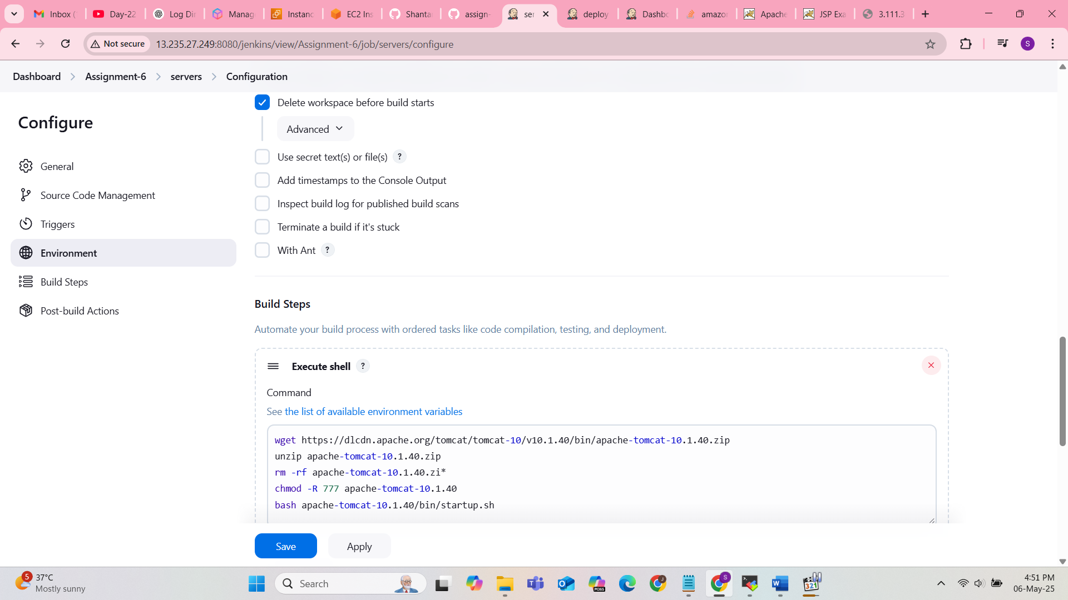

Job – 2 – triggered after installing tomcat server

Custom workspace = /project/build

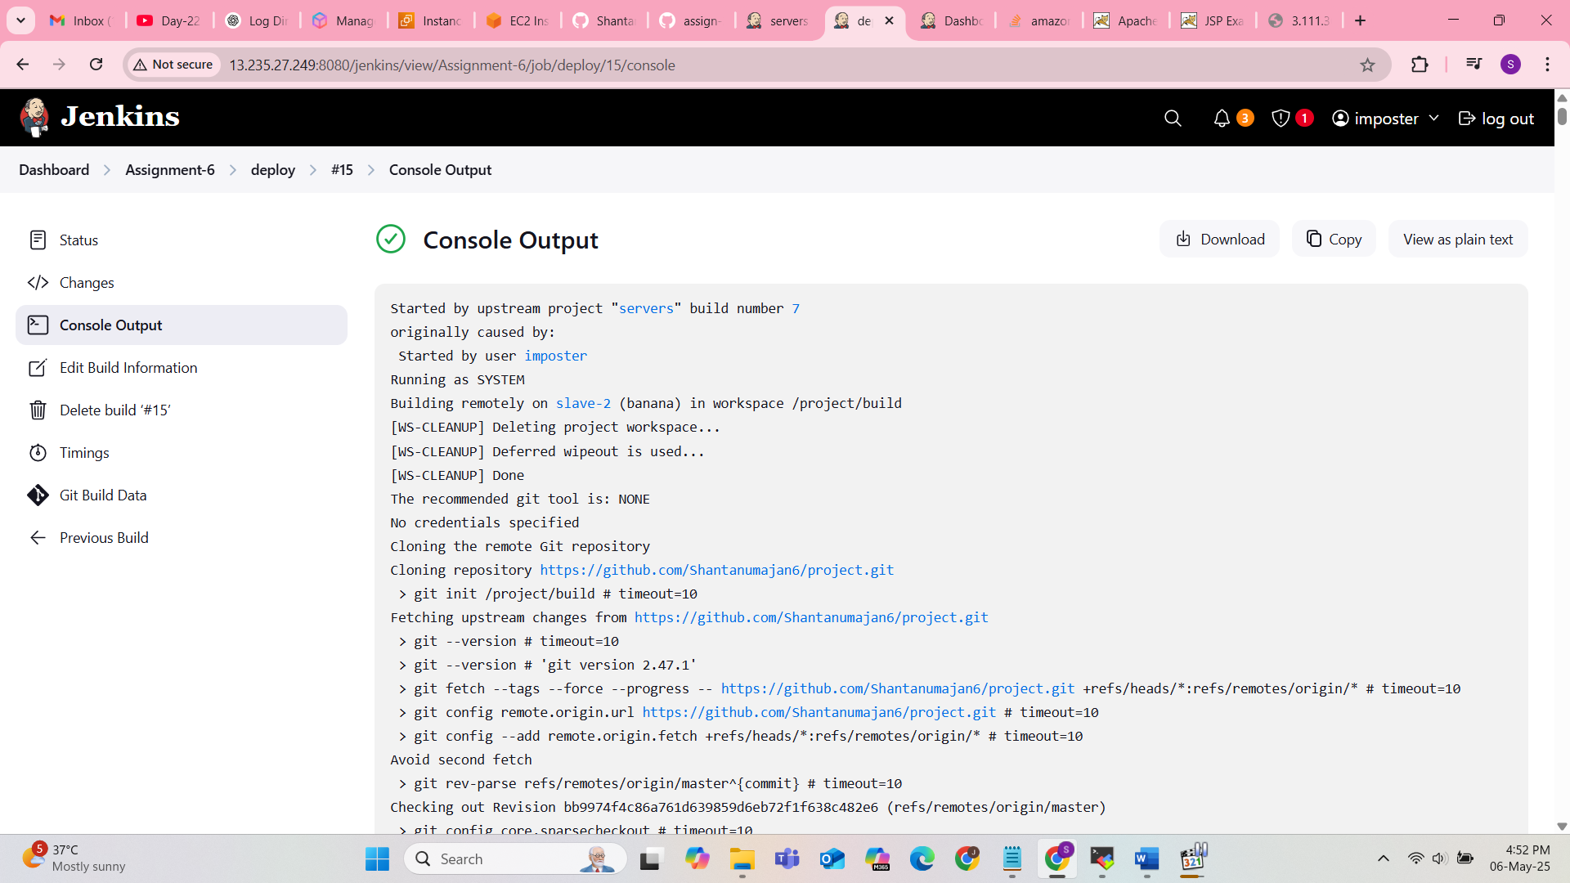

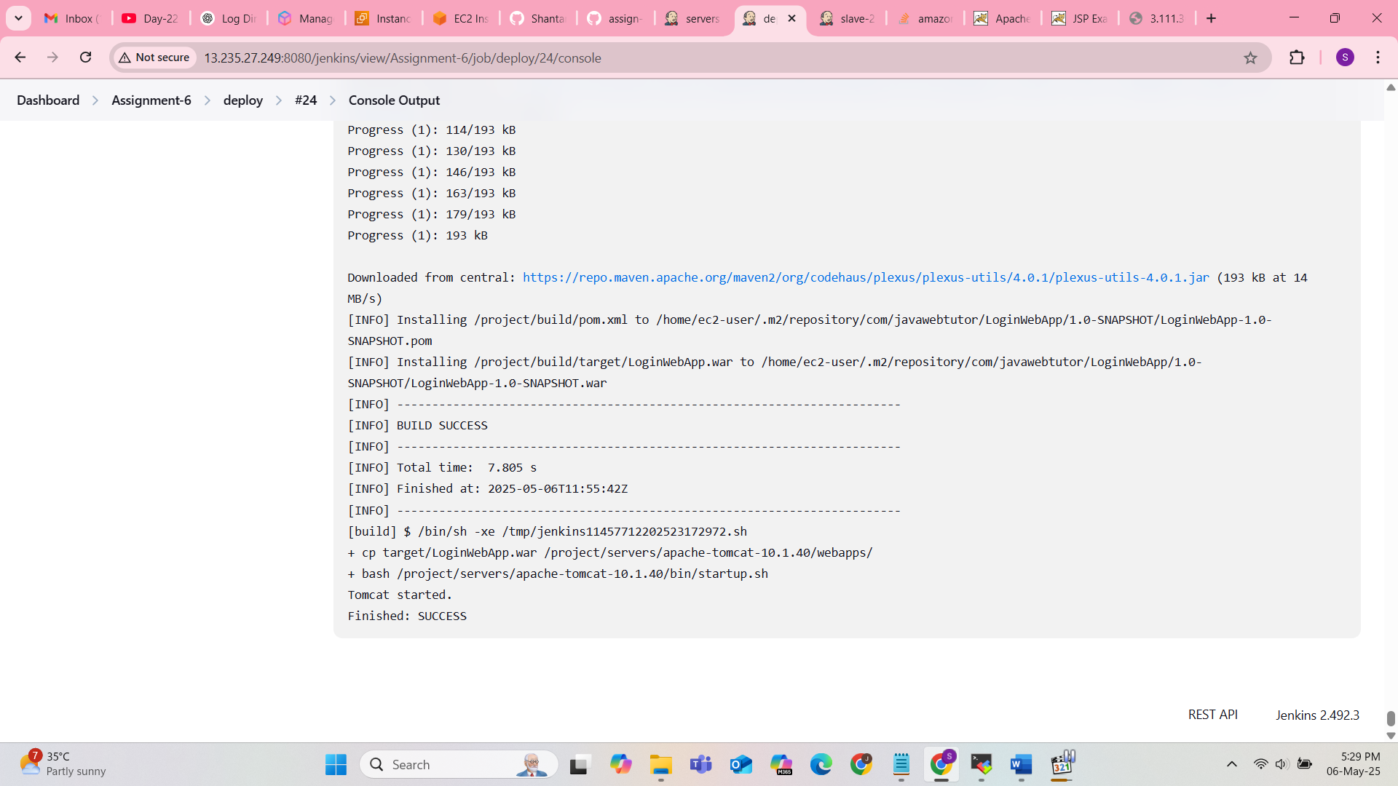

Showing tomcat started but actually it is not getting started

Need to start server manually

Solution : used sudo to start tomcat server in job 1 and job 2

