UnniAcco Internship

REPORT

TOPIC:

**Predictive Modeling for Customer Churn**

**Sarthak Bhalla**

**Manipal University, Jaipur**

INTRODUCTION

Every instance in any dataset used by machine learning algorithms is represented using the same set of features. The features may be continuous, categorical, or binary. If instances are given with known labels (the corresponding correct outputs) then the learning is called supervised , in contrast to unsupervised learning, where instances are unlabeled. There are numerous ML applications involve tasks that can be set up as supervised. In

the present report, we have concentrated on the techniques necessary to do this. This work is concerned with classification problems in which the output of instances admits only discrete, unordered values.

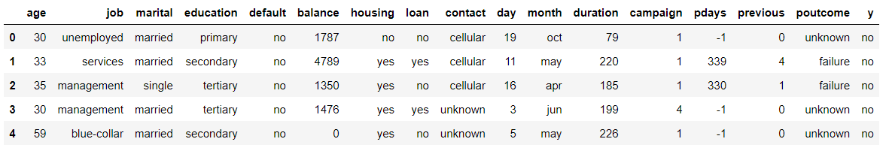

PROCESS

In this project I started with understanding the data-by-data visualization to spot certain trends and see the variables that does not affect the outcome. For example from the graph given below we can conclude that when a client is contacted fewer number of times and longer durations; he is very likely to accept the offer and subscribe to term deposit.

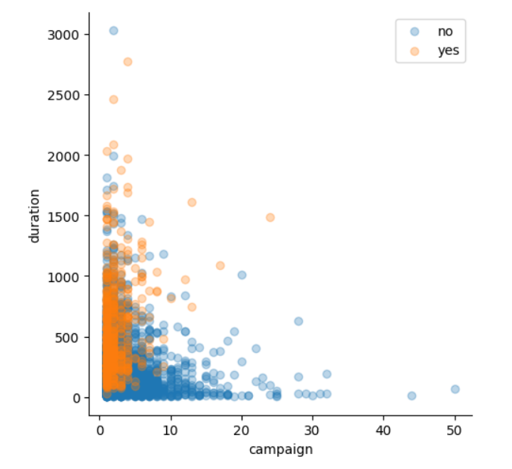

After data visualization , I proceeded with data preprocessing. I applied the label encoder to transform the categorical data to numerical data and then scaled the data using the MinMaxScaler.

After that I go on to building a neural network model and imported other models like SVM, Logistic regression, etc. Then I go on to train the models with training data.

**Results**

The accuracy scores and loss graphs are given below: -

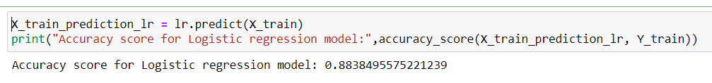

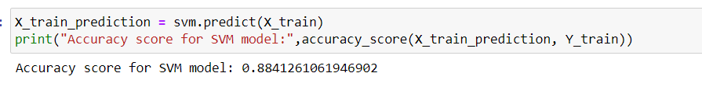

Confusion matrix for the neural network

