UiToRcGenerator
Architecture Deep Dive
From live desktop UI inspection to Visual C++ .RC resource generation

Document version | 1.1 — enhanced edition
Audience | Engineering leads, C++ developers, QA automation, technical stakeholders
Primary scope | Cursor interception, Windows UI Automation, text extraction, OCR fallback, .RC generation
Source basis | HOW_OUR_APP_WORKS_DEEP_DIVE.docx (10 pages)

Purpose
This guide reorganizes the supplied technical deep dive into a more readable engineering document, with end-to-end diagrams, component responsibilities, data flow, fallback behavior, resource-generation rules, and verification notes. The technical details and implementation names below are grounded in the supplied source; where the source makes performance or accuracy claims, they are presented as source-reported claims rather than independently measured guarantees.

Contents
- 1. Executive summary
- 2. System at a glance
- 3. Component architecture and responsibilities
- 4. Windows OS and cross-process UIA flow
- 5. Cursor capture and polling loop
- 6. Resolving text from a UIA element
- 7. Sanitization, deduplication and WPF dispatch
- 8. Generating Visual C++ .RC resources
- 9. Secondary engine: region OCR
- 10. End-to-end operational flow
- 11. Verification, limits and engineering notes
- Appendix A. Source implementation landmarks

1. Executive summary
The application is a real-time, non-invasive desktop UI inspector and resource-script generator. Instead of manually opening dialogs, retyping captions and guessing resource IDs, an engineer hovers over controls in a running desktop application. UiToRcGenerator samples the cursor position, asks Windows UI Automation (UIA) which element lies at that point, resolves readable text through a fallback sequence, filters repeated or noisy strings, and updates a Visual C++ .RC preview.
The supplied source describes the primary flow as UIA-first, with a separate OCR watcher for regions that do not expose useful UIA elements. The result is a captured list of strings and metadata that can be formatted into a STRINGTABLE and validated before export.

What the application does
- Reads the desktop cursor position using Win32 GetCursorPos through P/Invoke.
- Queries UI Automation with AutomationElement.FromPoint(X, Y).
- Reads properties such as Name, ControlType, HelpText, ValuePattern value and bounding rectangle.
- Uses a multi-stage fallback when the element's Name is empty.
- Removes system noise and repeated hover results, then dispatches new items safely to the WPF UI thread.
- Generates and validates Visual C++ .RC resource text, preserving accelerator markers such as &File and shortcuts such as \tCtrl+S.
- Provides region OCR using Windows.Media.Ocr or Tesseract when the selected UI region is not exposed usefully through UIA.

Important distinction
UIA does not mean reading the target application's private memory or source code. It asks the Windows accessibility layer for the information that a UI provider—or a Windows-provided proxy for supported legacy controls—makes available. If a custom-drawn control exposes no readable accessibility information, the primary path may not retrieve its text; the source's region OCR watcher exists for these cases.

2. System at a glance
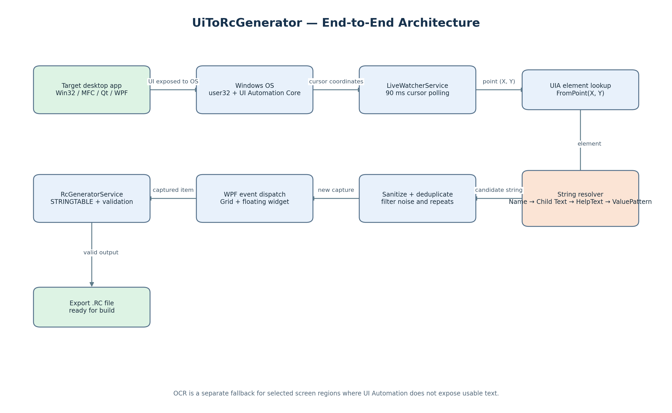
Figure 1. The main data path from a target application through Windows, the watcher and UIA resolver, into the WPF capture list and RC generator.
Layer | Responsibility | Key source components / APIs
Target application | Displays the control or UI element being inspected | Win32, MFC, Qt, WPF, Chromium and other desktop UI frameworks
Windows OS | Maintains cursor/window state and brokers accessibility queries | user32.dll, UIAutomationCore.dll, COM
Capture loop | Polls cursor position and coordinates inspection | LiveWatcherService; GetCursorPos; Task.Run; CancellationToken
Element resolution | Finds the UIA element and resolves a string | AutomationElement.FromPoint; Name / child Text / HelpText / ValuePattern
Capture hygiene | Cleans, filters and deduplicates results | CleanInsightPrefix; _lastUiaHoverText; ExtractedItems
Presentation | Shows captured strings in the WPF interface | StringCaptured event; Dispatcher.InvokeAsync; MainWindow; floating widget
Resource generation | Builds and validates .RC text | RcGeneratorService; STRINGTABLE; ValidateItems()
Fallback OCR | Reads text from selected screen regions where UIA is insufficient | ScreenCaptureService; ImagePreprocessingService; WindowsMediaOcrEngine; TesseractOcrEngine

3. Component architecture and responsibilities
The supplied project layout separates data models, services and views. This separation helps keep capture mechanics, text interpretation, UI presentation and resource generation from becoming one monolithic component.
Project area | File / component | Role described by the source
Models | ExtractedTextItem.cs | Data model for a captured UI control and string.
Models | PreprocessingOptions.cs | Configuration for contrast, binarization and scaling.
Models | AccuracyEvaluationResult.cs | Levenshtein distance and string-similarity metrics.
Services | LiveWatcherService.cs | Core engine: cursor polling, UIA inspection and OCR watcher.
Services | GlobalHotkeyManager.cs | Registers Win32 global hotkeys; source names Ctrl+Shift+H and F8.
Services | RcGeneratorService.cs | Generates and validates Visual C++ .RC syntax.
Services | ScreenCaptureService.cs | Low-level GDI+ screen/window bitmap capture.
Services | ImagePreprocessingService.cs | Enhances bitmap input for OCR fallback.
Services | WindowsMediaOcrEngine.cs | Windows.Media.Ocr engine, described as hardware-accelerated in the source.
Services | TesseractOcrEngine.cs | Offline Tesseract 5 OCR engine.
Views | MainWindow.xaml (.cs) | Main studio window with live table and code editor.
Views | HoverRecordingWidget.xaml | Floating semi-transparent recording-status widget.

Architecture boundaries
- Capture boundary: turns a physical cursor point into a candidate UI element.
- Extraction boundary: turns an element's accessibility properties into a text candidate.
- Quality boundary: cleans and deduplicates text before it becomes a captured item.
- Presentation boundary: marshals background-thread events onto the WPF dispatcher.
- Output boundary: converts captured items to resource-script syntax and validates them.
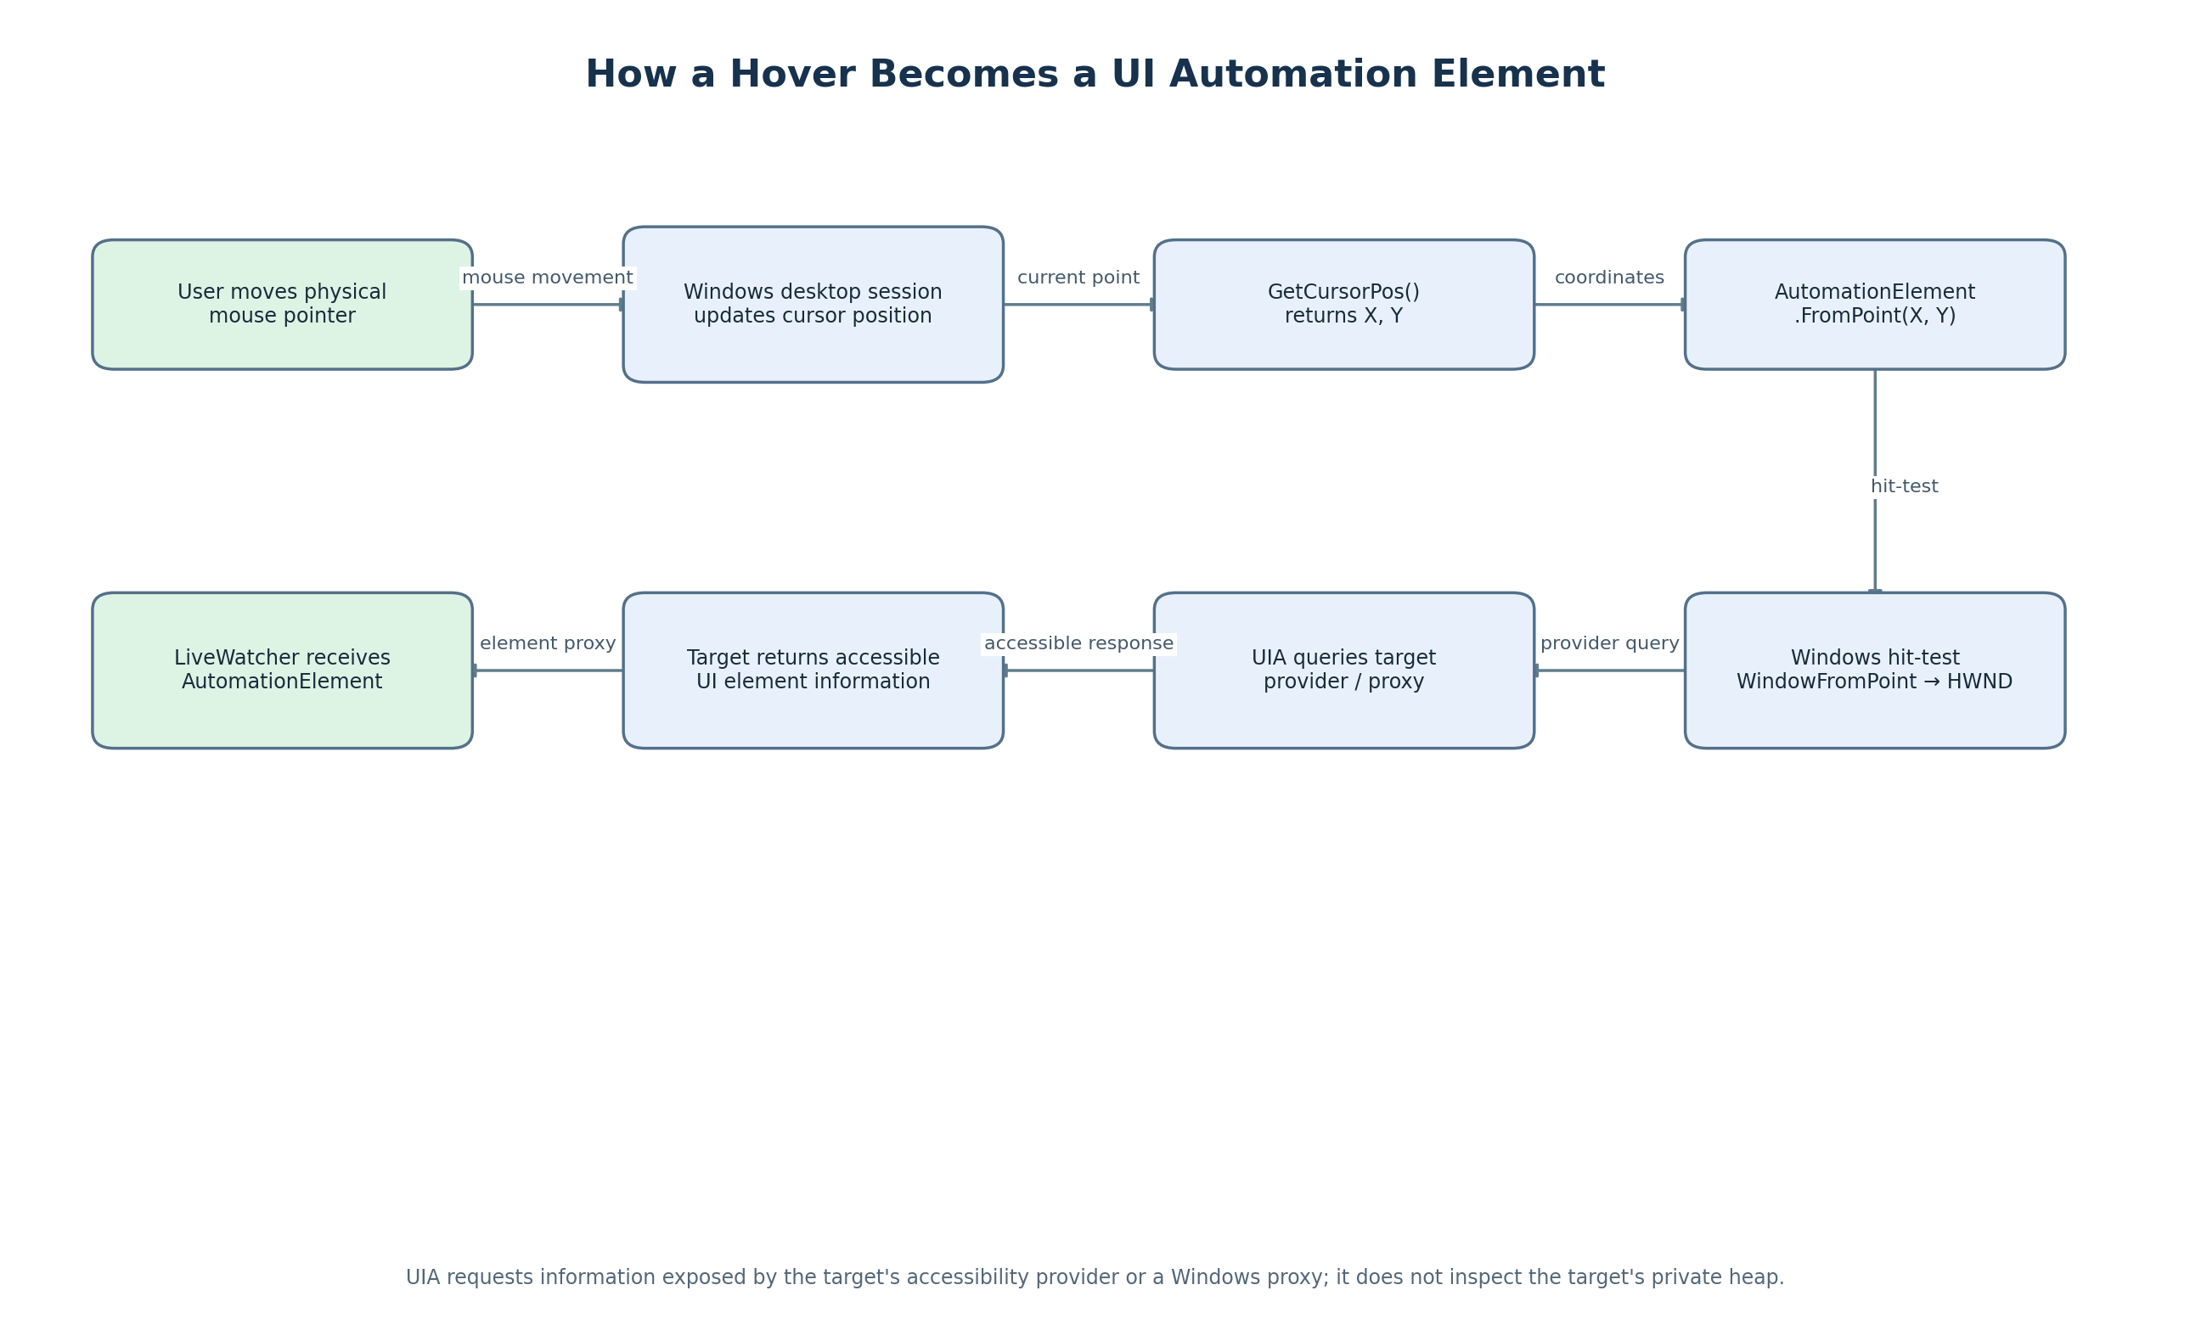
Figure 2. Conceptual sequence for cursor position → UIA lookup → returned element. The target app is queried through the Windows accessibility architecture, not by scanning its source code.

4. How Windows OS and UI Automation are involved
The source explains that ordinary desktop processes run in isolated user-mode address spaces. One application cannot simply inspect another application's private heap to discover its buttons. Windows provides the user subsystem for window and cursor operations, plus the UI Automation architecture for accessibility and automation clients.
Subsystem | Role in this application
Mouse / desktop session | Updates the desktop cursor position as the user moves the mouse.
user32.dll | Provides GetCursorPos and window-related APIs; the source also mentions RegisterHotKey.
UIAutomationCore.dll | Coordinates UIA hit-testing and accessibility queries.
UIA provider or proxy | Exposes element properties from the target application. A legacy Win32 proxy may bridge standard controls.
COM cross-process calls | Allows the UIA client to query the target-side accessibility provider across process boundaries.

Provider and client roles
- Target application / provider: exposes UI information through its native accessibility support, or through a Windows proxy for supported standard controls.
- UiToRcGenerator / client: uses System.Windows.Automation to request element properties.
- The returned AutomationElement is a client-side representation/proxy of an element in the target UI tree.

What UIA can and cannot promise
UIA can return only information made available by the target's provider or a supported proxy. The source describes broad framework coverage, but actual behavior depends on the particular control, its accessibility implementation, runtime state, permissions and whether the control is custom-rendered. The document's mention of a proxy should not be read as a guarantee that every legacy or custom control is fully inspectable.
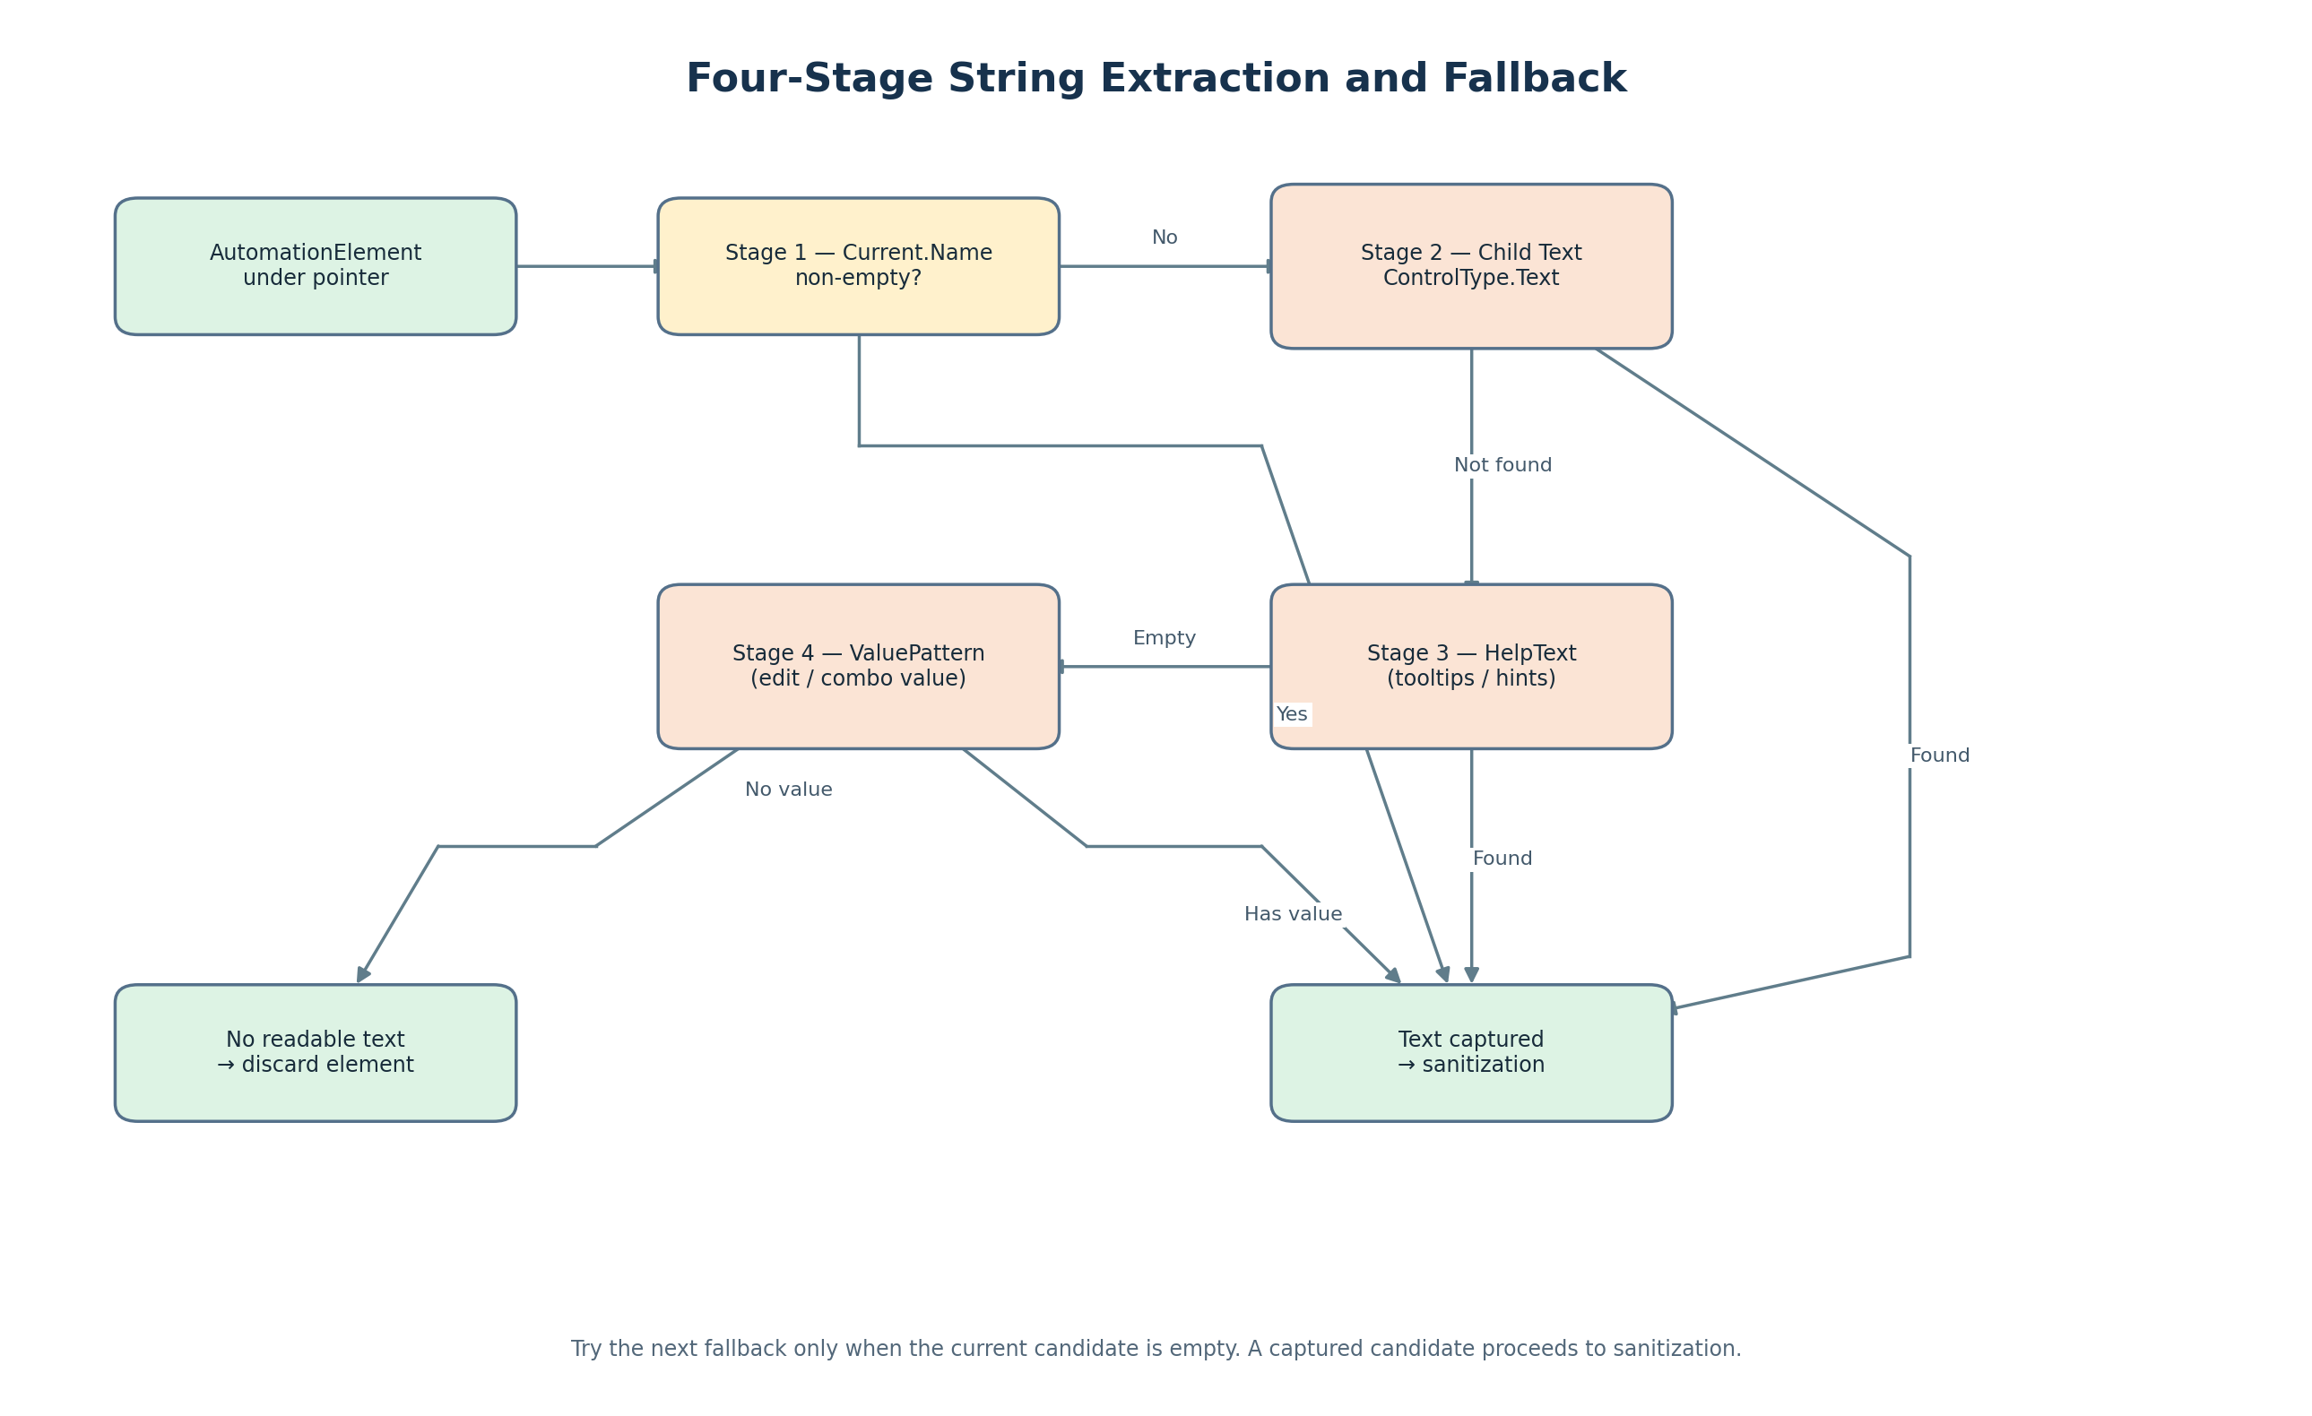

5. Cursor capture and polling loop
The source uses a native Win32 call through P/Invoke to retrieve the current desktop cursor coordinates. This is intended to work while the pointer is over another application's window, unlike WPF MouseMove or MouseEnter events that apply to the application's own window.

API shape shown in the source
[DllImport("user32.dll")]
private static extern bool GetCursorPos(out POINT lpPoint);

[StructLayout(LayoutKind.Sequential)]
private struct POINT
{
public int X;
public int Y;
}

Polling model
while (!token.IsCancellationRequested)
{
if (GetCursorPos(out POINT currentPos))
{
var point = new System.Windows.Point(currentPos.X, currentPos.Y);
// Process point...
}
await Task.Delay(90, token);
}

Source-reported design detail | Meaning
90 ms delay | Approximately 11 polling cycles per second.
Task.Run + CancellationToken | Runs the watcher asynchronously and gives it a cancellation path.
GetCursorPos | Reads the desktop cursor point even when it is over the target application.
Global hotkeys | The source lists Ctrl+Shift+H and F8 through GlobalHotkeyManager.
Performance claims | The source reports under 0.1% idle CPU and calls the delay imperceptible; these are source claims, not independently verified measurements.

Why not use a low-level mouse hook?
The source says it avoids WH_MOUSE_LL hooks because they can introduce latency or stuttering and may trigger antivirus false positives. Its chosen design polls the current cursor position instead of intercepting every mouse packet. This is the rationale stated in the source.

Engineering considerations
- The watcher should stop cleanly when cancellation is requested.
- UIA queries can take longer than a polling interval for some controls; avoid allowing slow queries to create overlapping work.
- Coordinate spaces and display scaling should be tested on multi-monitor and high-DPI configurations.
- The source's performance numbers should be validated with profiling on representative target applications.

6. Resolving text from a UIA element
Once the point is passed to AutomationElement.FromPoint, the watcher receives an element representing the UI node under the cursor. The source describes a fallback pipeline because not every control exposes its visible text through the Name property.
Order | Property / approach | When it helps | Outcome
1 | element.Current.Name | Default accessible name is present. | Use trimmed Name.
2 | FindFirst(TreeScope.Children, ControlType.Text) | A control contains a child Text element while its own Name is empty. | Use childText.Current.Name.
3 | element.Current.HelpText | Text is exposed as a tooltip or accessibility hint. | Use trimmed HelpText.
4 | ValuePattern.Current.Value | Editable or combo-like control exposes its value through a supported pattern. | Use trimmed Value.
Fallback | No readable candidate | All candidate properties are empty or unavailable. | Discard the element.

Implementation excerpt
name = element.Current.Name?.Trim() ?? string.Empty;
ctrlType = element.Current.ControlType.LocalizedControlType;

if (string.IsNullOrWhiteSpace(name))
{
var textChild = element.FindFirst(
TreeScope.Children,
new PropertyCondition(AutomationElement.ControlTypeProperty,
ControlType.Text));
if (textChild != null)
name = textChild.Current.Name?.Trim() ?? string.Empty;
}

if (string.IsNullOrWhiteSpace(name))
name = element.Current.HelpText?.Trim() ?? string.Empty;

if (string.IsNullOrWhiteSpace(name))
{
if (element.TryGetCurrentPattern(ValuePattern.Pattern, out object patternObj)
&& patternObj is ValuePattern valPattern)
name = valPattern.Current.Value?.Trim() ?? string.Empty;
}

Other UIA properties used
Property | Example from source | Potential use in the capture pipeline
Name | &Save Project...\tCtrl+S | Primary text candidate.
ControlType | MenuItem / button | Describes the control; can inform interpretation/output.
LocalizedControlType | menu item / button | Human-readable control descriptor.
BoundingRectangle | X, Y, width, height | Associates the capture with a screen/dialog region.
ProcessId | 14280 | Helps confirm the target process.
RuntimeId | [42, 189024] | Identifies an element instance within a UI session.

The examples above reproduce the kinds of values shown in the supplied source. Runtime IDs and process IDs are examples, not fixed identifiers.

7. Sanitization, deduplication and WPF dispatch
The source filters raw strings before they enter the generator. This matters because the watcher samples repeatedly, and a pointer may remain over the same control for many cycles.

7.1 Noise filtering
- Discard elements named "Desktop", empty values, taskbars and single punctuation marks.
- Apply a minimum string length threshold of at least two characters.
- Trim extracted candidates before comparing or storing them.

7.2 Accessibility-inspector prefix cleaner
The source describes strings that may arrive in diagnostic forms such as Name: "Save" or Text = "Open". CleanInsightPrefix uses a regular expression to extract the value or strip a recognized prefix.
public static string CleanInsightPrefix(string text)
{
var match = Regex.Match(text,
@"(?:Name|Text)\s*[:=]\s*""?([^""\r\n]+)""?",
RegexOptions.IgnoreCase);
if (match.Success) return match.Groups[1].Value.Trim();
return Regex.Replace(text, @"^(?:Name|Text|Label)\s*[:=]\s*", "",
RegexOptions.IgnoreCase).Trim(' ', '"');
}

7.3 Two layers of deduplication
Layer | Mechanism | Purpose
Immediate hover deduplication | Compare with _lastUiaHoverText. | Ignore repeated results from consecutive polling cycles over the same text.
Collection-level deduplication | If ChkAutoDeduplicate is enabled, check ExtractedItems.Any(...). | Avoid adding a string that is already present in the captured collection and reduce duplicate resource IDs.

7.4 Event dispatch to WPF
LiveWatcherService runs on a background worker thread. The source says it raises StringCaptured and marshals the collection update to the WPF UI thread using Dispatcher.InvokeAsync. The handler creates an ExtractedTextItem, assigns order and ID, carries text/control type/confidence/geometry, adds it to ExtractedItems and regenerates the preview.
Dispatcher.InvokeAsync(() =>
{
var newItem = new ExtractedTextItem
{
Order = ExtractedItems.Count + 1,
Id = $"{prefix}{ExtractedItems.Count + 1}",
Text = text,
ControlType = e.ControlType,
Confidence = 100.0,
X = e.Region?.X ?? 0,
Y = e.Region?.Y ?? 0,
Width = e.Region?.Width ?? 100,
Height = e.Region?.Height ?? 24
};
ExtractedItems.Add(newItem);
UpdateRcPreview();
});

The source assigns Confidence = 100.0 in this event path. That field value should not automatically be interpreted as a calibrated statistical confidence score unless the application defines it that way elsewhere.

8. Generating Visual C++ .RC resources
The generator converts captured strings into resource-script entries. In the Visual C++ workflow described by the source, rc.exe compiles .RC scripts into binary .res resources. The syntax is strict, so quoting, IDs and formatting must be checked before export.
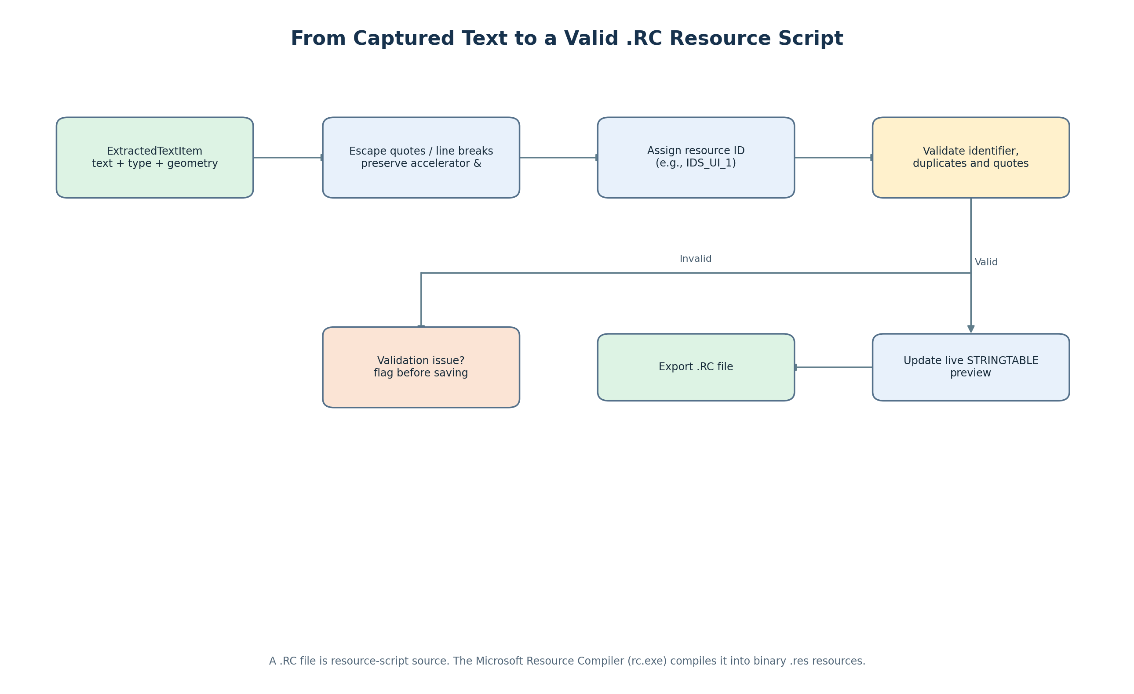

8.1 Formatting rules
- Escape embedded double quotes according to the resource-compiler conventions used by the generator (the source mentions "" or \" as forms to handle).
- Convert line breaks to the intended escaped line-break representation, such as \n or \r\n.
- Preserve ampersands used for keyboard accelerators: &File, Save &As..., E&xit.
- Preserve tab-delimited shortcuts such as \tCtrl+O or \tCtrl+S.

8.2 Representative STRINGTABLE
// Microsoft Visual C++ generated resource script.
#include "resource.h"
#define APSTUDIO_READONLY_SYMBOLS
#include <afxres.h>
#undef APSTUDIO_READONLY_SYMBOLS

LANGUAGE LANG_ENGLISH, SUBLANG_ENGLISH_US
#pragma code_page(1252)

/////////////////////////////////////////////////////////////////////////////
// String Table
STRINGTABLE
BEGIN
IDS_UI_1 "&File"
IDS_UI_2 "&Open Project...\tCtrl+O"
IDS_UI_3 "&Save"
IDS_UI_4 "Save &As..."
IDS_UI_5 "Export to DXF/DWG"
IDS_UI_6 "E&xit"
END

8.3 Validation before export
Validation | Rule described in source | Why it matters
Identifier verification | IDs must match ^[A-Za-z_][A-Za-z0-9_]*$. | Prevents malformed resource identifiers.
Duplicate ID detection | Flag collisions before compilation. | Prevents multiple entries from reusing an identifier unintentionally.
Format checking | Validate opening and closing quotes. | Catches common script syntax errors before build.

The supplied source names RcGeneratorService.ValidateItems() as the automatic linting step. It also says unit tests validate coordinate conversion, string escaping, regex cleaner patterns and .RC syntax compilation.

9. Secondary engine: region OCR
Direct UIA hover is the primary engine in the supplied design. The source identifies custom graphics viewports—such as custom OpenGL rendering, DirectX canvases and legacy bitmapped controls—as cases where UIA nodes may be missing or unhelpful. For those cases, the application includes a Live Region OCR Watcher.
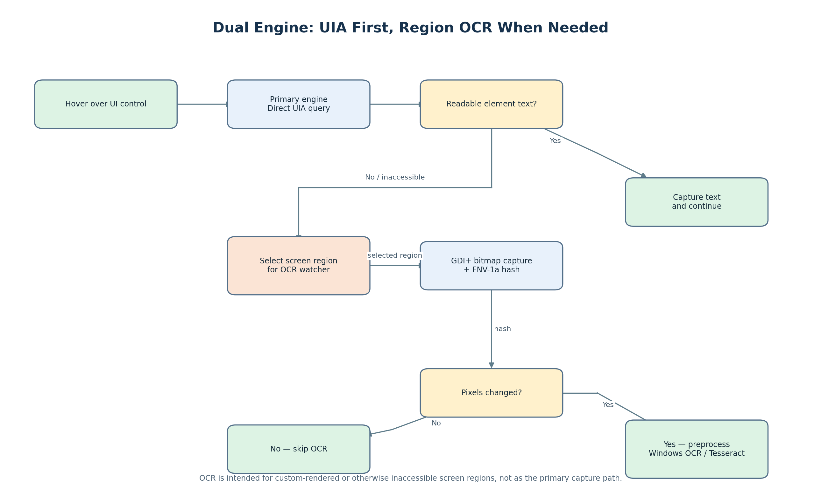

OCR processing sequence
- The user selects a bounding region to watch.
- ScreenCaptureService captures the region as a GDI+ bitmap.
- The watcher computes a 64-bit FNV-1a hash over raw bitmap memory.
- If the hash is unchanged, OCR is skipped to avoid repeating work on identical pixels.
- If pixels changed, ImagePreprocessingService applies the configured enhancement path; the source mentions adaptive thresholding and 2× scaling.
- The OCR engine—Windows.Media.Ocr or Tesseract 5—recognizes text.
- The recognized text is passed through the Insight-prefix cleaner and into the appropriate capture flow.

Hashing excerpt from the source
BitmapData data = bmp.LockBits(rect, ImageLockMode.ReadOnly,
PixelFormat.Format32bppArgb);
ulong hash = 14695981039346656037UL; // FNV-1a offset
byte* ptr = (byte*)data.Scan0.ToPointer();
for (int i = 0; i < totalBytes; i += 4) {
hash ^= ptr[i];
hash *= 1099511628211UL;
}

The source states that unchanged pixel hashes bypass OCR and keep CPU use near zero for those unchanged frames. Hashing is an optimization, not a guarantee that changed pixels contain changed text or that every text change will be recognized correctly.

Primary UIA vs. OCR fallback
Dimension | Direct UIA hover | Region OCR watcher
Input | Cursor point over an exposed UI element. | User-selected screen bounding region.
Read mechanism | Accessibility properties from UIA element. | Pixels captured as bitmap, then OCR.
Best fit | Controls exposing useful Name, HelpText, ValuePattern or child text. | Custom-rendered or inaccessible regions where UIA cannot provide readable text.
Main dependency | Target provider / Windows proxy exposes useful semantics. | Text is visually legible and preprocessing/OCR can recognize it.
Optimization | Repeated hover text is deduplicated. | Pixel hash skips OCR when the bitmap has not changed.
Failure mode | Element missing, properties empty, or text not exposed. | Low visual quality, scaling, ambiguous glyphs, or text outside the selected region.

10. End-to-end operational flow
This combined flow brings together the primary hover path, extraction fallbacks, capture hygiene and resource generation described across the source document.
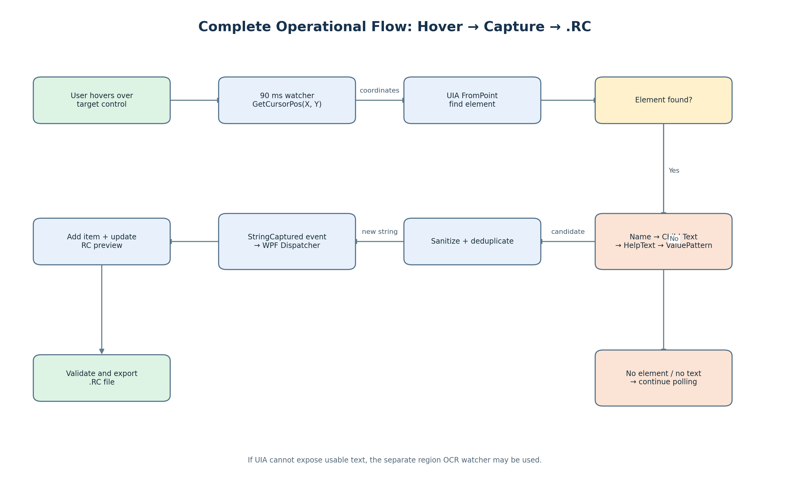

Operational narrative
- The user activates recording / watching (the source lists Ctrl+Shift+H and F8 as global hotkeys).
- LiveWatcherService repeatedly obtains the current desktop point through GetCursorPos.
- AutomationElement.FromPoint asks UIA for the element under the point.
- If an element is found, the string resolver tries Name, child Text, HelpText and ValuePattern in order.
- The candidate is trimmed, cleaned, filtered and compared with prior captures.
- A new capture is packaged and dispatched to the WPF UI thread.
- The captured item appears in the live table and preview; RcGeneratorService formats the resource entry.
- Validation checks IDs, duplicates and quote formatting before the user exports the .RC script.
- If UIA cannot expose text in a custom-rendered region, the separate region OCR watcher may be used.

11. Verification, limitations and engineering notes

Verification listed in the supplied source
- Unit tests are located in UiToRcGenerator.Tests/.
- The source says tests validate coordinate conversion, string escape mechanics, regex cleaner patterns and .RC syntax compilation.
- Reference-template compatibility is described as validated against existing production resource files such as 2dTransRes.rc.

Practical test matrix recommended for engineering review
Test area | Scenarios to cover | Expected observation
Cursor tracking | Own app, another app, multi-monitor, high-DPI displays | Coordinates consistently identify the hovered point.
UIA coverage | Standard Win32/MFC controls, WPF, Qt and custom-drawn controls | Readable properties are returned where the target exposes them; unsupported controls are identified.
Fallback order | Empty Name with child Text, HelpText or ValuePattern | First usable fallback wins; empty candidates are discarded.
Noise and duplicates | Repeated hover, punctuation, Desktop/taskbar, same string on different controls | Noise is filtered; duplicate policy behaves as configured.
Threading | Rapid captures while preview updates | WPF collection changes occur on the UI dispatcher without cross-thread errors.
RC formatting | Quotes, ampersands, tabs, line breaks, Unicode and long strings | Generated script preserves intended text and compiles.
Validation | Invalid IDs, duplicate IDs, malformed quotes | Issues are reported before export/build.
OCR fallback | Unchanged region, changed region, low contrast, scaled text, custom viewport | Hash avoids redundant OCR; changed regions are processed and accuracy is assessed.
Lifecycle | Start, stop, cancel, switch target window | Polling stops cleanly and does not continue after cancellation.

Claims that should be treated carefully
- The source uses phrases such as “100% string capture accuracy,” “Instant 100% Accurate String,” and “95% of standard applications.” These are statements in the supplied document, not evidence of a universal guarantee; actual accuracy should be measured against a representative test set.
- The source's <0.1% idle CPU and near-zero OCR CPU statements should be confirmed with profiling in the intended environment.
- A UIA element's Name is an accessibility property, not necessarily a perfect copy of the pixels displayed on screen. It may be absent, stale, localized differently, or semantically different from visible text.
- OCR is a visual fallback, so its output should be reviewed for ambiguous characters, accelerator markers, punctuation and keyboard shortcuts.
- The source's example Confidence = 100.0 is an assigned field value in the shown event handler; do not assume it reflects measured extraction certainty without additional implementation evidence.

Recommended engineering acceptance criteria
- Document supported target application types and known unsupported controls.
- Record extraction provenance per item (UIA Name, child Text, HelpText, ValuePattern or OCR) to make review and debugging easier.
- Measure precision, recall and exact-text accuracy separately for UIA and OCR test sets.
- Add explicit handling/logging for UIA exceptions, stale elements, empty properties and target-window changes.
- Validate .RC output with the actual resource compiler in CI or a controlled test harness, not only string-level checks.
- Test international characters and code-page settings; the source example uses #pragma code_page(1252), so encoding expectations should be confirmed for target languages.
- Define duplicate policy carefully: identical strings can legitimately appear on multiple controls, while resource-ID collisions are a separate validation concern.

Appendix A. Source implementation landmarks
Source file / symbol | Where it fits
LiveWatcherService.cs | Cursor polling, UIA lookup, string resolver, OCR watcher and captured-string event path.
GlobalHotkeyManager.cs | Win32 global hotkey registration; source lists Ctrl+Shift+H and F8.
RcGeneratorService.cs | Resource-script generation and ValidateItems() linting.
ScreenCaptureService.cs | GDI+ bitmap capture for the OCR watcher.
ImagePreprocessingService.cs | Contrast, binarization, scaling and OCR input enhancement.
WindowsMediaOcrEngine.cs | Windows OCR implementation.
TesseractOcrEngine.cs | Offline Tesseract 5 implementation.
ExtractedTextItem.cs | Captured item data: order, ID, text, control type, confidence and region geometry.
PreprocessingOptions.cs | OCR preprocessing configuration.
AccuracyEvaluationResult.cs | Levenshtein distance and string-similarity metrics.
MainWindow.xaml (.cs) | Live table, code editor, preview and UI dispatch integration.
HoverRecordingWidget.xaml | Floating recording-status widget.
UiToRcGenerator.Tests/ | Unit tests described by the source.
2dTransRes.rc | Example production resource file used for compatibility validation.

Closing summary
UiToRcGenerator combines desktop coordinate polling, Windows UI Automation, a staged text resolver, sanitization and deduplication, WPF event dispatch, and Visual C++ resource generation. Region OCR extends coverage to UI areas that do not expose useful accessibility properties. The most important engineering boundary is that UIA depends on what the target UI exposes, while OCR depends on what can be read from the selected pixels. Keeping these engines distinct, preserving text semantics such as accelerators, and validating the generated .RC script are central to a dependable workflow.
Source document reviewed: HOW_OUR_APP_WORKS_DEEP_DIVE.docx, 10 pages. This enhanced guide reorganizes and explains its material; no external research was added.

