"Design and Implementation of an 8-bit Booth's Multiplier Using Behavioural Verilog"

**1.Abstract**

The Booth's multiplier is an efficient algorithm for multiplying binary numbers, leveraging the principle of Booth's coding to reduce the number of required addition operations. This Verilog implementation of an 8-bit Booth's multiplier demonstrates a hardware design that performs signed multiplication by simulating Booth's algorithm in a sequential manner. The result is a 16-bit product of two 8-bit signed integers.

**2. Introduction**

Multiplication of binary numbers is a fundamental operation in digital systems, utilized in various applications ranging from arithmetic operations in processors to digital signal processing. Booth's multiplication algorithm optimizes this process by minimizing the number of addition and subtraction operations required. This report provides a detailed overview of the 8-bit Booth's multiplier implemented in Verilog, describing its design, functionality, and efficiency.

**3.History of Booth’s Multiplier**

Booth's algorithm, developed by Andrew Donald Booth in 1950, was initially designed to improve the speed of multiplication operations in computer arithmetic. The algorithm was particularly effective in handling binary numbers with large sequences of zeros and ones, thereby reducing the number of necessary arithmetic operations. Booth's approach to encoding the multiplicand and adjusting the partial products dynamically became a foundation for designing efficient digital multipliers.

**4.Algorithm**

**1)Start**

**2)Accept Inputs**

In1 & in2.

**3)Initialize Registers**

comp2s_In1 = {~In1 + 1'b1, 9'b000000000}.

Accu0 = {In1, 9'b000000000}.

Accu1 = {8'b00000000, In2, 1'b0}.

**4)Loop (i = 0 to 7)**

**Check Accu1[1:0]**

If Accu1[1:0] == 2'b00 or 2'b11:

Perform Arithmetic Right Shift: Accu1 = {Accu1[16], Accu1[16:1]}.

If Accu1[1:0] == 2'b01:

Add Accu0 to Accu1: Accu1 = Accu1 + Accu0.

Perform Arithmetic Right Shift: Accu1 = {Accu1[16], Accu1[16:1]}.

If Accu1[1:0] == 2'b10:

Add comp2s_In1 to Accu1: Accu1 = Accu1 + comp2s_In1.

Perform Arithmetic Right Shift: Accu1 = {Accu1[16], Accu1[16:1]}.

Default:

Accu1=17’bxxxxxxxxxxxxxxxxx.

**End Loop**

**5)Set Product**

Product = Accu1[16:1].

**6)End**

**5.Verilog Program (Design Source)**

`timescale 1ns / 1ps

module Booths_Multiplier_8bit(clk,Product,In1,In2);

input clk;

input [7:0]In1;

input [7:0]In2;

output reg [15:0]Product;

integer i;

reg [16:0]comp2s_In1,Accu0,Accu1;

always @ (posedge clk) // Positive edge triggred operations

begin

comp2s_In1 = {~In1 + 1'b1,9'b000000000}; // 2s complement of In1

Accu0 = {In1,9'b000000000};

Accu1 = {8'b00000000,In2,1'b0};

for(i=0; i<8; i=i+1)

begin

case(Accu1[1:0])

2'b00: Accu1 = {Accu1[16], Accu1[16:1]}; // Performing Signed right shift

2'b01: begin

Accu1 = Accu1 + Accu0;

Accu1 = {Accu1[16],Accu1[16:1]}; // Performing Signed right shift

end

2'b10: begin

Accu1 = Accu1 + comp2s_In1;

Accu1 = {Accu1[16],Accu1[16:1]}; // Performing Signed right shift

end

2'b11: Accu1 = {Accu1[16], Accu1[16:1]}; // Performing Signed right shift

default : Accu1 = 17'bxxxxxxxxxxxxxxxxx;

endcase

end // end of the loop

Product = Accu1[16:1];

end // end of always block

endmodule

**6.Test Bench (Simulation Source)**

`timescale 1ns / 1ps

module Booths_Multiplier_8bit_tb();

// Inputs

reg clk;

reg [7:0] In1;

reg [7:0] In2;

// Outputs

wire [15:0] Product;

Booths_Multiplier_8bit dut (clk,Product,In1,In2);

initial begin

// Initialize Inputs

clk = 0;

forever #2 clk =~clk;

end

initial begin

In1 = 8'h04; // In1=4

In2 = 8'h0a; // In2=10

#4

In1 = 1; // In1=1

In2 = -1; // In2=-1

#4

In1 = 8'h06; // In1=6

In2 = 8'h02; // In2=2

#4

In1 = 8'b00000111; // In1=7

In2 = 8'b1000; // In2=8

#4

In1 = 8'h02; // In1=2

In2 = 8'h1a; // In2=26

#4

In1 = 8'h02; //In1=2

In2 = 8'h0b; //In2=11

#4

In1 = 8'h06; //In1=6

In2 = 8'h05; //In2=5

#4

In1 = 10;

In2 = -11;

#4

In1 = -5;

In2 = -5;

#4 $finish;

end

endmodule

**7.Simulation Results**

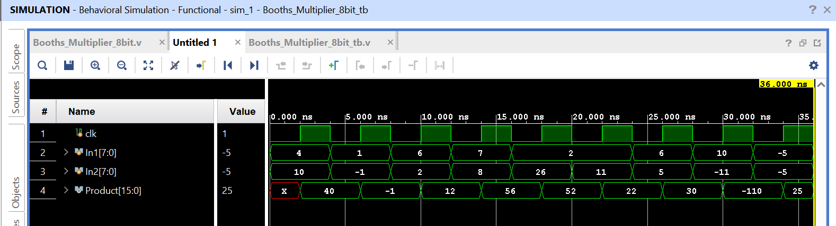

**8.Constraint File (For Artix-7 Nexys 4 DDR)**

#clock

set_property -dict { PACKAGE_PIN E3 IOSTANDARD LVCMOS33 } [get_ports { clk }];

create_clock -add -name sys_clk_pin -period 10.00 -waveform {0 5} [get_ports {clk}];

#Switches

set_property -dict { PACKAGE_PIN J15 IOSTANDARD LVCMOS33 } [get_ports { In1[0] }];

set_property -dict { PACKAGE_PIN L16 IOSTANDARD LVCMOS33 } [get_ports { In1[1] }];

set_property -dict { PACKAGE_PIN M13 IOSTANDARD LVCMOS33 } [get_ports { In1[2] }];

set_property -dict { PACKAGE_PIN R15 IOSTANDARD LVCMOS33 } [get_ports { In1[3] }];

set_property -dict { PACKAGE_PIN R17 IOSTANDARD LVCMOS33 } [get_ports { In1[4] }];

set_property -dict { PACKAGE_PIN T18 IOSTANDARD LVCMOS33 } [get_ports { In1[5] }];

set_property -dict { PACKAGE_PIN U18 IOSTANDARD LVCMOS33 } [get_ports { In1[6] }];

set_property -dict { PACKAGE_PIN R13 IOSTANDARD LVCMOS33 } [get_ports { In1[7] }];

set_property -dict { PACKAGE_PIN T8 IOSTANDARD LVCMOS18 } [get_ports { In2[0] }];

set_property -dict { PACKAGE_PIN U8 IOSTANDARD LVCMOS18 } [get_ports { In2[1] }];

set_property -dict { PACKAGE_PIN R16 IOSTANDARD LVCMOS33 } [get_ports { In2[2] }];

set_property -dict { PACKAGE_PIN T13 IOSTANDARD LVCMOS33 } [get_ports { In2[3] }];

set_property -dict { PACKAGE_PIN H6 IOSTANDARD LVCMOS33 } [get_ports { In2[4] }];

set_property -dict { PACKAGE_PIN U12 IOSTANDARD LVCMOS33 } [get_ports { In2[5] }];

set_property -dict { PACKAGE_PIN U11 IOSTANDARD LVCMOS33 } [get_ports { In2[6] }];

set_property -dict { PACKAGE_PIN V10 IOSTANDARD LVCMOS33 } [get_ports { In2[7] }];

# LEDs

set_property -dict { PACKAGE_PIN H17 IOSTANDARD LVCMOS33 } [get_ports { Product[0] }];

set_property -dict { PACKAGE_PIN K15 IOSTANDARD LVCMOS33 } [get_ports { Product[1] }];

set_property -dict { PACKAGE_PIN J13 IOSTANDARD LVCMOS33 } [get_ports { Product[2] }];

set_property -dict { PACKAGE_PIN N14 IOSTANDARD LVCMOS33 } [get_ports { Product[3] }];

set_property -dict { PACKAGE_PIN R18 IOSTANDARD LVCMOS33 } [get_ports { Product[4] }];

set_property -dict { PACKAGE_PIN V17 IOSTANDARD LVCMOS33 } [get_ports { Product[5] }];

set_property -dict { PACKAGE_PIN U17 IOSTANDARD LVCMOS33 } [get_ports { Product[6] }];

set_property -dict { PACKAGE_PIN U16 IOSTANDARD LVCMOS33 } [get_ports { Product[7] }];

set_property -dict { PACKAGE_PIN V16 IOSTANDARD LVCMOS33 } [get_ports { Product[8] }];

set_property -dict { PACKAGE_PIN T15 IOSTANDARD LVCMOS33 } [get_ports { Product[9] }];

set_property -dict { PACKAGE_PIN U14 IOSTANDARD LVCMOS33 } [get_ports { Product[10] }];

set_property -dict { PACKAGE_PIN T16 IOSTANDARD LVCMOS33 } [get_ports { Product[11] }];

set_property -dict { PACKAGE_PIN V15 IOSTANDARD LVCMOS33 } [get_ports { Product[12] }];

set_property -dict { PACKAGE_PIN V14 IOSTANDARD LVCMOS33 } [get_ports { Product[13] }];

set_property -dict { PACKAGE_PIN V12 IOSTANDARD LVCMOS33 } [get_ports { Product[14] }];

set_property -dict { PACKAGE_PIN V11 IOSTANDARD LVCMOS33 } [get_ports { Product[15] }];

**9.Power Report**

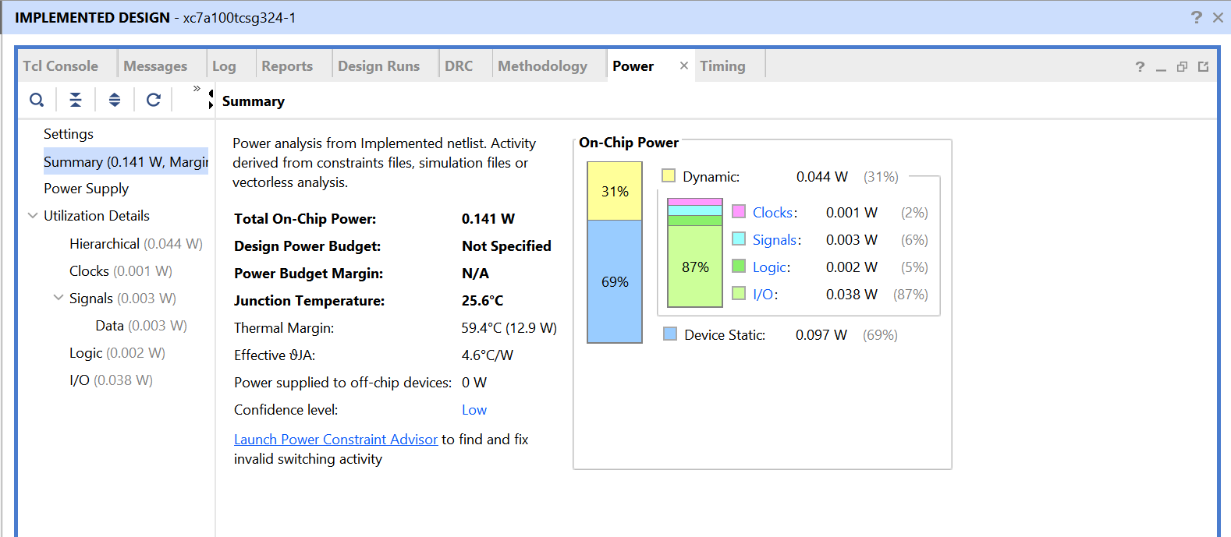

**10.Timing Report**

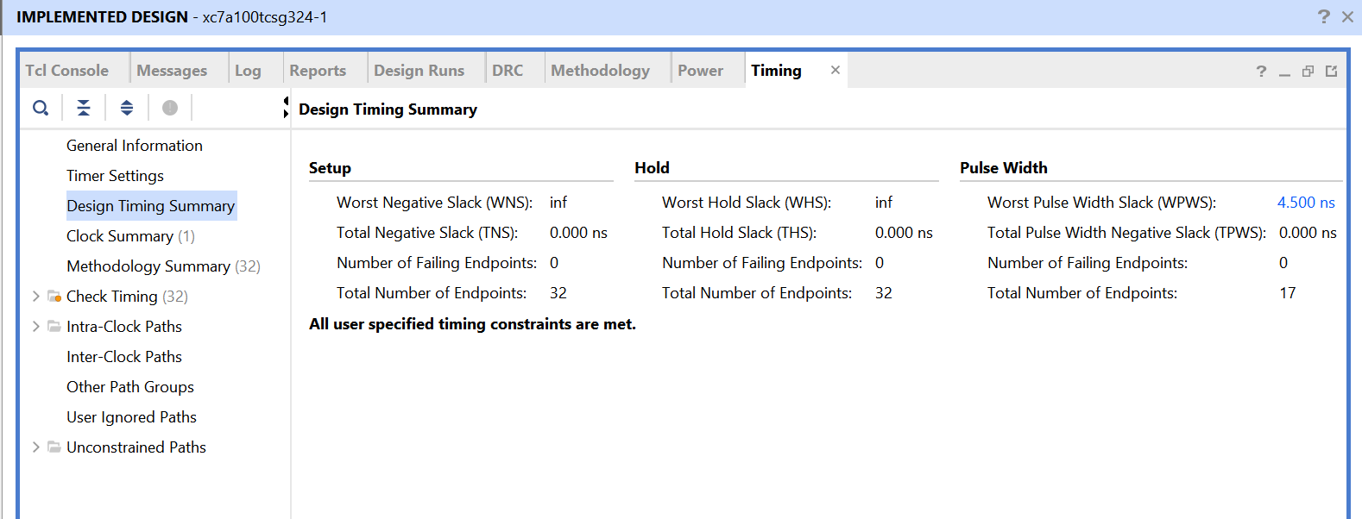

**11.Conclusion**

This report presents the design and implementation of an 8-bit Booth's multiplier in Verilog. By leveraging Booth's algorithm, the multiplier efficiently handles binary multiplication with fewer addition and subtraction operations. The design is suitable for digital systems requiring efficient arithmetic operations, demonstrating the practical application of historical algorithms in modern hardware design.

**12.References**

1)Booth, A. D. "A signed binary multiplication technique." Quarterly Journal of Mechanics and Applied Mathematics 4.2 (1951): 236-240.

2)Mano, M. Morris, and Michael D. Ciletti. "Digital Design." Pearson, 2013.

3)Wakerly, John F. "Digital Design: Principles and Practices." Pearson, 2018