1981-82 Recession in US

Macroeconomics Essay

By- Sarthak Dalmia

ID- 2018B3A70290G

**Introduction**

Before the Great Recession of 2008-09, the worst recession faced by the United States of America was the 1981-82 recession. The US entered into a mild recession in 1980, that lasted for about 6 months. After a short revival in the economy, US entered into 16-month long recession of 1981-82. This recession was quite interesting as it was caused due to the Federal Reserves efforts to reduce the almost decade long high inflation rates due to the Oil Crisis of 1973-74 and the energy crisis of 1979. This contractionary monetary policy resulted in a sharp decline in GDP and a subsequent increase in unemployment. Following the energy crisis in 1979, annual growth rate fell from 3.166% in 1979 to -0.257 in 1980 which further declined to a staggering -1.803% in 1982. Unemployment rose to record high in the months of November and December of the year 1982.

Both the 1980s recession and the 1981-82 recession were caused due application of contractionary monetary policy by the federal reserve. This contractionary monetary policy to combat inflation resulted in a consequent shift in the LM schedule towards left. This decrease in GDP level resulted in a subsequent shift in AD curve towards left and thus decreasing price level. This policy was implemented by raising the interest rates. This increase in lending and borrowing rate resulted in higher costs for companies. This led to companies laying off workers at a huge scale leading to high rates of unemployment. Despite knowing the effects of this type policy, the Feds continued their effort to control inflation once and for all for more than a year which indeed resulted in favorable outcome of controlled inflation in US over the next few decades. From a soring 14.8% inflation in March 1979, the inflation rates fell down to a good 5% in mid-1982. Finally, owing to increased tax deductions and defense spending US economy was slowly nursed back to health as evident from the acceptable 5% unemployment rate in 1989.

**Impulse and Propagation Mechanism**

Both the 1980 and 1981-82 recessions were triggered due to strict monetary policy decisions made to control the mounting inflation rates left in the wake of the oil and energy crisis in 1970s. Economists and policymakers in 1960s and 1970s believed that inflation and unemployment can be controlled at the expanse of the other following the tradeoff in Phillips Curve. Thus, the Federal Reserve under Paul Volcker applied what was known as a “stop-go” policy. During the “go” periods, the Feds used expansionary monetary policy by lowering the interest rates. This resulted in an increase in money supply which in-turn resulted in a right ward shift in LM schedule, thereby increasing GDP level and decreasing unemployment rate. This resulted in subsequent shift in the AD curve towards right which resulted in inflation. During the “stop” periods, interest rates would be increased so as to tighten the money supply. This resulted in left ward shift in LM schedule. This decrease in GDP level was accompanied by decrease in inflation thereby controlling the mounted-up inflation rates. This method did not prove to be effective. As was seen in the brief period of economic relief after July 1980, that even though economy was healing with expansionary monetary policy inflation rates remained at around 7% the rest of the year.

Paul Volcker was appointed the head of Federal Reserve of United States of America due to his anti-inflation views. He said: “In terms of economic stability in the future, inflation is what is likely to give us the most problems and create the biggest recession” (FOMC transcript 1979, 16). The failure of Phillips Curve in 1970s moved economists to understand the long-term relationship between inflation and unemployment. The idea of “natural rate of unemployment”, suggested by Edmund Phelps, was thus taken into mind while combating inflation. The first attempt to reduce the inflation in the early 1980 was unsuccessful. The credit control policies under Carter administration left the economy in a recession. Volcker used the feds fund rate, probably the most influential interest rate in the world, to combat the double-digit inflation. The Money Control Act of 1980 made it easier for the Federal Reserve to control money supply. Now increasing fed fund rate, could result in substantial inhibition in lending and borrowing activities by businesses and households. The reduced availability of mortgage loans left people feeling poorer which resulted in less consumer spending. As businesses found it hard to get capital their investment was reduced. This resulted in the reduction of GDP. This decrease in demand forced prices to go downwards and thus controlling inflation. As the recession worsened, Volcker faced repeated calls from the Congress to decrease the interest rates but he did not budge. According to him, if inflation was not controlled in one swift blow it could lead to an even worse recession down the line.

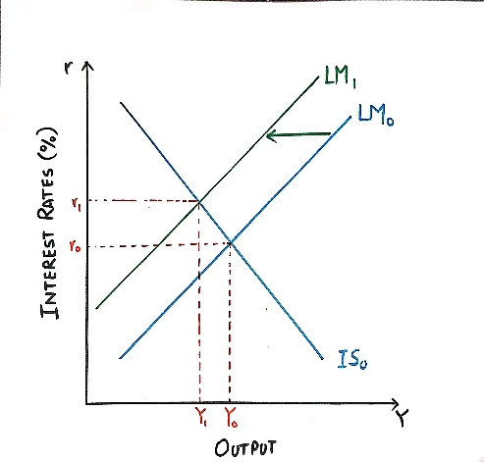 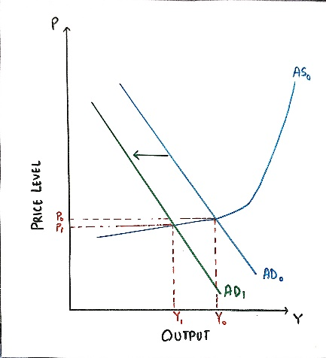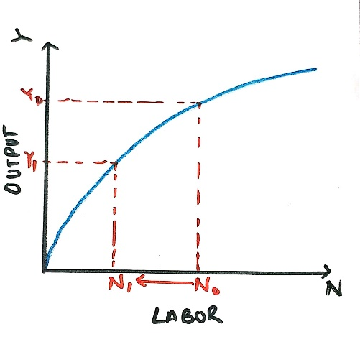

Production Function showing the effect of decrease in GDP level on employment

AS-AD Diagram showing the effect of decrease in money supply

IS LM Diagram showing the effect of decrease in money supply

Friedman’s monetarist view was relatively new and was starting to get accepted across the world. Although the Feds policies in 1980s proved monetary policy to be effective in an economy, it also showed the world its downfalls. The augmented Phillips Curve presented by Friedman and Phelps proved that monetary policy does lead a long term affect on real variables such as unemployment rate. Following the monetarists view that money supply has only lasting effect on price level and that its only beneficial in short term. Thus, Volcker shifted Fed policy to target the money supply rather than interest rates. He took this approach for two reasons. First, mounting inflation made it difficult to know what should be the target interest rate. While the nominal rates the Fed targeted could be quite high, the real interest rates (that is, the effective interest rates after adjusting for inflation) could still be quite low due to the expectation of inflation. Second, the new policy inspired a positive confidence in the economy. In an October survey of 1982, showed that despite 46% of the American families were worse off

*Source:* World Bank Data

than the year before, people 37% of the people still believed that good days lied ahead. This confidence in Reagan’s administration was very important because the current inflation was

majorly fueled by expectation of high inflation.

**Inflation rates in US**

|  |  |  |  |  |  |  |  |  |  |  |  |  |
| --- | --- | --- | --- | --- | --- | --- | --- | --- | --- | --- | --- | --- |
| **Year** | **Jan** | **Feb** | **Mar** | **Apr** | **May** | **Jun** | **Jul** | **Aug** | **Sep** | **Oct** | **Nov** | **Dec** |
| **1978** | 6.4 | 6.3 | 6.3 | 6.1 | 6 | 5.9 | 6.2 | 5.9 | 6 | 5.8 | 5.9 | 6 |
| **1979** | 5.9 | 5.9 | 5.8 | 5.8 | 5.6 | 5.7 | 5.7 | 6 | 5.9 | 6 | 5.9 | 6 |
| **1980** | 6.3 | 6.3 | 6.3 | 6.9 | 7.5 | 7.6 | 7.8 | 7.7 | 7.5 | 7.5 | 7.5 | 7.2 |
| **1981** | 7.5 | 7.4 | 7.4 | 7.2 | 7.5 | 7.5 | 7.2 | 7.4 | 7.6 | 7.9 | 8.3 | 8.5 |
| **1982** | 8.6 | 8.9 | 9 | 9.3 | 9.4 | 9.6 | 9.8 | 9.8 | 10.1 | 10.4 | 10.8 | 10.8 |
| **1983** | 10.4 | 10.4 | 10.3 | 10.2 | 10.1 | 10.1 | 9.4 | 9.5 | 9.2 | 8.8 | 8.5 | 8.3 |
| **1984** | 8 | 7.8 | 7.8 | 7.7 | 7.4 | 7.2 | 7.5 | 7.5 | 7.3 | 7.4 | 7.2 | 7.3 |
| **1985** | 7.3 | 7.2 | 7.2 | 7.3 | 7.2 | 7.4 | 7.4 | 7.1 | 7.1 | 7.1 | 7 | 7 |
| **1986** | 6.7 | 7.2 | 7.2 | 7.1 | 7.2 | 7.2 | 7 | 6.9 | 7 | 7 | 6.9 | 6.6 |
| **1987** | 6.6 | 6.6 | 6.6 | 6.3 | 6.3 | 6.2 | 6.1 | 6 | 5.9 | 6 | 5.8 | 5.7 |
| **1988** | 5.7 | 5.7 | 5.7 | 5.4 | 5.6 | 5.4 | 5.4 | 5.6 | 5.4 | 5.4 | 5.3 | 5.3 |
| **1989** | 5.4 | 5.2 | 5 | 5.2 | 5.2 | 5.3 | 5.2 | 5.2 | 5.3 | 5.3 | 5.4 | 5.4 |

*Source:* [*https://data.bls.gov/pdq/SurveyOutputServlet*](https://data.bls.gov/pdq/SurveyOutputServlet)

**Effectiveness of Policy interventions**

To combat the recession of 1981-1982 Ronald Reagan used mostly fiscal policy measures. As was clear from the events of last decade economists and policymakers had some idea of the temporary effect the monetary policy had on real variables. With inflation in control, feds eased up on the restrictive monetary policy. This relaxation led to some improvement in the economy. Inflation went from 14.8% in February 1980 to low of 3.8% in 1982 November. Just after 6 months of Reagans election as the 40th President on January 20th 1981, he signed Economic Recovery Tax Act of 1981 (ERTA), the largest tax cut in US history. ERTA slashed top income tax rates and allowed for faster depreciation pay out. The highest income tax rate was cut from 70% to 50% and the lowest was cut from 14% to 11%. Other features of this act included easier rules for establishing employee stock ownership plans (ESOP); expanded admissibility for Individual Retirement Accounts (IRAs); a decrease in the capital-gains tax from 28% to 20%; and a higher estate-tax exemption. This expansionary fiscal policy was inspired by supply-side theories of economics suggested by the economist Arthur Laffer. Despite the hopes f policymakers there was a substantial lag in the benefits of this policy. Unemployment was still rising; inflation was going down and annual GDP growth rate was as low as -1.803% in 1982 (lowest since the Great Depression till the 2008 financial crisis). This policy was directed so as to instigate “work, save and invest” among households and firms. All the while fiscal deficit was soring high. The deficit approximately tripled under Reagan’s administration from $74 Billion to $208 Billion in 1983. This in-turn had a negative affect afterwards.

Though consumer spending increased in 1981, investment fell by such a huge amount that overall affect on aggregate demand was negative. Where final consumption increased from 76.114% in 1981 to 78.527% in 1982, investment dropped from 24.28% in 1981 to 22.07% in 1982. This might be attributed to two reasons. First, business confidence was very low at the time. Second, high fed funds rate discouraged investment to much greater level than anticipated by the authorities. These reasons are furthered by the crowding out effect. 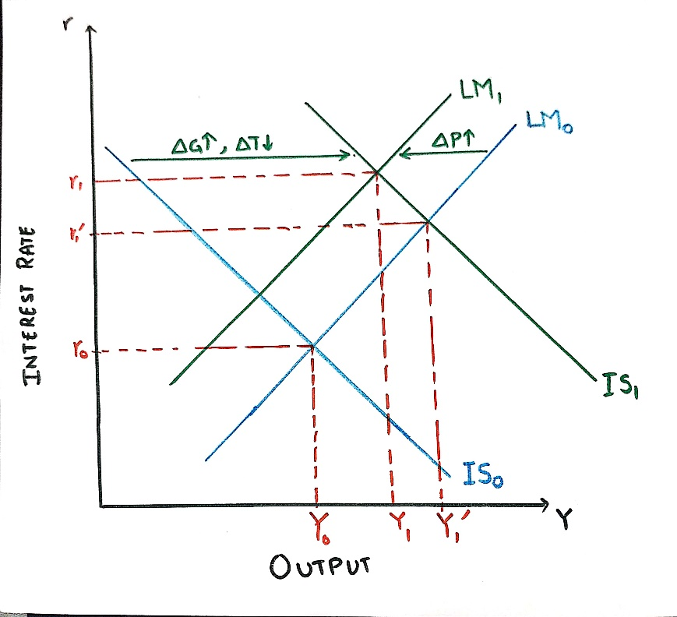

IS LM Diagram showing the effect of increased consumer spending before decrease in investment.

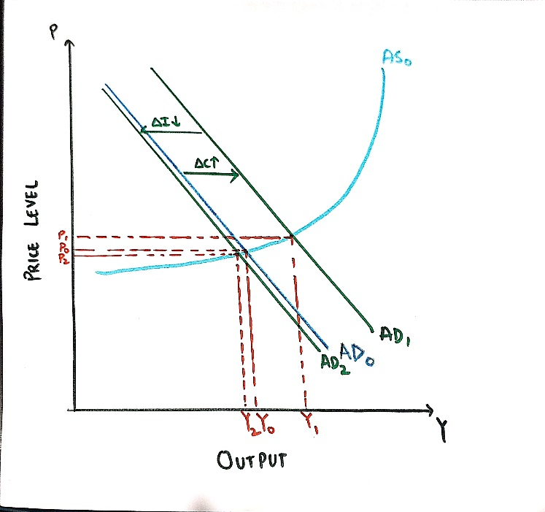

AS-AD Diagram showing the effect of increased consumer spending and decrease in investment.

Besides tax cuts another economic policy decision was increased defense spending. The budget increased from 4.96% in 1980 to 6.57% in 1982 and remained around 6% for the rest of the decade. This further contributed to the increasing fiscal deficit. Towards the end of 1982, the feds started lowering the feds fund rate. As a result, business sentiment became more and more positive. It is important to note that fourth quarter 1982 was a trough in business cycle. This resulted in somewhat relaxation in the economy. Investment rose from 22.07% in 1982 to 25.10% in 1984. This induced positive sentiment combined with tax cuts last year and increased defense spending led to a sustained yet uneven recovery. Unemployment decreased from 10.8% in 1982 November to 8.5% within a year and continued to decreased further averaging out at about 5.2% by the end of the decade. GDP growth rate increased from -1.803% in 1982 to 7.237% in 1984. Despite the growth, there were many scares of high inflation rates throughout the decade.

|  |  |  |  |  |  |  |  |  |  |  |  |
| --- | --- | --- | --- | --- | --- | --- | --- | --- | --- | --- | --- |
| **Variable\Year** | **1979** | **1980** | **1981** | **1982** | **1983** | **1984** | **1985** | **1986** | **1987** | **1988** | **1989** |
| **GDP growth(annual %)** | 3.166 | -0.257 | 2.538 | -1.803 | 4.584 | 7.237 | 4.17 | 3.463 | 3.46 | 4.177 | 3.673 |
| **Peak Unemployment rate(%)** | 6 | 7.8 | 8.5 | 10.8 | 10.4 | 8 | 7.4 | 7.2 | 6.6 | 5.7 | 5.4 |
| **Peak Inflation (%)** | 13.3 | 14.8 | 11.8 | 8.4 | 3.9 | 4.8 | 3.8 | 3.9 | 4.5 | 4.4 | 5.4 |

Short term (2-3 years) benefits of the fiscal policy, though delayed did help the economy in a major way. As discussed above the sharp decline in unemployment and increase in GDP was crucial in ending the recession. This was as expected. Fiscal policies take longer to implement but their effects once they are implemented are somewhat immediate. In the long-term Reagan’s economic policies help create a better future for Americans. Reagan’s tax cuts resulted in income equality. This helped lower- and middle-class American people by reducing financial burdens and thus enabling them to strengthen their businesses and professions. It also instilled corporations to invest in job growth. The gradual decrease of fed fund rate insured steady inflation rates over the period of recovery. In the year 1989, their 20 million more Americans employed than the start of the decade. Following are various macroeconomic variables during the decade of 1980. Real median household income also increased over the decade.

*Sources: Various sources listed below*

Edmund Phelps’ and Friedman’s version of Phillips Curve helped monetarists gain credibility during the stagflation of 1970s-80s. More and more central banks were starting to use money supply to manipulate the economy rather than interest rates. The 1981-82 recession posed a huge challenge for monetarists. Though the recession lessened the popularity of monetarists due to the “newly found” volatile money velocity in early 1980s, it proved the fact that money supply does in fact affect the economy. This forced Keynesians to adopt the major tenets of money supply (increase or decrease in money supply does not have long term effects on real variables like output and unemployment) and use monetary policy as a stabilizing agent in the economy. New Keynesian model took off in this decade. The Insider-Outsider Model was developed by new Keynesians after observing the hysteresis effect in unemployment rates when it, instead of returning to its natural rate, remained high after 1979 crisis. This further strengthened the importance of monetary and fiscal policy.  If temporary shocks in the economy (like the energy crisis) can leave a long-term effect; stabilization policies (like monetary policies) can also have effects lasting longer than anticipated. The recession of 1981-82 was handled using both fiscal and monetary policies. No particular model was found to be perfectly compatible with its happenings.

**Conclusion**

In order to combat high-inflation US had to face a severe recession in the year 1981-82. Where contractionary monetary policy helped stabilize inflation it paved a way for high unemployment and low GDP growth. Using careful and informed (as well as they could have been) decisions, the US government was successful in battling both the high inflation rates and high unemployment rates by the end of the decade. Reagan’s economics, though had some kinks here and there, solved the problem in long run. New schools of thought emerged from the surprising turn of events that unfolded during this rocky period of US economy in 1970s and 1980s.

References

<https://www.federalreservehistory.org/essays/recession_of_1981_82>

Martin Feldstein, ed., American Economic Policy in the 1980s (National Bureau of Economic Research and the University of Chicago Press, 1994). <https://www.nber.org/chapters/c7752.pdf>

<https://www.thebalance.com/fed-funds-rate-definition-impact-and-how-it-works-3306122>

<https://www.federalreservehistory.org/essays/monetary_control_act_of_1980#monetary>

<https://www.federalreservehistory.org/essays/great_inflation>

<https://www.investopedia.com/terms/e/economic-recovery-tax-act.asp>

<https://www.epi.org/publication/issuebriefs_ib157/>

[https://www.reagan.com/the-lasting-effects-of-reaganomics?_](https://www.reagan.com/the-lasting-effects-of-reaganomics?__cf_chl_jschl_tk__=3192c64f448fa7456e44d2574a01352f21805c62-1590339184-0-Aet_5wqeagQGknBVtBtL-rop_MM6_kFwoT6Dl7Z3DvNA6t20FFtceYajOnnB0KnldOIaxhcEVB5_NaNpvsbSHJSLDDkmtVSoXm-N871kDxVcecPW3C7Ne9PjNFfmRPDYVZVhHrv09iSQ4eX-8KUuMXhQBVzSsWVtYHm0QHa6Qlu4Vhlc8IcSYkxuKyAYEBNB3FXOkXjmVfhxugG0Wjd97SLW670z04VM-s9ghC3rUwZVbFxP49Um9UlBC7C2NnrrHC9xnHvB0hbkEW8w2TA67W1r31UQ13_beSlDQUV04YJ9KrT010Ko_MXd-oLYswMUNQ)

Data Sources

<https://data.bls.gov/pdq/SurveyOutputServlet>

<https://data.worldbank.org/indicator/NY.GDP.MKTP.KD.ZG?end=2018&locations=US&start=1961>

<https://www.usinflationcalculator.com/inflation/historical-inflation-rates/>

<https://www.macrotrends.net/2015/fed-funds-rate-historical-chart>

<https://www.macrotrends.net/countries/USA/united-states/military-spending-defense-budget>

<https://www.thebalance.com/us-deficit-by-year-3306306>

<https://www.epi.org/publication/issuebriefs_ib157/>

<https://data.worldbank.org/indicator/NE.CON.TOTL.ZS?end=1989&locations=US&start=1978>

<https://tcdata360.worldbank.org/indicators/inv.all.pct?country=USA&indicator=345&viz=line_chart&years=1980,2024>