1. **L&T INFOTECH**
   1. **Company-overview**Larsen & Toubro Infotech is a global technology consulting and digital solutions company with operations in over 32 countries in the world. It was founded 20 years ago as the information technology arm of its parent company, Larsen & Toubro, and has been ranked as the 6th largest Indian IT services company in terms of export revenues. It has more than 420 clients and 30,000 employees worldwide.

This report is an insight on its performance and its position in this pandemic situation.

* 1. **LTI revenue and revenue distribution**

The execution of LTI’s BCP plans helped them hit the 95% work from home enablement mark within a week of the lockdown in India. FY20 marked the fourth consecutive year of double-digit constant currency growth for LTI. It delivered revenues of USD 409.9 million up 3.9% quarter-on-quarter and 15.9% year-on-year. This helped it conclude the year with another year of industry-leading growth of 13% year-on-year in US Dollar terms and 14.2% year-on-year in constant currency.

BFS grew 2.9% quarter-on-quarter on back of a very strong Q3. Insurance registered a minor decline of 1.3% quarter-on-quarter in Q4. Manufacturing had second consecutive quarter of strong growth of 7.2% quarter-on-quarter. CPG, Retail & Pharma continued to do well with another quarter of steady performance of 3.3% quarter-on-quarter growth. The staple nature of the underlying business in this vertical helped it is revenue performance. It is expected that this vertical will grow above the company average in FY21 as well.

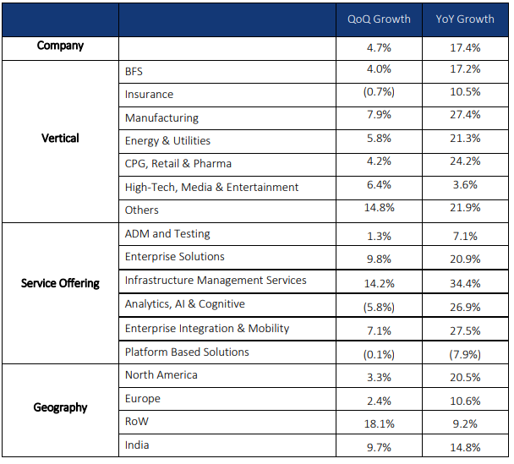  
*Fig. 3.1: Sector-wise revenue generation in CC*

EBIT for the quarter was INR 5,035 million translating into an operating margin of 16.7% as compared with 16.2% in the previous quarter. **This margin improvement of 110 basis points was equally contributed by working days, currency and operational efficiency partially offset by higher product and pass through revenue in the quarter.** For the full year, operating margin was INR 17,564 million at 16.1% against 18.4% of previous year. Accelerated growth momentum in second half of the year and programmatic efforts to improve operational efficiency helped in improving our profitability in H2. Reported profit after tax (PAT) was INR 4,275 million, which translates into a PAT margin of 14.2% this quarter compared to 13.4% in Q3. The full year PAT stood at INR 15,205 million, delivering a full year PAT margin of 14%.   
Such growth of LTI is supported by large number of deal signings in every quarter. In spite of the COVID-19 crisis, **the company managed to sign record eight deals in Q4**, with two large deals in Q4 with net-new TCV in excess of US$100 million, which followed six deals in Q3.

* 1. **Major risks and opportunities**

**Key strengths and opportunities:**

* Strong customer base and relations- LTI with its client-centric growth strategies and business model have led to better trust among the clients and helped in securing high profile deals every year.
* Diversified revenue stream with focus shifting to cloud computing to make customers’ cost structures lean and better equip them to handle the macroeconomic turbulence in the longer run
* Global presence and strong financial performance, revenue generation of USD 409.9 million in Q4
* Emerging markets such as pharma, robotics

**Weaknesses and risks:**

* Economic slowdown in US and uncertainty in Europe, the geographical regions which contribute to major share of the revenue.
* Strong competition from other IT companies such as TCS, Infosys, Wipro
* Major revenue coming from top clientele, 68% of its total revenue from its top 20 customers. Any customer facing issues (because of macroeconomic conditions or issues specific to the customer) can lead to pressure on LTI's overall revenue growth and performance
  1. **Future Predictions**

**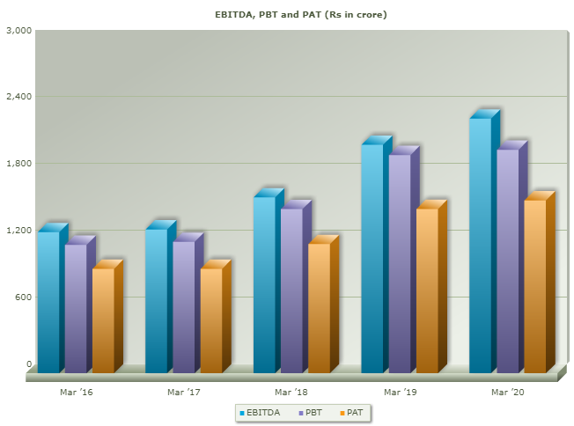***Fig. 3.2: EBITDA and PAT trends over last 5 years*

LTI reported EBITDA of INR 2287.4 cr, changing from INR 2052.1 cr, a change of 11.47%. following linear trend in the current bullish market, the annual earnings will increase to approx. INR 2550 cr in Mar ’21.

PAT has changed from INR 1447 cr to INR 1552 cr, an increase of 5.24%.

**WILLIAM O’NIEL METHODOLOGY**

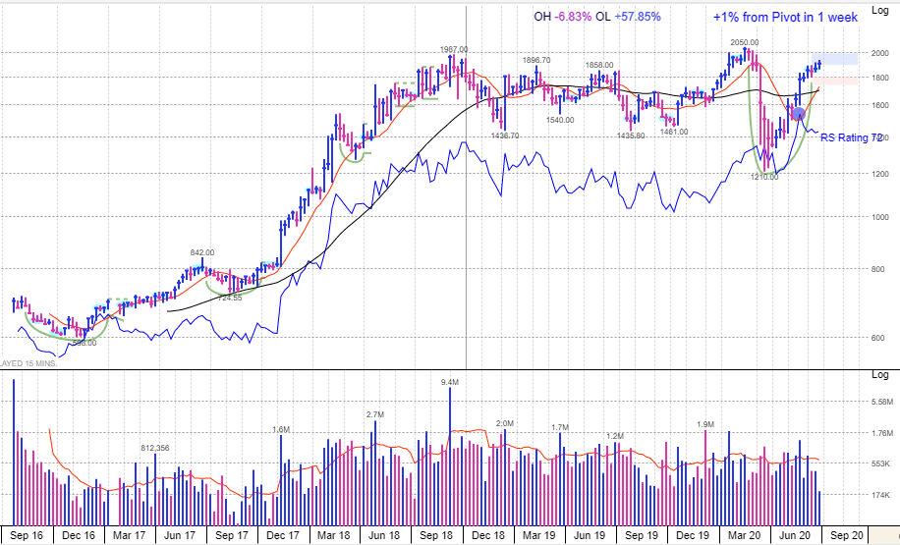The stock is trading above the 200 DMA and 50 DMA line.

The stock is forming a cup with handle pattern and is trading ~1% below the pivot which formed a week ago. It may be ideal to buy stocks now, seeing the bullish market trend.

RS line is moving sideways with a rating of 72 indication the handle formation of the cup pattern.

EPS rank of 83 reflects a good earning profile. Number of funds increased by 0.88%.