**PE and Revenue and Debt of Indonesia, Taiwan and Hong Kong and Mongolia from 1990 to 2020**



**Prepared By:**

|  |  |
| --- | --- |
|  |  |
| **Kushal Bakliwal** | **2018B3A30774G** |
| **Manav Tanwar** | **2018B3A70629G** |
| **Lakshay Dua** | **2018B3A70735G** |
| **Sarthak Dalmia** | **2018B3A70290G** |

**Submitted as a part of partial fulfilment of the course Public Finance: Theory and Practice (ECON F341)**

Table of Contents

**Abstract**3

**Introduction**4

**Literature Review**6

**Objective**9

**Data Sources**10

**Methodology** 12

**Results**15

**Conclusion**24

**References** 25

**ABSTRACT**

This paper examines the relationship between public expenditure, government revenue and public debt in Indonesia, Taiwan, Hong Kong and Mongolia by using the data of these variables for the period 1990 to 2018. Stationarity tests and ARDL model was employed to analyse the short-run and long-term dynamics and test whether a relationship between public expenditure(PE) and government revenue exists or not. Similarly, correlation tests were employed to test whether an increase in public debt will stimulate the public expenditure or not. We expect both the public expenditure and government revenue, and public debt and public expenditure to have a positive relationship between them. Further descriptive statistical analysis on the variables will help us in recommending appropriate measures that should be taken by the authorities on public finance policies. The co-integration results depicted a significant long run relationship between Government Expenditure, Government Revenue and Debt. The Error Correction Model also led to the conclusion that the Government Expenditure, Government Revenue and Debt Are Positively Correlated and the relationship was statistically significant.

**Keywords:** PE, Revenue, Debt, Indonesia, Taiwan, Hong Kong and Mongolia, Error Correction Model

**Introduction**

One of the most highly debated issues in economics is the potential trajectory of fiscal policy is the necessity to regulate debt (or keep it under strict control) and the viability of public finances. Furthermore, the global crisis and several countries' expansionary government reactions have restored the policymakers' and academics' interest on the effects of growth of large public debts and budget deficits. As a result, sustainability of the fiscal policy and PD (public debt) is a matter of concern for any economy be it developed or developing. All tax and non-tax revenues which are collected by the government including the grants constitute the total government revenues. All the development and operational expenditures incurred by the government constitute total government expenditure. Disparities between government expenditures and implies that there will be a budget deficit or surplus.

Since the 1990s, Indonesia, for example, has been trapped by a mountain of external debt, high inflation, and a high unemployment rate. So Indonesia had experienced fiscal risk ever since that period. (Kawai and Morgan 2013). Indonesia also faced rising fiscal risks as a result of both external and internal economic shocks in the same period. This situation can jeopardise fiscal sustainability and may result in a fiscal cliff. (Gnip 2013, Kiran 2011)

In order to achieve fiscal stability, it is important to consider the relationship between government revenue, expenditure, and public debt, as well as to determine whether spending by the government contributes to public debt and government revenue, or whether PD and government revenue are drivers of the spending for Indonesia, Hong Kong, Taiwan and Mongolia. It is critical to analyse and consider the underlying trends in light of growing questions regarding fiscal sustainability and increases in debt burdens, budget deficits and expenditure exceeding their thresholds in Indonesia, Hong Kong, Taiwan, and Mongolia.

This research paper examines the relationship between government expenditure, revenue and public debt in Indonesia, Hong Kong, Taiwan and Mongolia over the period from 1990 to 2018, in order to address the gap in the literature and answering the policy makers’ concerns regarding fiscal sustainability. This paper is specifically aiming to investigate the relationship between government revenue and expenditure, analyse the relationship between public debt and government expenditure. We also plan to determine the direction of causality between government revenue and government expenditure. Along with this, we also plan to determine the direction of causality between public debt and government expenditure.

**Literature Review**

**Sasmal, J., & Sasmal, R. (2018). Public Debt, Economic Growth and Fiscal Balance: Alternative Measures of Sustainability in the Indian Context. *Global Business Review*, *21*(3), 780–799. https://doi.org/10.1177/0972150918778940**

- Ritwik Sasmal, Joydeb Sasmal, 2017

Sasmal and Sasmal examine the effect of Government spending on Economic growth and fiscal balance from the year **1990 to 2015.** It aimed to analyse the viability of fiscal policy when public expenditure is financed by government borrowing. In this study, Ratio of gross fiscal deficit to NNP has been taken as fiscal balance. The results of time series analysis showed that the ratio of gross fiscal deficit to NNP has increased with increase in total government expenditure. The study also showed that private capital has a significant positive impact on NNP but the effect of fiscal deficit on economic growth is not clear. From time series analysis it is found that private capital has a significant positive impact on the growth of NNP. But the effect of public borrowing on growth is not clear.

**Gurdal, T., Aydin, M., & Inal, V. (2020). The relationship between tax revenue, government expenditure, and economic growth in G7 countries: new evidence from time and frequency domain approaches. *Economic Change and Restructuring*, *54*(2), 305–337. https://doi.org/10.1007/s10644-020-09280-x**

- Temel Gurdal , Mucahit Aydin , Veysel Inal, 2020

Gurdal et. al. examined the relationship between tax revenue, government expenditure, and economic growth for the USA, UK, Canada, France, Germany, Italy and Japan—the G7 countries using annual data from **1980-2016**. This study used two different panel causality approaches in order to make a comparison. Time domain panel causality test results showed that there is a bi-directional causality between economic growth and government expenditure and uni-directional causality between tax revenue and government expenditure. Frequency domain causality showed that there are a bidirectional short- and long-run causality between economic growth and tax revenue, and long-run causality between economic growth and government expenditure. All in all, positive effects of the taxation policies by the G7 countries suggested that their tax policies are in accordance with their economic goals

**Iiyambo, H., & Kaulihowa, T. (2020). An assessment of the relationship between public debt, government expenditure and revenue in Namibia. *Public Sector Economics*, *44*(3), 331–353. https://doi.org/10.3326/pse.44.3.3**

- Hambeleleni Iiyambo,Teresia Kaulihowa, 2019

This paper tried to find the relationship between government expenditure, government revenue and public debt in Namibia using the data from **1980 to 2018** for government expenditure, government revenue and public debt. Using the ECM and co-integration model, a positive relationship between government expenditure and government revenue was found. Using Granger causality test, unidirectional causality from government expenditure to public debt was found. And similarly a unidirectional causality from government revenue to government expenditure was found. All of this led to the finding that historical government expenditure values will aid in the prediction of debts, but that public debt is not a reliable method for assessing government expenditure. Such relationship indicated that policy-makers have the ability to control the country’s borrowings through government spending. The study also recommended policy-makers to thoroughly review fiscal policy by efficiently adopting the functional finance as suggested by the Lerner theory.

**Lojanica, N. (2015, February 2). *Government Expenditure and Government Revenue: The Causality on the Example of the Republic of Serbia*. Https://Ideas.Repec.Org/. https://ideas.repec.org/h/mgt/micp15/79-90.html**

- Nemanja Lojanica, 2015

This study investigated the relationship between government revenue and government expenditure in the Republic of Serbia. Monthly data from **2003 to 2014** was used. ADF and KPS tests showed that there is a cointegration between government expenditure and government revenue. Also a unidirectional causality from expenditure to revenue was found. It recommended policy makers to reduce the government expenditure in the long run which in turn will reduce the budget deficit.

**Ahuja, D., & Pandit, D. (2020). Public Expenditure and Economic Growth: Evidence from the Developing Countries. FIIB Business Review, 9(3), 228–236.** [**https://doi.org/10.1177/2319714520938901**](https://doi.org/10.1177/2319714520938901)

* Ahuja & Pandit, 2020

The purpose of this paper is to examine the impact of public expenditure on economic growth of India from 1998 to 2012.This study includes annual data of total public expenditure (TPE) and Gross Domestic Product (GDP) per capita as indicators of Economic Growth. ‘ADF Unit Root Test’, ‘Cointegration Test’ and ‘Granger Causality test’ techniques have been applied. The study reveals that there is linear stationarity in both the variables that indicates the long run equilibrium and there is a positive impact of Total public expenditure on economic growth. The results of this paper confirm the existence of a long run equilibrium relationship between public expenditure and economic growth. The relationship has been found positive, that is GDP responds positively to a shock in TPE. Granger Causality Test also supported the result of IRF that there is a unidirectional relationship from TPE to GDP (TPE granger cause GDP) and not the other way. Therefore, the paper concludes the government should increase their public expenditure to encourage economic growth.

**Objective**

Objective of this study is to investigate the causal relationship between Government Expenditure, Government Revenue and Public Debt in Indonesia, Taiwan, Hong Kong, and Taiwan, in long run and short run using Autoregressive Distributed Lag (ARDL) bound testing. Granger causality test is done to determine the direction of the causal relationship between government expenditure and government revenue; and government expenditure and public debt. This will help us to determine whether government expenditure can help predict the debts.

**Data Sources**

For the period 1990 to 2018, the report used actual government financial operations data on government spending, public debt and revenue majorly from the IMF and World Bank database.

|  |  |  |  |
| --- | --- | --- | --- |
| **Indicator** | **Country** | **Source** | **Link** |
| **Revenue** | **Hong Kong** | **International Monetary Fund** | <https://www.imf.org/external/datamapper/GGR_G01_GDP_PT@FM/ADVEC/FM_EMG/FM_LIDC/HKG> |
| **Indonesia** | **International Monetary Fund** |
| **Mongolia** | **International Monetary Fund** |
| **Taiwan** | **International Monetary Fund** |
| **Debt** | **Hong Kong** | **World Bank** | <https://data.worldbank.org/topic/external-debt?locations=HK> |
| **Indonesia** | **World Bank** | <https://data.worldbank.org/indicator/GC.DOD.TOTL.GD.ZS?locations=ID> |
| **Mongolia** | **World Bank** | [https://fred.stlouisfed.org/series/PDTLMNA188A](https://fred.stlouisfed.org/series/DEBTTLMNA188A) |
| **Taiwan** | **World Bank** | <https://www.statista.com/statistics/727610/national-debt-of-taiwan-in-relation-to-gross-domestic-product-gdp/> |
| **Expenditure** | **Hong Kong** | **World Bank** | <https://tradingeconomics.com/hong-kong/fiscal-expenditure> |
| **Indonesia** | **World Bank** | <https://data.worldbank.org/indicator/NE.CON.GOVT.ZS> |
| **Mongolia** | **World Bank** | <https://tradingeconomics.com/mongolia/government-budget> |
| **Taiwan** | **World Bank** | <https://tradingeconomics.com/taiwan/fiscal-expenditure> |

**Table 1: Data Sources**

**Methodology**

**Model Specifications**

We have done a time series analysis and tried to explore the relationship amongst Public Debt, government expenditure and revenue using a multiple regression analysis and causality tests.

In various policy analysis public debt turns out to be an important factor. Financing the government expenditure without the inclusion of public debt, alone with the revenue is inadequate. Also, government expenditure is affected by public debt through interest payments, debt servicing, interest payments.

The primary model of our study is:

**GvtExpt = F( PDt , GvtRvt )**

Where GvtExp = Government expenditure, PD= public debt , GvtRv = Government Revenue .

The issue of Autocorrelation was solved by transforming the variables to their logarithmic forms and the resulting multiple regression model is :

**Ln( GvtExpt ) = a + Ln( GvtExpt-I ) + BI Ln( PDt-I ) + B2 Ln( GvtRvt ) + Et**

Where Ln denotes the natural logarithmic function,

In the above specified model, Ln(PD) and Ln(GvtRv) are the independent variables whereas the Ln(GvtExp ) is the dependent variable , a is constant term and Et  is the error term ,

We get a positive relationship to hold between public debt and the government expenditure and between government revenue and government expenditure for all the countries taken into consideration.

As our original series might not follow the normal distribution, these variables were transformed into their logs form for further assessment so as to make the distribution as “normal” as possible. To check for stationarity, the following tests

**STATIONARITY TEST (ADF - TEST):**

To analyse the stationarity of the variables and the respective order of integration of non-stationary variables we used ADF test. Our regression model for the ADF test can be represented as

$$x_{t}= D_{t}γ_{t}+γ_{2}x_{t-1}+\sum{}π_{i}{∆x}_{t-i}+ε_{i}$$

Where, Dt is a deterministic movement and n means lagged difference, εt is the error term. And Δxt-i is the autoregressive–moving-average (ARMA) structure of the error

**Phillips–Perron unit root test:**

If we compare it to the ADF test, PP unit root test is more useful because the latter is proficient in dealing with the problem of Heteroscedasticity and serial correlation in errors. Where the ADF assessments use a parametric auto regression to estimate the ARMA structure of the errors, whereas any serial relationship in the regression is ignored in the PP test.

The regression of the PP test is expressed as:

$$x_{t}= D_{t}γ_{1}+γ_{2}x_{t-1}+ε_{t}$$

Where εt is I (0) and maybe Heteroscedasticity. The Phillips-Perron test rectifies any serial correlation and Heteroscedasticity in the error term.

**Autoregressive Distributed Lag (ARDL) model:**

In order to check the co-integration in the series, we used the ARDL model. Furthermore, the error correction model can be derived from the ARDL by exhausting the linear transformation.

As a result, we used the ARDL procedure because of its advantages over the other co-integration methods.

This methodology is more appropriate when variables are integrated of different orders. The ARDL model with certain applicable lags amends for the indignity and serial correlation problem. The model (Paul, 2014) can be expressed as:

$$Δy_{t}=σ_{1}+γ_{1}y_{t-1}+γ_{2}x_{i-1}+γ_{3}Z_{t-1} +θ_{1}\sum_{i=1}^{n}{} Δy_{t-1}+θ_{2}\sum_{i=1}^{n}{} Δx_{t-1} +θ_{3}\sum_{i=1}^{n}{} Δz_{t-1}+ε_{1t}$$

Where γ1, γ2, γ3 are long-run coefficients factors and θ1, θ2, θ3 shows the short run factors. The comprehensive ARDL model can be express as:

$Δln⁡(GVTEX)_{t}=α_{0}+ α_{1}Δln⁡(PD)_{t-1}+α_{2}Δln⁡({GVTRV)}_{t-1}+ { α}_{3}Δln⁡(GVTEX)_{t-1}+{ λ}_{0}ln⁡(GVTEX)_{t} +λ_{1}ln⁡(PD)_{t}+λ_{2}ln⁡(GVTRV)_{t}+ε_{t}$

**Results**

**ADF Test:**

The following table shows the results from **Phillips–Perron unit root test.** The first table is Ln transformed variable; the second table is the first difference of the variables that are not stationary.

|  |  |  |  |  |
| --- | --- | --- | --- | --- |
|  | Indonesia | Hong Kong | Taiwan | Mongolia |
| lnGVTRV | -2.066 (0.2583) | -2.869 (0.0491) | -1.425 (0.5701) | -1.032  (0.7412) |
| lnPD | -2.304 (0.1708) | -3.231 (0.0183) | -1.720 (0.4211) | -1.407 (0.5788) |
| lnGVTEX | -1.657 (0.4532) | -0.686 (0.8503) | 0.568 (0.9868) | -1.802 (0.3794) |

**Table 2: results from** **Phillips–Perron unit root test (log transformed variable)**

|  |  |  |  |  |
| --- | --- | --- | --- | --- |
|  | Indonesia | Hong Kong | Taiwan | Mongolia |
| dlnGVTRV | -7.182 (0.0000) |  | -6.709 (0.0000) | -8.137 (0.0000) |
| dlnPD | -5.608 (0.0000) |  | -8.617 (0.0000) | -4.924 (0.0000) |
| dlnPD | -6.102 (0.0000) | -3.588 (0.0060) | -7.069 (0.0000) | -5.273 (0.0000) |

**Table 3: results from** **Phillips–Perron unit root test (first difference of the variables that are not stationary)**

All the variables become stationary after the first difference, i.e. none are integrated of order more than 1 hence a co-integration test can be performed.

**Granger causality**

The Granger causality test is a technique for determining whether one time series is significant in forecasting another. Granger is of the opinion that Y “Granger causes” X if X is only best predicted by using the lag values of Y on assumptions that the future cannot cause the past, but the past can cause the present or the future; and that a cause contains unique information about an effect not available anywhere else. Based on the above, the study employs the pair-wise Granger causality test as proposed by Granger to test the causal relationship between variables. The test determines whether the causality runs from GVTEX to PD or rather from PD to GVTEX, implying a unidirectional causality; whether both the PD and GVTEX simultaneously Granger cause each other, implying a bidirectional causality; or whether causality between PD and GVTEX is non-existent. Similarly, the test also determines whether the causality runs from GVTRV to GVTEX, or rather from GVTEX to GVREV; or if both GVTEX and GVTRV mutually cause each other and lastly; whether there is no causality between GVTEX and GVTRV.

A simple Granger causality test involving the variables, government expenditure and public debt is written in equations 4 and 5, while that involving govern ment expenditure and government revenue is written in equation 6 and 7 as:

|  |  |
| --- | --- |
| http://www.pse-journal.hr/img_get.php?img=690&code=orig | (4) |

|  |  |
| --- | --- |
| http://www.pse-journal.hr/img_get.php?img=691&code=orig | (5) |

|  |  |
| --- | --- |
| http://www.pse-journal.hr/img_get.php?img=692&code=orig | (6) |

|  |  |
| --- | --- |
| http://www.pse-journal.hr/img_get.php?img=693&code=orig | (7) |

where LnGVTEX refers to government expenditure and LnPD and LnGVTRV refer to public debt and government revenue respectively. Also, *ε*1*t* and *ε*2*t* are the stochastic error terms that are not correlated with each other; and *αi*, *βj* , *λi*, *δj* are the coefficients of the variables. From the above equations, the null hypotheses to be tested are then H0: http://www.pse-journal.hr/img_get.php?img=694&code=orig= 0 for i = 1... n, which implies that LnPD does not Granger cause LnGVTEX and that LnGVTRV does not Granger cause LnGVTEX; and http://www.pse-journal.hr/img_get.php?img=695&code=origfor j = 1... n, implying that LnGVTEX does not Granger cause LnPD and that LnGVTEX does not Granger cause LnGVTRV. If none of the hypotheses are rejected, it means that LnPD does not Granger cause LnGVTEX nor does LnGVTEX Granger cause LnPD. Rejecting the first hypothesis while accepting the second hypothesis shows that LnPD Granger causes LnGVTEX, but LnGVTEX does not Granger cause LnPD. Similarly, accepting the first hypothesis while rejecting the second hypothesis indicates that the causality runs from LnGVTEX to LnPD. Lastly, if all the hypotheses in the above equations are simultaneously rejected, there is bidirectional causality between the two variables. The above interpretations will apply with regards to causality between government expenditure and government revenue.

**Diagnostic tests**

The heteroscedasticity test for each of the country taken was performed under the decision criteria of rejecting the null hypothesis of no heteroscedasticity, if the calculated F-statistic is greater than the critical F-statistic. The autocorrelation test, which tests for the inconsistency of the error term used the Breusch-Godfrey serial correlation LM test to test the null hypothesis that there is no serial correlation. To ensure that the model used in the study is normally distributed, the null hypothesis of normality was tested against the alternative. A stability test to ensure the model’s suitability for analysis was also confirmed.

**Co-integration using ARDL Bound Test:**

The following table shows the F-value and co-integration presence for 3 models: PD, GVTRV as the proxy. As shown, it is present for all cases

We selected 2 proxy indicators to measure the fiscal sustainability

**GVTRV as the proxy:**

|  |  |  |
| --- | --- | --- |
|  | F-Value | Co-Integration |
| Indonesia | 11.5561 | Present |
| Hong Kong | 11.6455 | Present |
| Taiwan | 11.5470 | Present |
| Mongolia | 13.1821 | Present |

**Table 4: F-value and co-integration presence taking GVTRV as proxy**

**PD as the proxy:**

|  |  |  |
| --- | --- | --- |
|  | F-Value | Co-Integration |
| Indonesia | 8.9408 | Present |
| Hong Kong | 7.2065 | Present |
| Taiwan | 10.6422 | Present |
| Mongolia | 9.3791 | Present |

**Table 5: F-value and co-integration presence taking PD as proxy**

**Long-run and Short-run coefficients (regressions):**

Long run coefficients are estimated using ARDL models with lnGVTEX. as the dependent variable and other variables in their log form. In short run estimation, first difference log form will be used. The following tables show the coefficients estimated and respective R2, Adj R2 for the model.

**Long Run:**

|  |  |  |  |  |
| --- | --- | --- | --- | --- |
|  | Indonesia | Hong Kong | Taiwan | Mongolia |
| Intercept | 3.974932 | 25.26013 | 4.537872 | 5.224372289 |
| lnGVTRV | 0.20248 | 2.884567 | 1.04092 | -0.565749274 |
| lnPD | 0.666176 | -1.18268 | -1.20008 | 1.493293935 |
| **R2** | **0.663355** | **0.90694** | **0.975908** | **0.942389537** |
| **Adj. R2** | **0.613848** | **0.871148** | **0.973677** | **0.936510918** |

**Table 6: Coefficients estimated and respective R2, Adj R2 in long run**

**Short Run:**

|  |  |  |  |  |
| --- | --- | --- | --- | --- |
|  | Indonesia | Hong Kong | Taiwan | Mongolia |
| Intercept | 0.064272 | 0.104933 | 0.055759 | 0.073393 |
| dlnGVTRV | 0.160982 | 1.457868 | 0.10728 | -0.04632 |
| dlnPD | 0.633974 | 0.053663 | 0.380243 | 0.125762 |
| **R2** | **0.4491** | **0.355474** | **0.092931** | **0.070879** |
| **Adj. R2** | **0.36563** | **0.086921** | **0.007359** | **-0.0259** |

**Table 7: Coefficients estimated and respective R2, Adj R2 in short run**

**VECM Granger Causality Analysis:**

Using the VECM estimation, coefficients of long run and short run causality is determined. The following table shows the coefficients with the error correction term explaining the long run causality with its respective significance score and other coefficients determine the short run coefficients.

**Indonesia:**

|  |  |  |  |
| --- | --- | --- | --- |
|  | dlnGVTRV | dlnPD | ECT |
| dlnGVTRV |  | .6793344 (0.279) | **.0131812 (0.000)** |
| dlnPD | .0586193 (0.319) |  | **.0017957 (0.000)** |

**Table 8: Coefficients with the error correction term for Indonesia**

**Hong Kong:**

|  |  |  |  |
| --- | --- | --- | --- |
|  | dlnGVTRV | dlnPD | ECT |
| dlnGVTRV |  | .195535 (0.739) | -.1034752 (0.117) |
| dlnPD | -.2638213 (0.300) |  | **-.1167228 (0.023)** |

**Table 9: Coefficients with the error correction term for Hong Kong**

**Taiwan:**

|  |  |  |  |
| --- | --- | --- | --- |
|  | dlnGVTRV | dlnPD | ECT |
| dlnGVTRV |  | .**4164694 (0.008)** | **.0414693 (0.020)** |
| dlnPD | **.3636898 (0.036)** |  | -.0196686 (0.217) |

**Table 10: Coefficients with the error correction term for Taiwan**

**Mongolia:**

|  |  |  |  |
| --- | --- | --- | --- |
|  | dlnGVTRV | dlnPD | ECT |
| dlnGVTRV |  | .1094394 (0.464) | -.0263934 (0.454) |
| dlnPD | .079381 (0.496) |  | **-.1088436 (0.000)** |

**Table 11: Coefficients with the error correction term for Mongolia**

**Important results from above:**

GVTRV, PD show in many cases long-run causality showing an impact of debt and revenue on the expenditure of the government.

+ve coefficient in granger causal shows that positive inflow will lead to positive change in debt.

This study also showed short-run causality in GVTRV and fiscal stability.

**Correlation plots:**

Note: (The strength of the correlation is depicted by the respective colour of the circle colij where i,j are the respective variables in which we need to find the correlation. Positive correlations are displayed in a blue scale while negative correlations are displayed in a red scale.).

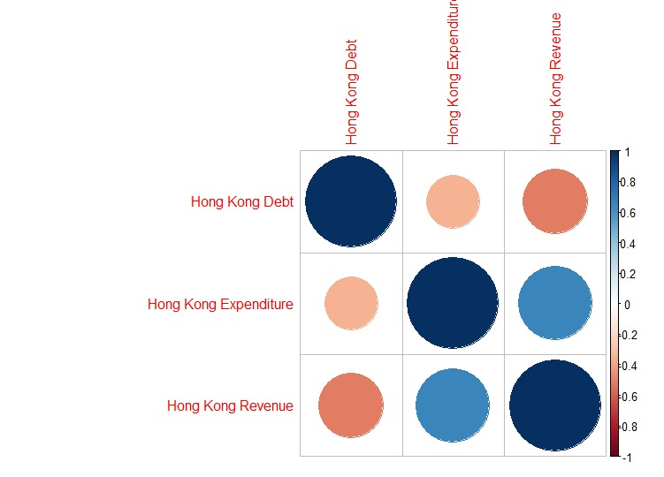

**Figure 1: Visualising Correlation matrix using correlogram for Hong Kong**

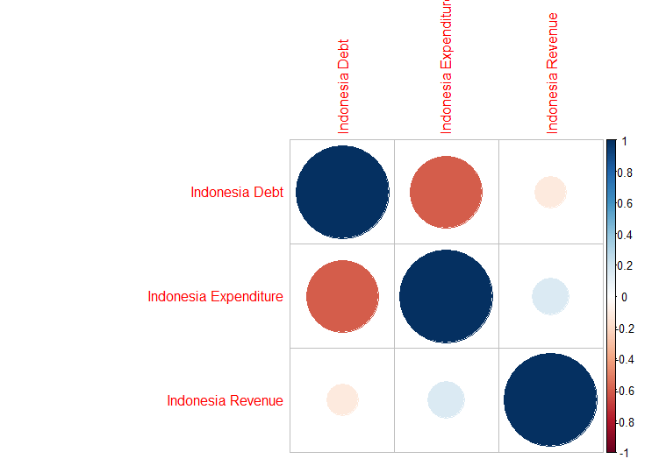

**Figure 2: Visualising Correlation Matrix using Correlogram for Indonesia**

**(3)**

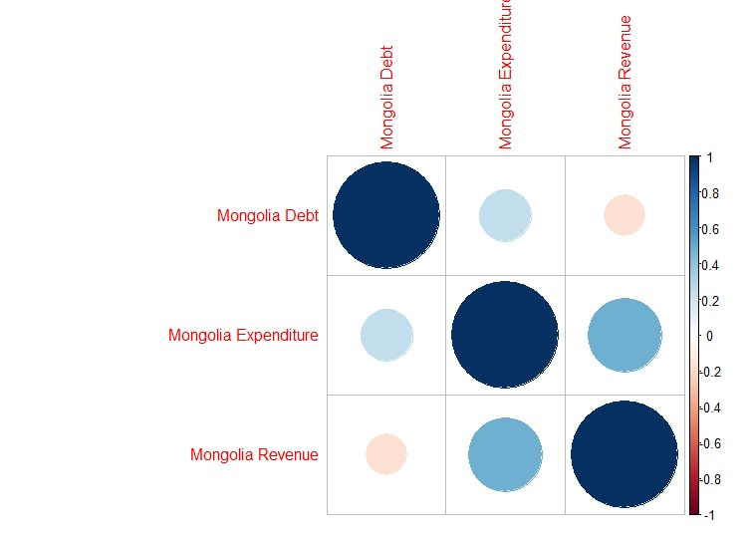

**Figure 2: Visualising Correlation Matrix using Correlogram for Mongolia**

**CONCLUSION**

Thisipaperiaimed to address both the literature gap and policy-makers’ concerns about fiscal sustainability by investigating the relationship between the dynamics of government expenditure, revenue and public debt for Indonesia, Hong Kong and Mongolia. The co-integration results indicated long-run relations between government expenditure, government revenue and public debt for all the mentioned countries. The ECM model revealed a positive and significant relationship between government expenditure, government revenue and public debt. In addition, the ECT from the study was negative and statistically significant confirming that all previous disequilibrium in the three variables is removed in the following period and is adjusted back to the long-run equilibrium. Therefore, the study confirms the existence of positive long-run relationships between government expenditure, publicidebt government revenue in all above mentioned countries. The Granger causality testing confirmed the existence of a unidirectional causality from government expenditure to public debt. Similarly, a unidirectional causality from government revenue to government expenditure is supported. This implies that the past values of government expenditure can help predict the government debts, but public debt is not a useful tool in determining government expenditure. Such a relationship indicates that policy-makers have the ability to control the country’s borrowings through government spending. The existence of the unidirectional causality from government revenue to government expenditure provides evidence that the tax-spend hypothesis is borne out in these countries as increasing taxes lead to more government spending. There is robust evidence that the government in these countries can efficiently use fiscal variables to achieve fiscal sustainability. The study recommends policy-makers to thoroughly review fiscal policy by efficiently adopting the functional finance as suggested by the Lerner theory. This involves judging all fiscal measures according to their functions in the economy. Fiscal imbalances can also be eliminated through implementation of long-term policies that stimulate government revenue, while still attempting to mitigate their expenditures to stabilise borrowings in the short run.

**References**

1. Abdulrasheed, B. (2017). Causality between Government Expenditure and Government Revenue in Nigeria. *Asian Journal of Economics and Empirical Research*, *4*(1), 91–98. <https://doi.org/10.20448/journal.501.2017.42.91.98>
2. Ahuja, D., & Pandit, D. (2020). Public Expenditure and Economic Growth: Evidence from the Developing Countries. *FIIB Business Review*, *9*(3), 228–236. <https://doi.org/10.1177/2319714520938901>
3. Eita, J. H., & Mbazima, D. (2008). The causal relationship between government revenue and expenditure in Namibia. *Journal of Economic and Financial Sciences*, *2*(2), 175–186. <https://doi.org/10.4102/jef.v2i2.353>
4. Granger, C. W. J. (1969). Investigating Causal Relations by Econometric Models and Cross-spectral Methods. *Econometrica*, *37*(3), 424. <https://doi.org/10.2307/1912791>
5. Gurdal, T., Aydin, M., & Inal, V. (2020). The relationship between tax revenue, government expenditure, and economic growth in G7 countries: new evidence from time and frequency domain approaches. *Economic Change and Restructuring*, *54*(2), 305–337. <https://doi.org/10.1007/s10644-020-09280-x>
6. Iiyambo, H., & Kaulihowa, T. (2020). An assessment of the relationship between public debt, government expenditure and revenue in Namibia. *Public Sector Economics*, *44*(3), 331–353. <https://doi.org/10.3326/pse.44.3.3>
7. Imana, D. K. (2017). The Determinants of Public Education Expenditures: An Empirical Analysis of Changing Patterns and Growth of Public Expenditure on Education in Kenya. *Journal of Public Administration and Governance*, *7*(4), 1. <https://doi.org/10.5296/jpag.v7i4.11972>
8. Kawai, M., & Morgan, P. (2013). Long-Term Issues for Fiscal Sustainability in Emerging Asia. *SSRN Electronic Journal*. Published. <https://doi.org/10.2139/ssrn.2312215>
9. Lojanica, N. (2015, February 2). *Government Expenditure and Government Revenue: The Causality on the Example of the Republic of Serbia*. Https://Ideas.Repec.Org/. <https://ideas.repec.org/h/mgt/micp15/79-90.html>
10. Presbitero, A. F. (2010). Total Public Debt and Economic Growth in Developing Countries. *SSRN Electronic Journal*. Published. <https://doi.org/10.2139/ssrn.1697506>
11. Sasmal, J., & Sasmal, R. (2018). Public Debt, Economic Growth and Fiscal Balance: Alternative Measures of Sustainability in the Indian Context. *Global Business Review*, *21*(3), 780–799. <https://doi.org/10.1177/0972150918778940>
12. Ukwueze, E. R. (2015). Determinants of the Size of Public Expenditure in Nigeria. *SAGE Open*, *5*(4), 215824401562134. <https://doi.org/10.1177/2158244015621346>