EXP 1: Square of a Number:

#include <stdio.h>

void main()

{

    double num, result;

    printf("Enter a number: ");

    scanf("%lf", &num);

    if (num > 0)

    {

        result = num \* num;

        printf("Square of the number %lf is: %lf\n", num, result);

    }

    else

    {

        printf("Error! Number must be positive.\n");

    }

}

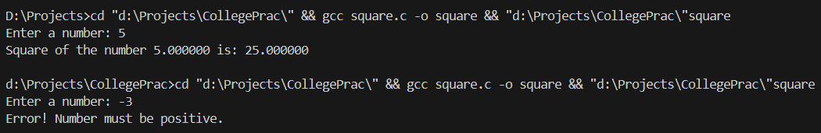Output:

EXP 2: Square root of a number:

#include <stdio.h>

#include <math.h>

void main()

{

    double num, result;

    printf("Enter a number: ");

    scanf("%lf", &num);

    if (num > 0)

    {

        result = sqrt(num);

        printf("Square root of the number %lf is: %lf\n",

num, result);

    }

    else

    {

        printf("Error! Number must be positive.\n");

    }

}

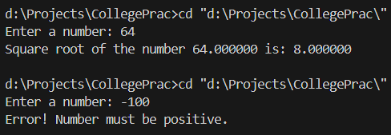Output:

EXP 3: Cube of a Number:

#include <stdio.h>

void main()

{

    double num, result;

    printf("Enter a number: ");

    scanf("%lf", &num);

    if (num > 0)

    {

        result = num \* num \* num;

        printf("Cube of the number %lf is: %lf\n", num,

result);

    }

    else

    {

        printf("Error! Number must be positive.\n");

    }

}

Output:

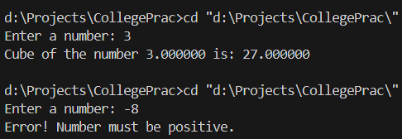

EXP 4: Cube root of a Number:

#include <stdio.h>

#include <math.h>

void main()

{

    double num, result;

    printf("Enter a number: ");

    scanf("%lf", &num);

    if (num > 0)

    {

        result = cbrt(num);

        printf("Cube root of the number %lf is: %lf\n", num,

result);

    }

    else

    {

        printf("Error! Number must be positive.\n");

    }

}

Output:

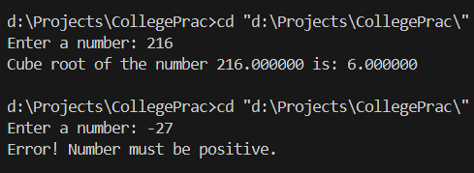

EXP 5: Check if number is Prime:

#include <stdio.h>

void main()

{

    int num;

    int prime = 1;

    printf("Enter your number: ");

    scanf("%d", &num);

    for (int i = 2; i < num; i++)

    {

        if (num % i == 0)

        {

            prime = 0;

            break;

        }

    }

    if (prime)

    {

        printf("%d is a prime number!\n", num);

    }

    else

    {

        printf("%d is not a prime number.\n", num);

    }

}

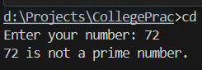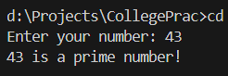Output:

EXP 6: Calculate Factorial of a number:

#include <stdio.h>

void main()

{

    double num, fact;

    printf("Enter a number: ");

    scanf("%lf", &num);

    fact = 1;

    for (double i = num; i > 0; i--)

    {

        fact \*= i;

    }

    printf("Factorial of %.0lf is %.0lf\n", num, fact);

}

Output:

