

1. Your Team Name :- **Cyber Knights**

Team Member Names :-

1.Sarthak Kanade

1. Nivedita Biswas
2. Adarsh Singh

Problem Statement –

SaaS – Platform, Marketing, CRM

MaCRM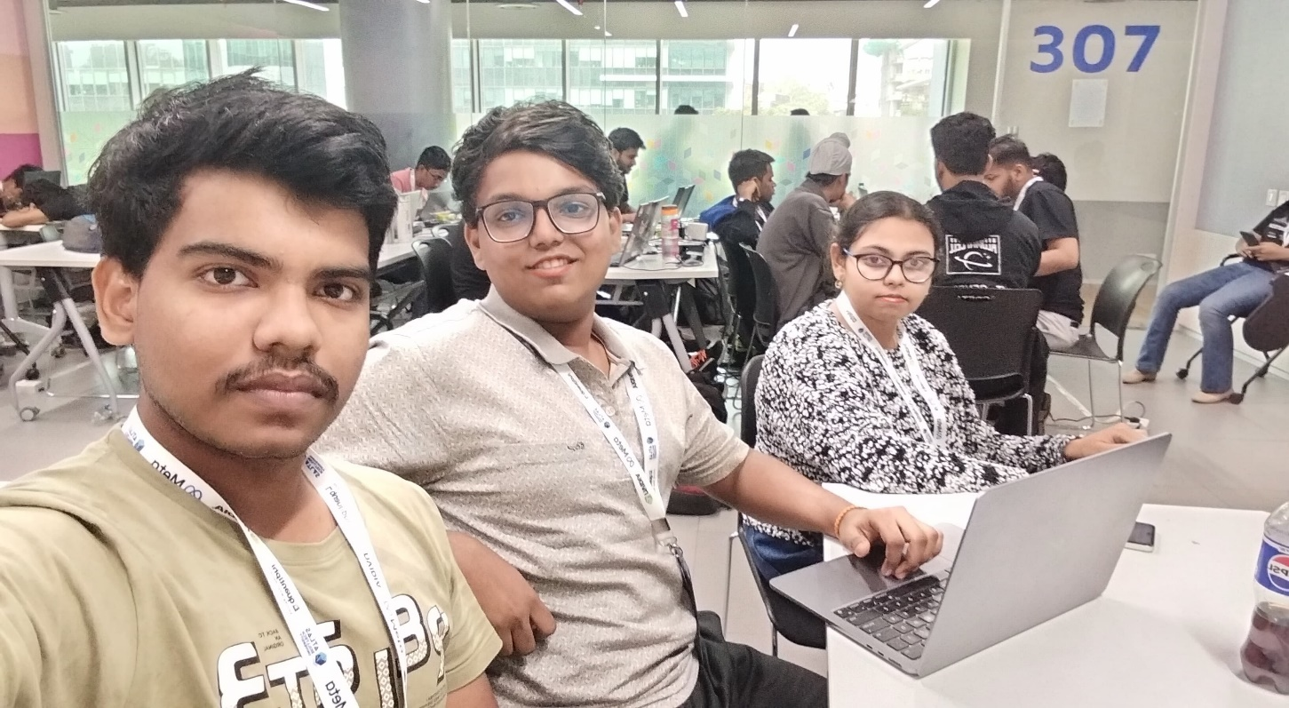

Solution-

The solution for the problem statements we have choosen consist of a Website with an AI which basically consists of a chat bot. the AI is used to understand the inventory of the client in business and manage it. It gets updated with different inputs with coordination with different AI and provide the client with a proper marketing stratergy the AI also helps the client to use CRM effectively. The AI remain up to date to provide advices to the client and have him upto date



Thank you