Experiment No. : 5

Statement Make a street light controller...

Date of Exp :

Author :Sarthak Kanoje (A-34)

int ldrPin=A0;int led[]={2,3,4,5,6};int loopLed =5;void setup(){ Serial.begin(9600); for(int i=0;i<= loopLed;i++){ pinMode(led[i],OUTPUT); digitalWrite(led[i],HIGH); } }void loop(){ int sensorValue=analogRead(ldrPin); int threshold=500; if(sensorValue>threshold){ for(int i=0;i<loopLed;i++){ digitalWrite(led[i],LOW); } } else{ for(int i=0;i<loopLed;i++){ digitalWrite(led[i],LOW); } }delay(500);}

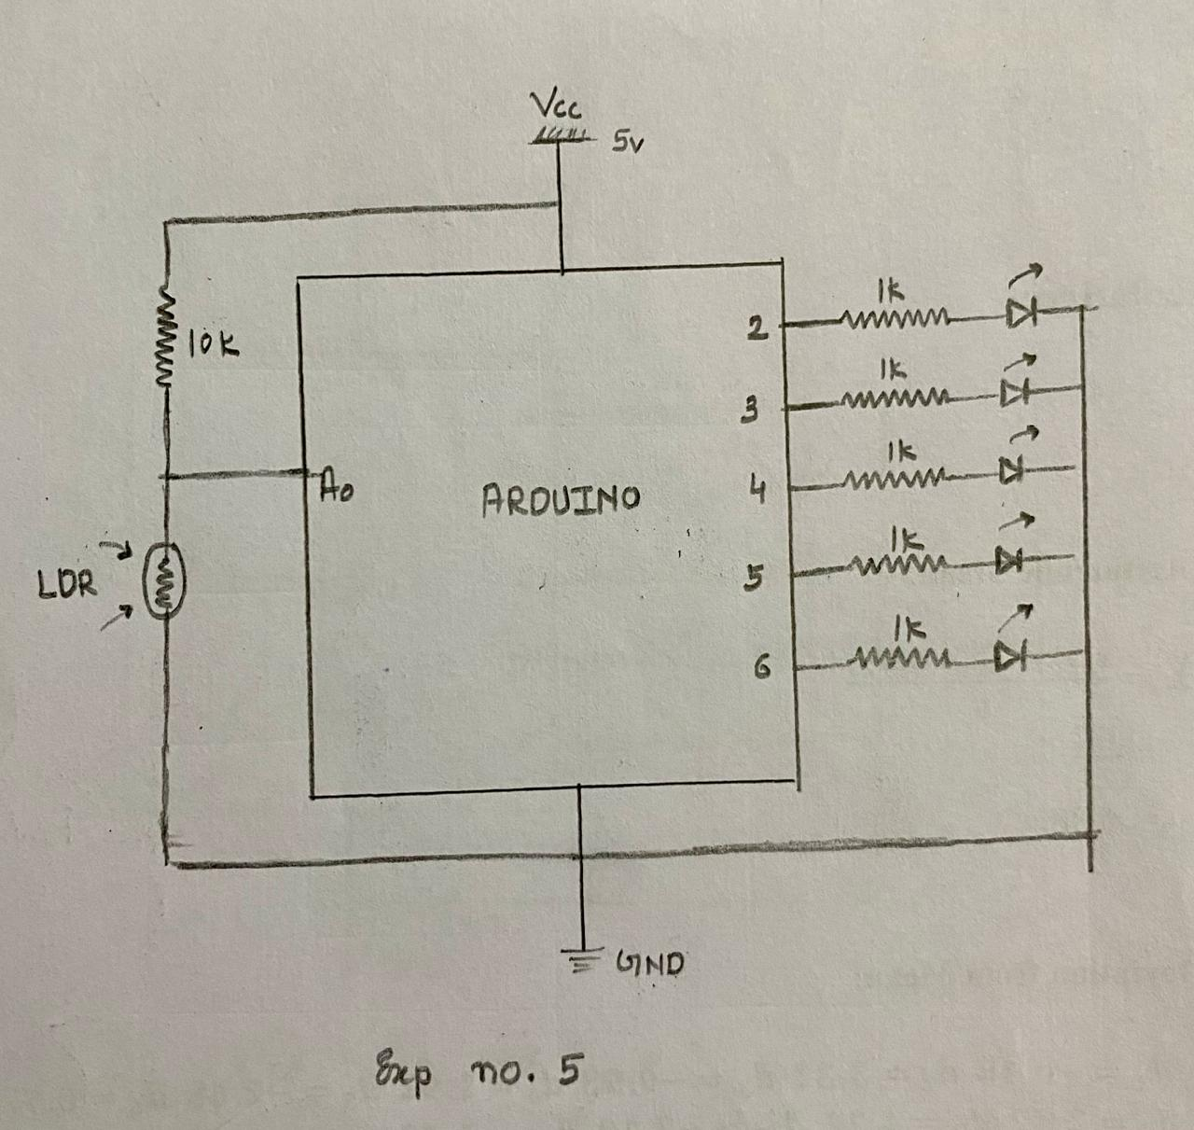

xxccccc