**Introduction to Java programming language**

**Overview:**

In this article we will discuss about what is programming language what is java programming, it's introduction, history, advantages, disadvantages and it's application in real world.

**Introduction to programming languages:**

Before we dig in java, first we should learn what is programming language. Let's take a scenario of communication or interaction of human being with each other. To communicate with each other we need a language which must be understand by the speaker as well as the listener then and then the communication will attractive and it will have value, suppose a Person belongs to Russia who understand Russian language, and another person from England who understand English language if they talk each other what would happen, both person will waste their time because British person will talk in English which Russian can't understand and Russian will talk in Russian, British person can't understand.

To talk with each other there should be a common medium which is language. In this case language is present but both the person didn't know the same language.

If at communication time the third person is present who knows English and Russian both then that person will translate the one language into another that way the interaction will have some value.

Now let's come to our topic programming language. We know that computer are made and their works are done in binary language (0's and 1's) and humans can't understand binary language easily, To write the 1 in binary it is written as 0001, and so on. To write code in this format it is very difficult to understand and write the code to communicate with machines so engineers developed a language called programming languages to program the computers to work as per human need, which is understandable by humans but not understandable by machines, to convert the one language to another we use compiler, Recall the above Prapgarh so you can understand effectively.

Many programming languages were made in computer science field like C, C++, COBOL (Common Business Oriented Language) before 1980, they have their disadvantage and the need of the new language was felt to users then the new programming language was introduced called Java programming language which has more advantages than the older ones.

**Introduction to Java:**

Java programming language is a Object oriented programming language. It has the most important feature which is platform independence. We will discuss it in more deep in advantage section.

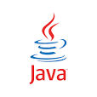

Fig: Logo of the Java programming

Let's discuss the most important topic how java is converted to machine level language.

Some programming languages are converted into machine code usin compiler those languages are clled compiled language and some are converted using interpreter those are called interpreted language, but what about java, is it compiled or interpreted, the answer is straight forward, java is hybrid language, let's discuss it.

The execution of Java program depends on two step as follows

Step 1- First when we write code and save it, the extension will .java, that .java file passed through the compiler, compiler convert the .java file into .class file which stores the byte code. The .class file is independent of the OS.

Step 2- The .class file is passed through the JVM (Java Virtual Machine) it executes the .class file, JVM is specific to operating systems, if tou use windows download JVM for windows and so on.

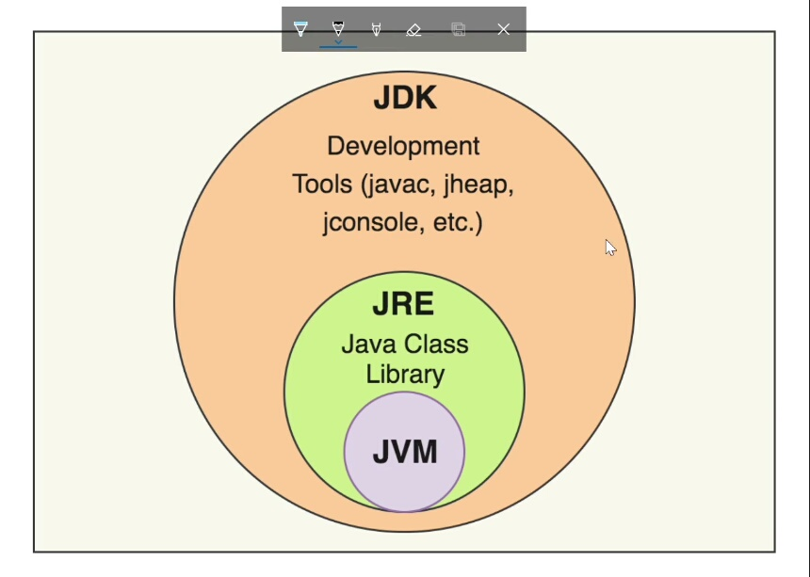

Fig: JDK (Java Development Kit)

Download link JDK:

https://www.oracle.com/java/technologies/downloads/#java16-linux

**History of Java:**

Java was introduced in 1995 by James Arthur Gosling, a Canadian computer scientist who is recognized as the “father” of the Java programming language. Java was developed in Sun Microsystems, (American company).

At the starting days of the java it's name was Oak (Oak tree which stood outside the office of James Gosling).

In 1996 the first version of java, java 1.0 was released. Nowadays java is of version Java8. Now java is owned by Oracle.



Fig: Father of java programming (James Gosling)

**Advantages of Java:**

As we mentioned in introduction section, java supports oops concept (Object Oriented Programming System). In java, programs are written in classes, then we make the objects of that classes for the sake of simplicity. This concept helps us to understand the code and the logic in more easier way, it helps to relate the programming logic to the real world instances.

The most important advantage of the java is that, it is platform independent. Java supports (Write ones run every where) means write the code on any OS (operating system) and compile it (conversion of the human readable language into machine code) and run the program on any other OS.

E.g: write the code on Linux or Mac, compile the code then run it on any of your choice's OS, on windows or Linux or Mac.

Using the OOPs concept we can write the code secure, efficient and hidden from the user.

Java provides the use of interfaces, using this we can achieve multiple inheritance type features.

Java provide us the functionality of multithreading (basically multithreading is the ability of a central processing unit (CPU) to provide multiple threads of execution concurrently).

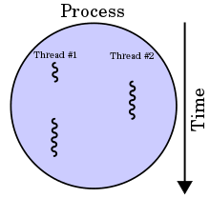

**fig: Multithreading**

It also supports exception handling, exception handling is the process to handle the unwanted exceptions which may occur at runtime.

**Drawbacks of java:**

Java has disadvantages also, it doesn't support multiple inheritance (Inheritance is a concept of object oriented programming, using inheritence we create the class and extend its properties, methods in another class. It helps us to write the code fast and in efficient manner).

In programming the DRY principal is very important (DRY-> Do not Repeat Yourself) using inheritence we can achieve the DRY principal.

Multiple inheritance means it cannot extends properties of the two class at same time but java doesn't support multiple inheritance.

Available IDE's

Before mentioning IDE's you should know what is IDE, Full form of IDE is (Integrated Development Environment), basically the IDE is a application program which helps us to write codes efficiently and in very less time and without any frustration because it provides us very attractive themes to write code comfortably. We can write code in any editor like in windows notepad, in Ubuntu G-edit, but they are not very programmer friendly, that's why most of the programmers prefer IDE to write code.

There are so many IDE's to write java code, here we mention some of those below.

Intellij idea:

* Intellij idea is the most widely used IDE to write java code, it provides multiple themes.
* This is developed by JetBrains

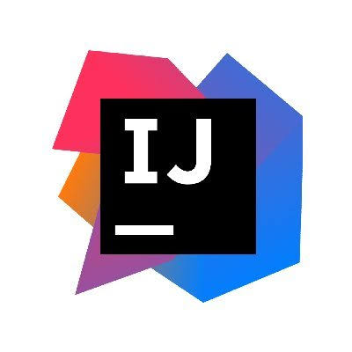

Fig: Logo of Intellij idea

Download link of intellij idea:

https://www.jetbrains.com/idea/download/#section=windows

Eclipse IDE:

* Eclipse is developed by IBM, this IDE is very similar to the Intellij idea in themes.



Fig: Eclipse IDE

Download link of Eclipse:

https://www.eclipse.org/downloads/packages/release/helios/sr1/eclipse-ide-java-developers

VS code:

* VS code stands for Visual Studio code.
* In this IDE you can write the java code as well as C, C++ and other programming languages.
* It is developed by Microsoft.

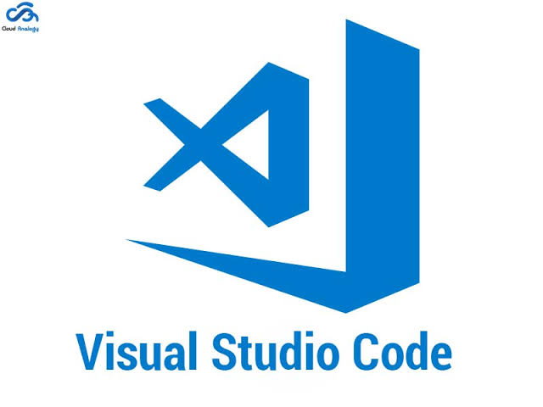

Fig: logo of the VS code

Download link of VS code:

https://code.visualstudio.com/download

Apache NetBeans:

* Apache NetBeans is official IDE to write java code.
* It is developed by Apache Foundation.



Fig: Logo of NetBeans IDE

Download link of Apache NetBeans:

https://netbeans.apache.org/download/nb125/nb125.html

Application of Java

* Java has larger community due to its application in real world.
* Before 2019 java was the official language for the Android operating system, now it is changed to kotlin.
* Java is also used in Mobile applications, web applications.
* Java programming is also used in backends of the servers, Gaming applications etc.