**PROJECT: Myntra Clone website**

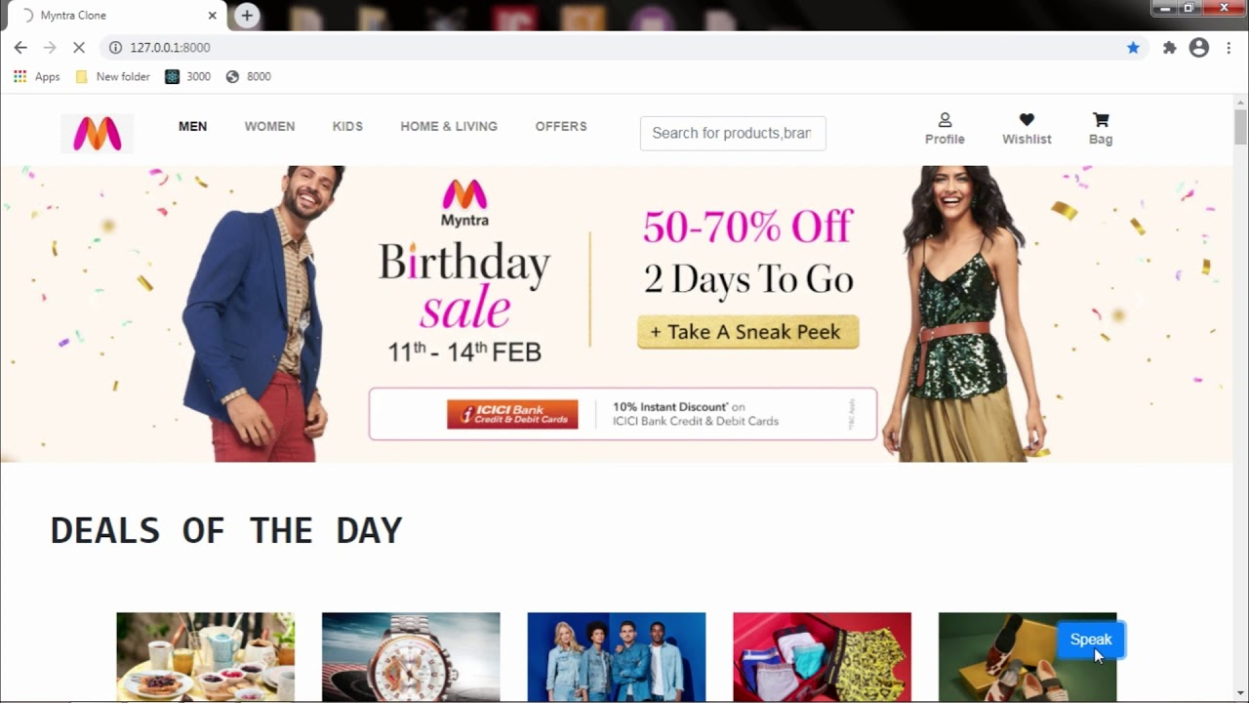

**OBJECTIVE:**

Myntra is an e-commerce website for fashion and clothing known worldwide. Myntra is a one stop shop for all your fashion and lifestyle needs. Being India's largest e-commerce store for fashion and lifestyle products, Myntra aims at providing a hassle free and enjoyable shopping experience to shoppers across the country with the widest range of brands and products on its portal. The brand is making a conscious effort to bring the power of fashion to shoppers with an array of the latest and trendiest products available in the country.

Objective of this project “Myntra-clone website” is to develop a website which looks and works similar to myntra. All the execution and functionality should be same as a ordinary e-commerce website that we use in our daily life.

**Features to achieve:**

* Login and logout page
* Quick search
* Recent views
* Payment Gateway
* Sort animations

**Technologies will be used(Considering for final):**

1. **HTML**
2. **CSS**
3. **JavaScript**
4. **React**
5. **Express**
6. **NodeJs**
7. **MongoDB**

**Name: Sarthak Kumar**

**Batch:79**