CalciUltra Calculator App
Internship Mini Project Submission Document
Task | JavaScript calculator app using DOM manipulation
Technology | HTML, CSS, Vanilla JavaScript
Live Demo Link | https://calciultra.netlify.app/
GitHub Repository | https://github.com/SarthakMR2006/CalciUltra

1. Project Overview
This project is a responsive calculator web app built with HTML, CSS, and JavaScript. The main purpose of the project was to practice DOM manipulation by creating an interactive app where every button updates the display and performs a real action.
I kept the app simple enough to understand, but added useful extra features so it feels more complete than a basic calculator. The final version includes standard calculation, scientific functions, memory, history, copy result, keyboard input, and a unit converter.

2. Hosted Links
Live Demo: https://calciultra.netlify.app/
GitHub Repository: https://github.com/SarthakMR2006/CalciUltra

3. Screenshots
Live application screenshot:
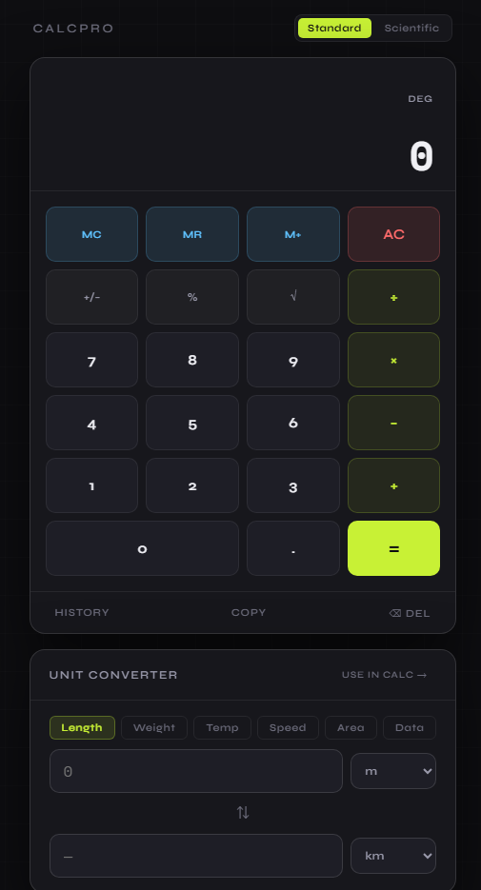
GitHub repository screenshot:
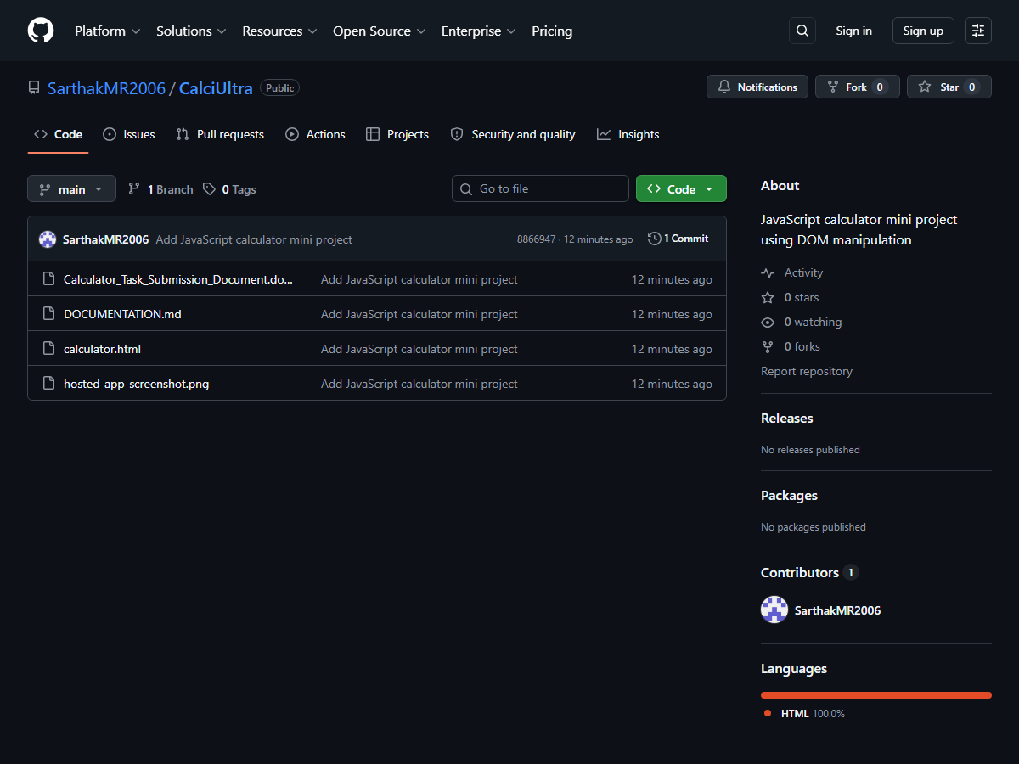

4. Technology Used
- HTML for the calculator layout, display area, buttons, and unit converter structure.
- CSS for the dark calculator UI, button styling, responsive layout, spacing, and visual polish.
- JavaScript for button clicks, DOM updates, calculations, history, memory, scientific mode, and unit conversion.
- Netlify for hosting the live application.
- GitHub for storing and sharing the project source code.

5. Features Implemented
- Standard calculator operations: addition, subtraction, multiplication, and division.
- Decimal input, percentage, plus/minus toggle, square root, AC, and backspace.
- Scientific mode with sin, cos, tan, inverse trig, log, ln, powers, constants, reciprocal, absolute value, and factorial.
- Function-first input such as sqrt then 8 then equals, with the expression shown clearly on the top display line.
- Memory controls: MC, MR, and M+.
- Calculation history panel with previous answers.
- Unit converter for length, weight, temperature, speed, area, and data.
- Copy button with fallback logic for browsers that block direct clipboard access.
- Keyboard support for common calculator actions.

6. Commands Used
The project can be tested locally with a simple static server command:
python -m http.server 8080

Then open this local URL:
http://127.0.0.1:8080/calculator.html

GitHub setup and push commands used:
git init
git add calculator.html DOCUMENTATION.md Calculator_Task_Submission_Document.docx hosted-app-screenshot.png
git commit -m "Add JavaScript calculator mini project"
git branch -M main
git remote add origin https://github.com/SarthakMR2006/CalciUltra.git
git push -u origin main

Netlify deployment was done by uploading the project file/folder to Netlify and using the hosted app link shown above.

7. Important Code Snippets
These are the parts of the code that handle the most important project behavior.

HTML display area
<div class="display">
<div class="history-expression" id="histExpr"></div>
<div class="main-display" id="mainDisplay">0</div>
</div>

Calculator state
let display = '0';
let expression = '';
let pendingOp = null;
let prevVal = null;
let pendingUnary = null;

Prefix function handling
function setPendingUnary(op) {
if (display === 'Error') return;
pendingUnary = op;
justCalc = true;
refreshInputDisplay();
}

function applyPendingUnary() {
if (pendingUnary === null || display === 'Error') return;
const n = parseFloat(display);
const op = pendingUnary;
pendingUnary = null;
finishUnary(op + '(' + display + ')', runUnary(op, n));
}

Unit converter formula
result = (fromVal * cat[fromUnit]) / cat[toUnit];

8. Manual Testing
Test Area | What Was Checked | Status
Basic calculator | Numbers, operators, decimal, equals, AC, and backspace | Passed
Error handling | Division by zero shows Error instead of crashing | Passed
Scientific mode | sin, cos, tan, inverse trig, powers, constants, factorial | Passed
Function-first input | sqrt then 8, sin then 30, inverse functions before number | Passed
Memory and history | M+, MR, MC, and history panel | Passed
Unit converter | Length, Weight, Temperature, Speed, Area, and Data | Passed
Hosted app | Live Netlify link opens and app loads correctly | Passed

9. Short Code Explanation
The calculator stores the current number in the display variable. When a number button is clicked, JavaScript changes the text on the screen using DOM manipulation. When an operator is clicked, the first value and selected operator are stored until the user enters the second value and presses equals.
Scientific functions use a separate pendingUnary variable. This is useful because it allows natural calculator input such as pressing sqrt first, typing 8, and then pressing equals. The smaller top display line shows the full expression, while the main display remains easy to read.
The unit converter uses conversion factors. For most unit types, the value is converted to a base unit first and then converted to the selected target unit. Temperature uses separate formulas because it needs offsets, not just multiplication.

10. Final Submission Checklist
- Hosted link included.
- GitHub repository link included.
- Source code included in repository.
- Screenshots included.
- Important code snippets included.
- Commands included.
- Short documentation included.

