Spotify Web Player UI Clone
Internship Project Submission Document

1. Project Overview
This project is a responsive UI-only clone of the Spotify Web Player. It was created using HTML, CSS, and JavaScript to demonstrate front-end layout, styling, responsiveness, and small interactive UI behavior.
Task | Clone the UI of a real-world website using HTML, CSS, and JS
Selected Option | Spotify Web Player (UI only)
Live Demo Link | https://sarthakmr2006.github.io/spotify-web-player-clone/
Source Code Link | https://github.com/SarthakMR2006/spotify-web-player-clone

2. Hosted Links
Live Demo: https://sarthakmr2006.github.io/spotify-web-player-clone/
GitHub Repository: https://github.com/SarthakMR2006/spotify-web-player-clone

3. Screenshots
Live demo screenshot:
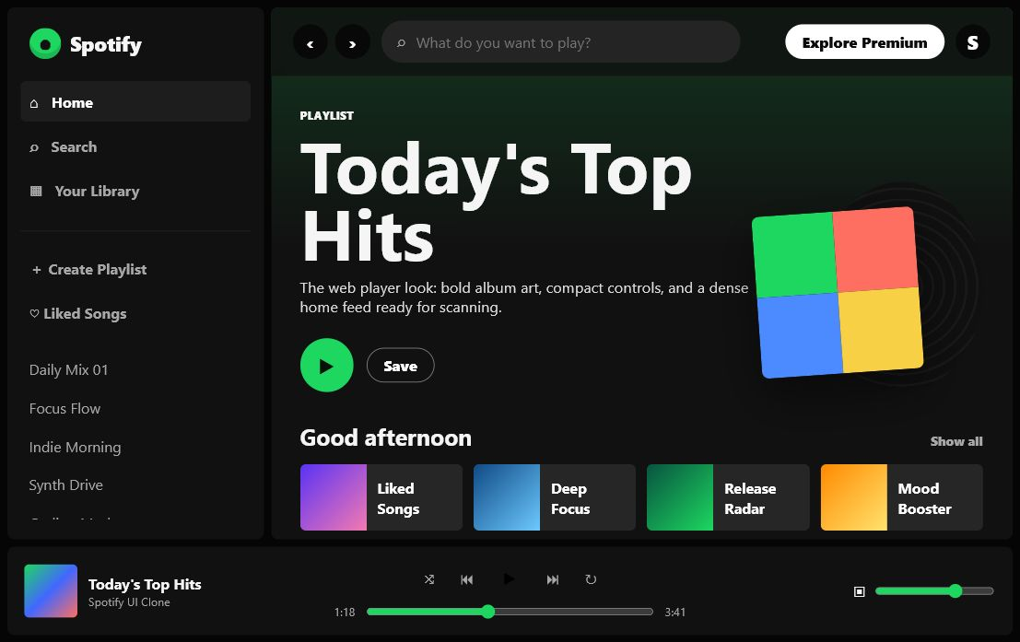
GitHub repository screenshot:
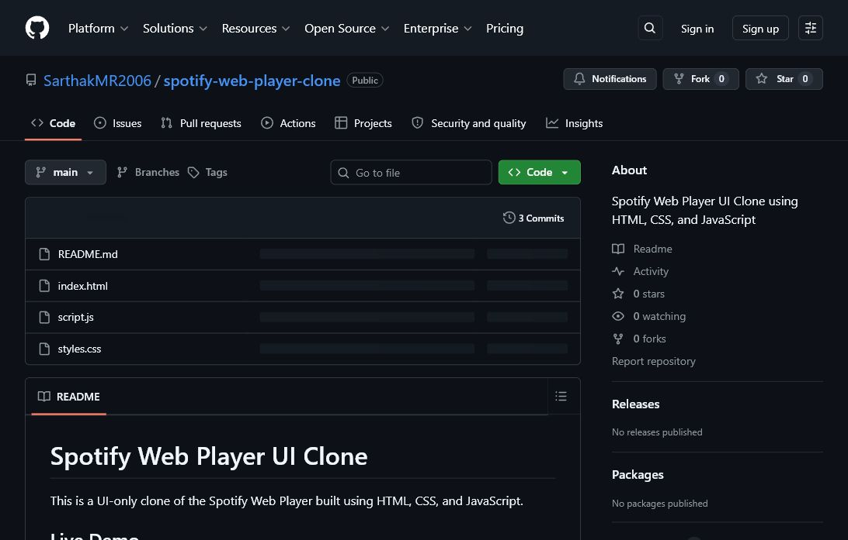

4. Technology Used
- HTML for the page structure and content sections.
- CSS for Spotify-style layout, colors, spacing, responsive design, and player styling.
- JavaScript for UI-only interactions such as play button state, track selection, and mobile sidebar toggle.
- GitHub for source code hosting.
- GitHub Pages for live deployment.

5. Features Implemented
- Spotify-style sidebar with navigation and playlist links.
- Top navigation bar with search input and account controls.
- Featured playlist hero section.
- Quick playlist cards and album recommendation cards.
- Bottom music player UI with play controls, progress bar, and volume control.
- Responsive layout for desktop and smaller screens.
- Interactive track selection that updates the now-playing area.

6. Commands Used
The project can be tested locally with a simple static server command:
python -m http.server 4173 --bind 127.0.0.1
Then open the local preview URL:
http://127.0.0.1:4173/
GitHub Pages deployment was completed from the GitHub website:
- Open the repository on GitHub.
- Go to Settings > Pages.
- Choose Source: Deploy from a branch.
- Choose Branch: main and Folder: / (root).
- Save the settings and use the generated github.io live demo link.

7. Code Snippets

HTML structure
<link rel="stylesheet" href="styles.css" />
<script src="script.js" defer></script>
<aside class="sidebar" id="sidebar">
<div class="brand">
<span class="brand-mark"></span>
<span>Spotify</span>
</div>
</aside>
<footer class="player">
<strong id="trackTitle">Today's Top Hits</strong>
</footer>

CSS layout and responsive design
.app-shell {
display: grid;
grid-template-columns: 278px minmax(0, 1fr);
grid-template-rows: minmax(0, 1fr) 96px;
gap: 8px;
height: 100vh;
}
@media (max-width: 980px) {
.sidebar {
position: fixed;
transform: translateX(-110%);
}
.sidebar.open {
transform: translateX(0);
}
}

JavaScript interaction
function setTrack(title) {
trackTitle.textContent = title;
isPlaying = true;
mainPlay.textContent = "Pause";
document.title = `${title} - Spotify Web Player UI Clone`;
}
menuToggle.addEventListener("click", () => {
sidebar.classList.toggle("open");
});

8. UI-only Scope
This submission is intentionally UI-only. It recreates the visual layout and front-end interactions of a Spotify-style web player, but it does not include real Spotify login, music streaming, backend APIs, real user accounts, or real playlist data.

9. Conclusion
The project satisfies the requirement to clone the UI of a real-world website using HTML, CSS, and JavaScript. The live demo is hosted publicly through GitHub Pages, and the source code is available in a public GitHub repository.

