**Biodiversity:**

* **Definition: genetic, species and ecosystem diversity.**
* **Value of biodiversity: consumptive use, productive use.**

**Threats to biodiversity: habitat loss, poaching of wildlife, man-wildlife conflicts.**

1. **Definition:**

The living world is a complex combination of different levels of organisms. The key components of life are at one extreme and communities of species at the other extreme. The manifestations of all types of diversities are found at all these levels of organisms. Biodiversity is the shorter form of word biological diversity which means diversity in the biological world. Thus one can define biodiversity as the degree of variety in nature with regards to biological species.

**Biodiversity coined by walter .g rosen in 1985;**

**Father of biodiversity= Edward o Wilson(he popularized biodiversity)**

**2011-2020------------biodiversity decade;**

**2020-2030---------** Decade of Ocean Science for Sustainable Development;

What is biodiversity?

Ans:

Biodiversity refers to the varity and variability among living organisms and ecological complexes in which they occur thud biodiversity could be defined as the protality of genes and species and ecosystem of a region.

Eg: farmers are using hybrid seeds for high yield and they have high resistance and can be grown in vulranable enviroments

Why do we save seeds?

If condition arises due to which particular crop vanishes then we can have seeds from seed banks and bring it back

Pitty cotton

**2. Types of Biodiversity:**

**(a) Genetic diversity:**

It is the variation of genes within the species. This results distinct population of one, even same species. It gives genetic variation within a population or varieties within one species. There are two reasons for differences between individual organisms. One is variation in the gene which all organisms possess which is passed from one to its offspring’s.

The other is the influence of environment on each individual organism. The variation in the sequence of four base pairs in DNA chain forms the genetic variation in the organism. The recombination) of genetic material during cell division makes it an imperative for genetic diversity within a species. Loss of genetic diversity within a species is called genetic erosion.

The whole area of agricultural productivity and development depend on genetic diversity. The plant as well as animal genetic resources play important role in the economy of a country. Genetic diversity is the whole basis for a sustainable life system in the earth.

Scientists in many parts of the world are trying to introduce genetically modified seeds in the agriculture sector for better yield as well as for the resistance of drought and flood situations. The local people or farmers are not showing any interest to preserve the natural way of genetic diversity.

**(b) Species diversity:**

This refers to the variety of species within a particular region. The number of species in a region is a measure for such diversity. The richness of species in a given region provides a yard stick for species diversity. Species diversity depends as much on the genetic diversity as on the environmental condition.

Colder regions support less than the warmer regions for species diversity. The good climate with good physical geography supports a better species diversity. Species richness is a term which is used to measure the biodiversity of a given site.

In addition to species richness, species endemism is a term used to measure biodiversity by way of assessing the magnitude of differences between species. In the taxonomic system similar species are grouped together in general, similar genera in families, families in orders and so on till in the level of kingdom. This process is a genuine attempt to find relationships between organisms. The higher taxa have thousands of species. Species that are very different from one another contributes more to overall biodiversity.

**Browny points**

* **1.75 million different species**
* **950000 insects**
* **270000 plants**
* **19000 fishes**
* **4000 mammels**

**Diversity on which calculation of species is done**

**Alpha diversity;**

Total number of species in ecosystem

**mean diversity of species in different sites or habitats within a local scale**

**Beta diversity;**

Comparison of two ecosystem

Similar cheezo ko hata denge when comparing two ecosystem ans 1 and 5

2,3,4,5,

1,2,3,4,

**Gamma diversity;**

**India has very high biodiversity because combination of various ecosystem as compared to Norway**

**More rainfall more biodiversity but moving towards polar region**

In ecology, gamma diversity (γ-diversity) is the**total species diversity in a landscape**. Or that means combination of ecosystem;

**(c) Ecological diversity:**

This is the number of species in a community of organisms. Maintaining both types of diversity is fundamental to the functioning of ecosystems and hence to human welfare. India is one of the 12 centres of diversity and origin of several cultivated plants in the world. It is estimated that 15,000 species of plants occur in India. The flowering plants comprise 15,000 species of which several hundred (5000-7500) species are endemic to India. The region is also rich in fauna, containing about 65,000 species of animals.

Among these, more than 50,000 species of insects, 4,000 of molluscs. 6,500 of other invertebrates, 2,000 offish, 140 of amphibians, 420 of reptiles, 1,200 of birds and 340 of mammals are recorded from India. This richness in biological diversity is due to immense variety of climatic and altitudinal conditions coupled with varied ecological habitats.

These vary from the humid tropical Western Ghats to the hot desert of Rajasthan, from the cold desert of Ladakh and the icy mountains of Himalayas to the warm coasts of peninsular India including coastal region of Orissa. Gandhamardan Hills of Sambalpur is rich in biodiversity. The Indian tradition teaches us that all forms of life, human, animal and plants are so closely linked that disturbance in one gives rise to imbalance in the other. Our old scriptures tell lot about these things.

**3.Value of biodiversity**

Some of the classifications of biodiversity value are: 1. Consumptive use Value 2. Productive use Values 3. Social Value 4. Ethical Value 5. Aesthetic Value 6. Option Values 7. Ecosystem Service Value.

The value of biodiversity in terms of its commercial utility, ecological services, social and aesthetic value is enormous. We get benefits from other organisms in innumerable ways. Sometimes we realize and appreciate the value of the organism only after it is lost from this earth.

**Biodiversity value may be classified as follows:**

**A. Consumptive use Value:**

These are direct use values where the biodiversity products can be harvested and consumed directly e.g. fuel, food, drugs, fibre etc.

**(a) Food:**

A large number of wild plants are consumed by human beings as food. About 80,000 edible plant species have been reported from the wild. About 90% of present-day food crops have been domesticated from wild tropical plants.

**(b) Drugs and medicines:**

About 75% of the world’s population depends upon plants or plant extracts for medicines. The wonder drug Penicillin used as an antibiotic is derived from a fungus called Penicillium. Likewise, we get Tetracycline from a bacterium. Quinine, the cure for malaria is obtained from the bark of Cinchona tree, while Digitalin is obtained from foxglove (Digitalis) which is an effective cure for heart ailments.

Recently Vinblastine and Vincristine, two anticancer drugs, have been obtained from Periwinkle (Catharanthus) plant, which possesses anticancer alkaloids. A large number of marine animals are supposed to possess anti-cancer properties which are yet to be explored systematically.

**(c) Fuel:**

Our forests have been used since ages for fuel wood. The fossil fuels like coal, petroleum and natural gas are also products of fossilized biodiversity. Firewood collected by individuals is not normally marketed, but are directly consumed by tribes and local villagers, hence falls under consumptive value.

**B. Productive use Values:**

These are the commercially usable values where the product is marketed and sold. It may include number of wild gene resources that can be traded for use by scientists for introducing desirable traits in the crops and domesticated animals.

These may include the animal products like tusks of elephants, musk from musk deer, silk from silkworm, wool from sheep, fir of many animals, lac from lac insects etc, all of which are traded in the market. Many industries are dependent upon the productive use values of biodiversity e.g. the paper industry, plywood industry, railway sleeper industry, silk industry, textile industry, ivory-works, leather industry, pearl industry etc.

**C. Social Value:**

These are the values associated with the social life, customs, religion and psycho-spiritual aspects of the people. Many of the plants are considered holy and sacred in our country like Tulsi (holy basil), Peepal, Mango, Lotus, Bael etc. The leaves, fruits or flowers of these plants are used in worship.

Social value of biodiversity prospecting motivated habitat conservation in some areas, as traditional societies valued it as a resource. Ecosystem people value biodiversity as a part of their livelihood as well as through cultural and religious sentiments. A great variety of crops have been cultivated in traditional agricultural systems and permitted a wide range of produce to be grown and marketed throughout the year and acted as an insurance against the failure of one crop. In recent years, farmers have begun to receive economic incentives to grow cash crops for national or international markets, rather than to supply local needs. This has resulted in local food shortages, unemployment, landlessness, and increased vulnerability to drought and [floods](http://ecoursesonline.iasri.res.in/mod/page/view.php?id=119560).

**D. Ethical and moral values:**

Ethical values related to biodiversity conservation are based on the importance of protecting all forms of life against illegal activities like cloning of animals, smuggling of valuable biodiversity instances, bio-piracy, illicit trade etc. In India, several generations have preserved nature through local traditions. However, immediate benefit rather than ethics appears to be modern man’s objective.

**E. Aesthetic value:**

Biodiversity is a direct source of pleasure and aesthetic satisfaction – its contribution to quality of life, outdoor recreation and scenic enjoyment. They provide opportunities for recreational activities such as hiking, canoeing, bird watching, river rafting, rock climbing, trekking, parasailing, bird watching and nature photography. The designing of thousands of new horticultural species, wild life conservation, landscape luxury, national parks, zoological and botanical gardens, snake, crocodile, butterfly parks, and biotechnologically manipulated novel curios species added to the existing aesthetics.

**4. Major Threats To Biodiversity**

Biodiversity, which literally means “*the diversity of life*“, refers to the variety of life forms on Earth. This diversity includes all the variations that exist in all **levels of biological organization**.

But bear in mind that biodiversity is more than just species. To correctly classify life forms, the diversity among different habitats and ecosystems as well as the diversity among individuals regarding genetic makeup should be considered.

Biodiversity is vital to boost productivity in ecosystems where species depend on to live. However, a lot of man-made activities impose huge impacts on biodiversity.

Below, we discuss six of the major threats to biodiversity: *climate change*, *habitat loss and degradation*, *pollution*, *invasive species*, *over-exploitation* and *epidemics*. Learn how serious these threats are in contributing to the loss of biodiversity in our planet.

**Table of Contents**

* [Threats To Biodiversity](https://www.bioexplorer.net/threats-to-biodiversity.html/#Threats_To_Biodiversity)
  + [1. Climate Change](https://www.bioexplorer.net/threats-to-biodiversity.html/#1_Climate_Change)
  + [2. Habitat Loss and Degradation](https://www.bioexplorer.net/threats-to-biodiversity.html/#2_Habitat_Loss_and_Degradation)
  + [3. Pollution](https://www.bioexplorer.net/threats-to-biodiversity.html/#3_Pollution)
  + [4. Invasive Species](https://www.bioexplorer.net/threats-to-biodiversity.html/#4_Invasive_Species)
  + [5. Overexploitation](https://www.bioexplorer.net/threats-to-biodiversity.html/#5_Overexploitation)
  + [6. Other Potential Threats](https://www.bioexplorer.net/threats-to-biodiversity.html/#6_Other_Potential_Threats)

**Threats To Biodiversity**

1. Climate Change

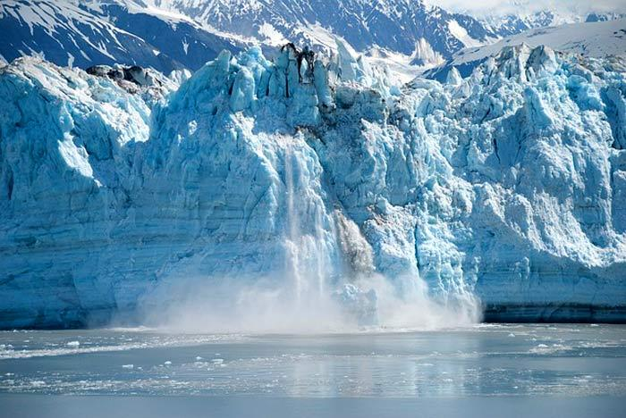

Climate change refers to the long term and irreversible change that occurs in the Earth’s climate. This increase in the temperature of the atmosphere has major effects on the environment such as the seasons, rising of the sea levels, and glacial retreats.

* The biodiversity of organisms are affected regarding their population, distribution, level of the ecosystem, and even the individuals’ morphology and function.
* Because of the increase in temperature, organisms have already adapted by expanding their ranges in latitudes. Because of this behavior, many species population have declined. Aside from this, many **animals** have exhibited changes in the timings of their physiological functions. These include the birds and insects migrating and mating earlier than usual, which then result in some failure in breeding and production of young.
* Regarding ecosystems, studies revealed that climate change has brought the expansion of many desert ecosystems and thus have effects on the function and services that the ecosystem can provide.

For humans, the rapidly increasing rate in climate change imposes great threats for human security as the natural resources are becoming more and more limited. At present, global warming and climate change already have irreversible impacts on biodiversity. And these effects, if not mitigated, can lead to more significant threats in the future.

2. Habitat Loss and Degradation

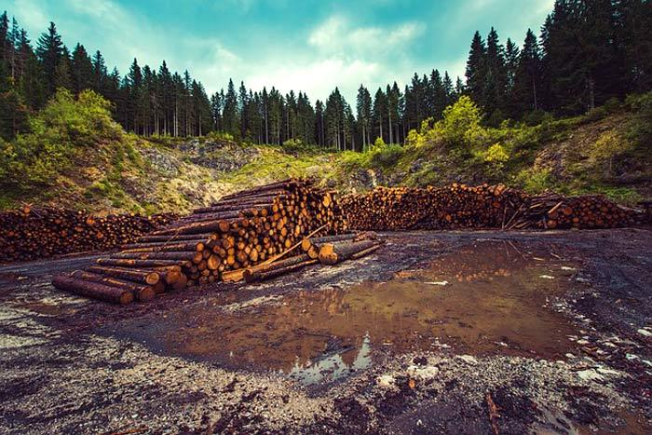

Habitat loss refers to changes in the environment that result to the rendering of a specific habitat to be functionally valuable. The habitat can no longer accommodate and support the life of the organisms present, thereby declining their population.

* Habitat loss may either be caused by natural events like natural calamities and geological events or anthropogenic activities like deforestation and man-induced climate change.
* In the process of habitat degradation, the organisms that were once living in a particular area or region are displaced and are forced to relocate; thus resulting in biodiversity reduction.

Indeed, man-made efforts are the prime reasons for habitat loss. At present, the practice of clearing out ecosystems for agriculture conversion and industrial expansion continues to displace organisms of their natural habitat. Other activities include logging and mining.

3. Pollution

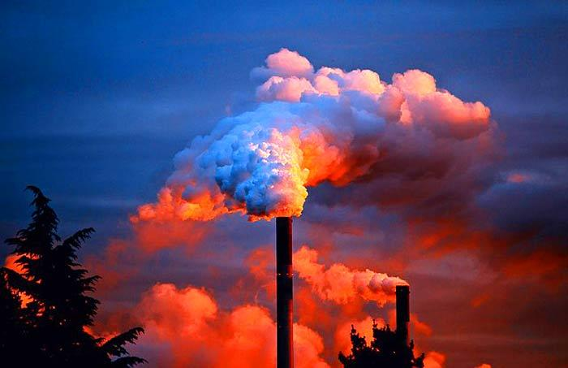

Be it water, air, or land pollution, all forms of pollution appear to be a threat to all life forms on Earth. However, it plays a major threat to biodiversity when it comes to the nutrient loading of the elements nitrogen and phosphorus.

* In Europe, atmospheric nitrogen is the only pollutant that has not decreased in concentration since the implementation of legislation. Its mere presence poses huge challenges to the conservation measures intended to natural habitats and species living there.
* Furthermore, the presence of nitrogen compounds in water systems can cause eutrophication (excessive plant and algal growth).
* The presence and accumulation of phosphorus in water systems can alter the way food webs function. Excessive phosphorus, like nitrogen can result to the uncontrolled growth of planktonic **algae**; thus increasing organic matter deposition in the seabed.
* Another form of pollution that can damage and kill living organisms is acid rain. Acid rain, as its name suggests, is rain that is composed of harmful acids (i.e., nitric and sulfuric acid). This rain is usually a result of pollution coming from the excessive burning of fossil fuels.

Some types of pollution, like the depletion of the ozone layer, can be reversible. However, this shall only happen when humans stop or limit the use of various chemicals that contribute to its destruction.



4. Invasive Species

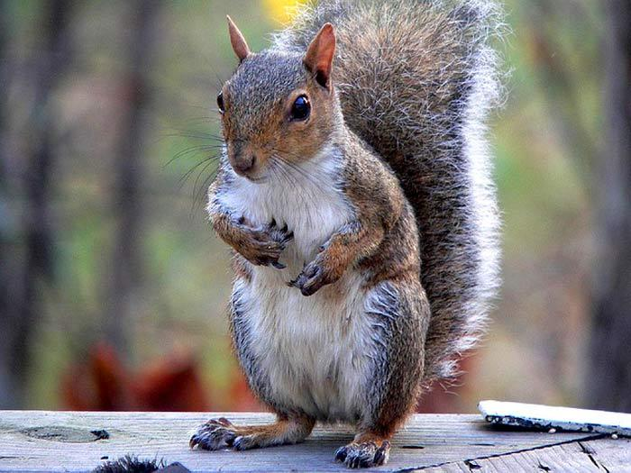

An exotic or unnatural species can be any kind of organism that has been introduced to a foreign habitat. This introduction can cause major threats to the native species as they often become subjected to great competition for resources, disease, and predation. When these species have successfully colonized the area, they are already called “*invasive*” ones.

* Next to habitat loss, invasive species are ranked as the second biggest threat to biodiversity.
* The greatest threat that invasive species can bring is their capability to change an entire habitat. These species are highly adaptable and can easily dominate a certain area. Because many natural species survive only in a particular environment, they tend to be displaced, or worse, perish.
* Some places have very low possibilities for the invasion of species. Usually, these places include those with harsh environmental conditions like extreme temperatures and high salinity.

            Invasive Species Examples

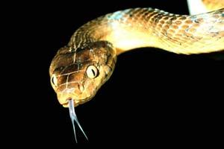

Brown Tree Snake When the brown tree snake was introduced to Guam (an island in Pacific Ocean), it wiped out 3/4th of the bird population by eating their eggs and young birds from the nests. This is one of the examples of invasive species by predation. Read more about this [here](https://www.theatlantic.com/science/archive/2017/08/guam-military-wildlife/536622/).

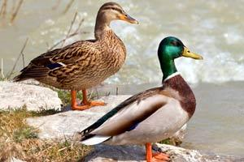

Hawaiian Duck Vs. North American MallardAs Hawaiian ducks and North American ducks share similar genetic composition, they mate each other to create a new breed of ducks. This causes of gradual reduction of Hawaiian ducks species. This is an example of invasive species by hybridization. Refer to this good article from University of California for more coverage on this.

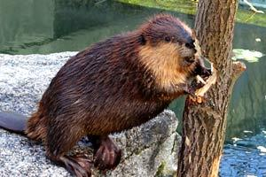

BeaversIn the early 1940s, North American beavers were introduced to grow the fur industry in Argentina. The result was very astounding. Beavers chewed down the native South American tree roots and trunks which wiped out about 40 million acres of pure forest area into plain lands.

Most exotic species are brought to a certain place to replace or add something to the vegetation. It is important to note that not all introduced species become invasive. Most of these attempts have become successful.

5. Overexploitation

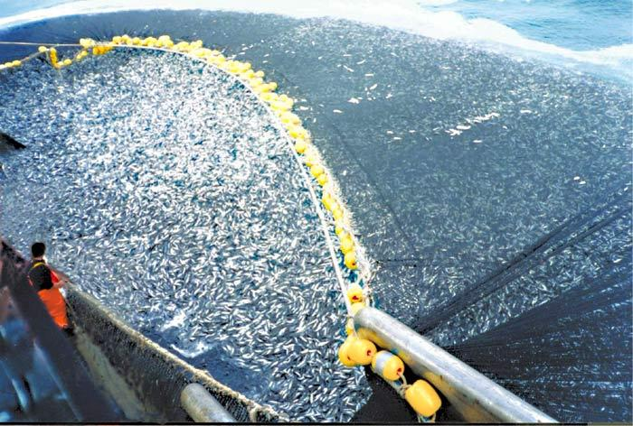

Overexploitation refers to the act of overharvesting species and natural resources at rates faster than they can actually sustain themselves in the wild. Because of this, species population is put into great risk of reduction.

* Overharvesting, overfishing, and overhunting are some examples of overexploitation.
* Additionally, some species of living organisms find it hard to reproduce when their number is too small.
* So as a population or ecosystem continues to suffer from low species diversity, the probability of getting wiped out completely when a natural disaster or other forces increases.

If the act of overexploitation continues, it can ultimately bring [**extinction to many species**](https://www.bioexplorer.net/extinct-birds.html/), even if they still exist in the wild.

6. Other Potential Threats

A. M**an-wildlife conflicts.**

Conflict between humans and wildlife – which takes many forms, and varies greatly in intensity – is one of the most serious threats to India’s wildlife. Not only does conflict directly threaten individual species (through, for example, revenge killings) and their habitats, it also indirectly exacerbates other factors (the illegal trade in wildlife, for example) that threaten the continued existence of wild India. Further, the causes of human-wildlife conflict are, in many cases, themselves factors that independently threaten wildlife. It is essential, therefore, to place instances of conflict within a wider context of habitat destruction, population growth, poverty, and a largely unresponsive legal/administrative climate. Human-wildlife conflict is a highly politicized issue that evokes heated opinions and, often, knee-jerk responses. It is not a new phenomenon, but the scale and scope of this conflict has been growing exponentially over time, and is likely to do so indefinitely, given India’s evergrowing population, its ever-shrinking forests, and a host of other factors. For the sake of simplicity, and in a search for pragmatic solutions rather than scapegoats, this paper adopts a deliberately narrow scope; it defines human-wildlife conflict as instances where the actions of wild fauna cause damage to human beings or their property. This does not mean, and it should be taken to mean, that wildlife is ultimately responsible for these outcomes. Technically, human actions that cause harm to wildlife and its habitat – and many such actions can be readily identified! – could also be regarded as cases of “human-wildlife conflict.” However, such actions are assumed here to be among its causes; this helps us to more easily identify solutions. We firmly believe that elimination of wildlife in a conflict situation should be the very last option when all else has failed. It must never be forgotten that conflict arises largely due to encroachment by humans into wildlife habitats. Equally, it must be remembered that all species were created equal and have an inherent right of survival.

1: Human-Wildlife Conflict: Some General Considerations

1. 1. Broad Causes of Conflict

1 At a general level, we can identify five main categories of “causes” leading to human-wildlife conflict:

1. A reduction in the size and quality of available habitat due to encroachments, deforestation, denotification of Protected Areas (PA), expansion of cultivation and habitation, etc.

2. The easier availability and/or greater abundance of palatable food and other resources to a given species outside a protected area than inside, even in cases where the PA is both large and nutrition-abundant.

3. Behavior and social organization of a given species, such that individuals and groups may be forced to split from the main population, and thereby establish themselves on PA fringes, close to (or within) human settlements.

4. Poverty and other constraints that force disadvantaged humans to enter protected areas and to exploit natural resources (through hunting, grazing, collection of wood, leaves, fruits, etc.), bringing them into conflict with wild species, both directly and indirectly.

5. High rates of human or wild animal population growth, which increases the number of encounters between the two “sides” and exacerbates other factors leading to conflict. (Wild animal populations may grow beyond the carrying capacity of a PA, causing individuals and groups to “spill over” into human settlements and cultivations.)

**B. Poaching of wildlife**

Hunting and poaching animals is one of the leading drivers of biodiversity loss. For mammals, birds, and some other species groups, it is *the* biggest threat. This risk is compounded by growing markets for wildlife trade: luxury foods, pets and medicinal remedies is itself a dominant risk. In fact, some of the world’s most charismatic species have already gone extinct as a result of wildlife trade. As we saw in our [work on elephant populations](https://ourworldindata.org/mammals#elephants), the last Javan rhino, *Rhinoceros sondaicus annamiticus* in Vietnam was shot for its horn in 2010. This subspecies is now extinct. The Northern White rhino is also on the brink of extinction – there are only two individuals left, and both of them are female.

It’s a complex problem. Many communities – particularly in poorer countries – rely on bushmeat for subsistence, or income from traded animals and body parts to feed their families. This is nothing new. Humans have hunted wild mammals and other wildlife for millennia; our ancestors drove hundreds of the world’s largest mammals to extinction as they migrated out of Africa. But the problem has been heightened by population growth, increased connectivity to markets, commercialization of luxury goods, and better technologies to catch and sell wildlife parts.

The route out of this problem is also not straightforward. Richer countries managed to switch from wild catch to livestock of their own. Lots of cattle, pigs and chickens. This probably saved a lot of wild animal populations from total demise. But the expansion of agricultural land for livestock has also come at a high environmental cost. Deforestation and habitat loss is a close second to poaching as the leading driver of biodiversity loss. We see this in many middle-income countries today: more than 40% of the world’s deforestation is driven by the expansion of pastures for beef. By transitioning from wild game to livestock, countries will save precious species from extinction by hunting, but put increasing pressures on wildlife through habitat loss. Without solutions such as alternative proteins, lab-grown meat, or a massive shift in attitudes towards plant-based sources of protein, it’s hard to see a way out of this that avoids large ecological damage.

But it’s not just our concern for other species that should motivate us to take wild hunting and poaching seriously. There’s also a more selfish reason: zoonotic diseases, and the risk of future pandemics. Given the tragic consequences of the Coronavirus (COVID-19) pandemic, the need to take this risk seriously should be obvious. There are several reasons why the overexploitation of wildlife – and large mammals in particular – can increase the likelihood of zoonotic disease outbreaks. Firstly, the basic nature of hunting, gathering and preparing wild meat increases the risk of transmission to humans: there can be high levels of direct contact of body fluids, which is thought to have been an important factor in the emergence of diseases including Ebola, [HIV](https://ourworldindata.org/hiv-aids), Anthrax, Salmonellosis, and many others. Second, the selective loss of large mammals and primates (we tend to hunt larger animals in particular) changes the dynamic of ecosystems; when larger animals disappear, populations of smaller animals including rodents tend to flourish. Rodents are very effective hosts and spreaders of diseases that can transfer to humans. Even if you don’t care about other species, there’s a strong human case for better management and regulation of hunting and wildlife trade.

Topics to evaluate:

**CBD :**

**Convections on biodiversity;**

**Rio de agenda 21**

**COP (conference of parties) :-**

**Cartgenia protocols and Nagoya protocols(hybrid seeds coordination among country to overcome a particular problem)**

* **Protocols on biosafety**
* **Framework of action on cartegena protocols of biosafety**
* **Transboundry movements**
* **Bt cotton**
* **Bt bringal**
* **Objective of cargina protocols**
* **Objective of Nagoya protocols**
* **Significance of Nagoya protocols**
* **International protocols of Nagoya and cargina**
* **Environment protections act 1986;**
* **Environment protections act 1986 salient features;**
* **Forest conservation act 1972 and project tiger of 1973;**
* **Objective Forest conservation act 1972 and project tiger of 1973;**
* **Significance Forest conservation act 1972 and project tiger of 1973;**
* **Steps taken to protect biodiversity in india…..forest department.**
* **{Under the provision of this act modifying forest prior approval of central government is required]**
* **Types of forest: reserve forest,village forest,prohibited forest**
* **Sanctuary(small area)**
* **Wildlife reserve**
* **Biosphere reserve (large area)**
* **Difference between Sanctuary(small area), Wildlife reserve , Biosphere reserve (large area)**
* **Biodiversity act 2000{VIMP}**
* **Salient features of biodiversity act 2000;**
* **Bio piracy**
* **Forest right act 2006;**
* **Salient features of forest act 2006**
* **Coastal regulatory zone**
* **Category of CRZ**
* **Mega diversity nations**
* **Types of wildlife conservation**
* **Isitu methords for wildlife conservation**
* **Exsitu methords**
* **Botanical garden**
* **Tissue culture**
* **Projects**
* **Vultures conservation**
* **Drug dicofinac.**
* **Rhino conservation project**
* **Snow lepord conservation project**