Inventory Management in Accounting:

Aaditya Shrivastav1,Sarthak Mittal2( Student)

1NarseeMonjee Institute of Management Studies Indore, Madhya Pradesh India

Correspondingauthor:Sarthak Mittal & Aaditya Shrivastav([mittalsarthak863@gmail.com](mailto:mittalsarthak863@gmail.com),[aadityashrivastav30@gmail.com](mailto:aadityashrivastav30@gmail.com))

.

**ABSTRACT**The purpose of this study was to assess the Understand the inventory management and integration of modern methods to make it much more effective.Premised on a narrative and framework for assessing Inventory identified from a preliminary analysis, the scopeofthestudywaslimitedtotheapplicationandeffectsofModernizationinventory management, administration,Management Accounting,andFinancial Accounting.A qualitative research approach, leveraging the use of literature review as a research design and approachwas used and effectively facilitated the realization of the study purpose.It is really required to develop a better approach of inventory management so that to improve learningand decision-making capabilities in a Business which would lead to accurate Decision Making and Business Profits. Integrating the Business with modern methods and Tech Engineering can open new success path to Business.

**INDEXTERMS**Education,artificialintelligence,Inventory Management, Management Accounting.

**INTRODUCTION** One of the most important elements in financial position statements is assets as the key items in any corporation. Assets are divided into two categories: Non-current assets (fixed assets) in which their values are so high and beneficial for more than a year; and current assets such as cash in hand, inventory, cash in bank, and accounts receivable. These kinds of assets are characterized to be more liquid when compared to the non-current assets indicating that the current assets can be as cash in a short time. Thus, managing the items related to the current assets, such as inventory, is extremely remarkable for enhancing the profitability of organization due to the important role of inventory in occupying a vital part from the equity or from the current assets for several companies (Pirttilä et al., 2019). The recent research derives its importance from taking into consideration to focus on the inventory as the current assets, as recommended by the previous studies. For example, a recent study conducted by Hilmola (2020) mentioned the necessity for researchers to conduct additional research on inventory due to the importance in promoting the firm performance and shareholders related to the value creation (Alabdullah& Ahmed, 2020; Ahmed et al., 2020; Ahmed et al., 2016; and Alabdullah et al., 2016). The previous research has given an empirical evidence that inventory management strategies had a positive impact on the financial performance (Muchaendepi, Mbohwa, Hamandishe, &Kanyepe, 2019; Alabdullah et al., 2020; Alfadhl&Alabdullah, 2013). Karim et al. (2018) showed that the company may strongly face a big loss when there is incompetency in controlling and managing the inventory. Furthermore, a large investment is greatly required, such as considerable warehouses and therefore a mistake in making decisions related to investment would make a firm fall in loss. Moreover, the inventory management as an investment cannot be considered as everyday expense, yet as the incurred expenditure staying for a long time.

A good inventory management strategy (IMS) has a significant impact on financial performance as mentioned by (Muchaendepi et al., 2019; Brigham & Ehrhardt, 2013; and Chow et al., 2006). They revealed that inventory management strategy is greatly essential in the firm financial performance since this strategy occupies the top level as a very useful physical item in the balance sheet related to the assets. Therefore, a right inventory, quantity, and availability to possibly offer the lowest price must be obtainable in the right place. The elements affecting the efficiency of inventory management include documentation/store records, planning, employee‟s knowledge/funding, and staff skill (Chan et al., 2017). Notably, there are several problems related to the inventory management appearing in companies, particularly in the industrial ones. For instance, frauds in inventory which represent a popular problem which gives the unreal figures of companies' profitability as argued by Birol (2019). Based on KPMG Malaysia (2014), frauds related to the inventory theft ranked the second which were faced by the Malaysian companies of approximately 13 percent, while the cash theft ranked the first with 26 percent of the total number of all committed frauds. Another survey study conducted by PWC Malaysia (2016) showed that embezzlement in assets represented a real crime with 57 percent, while it was revealed that 17 percent was for the procurement. Several problems are going to take place due to the inability in managing the inventory, such as productivity decrease, changes in customers‟ commitment levels, and unfavorable cost increase to organization. Those facts are confirmed by several studies conducted by Rajeev (2008). As a result, several organizations have focused more on the importance of improving the efficiency of inventory management's internal control system. The internal control‟s weaknesses may result in opportunities for fraud phenomena, as established by Cressey (1973) that Fraud Training Theory can explain the fraud phenomena. This theory demonstrated that three factors representing the reasons leading to the committed frauds included opportunities, pressure, and rationalization.

The Older methods of inventory management has many drawbacks that needed to be covered by opting modern methods of inventory management.

**METHODS**

### Automated Guided Vehicles (AGVs) and Automated Mobile Robots (AMRs)

### Artificial intelligence

### Cloud-based solutions

### Distributed inventory management

### Predictive pickings

### Personalization

### Creative financing

### Automation

### Hybrid warehousing & shipping

### Omni-channel inventory control

### Blockchain

### Reporting & analytics

**AUTOMATED GUIDED VEHICALS:** Automated guided vehicle systems are used for tasks that would typically be handled by forklifts, conveyor systems or manual carts, moving large volumes of material in a repetitive manner. AGVs are used in a variety of applications. They’re often used for transporting raw materials such as metal, plastic, rubber or paper. For example, AGVs can transport raw materials from receiving to the warehouse or deliver materials directly to production lines. AGVs consistently and reliably deliver raw materials needed without human intervention, ensuring that production lines always have the materials they need without interruption.

**AUTOMATED MOBILE ROBOTS:** An autonomous mobile robot (AMR) is a type of robot that can understand and move through its environment without being overseen directly by an operator or limited to a fixed, predetermined path.AMRs dynamically assess and respond to their surroundings while completing a variety of tasks—all without the direct supervision of an operator. Simultaneous location and mapping (SLAM) solutions and advanced mapping technology enable AMRs to understand and adjust to changes in their environment.

C**LOUD-BASED SOLUTION:** The ability to track inventory in real-time can be a game-changer for any business. Because cloud-based solutions allow all of your company’s data to be stored securely and centrally and accessed from anywhere, decision-makers can more quickly respond to and solve inventory issues. And, cloud, like [software as a service, delivers other benefits](https://www.netsuite.com/portal/resource/articles/erp/software-as-a-service-saas.shtml) over on-premises applications: Lower upfront costs since there’s no hardware to buy, faster implementation, consistently up-to-date software and better security and resilience than most organizations can build on their own.From an inventory management perspective, situating data in a central location simplifies adding new warehouse locations, even doing pop-up fulfillment centers in stores. Centralization enables a GPS location project, where you track on-the-move pallets, containers or delivery vehicles in real time to predict when items will arrive at their destinations. That data can then be mined to find the reasons for recurring delays.Any cloud-based inventory management software you choose, whether SaaS/cloud or on-premises, should integrate with your finance and accounting and order management systems and allow for granular tracking of inventory down to the SKU or barcode, whether items are in a warehouse or in transit.

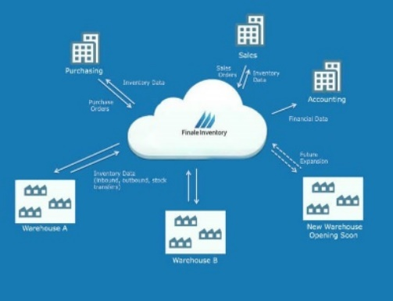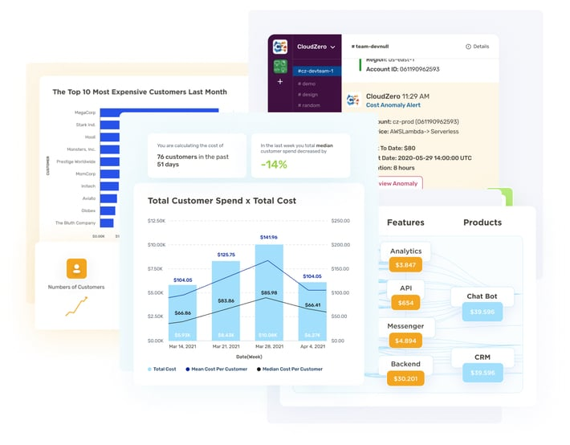

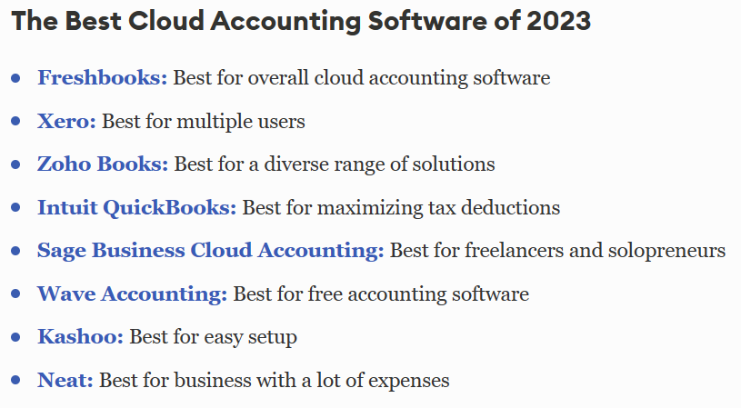

DISTRIBUTED INVENTORY MANAGEMENT Distributing inventory across multiple warehouses can reduce transportation costs and speed up delivery times — if you can put the right products in the right places and consistently dispatch items from the warehouse closest to the customer.Success requires data analysis to see where orders are coming from versus where stock is located, the flexibility to set up distribution centers in the right sites based on data and the technology to direct suppliers to properly split up shipments.In most cases, when a company is managing more, smaller warehouses versus a few huge locations, it can more tightly manage inventory.

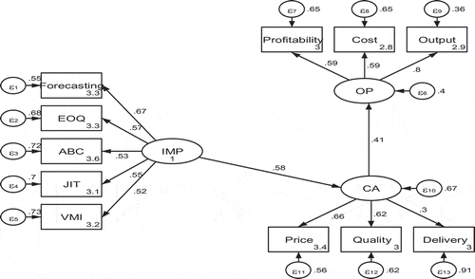

DISTRIBUTED INVENTORY MANAGEMENT Predictive inventory management refers to the integration of predictive analytics to forecast the future risks that have the potential to disrupt inventory availability. The analytical process takes into consideration fluctuating demand, which is demand forecasting, historical data, and economic trends to proactively manage inventory. Thus, predictive inventory management includes demand forecasting, supply chain planning, and assortment planning.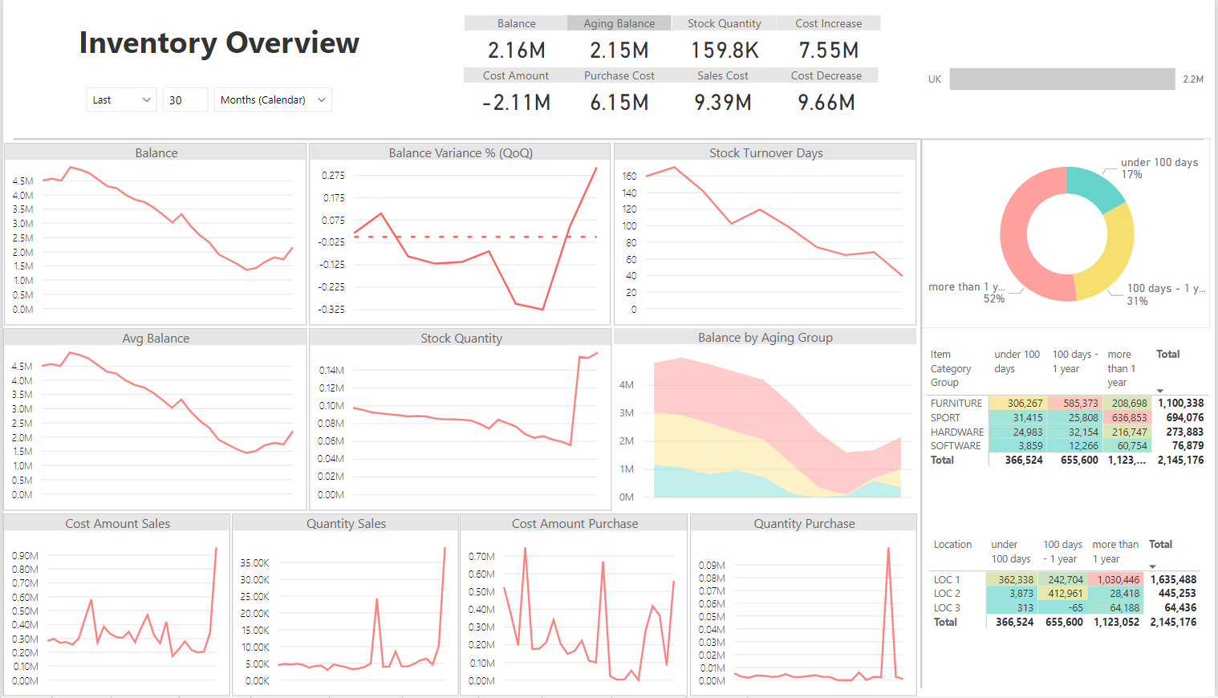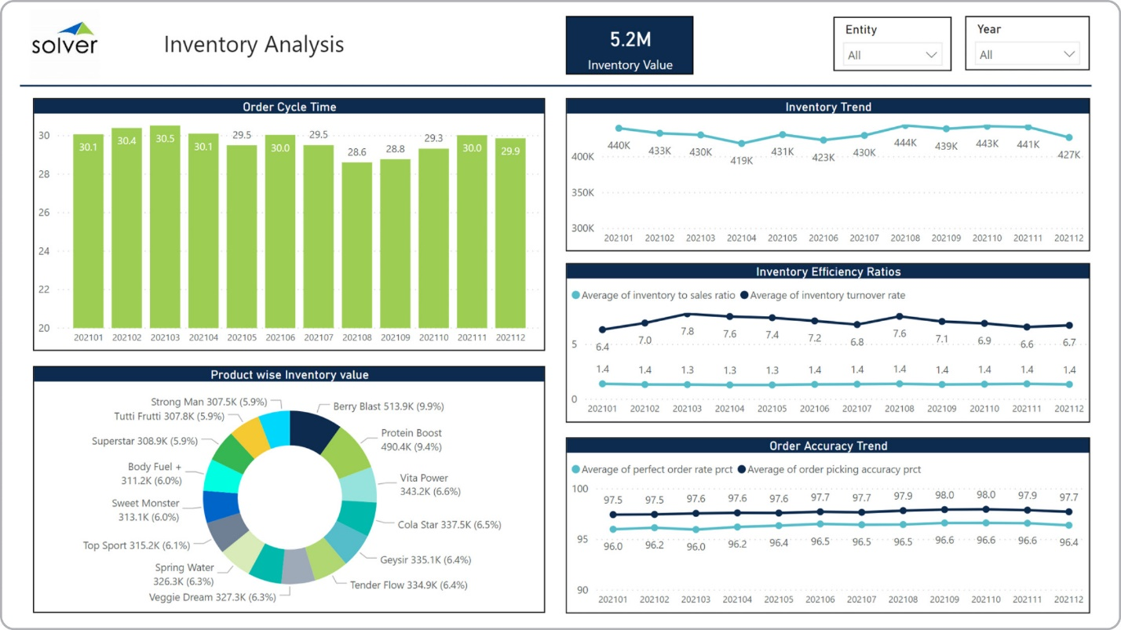

PREDICTIVE PICKINGS Predictive inventory management refers to the integration of predictive analytics to forecast the future risks that have the potential to disrupt inventory availability. The analytical process takes into consideration fluctuating demand, which is demand forecasting, historical data, and economic trends to proactively manage inventory. Thus, predictive inventory management includes demand forecasting, supply chain planning, and assortment planning.Implementing predictive analytics in inventory management provides organizations within the manufacturing and retail industries with multiple benefits. These benefits include:

* An increased cash flow due to reductions in the working capital spent servicing over-estimated demand requirements.
* Improved customer service by meeting consumer requests or orders in a timely fashion.
* Optimizing machine utilization and productivity within manufacturing plant floors.
* Reducing scrapping, shrinkage, and other damages related to inadequate inventory management.
* Predict the correct amount of materials or ingredients a facility needs which eliminates stockouts and redundant stock.

To automate the integration of predictive analytics in demand forecasting and inventory management, diverse applications have been developed to handle the process. These software applications include:

* **Vendor managed inventory solutions** – Vendor managed inventory refers to a process of executing inventory management. In this process, the supplier of a product, which is generally its manufacturer, is responsible for optimizing the inventory held by a distributor or retailer.

In many cases, the VMI process means the retailer does not own the goods but houses them for sale to the consumer. In situations where the items are not sold, the manufacturer takes them back and bears the losses. When the items are sold, the retailer takes a commission for sales and returns the balance to the manufacturer.

In this practice, the manufacturer is responsible for determining what gets on the shelf that customers can purchase. The manufacturer can either make use of a third-party logistics provider to handle its demand forecasting or use VMI software to do the analysis. VMI applications are limited to handling analytics based on the practice. While they are capable of aggregating historical data they cannot integrate constraints to make an accurate demand forecast. This can be limiting for organizations that want to scale up or reevaluate their approach to inventory management.

* **Market Basket Analysis Solutions** – The market basket analysis process to inventory management analyses historical customer data to detect purchasing patterns. Analyzing customer behavior patterns help with developing multiple products or combining products into packs/offers to meet the purchasing patterns of consumers.

This process and practice help with managing sales and getting consumers to purchase more items. What market basket analysis software does not do, is predict demand which is the most important factor in managing inventory. Thus, they are generally viewed as more of a product design and sales tool than a predictive inventory management solution.

* **Supply Chain Planning (SCP) Software** – The supply chain planning software adopts an agile approach to inventory management which takes into consideration demand forecasting, supply planning, capacity planning, and distribution requirements planning. The agility a supply chain planning software brings to the table ensures that every form of constraint can be introduced into the analytical process to produce accurate evaluations. This makes SCPs full-scale predictive inventory management tools.

Supply chain planning software also provides the tools needed to execute vendor managed inventory and market basket analysis which makes it a more robust tool for inventory management. The SCP collects data from inventory sources, organizes the data, integrates constraints, and conducts the required analysis. Once the analysis is conducted, it interprets evaluations to help organizations identify the important factors driving sales and customer demand. It also provides insight into a supplier’s capabilities and preferences which help optimize supply chain logistics

## Supply Chain Planning Software and Optimizing Your Inventory Management Process

The extended capability supply chain planning software makes it possible to automate predictive inventory management among other benefits. These benefits include:

* Developing agile inventory strategies – The tools SCP provides enable you to understand the significant factors that affect the cost and service-levels of the inventory strategy you currently use. With this insight, effective cost-cutting measures can be put in place to optimize the inventory management process.
* Simulate and Predict Outcomes – SCP software provides you with an intelligent platform capable of answering what-if questions. With the data it captures or inputted in it, enterprises can introduce constraints or evaluate diverse scenarios to determine the business outcomes and its effect on available inventory or the supply chain. This makes supply chain planning software effective decision-making tools due to the insight and predictions they provide.
* Share Insights to Enhance Collaboration – SCP software doubles as a collaboration tool for organizations interested in ensuring every facet of their operations is in sync. This includes the various departments involved in production processes, third-party suppliers, and customers. Ensuring everyone has access to production-related timelines enables the involved parties to understand their responsibilities and the importance of meeting specified schedules.

INVENTORY FINANCINGInventory financing is a form of asset-based financing. Businesses turn to [lenders](https://www.investopedia.com/terms/l/lender.asp) so they can purchase the materials they need to manufacture products they intend to sell at a later date.1This kind of financing is common for small to mid-sized retailers and wholesalers, especially those with a large amount of available stock.2 That's because they typically lack the financial history and available [assets](https://www.investopedia.com/terms/a/asset.asp) to secure the institutional-sized financing options larger corporations are able to access, such as Walmart ([WMT](https://www.investopedia.com/markets/quote?tvwidgetsymbol=WMT)) and Target ([TGT](https://www.investopedia.com/markets/quote?tvwidgetsymbol=TGT)).Because they are generally [private companies](https://www.investopedia.com/terms/p/privatecompany.asp), they cannot raise money by issuing bonds or new rounds of stock. Companies may use all or part of their existing stock or the material they purchase as [collateral](https://www.investopedia.com/terms/c/collateral.asp) for a loan that is used for general [business expenses](https://www.investopedia.com/terms/b/businessexpenses.asp).As noted above, inventory financing allows businesses to purchase inventory to run their businesses. The reasons why they rely on this kind of financing include:

* Keeping cash flow steady through busy and slow seasons
* Updating product lines
* Increasing supplies of inventory
* Responding to (high) customer [demand](https://www.investopedia.com/terms/d/demand.asp)3

Types of Inventory Financing Lenders provide businesses with two different kinds of inventory financing. The option that the company chooses is dependent on its business operations. [Interest rates](https://www.investopedia.com/terms/i/interestrate.asp) and fees depend on the lender and the type of business.

* **Inventory loan:**Also referred to as term loans, this kind of financing is based on the total [value](https://www.investopedia.com/terms/v/value.asp) of the company's inventory. Just like a regular loan, the lender issues the company a specific amount of money. The company agrees to make fixed payments every month or to pay the loan off in full once the inventory is sold.
* **Line of credit:** This form of financing provides businesses with [revolving credit](https://www.investopedia.com/terms/r/revolvingcredit.asp), unlike a loan. It gives them regular access to credit as long as they make regular monthly payments to satisfy the terms and conditions of the contract

**AUTOMATION IN INVENTORY MANAGEMENT**An automated inventory management system is**a set of technologies, processes, and procedures for monitoring and servicing goods in warehouses**. It involves the use of systems and software to automate tasks such as tracking inventory levels, forecasting demand, ordering, and replenishing stock, and monitoring stock movements. The system can use barcoding, RFID, and other technologies to track inventory in real-time and automate various processes. Automated inventory systems are computerized methods of inventory tracking that work within EPOS to maintain, update, and monitor inventory. They use IoT and AI technologies to provide end-to-end inventory automation, support multi-location inventory management, demand-driven inventory planning, and inventory optimization based on advanced analytics. Automated inventory management systems optimize the inventory management process and let retailers and wholesalers manage their inventory in real-time.

Overall, an automated inventory tracking system can help you deal with inaccuracies and improve the production cycle. More specifically, you can benefit from:

* Redirecting your resources to high-value tasks that can make a greater impact on your business (with automation, you've got simple tasks covered).
* Reduced vulnerability and risk due to human error.
* The ability to scale quickly and add more products that your customers will love.
* Quick access to the data you need to deliver great customer service and make better business decisions.
* Less stress on your team, helping them work proactively to address potential issues.

**Hybrid warehousing & shipping**: A hybrid warehouse could be considered as one that mixes several different activities (reception, storage area, picking, shipping, supply to production lines and production preparation tasks) and brings together many different materials or raw materials and components. Warehousing is the process of storing physical inventory for sale or distribution. Warehouses are used by all different types of businesses that need to temporarily store products in bulk before either shipping them to other locations or individually to end consumers. In the outer zone of the warehouse reception, have been detected a set of problems that make difficult its management. It was verified the existence of two gates that are used for the discharge of the materials by the suppliers, which cause embarrassment in the flows of materials reception. The check operation of the materials received is carried out by the employees in the covered area of the warehouse. There are also in the discharge operations, some lack of definition of zones for discharges of the local/international suppliers, as well as the existence of failures in the temporary windows of discharge. Regarding the park, there is a large area that is not used for the storage of materials due to the existence of disorganization. The outer platform is the suitable place for storing materials with reduced rotation. However, it is not being used in its entirety for this purpose since it is allocated to other materials with medium-high rotation.

### Omni-channel inventory control: Omnichannel inventory management — tracking inventory across all sales channels — is in. This could mean a brick-and-mortar location, [online store](https://www.bigcommerce.com/articles/ecommerce/ecommerce-platforms/), social media or any other platform where sales are made. Customers are expecting it now and [72% of retailers intend to provide it](https://www.zebra.com/content/dam/zebra_new_ia/en-us/solutions-verticals/vertical-solutions/retail/vision-study/retail-vision-study-2017-en-gb.pdf). Omnichannel inventory management is turning from something that’s nice to have to something that is a must have, enabling companies to forecast demand and avoid stockout situations. For ecommerce businesses and business owners, effectively managing inventory through one channel is difficult. Doing so over multiple channels is even more so. Trying to do so manually or with a siloed digital solution only leads to mistakes or inaccurate data.

### A quality omnichannel retail operation needs a single source of truth to serve as the centralized data hub for the organization.

* Increased productivity.
* Decreased costs.
* Improved margins.

**Blockchain:** Blockchain allows warehouses, manufacturers, suppliers and production sites, distribution centers and retail partners to connect to each other through a permanent record of every transaction that takes place. All the records are then stored and accessible to everyone within the network. With such transparency, manufacturers are better able to manage product origins, traceability, potential recalls and perishable goods. Manufacturers can actually see consumer-level demand in real time, allowing them to forecast demand accurately and plan manufacturing and replenishment.

Before blockchain, inventory management was based on a reactive model, where replenishments were ordered once inventory was depleted, or a predictive model that estimated when inventory would run out. With blockchain, warehouse inventory management can forecast demand accurately and thereby always have the right type and quantity of stock needed to meet expected demand. The technology makes it possible to optimize revenue and profitability, while reducing the risk of lost sales.

Blockchain is still in its infancy, especially in the world of [warehouse operations](https://www.prologis.com/industrial-development-capabilities/real-estate-operations), but the promise it holds for the industry can’t be denied. It has the potential to change everything from inventory management to transportation tracking to logistics. By using the blockchain for data authentication, the entire supply chain can contribute and validate data, knowing the data is not susceptible to tampering.

### Reporting & analytics: An inventory report is a summary of a retailer's existing stock. It distills details like how much stock you have, which products are selling fastest, category performance, and other information about the status and performance of inventory. “Inventory reports are important to [monitor the biggest and most expensive asset of your business](https://www.vendhq.com/blog/inventory-management/),” says Elliot Walters, implementation manager at [Stitch Labs](https://www.stitchlabs.com/). Retail businesses rely on inventory to generate revenue and profit — without it, you don’t have anything to sell. The value of inventory reporting mainly boils down to the insight it gives retailers into their business. The industry’s top performers are data-driven, and inventory reporting metrics provide both big picture and hyper-focused views into the business. Types of inventory reports to create

* **Inventory on hand**
* **Low stock**
* **Product performance report**
* **Shrink**
* **Inventory replenishment report**
* **Benchmark comparisons**

### Inventory analytics refers to tracking metrics that gauge the movement and performance of your physical products. The ongoing assessment and evaluation of inventory provides the insights needed to optimize stock availability to meet demand while keeping storage costs to a minimum. Inventory analysis also helps reduce risks and common challenges related to inventory, such as stockouts or accumulating [dead stock](https://www.shipbob.com/inventory-kpis/dead-stock/), and uses technology and processes to ensure[inventory accuracy](https://www.shipbob.com/inventory-kpis/inventory-accuracy/). It is a critical component of managing[logistics operations](https://www.shipbob.com/blog/logistics-operations/) and can help can improve[inventory control](https://www.shipbob.com/blog/inventory-control/),[supply chain efficiency](https://www.shipbob.com/blog/supply-chain-efficiency), and profitability. Analyzing data can be confusing because there is so much information to process and there are several ways to perform inventory analysis. There are four common types of inventory analysis,

* Descriptive inventory analytics
* Diagnostic inventory analytics
* Predictive inventory analytics
* Prescriptive inventory analytics

CONCLUSIONS This recent study aims at figuring out the best ways of inventory management and eliminating the drawbacks of traditional inventory management methods . The Research Paper successfully overviewed the new technology that made inventory management much easier efficient

and accurate the use of modern technology, mathematics and statistics has made the accounting process more transparent and relevant.