**EXPERIMENT: 1**

**Aim:**

1. To understand the phenomenon Photoelectric effect as a whole.
2. To draw kinetic energy of photoelectrons as a function of frequency of  incident radiation.
3. To determine the Planck's constant from kinetic energy versus frequency graph.
4. To plot a graph connecting photocurrent and applied potential.
5. To determine the stopping potential from the photocurrent versus applied potential graph.

**Theory:**

During his experiments on electromagnetic radiation (to demonstrate light consists of e-m waves), Hertz noticed a spark between the two metallic balls when a high frequency radiation incident on it. This is called photoelectric effect. Photoelectric effect is the emission of electrons when electromagnetic radiations having sufficient frequency incident on certain metal surfaces. We call the emitted electrons as photoelectrons and the current they constitute as photocurrent. The phenomenon was first observed by Heinrich Hertz in 1880 and explained by Albert Einstein in 1905 using Max Planck's quantum theory of light. As the first experiment which demonstrated the quantum theory of energy levels, photoelectric effect experiment is of great historical importance.

**The important observations on Photoelectric effect which demand quantum theory for its explanation are:**

1. The Photoelectric effect is an instantaneous phenomenon. There is no time delay between the incidence of light and emission of photoelectrons.
2. The number of photoelectrons emitted is proportional to the intensity of incident light. Also, the energy of emitted photoelectrons is independent of the intensity of incident light.
3. The energy of emitted photoelectrons is directly proportional to the frequency of incident light.

 The basic experimental set up which explains Photoelectric effect is as given below,

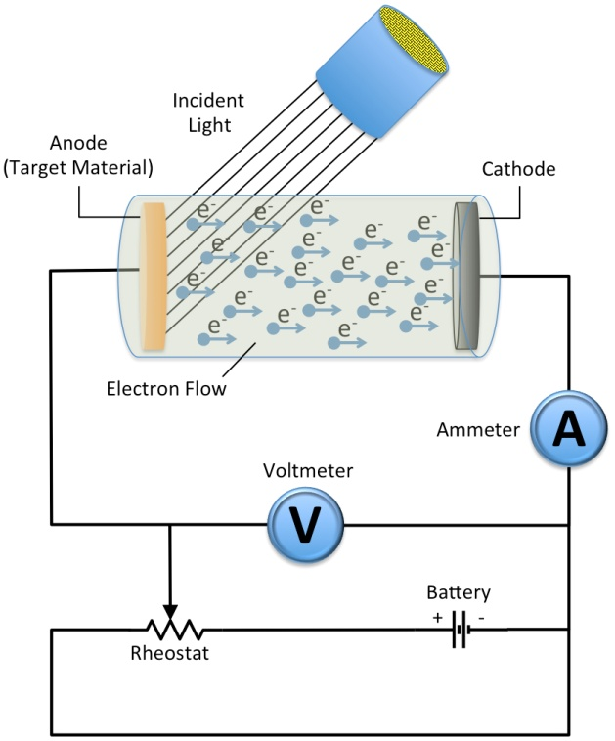

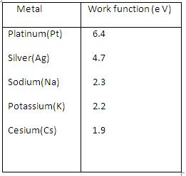It has been observed that there must be a minimum energy needed for electrons to

escape from a particular metal surface and is called work function 'W' for that

metal. The work function can be expressed in terms of frequency as,

«math xmlns=¨http://www.w3.org/1998/Math/MathML¨»«mi»W«/mi»«mo»=«/mo»«mi»h«/mi»«msub»«mi»§#957;«/mi»«mn»0«/mn»«/msub»«mo».«/mo»«mo».«/mo»«mo».«/mo»«mo».«/mo»«mo».«/mo»«mo».«/mo»«mo».«/mo»«mo».«/mo»«mo».«/mo»«mo».«/mo»«mo».«/mo»«mo».«/mo»«mo».«/mo»«mo».«/mo»«mo».«/mo»«mo».«/mo»«mo»(«/mo»«mn»1«/mn»«mo»)«/mo»«/math»

 Where h is the Planck's constant and

«math xmlns=¨http://www.w3.org/1998/Math/MathML¨»«msub»«mi»§#957;«/mi»«mn»0«/mn»«/msub»«/math» is the threshold frequency (minimum frequency for photoelectric effect).

The work function for some metals are listed in the table.

 According to Einstein the Photoelectric effect should obey the equation,

«math xmlns=¨http://www.w3.org/1998/Math/MathML¨»«mi»h«/mi»«mi»§#957;«/mi»«mo»=«/mo»«mi»K«/mi»«msub»«mi»E«/mi»«mrow»«mi»m«/mi»«mi»a«/mi»«mi»x«/mi»«/mrow»«/msub»«mo»+«/mo»«mi»W«/mi»«mo».«/mo»«mo».«/mo»«mo».«/mo»«mo».«/mo»«mo».«/mo»«mo».«/mo»«mo».«/mo»«mo».«/mo»«mo».«/mo»«mo».«/mo»«mo».«/mo»«mo»(«/mo»«mn»2«/mn»«mo»)«/mo»«/math»

From the above expression,

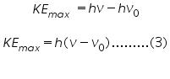

Which says the graph connecting the maximum kinetic energy of photoelectrons 'KEmax' and frequency of incident radiation'«math xmlns=¨http://www.w3.org/1998/Math/MathML¨»«mi»§#957;«/mi»«/math»'will be a straight line with slope and Y-intercept «math xmlns=¨http://www.w3.org/1998/Math/MathML¨»«mi»h«/mi»«msub»«mi»§#957;«/mi»«mn»0«/mn»«/msub»«/math»= work function.

## Graph connecting 'KEmax' and frequency:

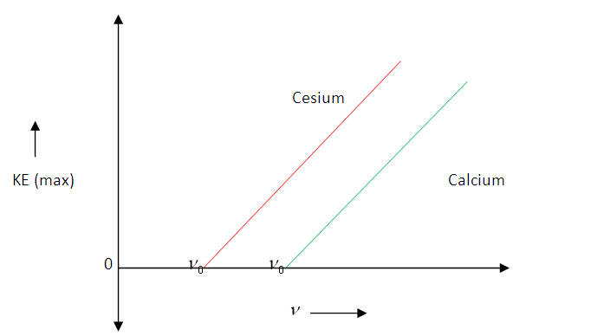

 Maximum kinetic energy of photoelectrons versus frequency of incident radiation graph

Now, if we increase the reverse potential, the photocurrent gradually decreases and becomes zero at a particular reverse potential. This minimum applied reverse potential is called **stopping potential V0**. Hence the maximum kinetic energy of photoelectrons can be written as,

«math xmlns=¨http://www.w3.org/1998/Math/MathML¨»«mi»K«/mi»«msub»«mi»E«/mi»«mrow»«mi»m«/mi»«mi»a«/mi»«mi»x«/mi»«/mrow»«/msub»«mo»=«/mo»«mi»e«/mi»«msub»«mi»V«/mi»«mn»0«/mn»«/msub»«mo».«/mo»«mo».«/mo»«mo».«/mo»«mo».«/mo»«mo».«/mo»«mo».«/mo»«mo».«/mo»«mo».«/mo»«mo».«/mo»«mo».«/mo»«mo».«/mo»«mo».«/mo»«mo».«/mo»«mo»(«/mo»«mn»4«/mn»«mo»)«/mo»«/math»

## Graph connecting photocurrent and applied reverse potential :

### For constant intensity and different frequencies

#### http://vlab.amrita.edu/userfiles/1/image/photo_.JPG

### For constant frequency and different intensities

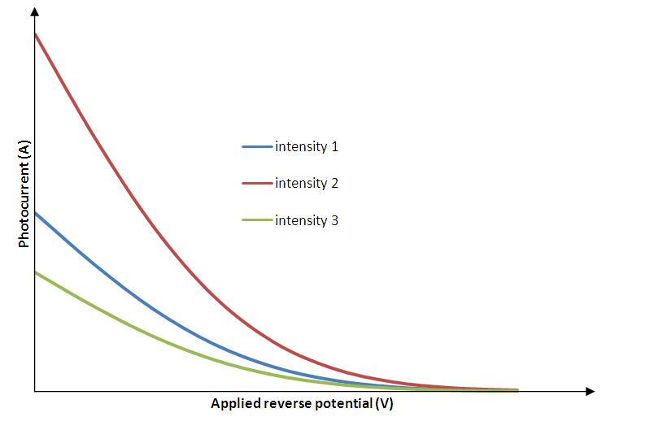

**ASSIGNMENT: 1**

1. Determine the minimum frequency required to have Photoelectric effect for an EM radiation, when incident on a zinc metal surface.

2. Determine the target material if the threshold frequency of EM radiaion is 5.5x1015Hz in a particular photoelectric experimental set up.

3. Determine the maximum kinetic energy of photo-electrons emitted from a Zinc metal surface, if the incident frequency  is 3x1015Hz.

4. What sould be the stopping potential for photoelectrons if the target material used is Platinum and incident frequency is 2x1015Hz?

5. What should be the minimum applied potential for complete stoppage of photocurrent in an experimental if the target material is copper and the incident frequency is 2.7x1015Hz.

**EXPERIMENT 1:**

**OBJECTIVE:**

1. Determine the minimum frequency required to have Photoelectric effect for an EM radiation, when incident on a zinc metal surface.

**Material Required:**

1. Amrita lab simulation module

**Calculations:**

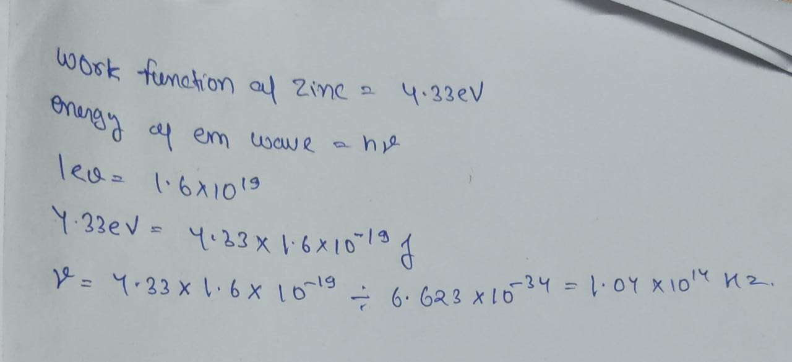

**Observation and Simulation:**

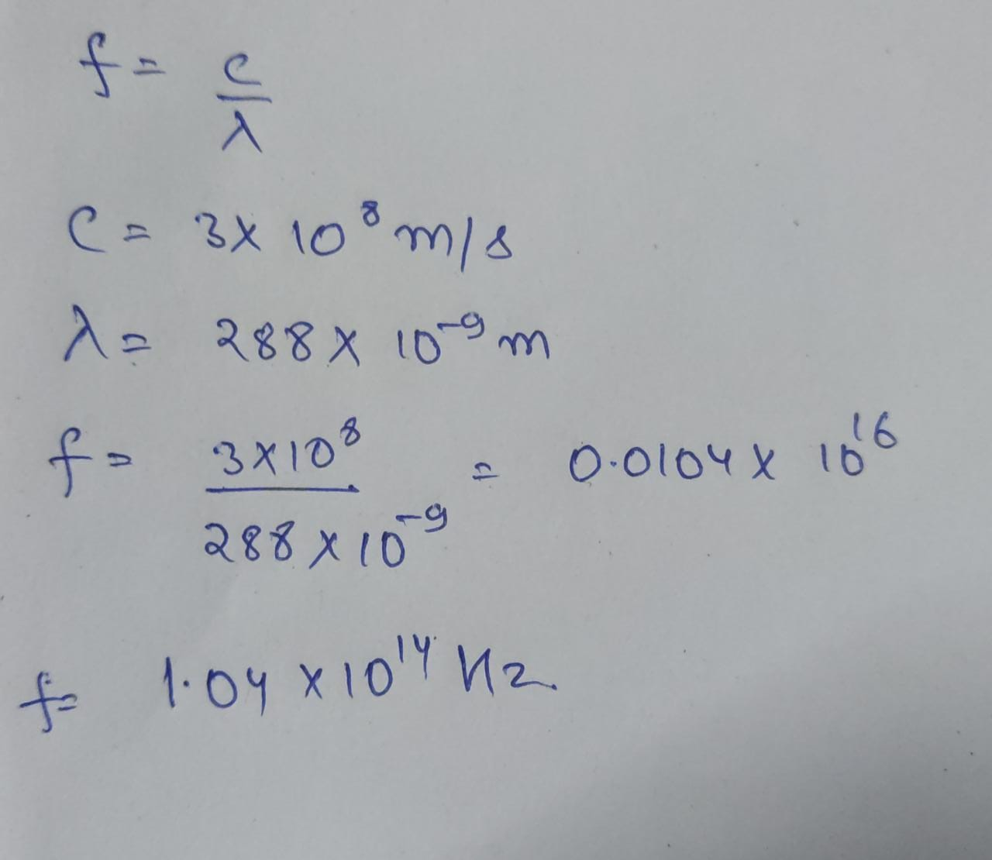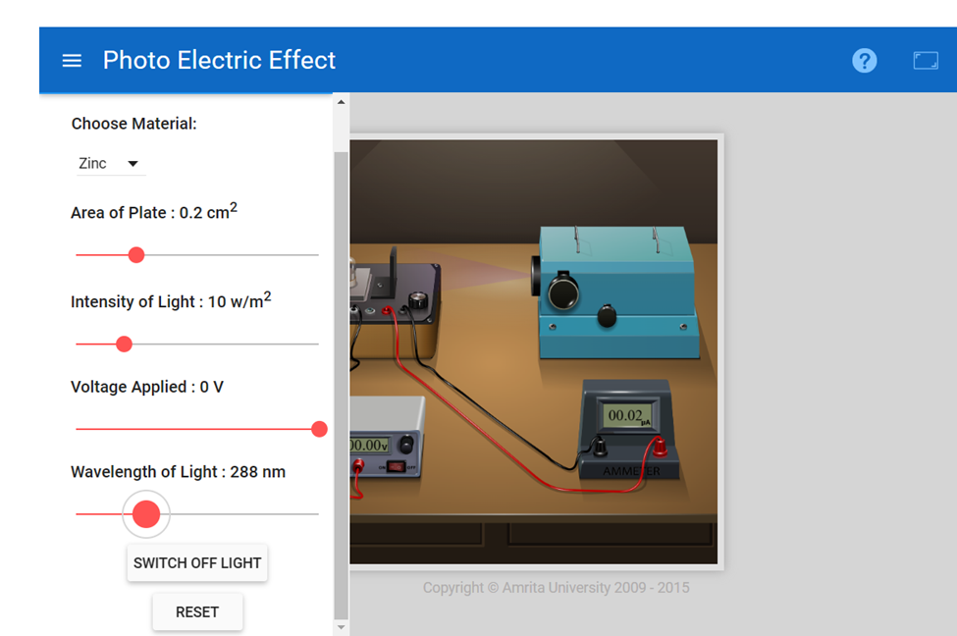

**Conclusion:**

Hence we successfully determined the minimum frequency required to have photoelectric effect for zinc metal surface.

The value of minimum frequency is:

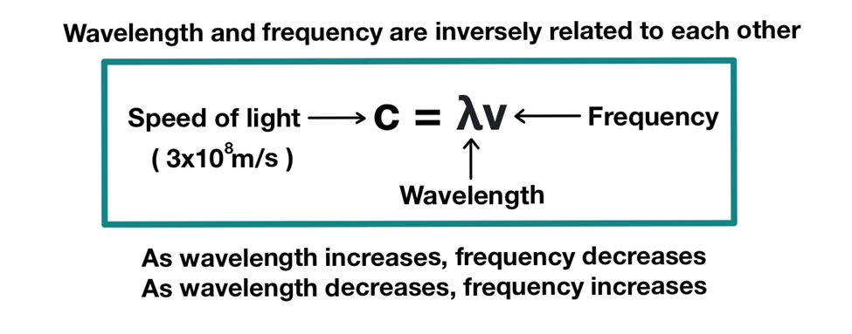

By Simulation we obtained the value of the maximum value of wavelength by the above formula we obtained the frequency that is: 1.04 x 1014 hertz.

**EXPERIMENT 2:**

**Objective:**

1.Determine the target material if the threshold frequency of EM radiation is 5.5x1015Hz in a particular photoelectric experimental set up.

**Material Required:**

1. Amrita lab simulation module

**Calculations & Observations:**

**Formula:**

**KEmax=hv–ϕ**

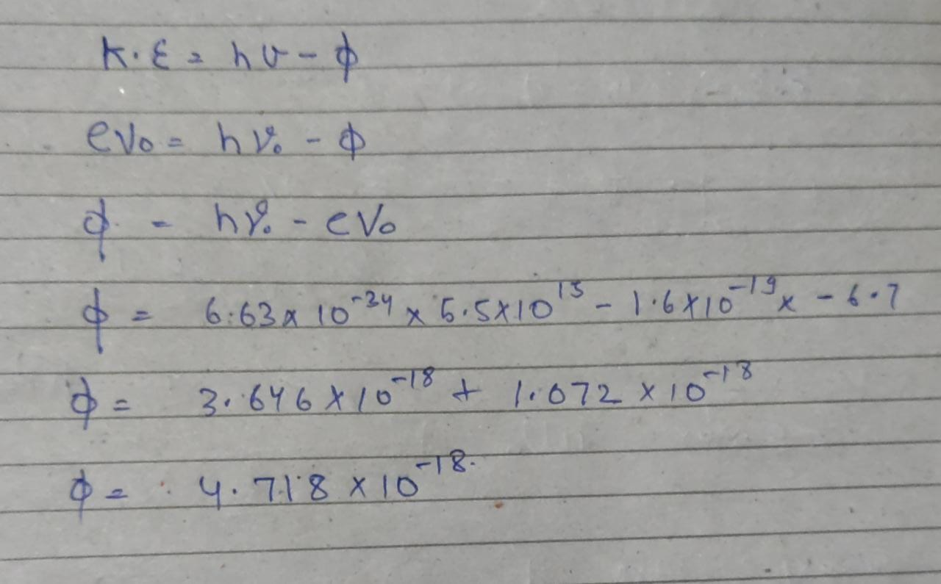

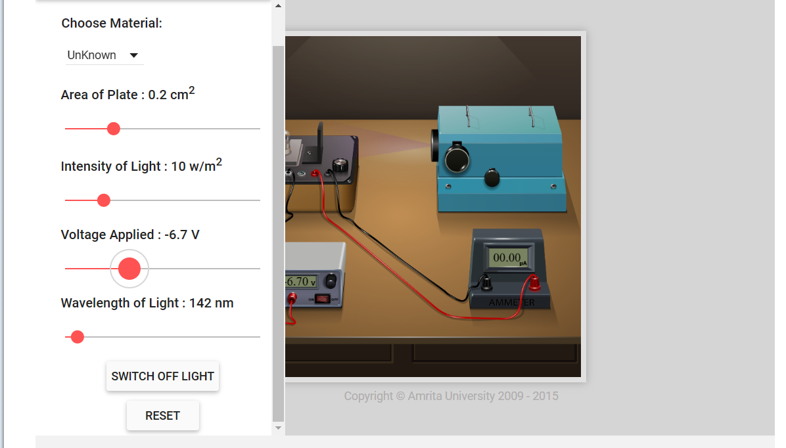

**Conclusion:**

Hence we obtained the value of work function and we can determine metal by using below table.



**EXPERIMENT 3:**

**Objective:**

What should be the stopping potential for photoelectrons if the target material used is Platinum and incident frequency is 2x1015Hz?

**Material Required:**

1. Amrita lab simulation module

**Calculations/Observations:**

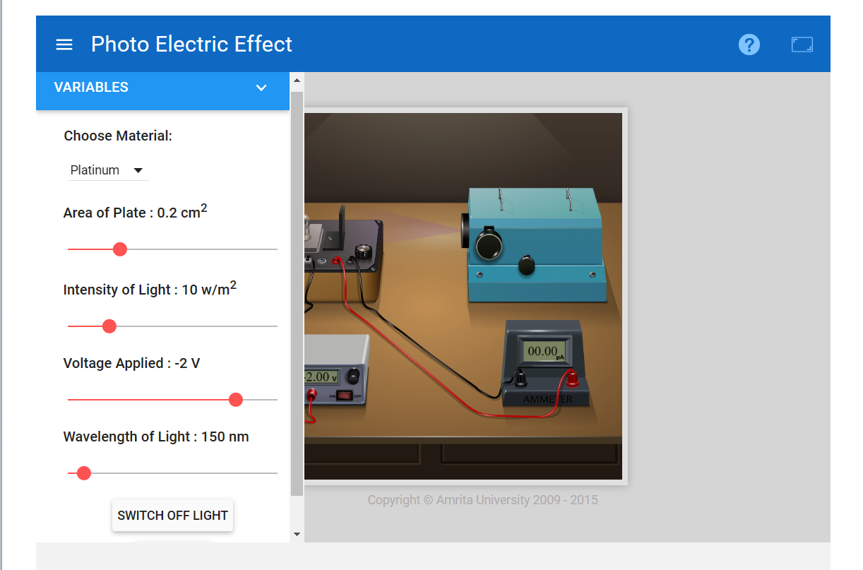

**Conclusion:**

Here we can see that frequency of incident light is given to us therefore when we vary voltage toggle at -2V the current in Ammeter become zero therefore no electron flow at -2V.

Hence we obtained the value of stopping potential for photoelectrons that is: -2V

**EXPERIMENT 4:**

**Objective:**

1. What should be the minimum applied potential for complete stoppage of photocurrent in an experimental if the target material is copper and the incident frequency is 2.7x1015Hz.

**Material Required:**

1. Amrita lab simulation module

**Calculations/Observations:**

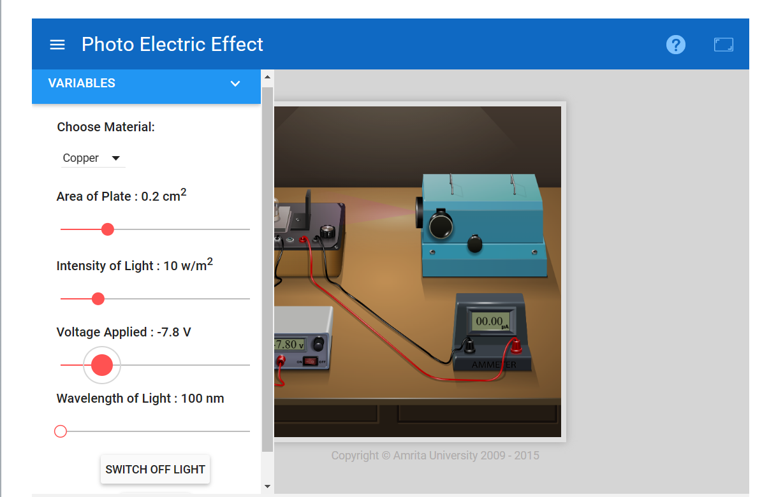

**Conclusions:**

Hence we obtained the value of minimum applied potential by simulation that is equivalent to -7.8V respectively.

**EXPERIMENT 5:**

**OBJECTIVE:**

3. Determine the maximum kinetic energy of photo-electrons emitted from a Zinc metal surface, if the incident frequency  is 3x1015 Hz.

**Material Required:**

1. Amrita lab simulation module

**Calculations:**

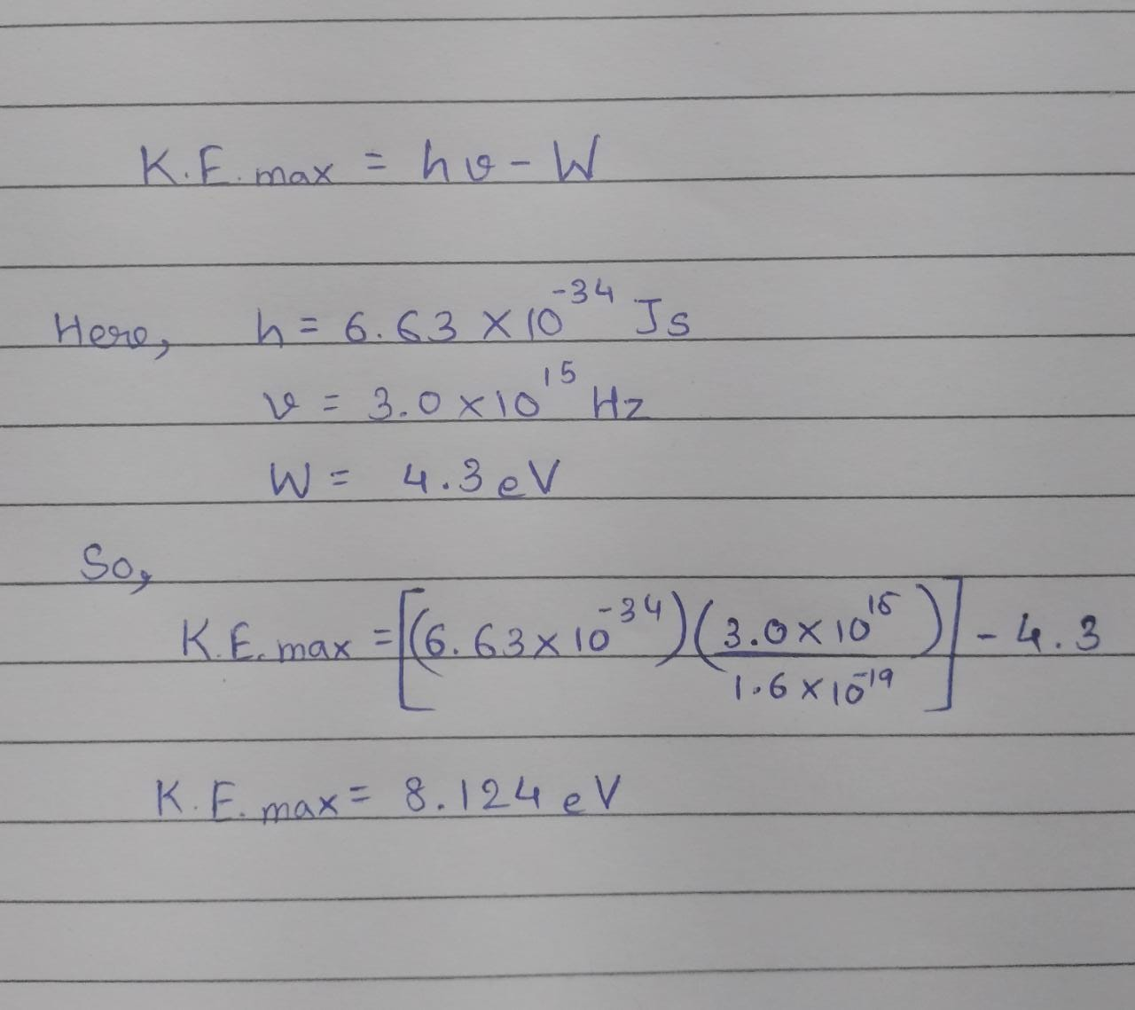

**Conclusions:**Hence the Maximum kinetic energy of photo-electrons is 8.124 eV.

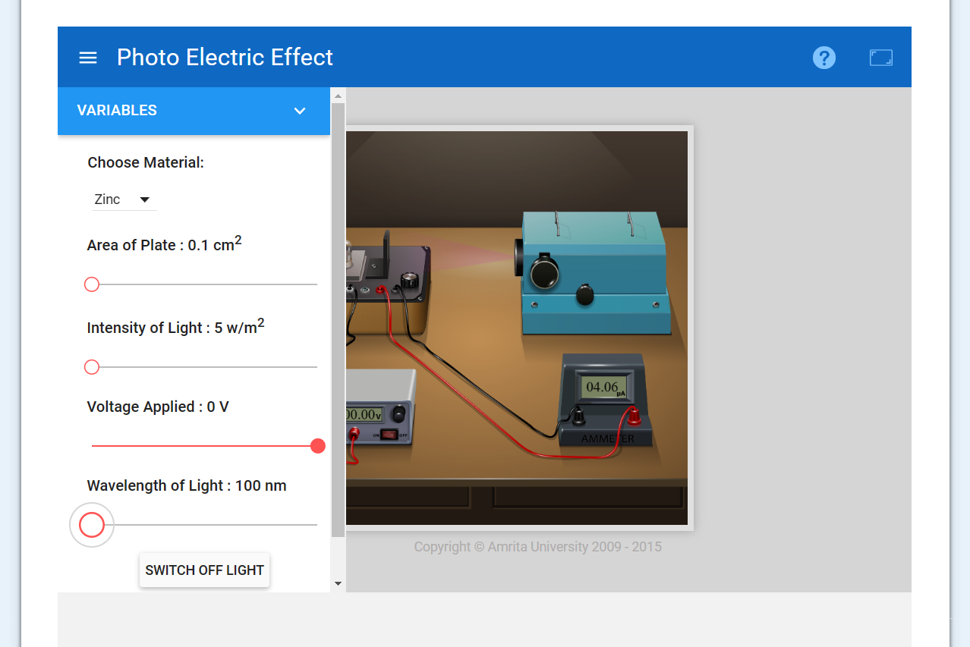

**EXPERIMENT: 2**

**Aim**

1. To experimentally demonstrate the concept of Millikan’s oil drop experiment.
2. To find the terminal velocity of the drop.
3. To find the charge on a drop.

**Apparatus**

Millikan’s oil drop apparatus,oil, Dc supply.

**Construction**

Oil drop experiment was performed originally by the American physicist Robert A. Millikan in 1909. It measures the size of charge on a single electron.

Apparatus consist of an atomizer, which helps to spray tiny droplets. By means of a short focal distance telescope, the droplets can be viewed. There are two plates, one positive and the other

negative above and below the bottom chamber. dc supply is attached to the plates.

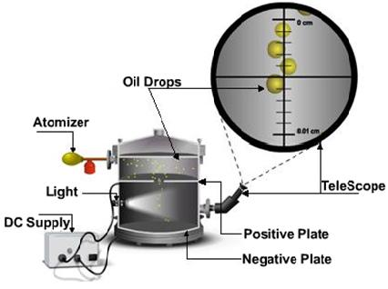

Using X-rays the bottom chamber is illuminated causing the air to ionize. As the droplets traverses through the air, electrons accumulate over the droplets and negative charge is acquired. With the help of dc supply a voltage is applied. Speed of its motion can be controlled by altering the voltage applied on the plates. By adjusting the voltage applied, drop can be suspended in air. Millikan observed one drop after another, varying the voltage and noting the effect. After many repetitions he concluded that charge could assume only certain fixed values.  
  
He repeated the experiment for many droplets and confirmed that the charges were all multiples of some fundamental value and calculated it to be 1.5924(17) ×10−19 C, within one percent of the currently accepted value of 1.602176487(40) ×10−19 C. He proposed that this was the charge of a single electron.

**Theory**

Initially the oil drops are allowed to fall between the plates in the absence of electric field. Due to gravity they accelerate first, but gradually slowdown because of air resistance.

The terminal velocity v1 in the absence of an electric field is calculated as

«math xmlns=¨http://www.w3.org/1998/Math/MathML¨»«msub»«mi»v«/mi»«mn»1«/mn»«/msub»«mo»=«/mo»«mfrac»«msub»«mi»l«/mi»«mn»1«/mn»«/msub»«msub»«mi»t«/mi»«mn»1«/mn»«/msub»«/mfrac»«/math»

where 'l1' is the distance travelled by the oil drop and ’t1’ is the time taken.

The drag force acting upon the drop is calculated from stokes’s law and is given as

«math xmlns=¨http://www.w3.org/1998/Math/MathML¨»«msub»«mi»F«/mi»«mi»v«/mi»«/msub»«mo»=«/mo»«mn»6«/mn»«mi»§#960;«/mi»«mi»§#951;«/mi»«mi»r«/mi»«msub»«mi»v«/mi»«mn»1«/mn»«/msub»«/math»

The apparent weight (true weight minus up thrust) for a perfectly spherical body is given by,

«math xmlns=¨http://www.w3.org/1998/Math/MathML¨»«msub»«mi»F«/mi»«mi»G«/mi»«/msub»«mo»=«/mo»«mfrac»«mn»4«/mn»«mn»3«/mn»«/mfrac»«mi»§#960;«/mi»«msup»«mi»r«/mi»«mn»3«/mn»«/msup»«mi»g«/mi»«mo»(«/mo»«mi»§#961;«/mi»«mo»-«/mo»«msub»«mi»§#961;«/mi»«mrow»«mi»a«/mi»«mi»i«/mi»«mi»r«/mi»«/mrow»«/msub»«mo»)«/mo»«/math»

At terminal velocity the oil drop is not accelerating, so the total force acting on it must be zero

                           FV-FG=0.

i.e.,

«math xmlns=¨http://www.w3.org/1998/Math/MathML¨»«msub»«mi»F«/mi»«mi»V«/mi»«/msub»«mo»=«/mo»«msub»«mi»F«/mi»«mi»G«/mi»«/msub»«/math»  
                    «math xmlns=¨http://www.w3.org/1998/Math/MathML¨»«msup»«mi»r«/mi»«mn»2«/mn»«/msup»«mo»=«/mo»«mfrac»«mrow»«mn»9«/mn»«mi»§#951;«/mi»«msub»«mi»v«/mi»«mn»1«/mn»«/msub»«/mrow»«mrow»«mn»2«/mn»«mi»g«/mi»«mo»(«/mo»«mi»§#961;«/mi»«mo»-«/mo»«msub»«mi»§#961;«/mi»«mrow»«mi»a«/mi»«mi»i«/mi»«mi»r«/mi»«/mrow»«/msub»«mo»)«/mo»«/mrow»«/mfrac»«/math»

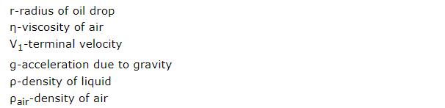

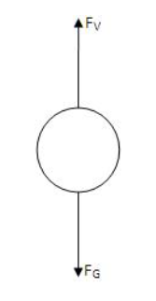

Now a field is produced in the bottom chamber with the supply voltage. A likely looking drop is selected and kept in the middle of the field of view by adjusting the voltage.  
  
If the electric forces Fe, balances the gravitational force FG, the drop suspends in the air.  
Then,

«math xmlns=¨http://www.w3.org/1998/Math/MathML¨»«msub»«mi»F«/mi»«mi»e«/mi»«/msub»«mo»=«/mo»«msub»«mi»F«/mi»«mi»G«/mi»«/msub»«/math»

«math xmlns=¨http://www.w3.org/1998/Math/MathML¨»«mi»q«/mi»«mi»E«/mi»«mo»=«/mo»«mi»m«/mi»«mi»g«/mi»«/math»

«math xmlns=¨http://www.w3.org/1998/Math/MathML¨»«mfrac»«mrow»«mi»q«/mi»«mi»V«/mi»«/mrow»«mi»d«/mi»«/mfrac»«mo»=«/mo»«mi»m«/mi»«mi»g«/mi»«/math»

where V is the balancing potential and d is the distance between the plates.

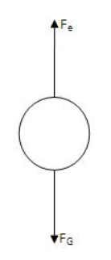

If the applied electric force Fe is greater than the downward forces, some of the drops (the charged ones) will start to rise. Now the electric force will act upwards,gravity and viscous forces acts downwards.

Corresponding terminal velocity v2 is calculated as,

«math xmlns=¨http://www.w3.org/1998/Math/MathML¨»«msub»«mi»v«/mi»«mn»2«/mn»«/msub»«mo»=«/mo»«mfrac»«msub»«mi»l«/mi»«mn»2«/mn»«/msub»«msub»«mi»t«/mi»«mn»2«/mn»«/msub»«/mfrac»«/math»

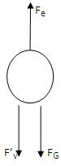where l2 is the distance travelled by the oil drop and t2 the time taken.

Now the total force acting on drop is Fe-F’v-FG=0.

                                       Fe=F’v+FG

F'Vis the new viscous force under the action of electric field.

«math xmlns=¨http://www.w3.org/1998/Math/MathML¨»«mtable columnalign=¨left¨ rowspacing=¨0¨»«mtr»«mtd»«mi»q«/mi»«mi»E«/mi»«mo»=«/mo»«mn»6«/mn»«mi»§#960;«/mi»«mi»§#951;«/mi»«mi»r«/mi»«msub»«mi»v«/mi»«mn»2«/mn»«/msub»«mo»+«/mo»«mn»6«/mn»«mi»§#960;«/mi»«mi»§#951;«/mi»«mi»r«/mi»«msub»«mi»v«/mi»«mn»1«/mn»«/msub»«/mtd»«/mtr»«mtr»«mtd»«mo»§nbsp;«/mo»«mo»§nbsp;«/mo»«/mtd»«/mtr»«/mtable»«/math»

«math xmlns=¨http://www.w3.org/1998/Math/MathML¨»«mfrac»«mrow»«mi»q«/mi»«mi»V«/mi»«/mrow»«mi»d«/mi»«/mfrac»«mo»=«/mo»«mn»6«/mn»«mi»§#960;«/mi»«mi»§#951;«/mi»«mi»r«/mi»«mo»(«/mo»«msub»«mi»v«/mi»«mn»1«/mn»«/msub»«mo»+«/mo»«msub»«mi»v«/mi»«mn»2«/mn»«/msub»«mo»)«/mo»«/math»

«math xmlns=¨http://www.w3.org/1998/Math/MathML¨»«mi»q«/mi»«mo»=«/mo»«mn»6«/mn»«mi»§#960;«/mi»«mi»§#951;«/mi»«mi»r«/mi»«mo»(«/mo»«msub»«mi»v«/mi»«mn»1«/mn»«/msub»«mo»+«/mo»«msub»«mi»v«/mi»«mn»2«/mn»«/msub»«mo»)«/mo»«mfrac»«mi»d«/mi»«mi»V«/mi»«/mfrac»«/math»

Millikan repeated the experiment no. of times, each time varying the strength of X-rays ionizing the air. As a result no. of electrons attaching to the oil drop varied. Then he obtained various values for q, and is found to be a multiple of 1.6 x 10-19C.

**ASSIGNMENT: 2**

1. An oil drop of 12 excess electrons is held stationary under a constant electric field of 2.55 x 104V/m in Millikan’s oil drop experiment. The density of the oil drop is 1.26 cgs units. Estimate the radius of the oil drop.

2. Use the simulation and find out the charge on any five drops. By comparing the charges on the drops, find out the charge on an electron?

3. Why bubbles are rising up through water or any other liquid?

4. Why tiny drops becomes clouds where as bigger drops fall as rain?

5. Calculate the terminal velocity of an olive oil drop and then its radius.

**EXPERIMENT 1:**

1. An oil drop of 12 excess electrons is held stationary under a constant electric field of 2.55 x 104V/m in Millikan’s oil drop experiment. The density of the oil drop is 1.26 cgs units. Estimate the radius of the oil drop.

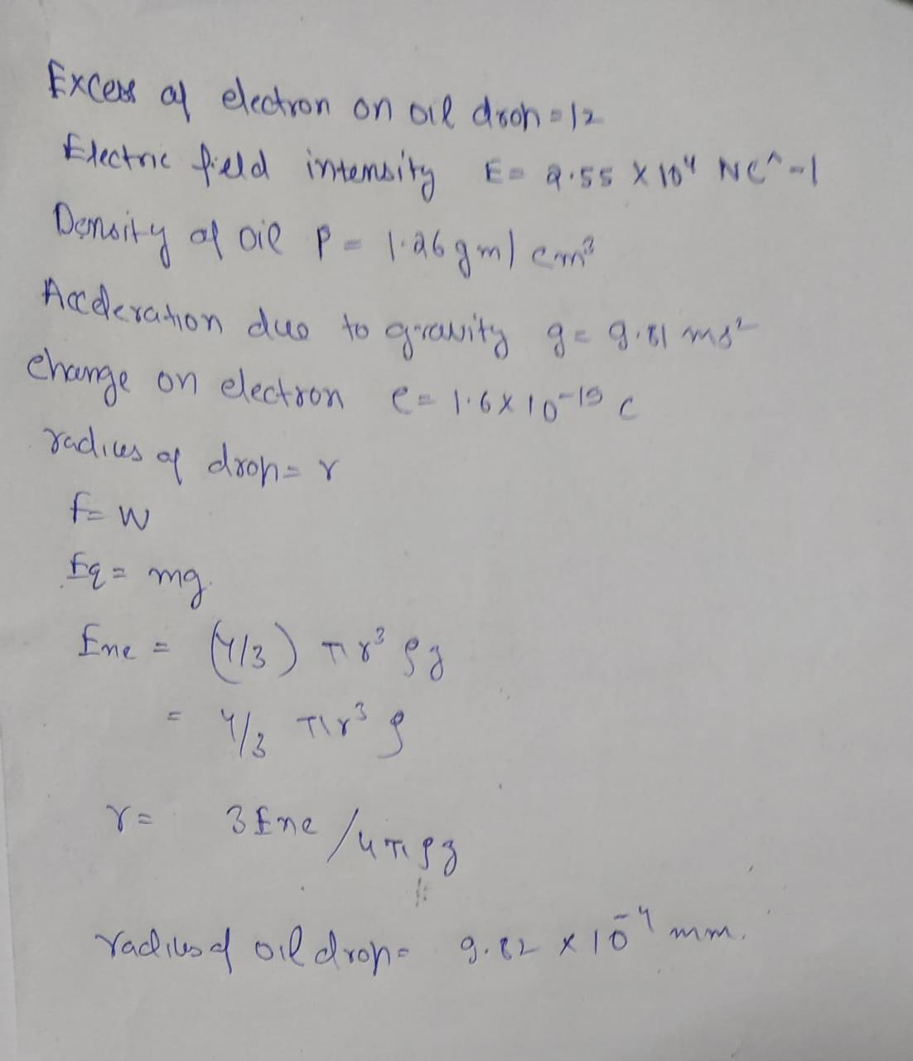

**EXPERIMENT 2:**

Use the simulation and find out the charge on any five drops. By comparing the charges on the drops, find out the charge on an electron?

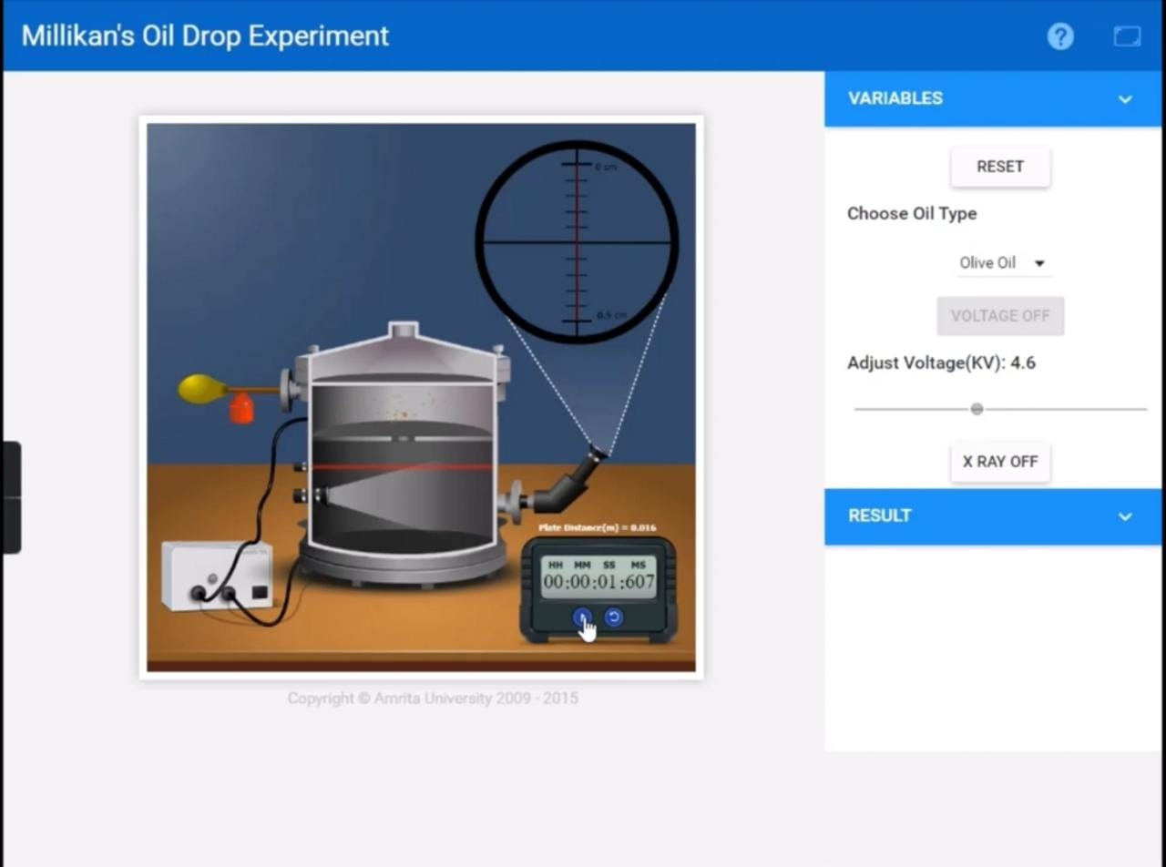

**EXPERIMENT 2:**

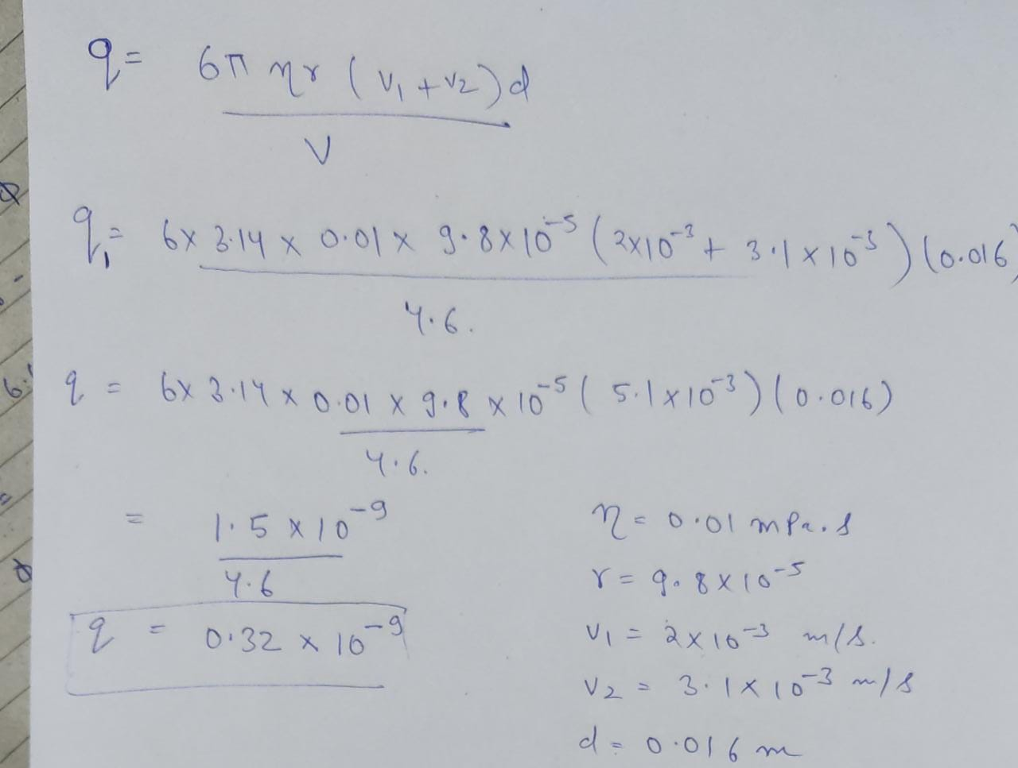



**EXPERIMENT 3:**

**Why bubbles are rising up through water or any other liquid?**

**ANS:** Bubbles are comprises of gases, which have a lesser density than water. Since they are less dense, they get pushed up to the surface, and they rise, lighter than the liquid around them

**EXPERIMENT 4:**

**Why tiny drops becomes clouds where as bigger drops fall as rain?**

**ANS:** Clouds are made up of tiny water droplets. When these droplets grow, they eventually become too heavy to stay suspended in the sky and fall to the ground as rain. Some droplets fall through the cloud and coalesce into raindrops on their way down.Rain always fall in drops and not as a continuous stream. This is mainly due to the surface tension of water caused due to the tendency of water molecules to stick together.

**EXPERIMENT 5:**

**Calculate the terminal velocity of an olive oil drop and then its radius.**

**ANS:** 

