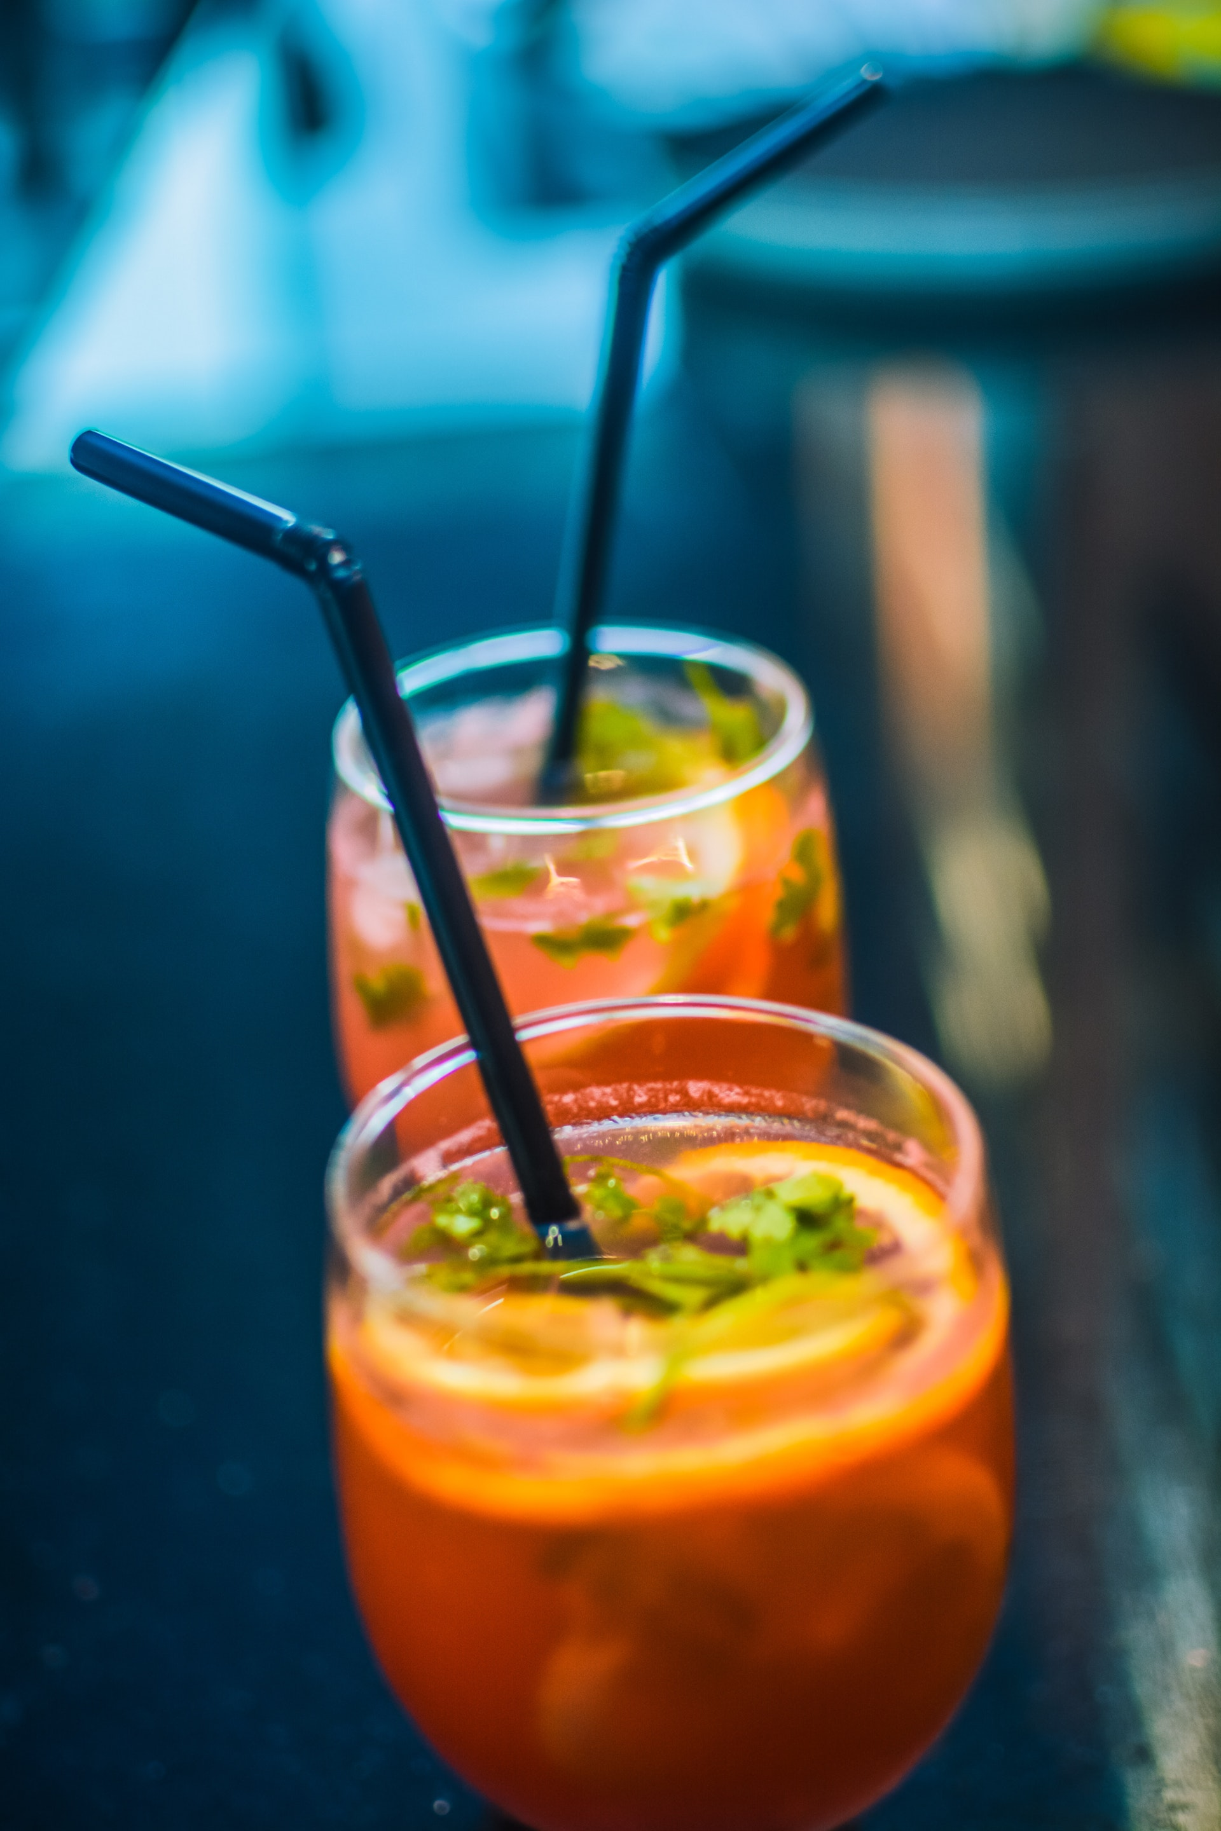

|  |  |
| --- | --- |
| SET11112 Web Design and Development | Student name |

**Contents**

3.1.1. Research 2

3.1.2. Mission Statement 3

3.1.3. Evaluation Criteria 3

Responsive approach 3

Navigation property 3

Multi browser accessibility 3

Load time 4

Unique texts and theme 4

Error messages 4

Form Validations 4

Proper styling using CSS 4

Footer & Copyright 4

CTA Buttons 4

3.1.4. Measuring Success 4

3.1.5. Requirements 5

Common requirements for all pages 5

Navigation Bar 5

Home Page 6

Discover Us Page 6

Contact Page 6

Login Page 6

Register Page 7

# 3.1.1. Research Work

On the way to developing this frontend prototype of this pizza delivery website, relatively extensive studies were made to realize what can be the pros and cons of a website. In course of time, getting to see more websites and scanning to realize what can be the plus and minus points of a certain website became time consuming. So hereby, a generalized opinion is put down to express what can be the factors that can lead to liking and disliking a website. Following are the points:

1. load time: if a website takes forever to load, that won’t be visited by many customers to order online. If someone faces the problem of half loaded website or not loading at all due to poor internet connection, that website needs some work. About 47% of the general masses looks for the websites that load in 2 seconds or lesser. That should be the aim for designing a website in the first place.
2. Mobile optimization: mobile devices are on their way to outrun desktop pc’s with their improved processors and RAM combined with beefy storage solutions. In such an era, it is very evident that people are going to surf the websites on their handheld devices first than on a pc. So, if a website doesn’t properly load on a mobile device, it won’t attract much traffic and eventually will be of no use being presented so beautifully on a pc. So responsive design is the key. One has to make their website responsive in order to make sure that is it compatible on all kinds of screen widths.
3. Pop-ups: lesser the pop-ups, more convenient to use the website is. If pop-ups keep appearing, the website will be full of clutter even before someone actually sees the content of the website – a major turnoff for a customer.
4. Unnecessary animations: a small entry/landing animation is fine, but those websites that are loaded with animations are a big no-no. so keep animations modest and simple, not too overwhelming that the motto of the website gets disoriented in time.
5. Contact info: what would someone do if they’ve got a query not to be typed in a contact form but to be verbally discussed with someone? A contact page with no contact information but just a contact form is not entertained. So, an additional contact details section and a contact form completes a contact page that can be put up on a functional website.

All the above factors were realized by looking at several websites. The URL’s are provided hereby.

<https://www.art.yale.edu/>

<http://www.suzannecollinsbooks.com/>

<http://www.patimex.com/>

# 3.1.2. Mission Statement

Our main purpose is to have the option to convey delicious Pizza items to clients from a wide scope of decision and further more inside reasonable costs to have the option to appreciate the bites of crunchy items from the consolation of their own living arrangement.

# 3.1.3. Evaluation Criteria

Following properties can be used to judge the level of excellence website:

Responsive approach – the website should be equally workable in all types of devices with small, medium and large screens as in mobiles, tablet and desktop Computers. All types of screen sizes should load a proper website version.

Navigation property – a proper navigation section should be present in all the pages of the website so that one can travel to any and all pages from a single page.

Multi browser accessibility – the website should be browser independent, otherwise the experience of a user might differ from another user’s based on the different browser they uses daily.

Load time – the website should be tested for load time on slow but constant internet connection to ensure all types of users with fast and slow internet can enjoy the website and enjoy the services.

Unique texts and theme management – the website should have a proper theme both with colors and fonts. Any single or at most two font styles are entertained for business class website conventions.

Error messages– the user should get notified and made alert if any error occurs on the server as well as client side while using the website.

Form Validations – There should be server-side and as well as client-side form validations to ensure no wrong form data gets submitted and important data gets not given in or any user is deprived of services due to verification errors.

Proper styling using CSS – enough CSS properties should be used with classes, ids and tags to ensure proper presence and feel of the UI/UX of the website so as to draw attention of the general masses.

Footer & Copyright– a proper footer displaying copyright information and year of launch of website should be enabled

Call To Action Buttons – Call to action buttons like ‘know more’ in the landing page should be included to draw the attention of the visitors so as to increase website traffic and help improve user experience in course of time.

# 3.1.4. Measuring Success

The following ways can be used to decide the success of a website.

1. No of visitors: number of visitors per unit time as in per month or per day can help decide the quality of a website. More the visitors more the traffic it earns for advertisements.
2. Average time on a page: the more average time shows that the website is actually immersive and draws user’s attention. Might be more informative that each page is that leads to the spread of the website.
3. Click through rate: Call to action (CTAs) are a basic part of each site page. You have to guide your guests to the following thing you need them to do (i.e., download now, see more, add to truck). In the event that your CTAs are not being clicked, you have to make changes so your guests step toward turning out to be clients.
4. Conversion rate: conversion rates can allude to a presentation page transformation rate, email change rate, guest-to-lead transformation rate, prompt client change rate, etc.
5. Goal: Considering your site a triumph is about something other than what it looks like from an external perspective. All things considered estimating its prosperity requires an inside and out glance at the investigation and information.

# 3.1.5. Requirements

Following are the necessary things for the developing the website:

## Common requirements for every pages

* A horizontal navigation menu-bar which becomes vertical in responsive mode.
* A proper landing page with an attractive tagline and background image. Other pages also have background images with a relevant description and headline.
* Two types of fonts - one for headline, navigation menu, footer text and another is for general and button text should be found in all pages that site.
* Every pages should have an attractive and eye catchy headline showing the relevance of the particular page.

## Navigation Menu Section

* The nav-bar is made horizontal and top of the screen for desktop and vertical and full screen for tablet and mobile users.
* The color of the navigation section is rgb(245, 89, 28).
* Home, Discover Us, Contact, Products and Login/Signup links should be provided in the navigation section.
* It is given a custom logo for a cleaner look.
* In responsive view the navigation section covers the whole page but not interfering with other HTML elements in the page and in desktop view it strict to the top of page.

## Landing Page

* On the home page, a tagline with a “Our Products” button should be provided to navigate to the Product page.
* Beside that a png image of pizza is added for the elegant look of the page comes below the button in responsive mode.
* Below that, a brief description about us should be displayed.
* Three divs are equally spaced in the testimonial section for a better outlook and made horizontally fit to screen in responsive mode.

## Discover Us Page

* “About The Ancient Pizzeria” - should be the heading of that webpage.
* Details of the site should be displayed in the left below of the heading.
* Social media links are attached in their relevant icons with decent hover effects.

## Contact Page

* The webpage is topped with address, email, phone information for convenience.
* A map with a location of the company is embedded.
* The div in the middle contains the map with some padding on left and right.
* A form is provided to share reviews and opinions of the customers with their name and email.

## Login Page

* EmailID and Password input fields should be available.
* One User Icon is given in that Login form for catchy looks.
* Link is provided in “SIGN UP” word to navigate to sign up page and the color of rgb(245, 89, 28) and a text shadow makes it CTA link.
* User gets an Error message while submitting the form if any field is kept blank

## Register Page

* Full Name, EmailID, Address and Password input fields should be available.
* One User Icon is given in that Login form for catchy looks.
* Link is provided in “Log In” word to navigate to sign up page and the color of rgb(245, 89, 28) and a text shadow makes it Call to Action link.
* User gets an Error message while submitting the form if any field is kept blank or invalid email is provided or the provided password length is less than 6.