CPSC 8430 Deep Learning – Homework 4 Report

~ Sarthak Nikhal (C12796856)

GitHub repo link - <https://github.com/SarthakNikhal/8430_DL_HW4>

1. Problem Statement

Create basic GAN model that generates images for input images which is complex architecture based on CNNs. The input is images that is fed to the network. The output will also be a fake generated image based on the learnings from input images. The above is achieved by discriminator and generator networks functioning in the GAN. The stack used is;

• Python • CUDA • torch • numpy • scipy • pickle • pandas

1. Data set

The dataset provided as part of the homework is used to train the model. The CIFAR10 dataset contains There are 50000 training images and 10000 test images. The data is in their respective png files.

1. Method

The models in this homework are DCGAN, ACGAN and WGAN models that takes images as input and generates images. The main difference in these models is the loss function. They are BCE loss, NLL loss and W loss for DCGAN, ACGAN, WGAN respectively. The process goes through the steps like processing via CNN (using pixels to feed), weight initialization, hyperparameter declaration, error and score function declaration, training, testing and visualizing the learning graphs. We also use an InceptionV3 network that returns feature maps. We use the Fretchet distance as metric to check the quality of images.

1. Analysis

WGAN is slower to train than DCGAN but better in giving variety of results. ACGAN is better when it comes to reconstructing class label through discriminator. DCGAN can sometimes give just one type of result even though it was trained on variety of images. Also it is important to correctly initialize all parameters before training to ensure that the loss gets smaller with every epoch.

1. Results
   1. DCGAN;



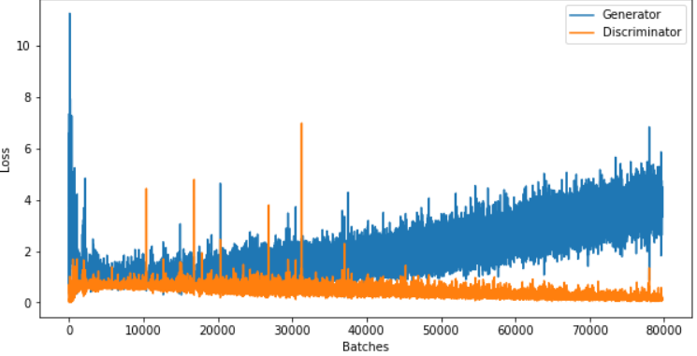

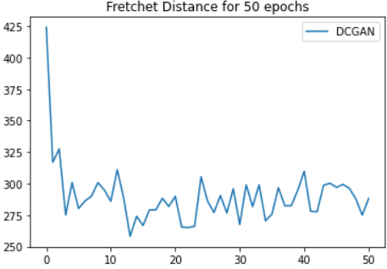

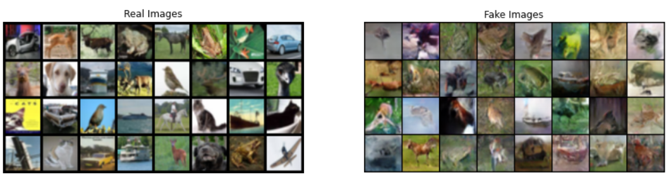

* 1. WGAN;

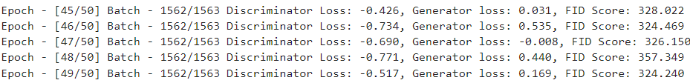

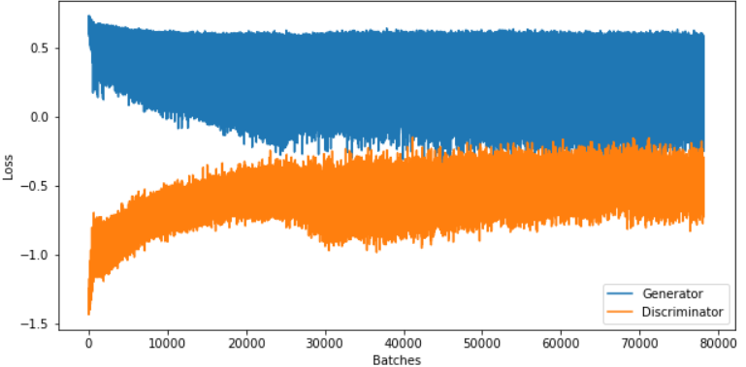

* Error during training for WGAN

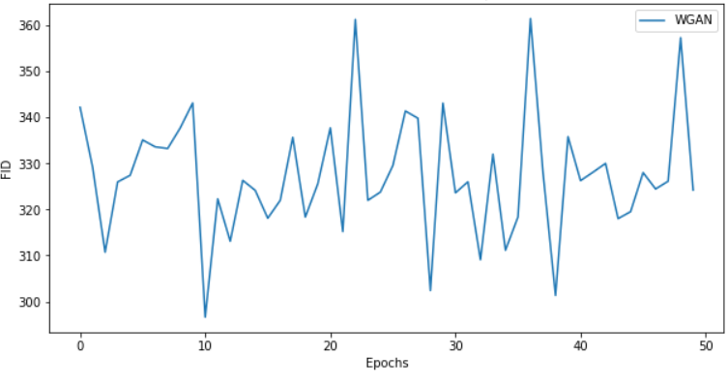

* Fretchet distance for WGAN

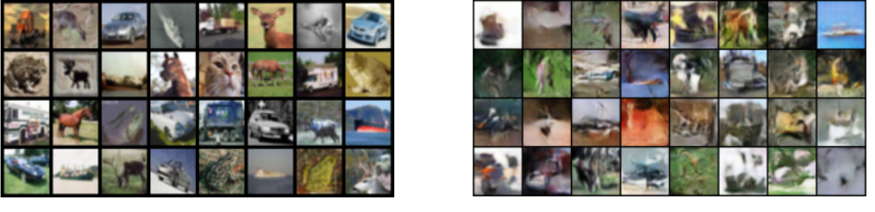

* Real v/s model generated
  1. ACGAN:

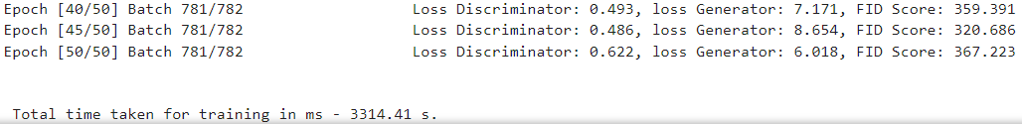

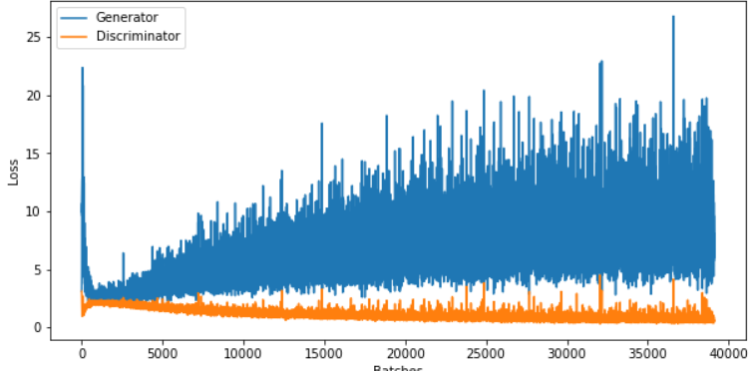

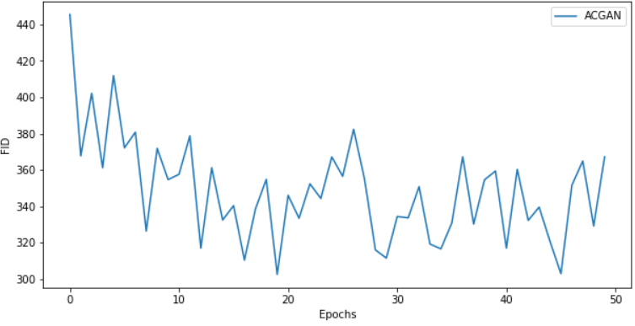

Fretchet distance for ACGAN

