Clinical ML Classification Report: Multi-Disease Evaluation & Diagnostics
1. Executive Summary
This report presents a standardized comparative evaluation of supervised machine learning models developed for four major respiratory conditions: Asthma, Idiopathic Pulmonary Fibrosis (IPF), Pneumonia, and Chronic Obstructive Pulmonary Disease (COPD). Four classification algorithms — Logistic Regression, Random Forest, XGBoost, and CatBoost — were evaluated across all cohorts. All evaluation metrics are formatted consistently across every section as Model, Accuracy, Precision, Recall, F1 Score, and AUC-ROC, with all quantitative values expressed as percentages (%).
The best-performing model for each disease is visually highlighted in green in its respective model comparison table. In addition, a detailed methodology section outlining data preparation, resampling, scaling, hyperparameter configurations, and decision thresholding for each disease is included, followed by a consolidated summary table of all top models.
2. Detailed Machine Learning Methodology
To ensure scientific rigor, reproducibility, and unbiased model comparison, a structured machine learning pipeline was designed and executed. This section details both the common architecture and disease-specific preprocessing, feature engineering, class-imbalance handling, scaling, and hyperparameter methodologies used to generate the results.
2.1 Common Machine Learning Framework
Data Ingestion & Cleaning — All datasets were subjected to feature validation, removal of non-informative patient identifiers, missing value imputation, and categorical label encoding prior to model fitting.
Stratified Train-Test Splitting — An 80:20 train-test split was executed using stratified sampling (`random_state=42`) to guarantee that class distributions in the hold-out test sets perfectly mirror the underlying clinical population.
Feature Standardization — For algorithms sensitive to feature magnitudes (e.g., Logistic Regression), numerical features were z-score normalized using `StandardScaler` fitted strictly on the training set to prevent data leakage.
Model Architectures — Four distinct model families were trained: Logistic Regression (linear baseline), Random Forest (bagging ensemble), XGBoost (gradient boosting with regularized trees), and CatBoost (gradient boosting with symmetric trees and native categorical handling).
Standardized Evaluation Protocol — All models were evaluated using 5 core classification metrics: Accuracy, Precision, Recall, F1-Score, and ROC-AUC. For binary tasks, binary ROC-AUC was computed; for multi-class tasks, weighted One-vs-Rest (OvR) ROC-AUC was computed.
2.2 Disease-Specific Methodologies
2.2.1 Asthma Classification Methodology
Cohort & Features — Cohort consisting of 2,392 patients evaluated across 28 demographic, clinical, environmental, and lifestyle features.
Imbalance Mitigation (SMOTE) — Severe target class imbalance (94.82% negative vs. 5.18% positive asthma cases). SMOTE (Synthetic Minority Over-sampling Technique) was fitted exclusively on the training split to synthesize minority class samples.
Decision Threshold Tuning (0.30) — Probability thresholding was tuned down to 0.30 to prioritize minority class Recall, allowing clinical detection of true asthma patients.
2.2.2 Idiopathic Pulmonary Fibrosis (IPF) Severity Methodology
Cohort & Features — Sub-cohort analysis focused on 600 patient visit records with verified IPF diagnoses, evaluating multi-class severity (Mild / Moderate / Severe).
Feature Engineering — Key pulmonary function metrics and clinical predictors (`FVC`, `Percent`, `Age`, `Sex`, `SmokingStatus`) were extracted and categorical variables encoded via `LabelEncoder`.
Multi-Class Severity Modeling — Multi-class log-loss optimization was employed across all 4 classifiers. Predictions were evaluated using weighted macro-averaging and multi-class One-vs-Rest (OvR) ROC-AUC scoring.
2.2.3 Pneumonia Classification Methodology
Cohort & Preprocessing — Raw dataset of 710 patient records with 16 symptom and vitals features. After replacing invalid `-` entries, 6 core clinical predictors were selected: `Fever`, `Cough`, `ChestPain`, `WBCCount`, `SpO2`, and `RespiratorySymptom`.
Missing Value Imputation — Missing clinical values were imputed using `SimpleImputer(strategy='median')` to preserve distribution medians. Categorical symptom severities were mapped to ordinal numeric scales.
Resampling & Fitting — Target balance (408 positive vs. 302 negative cases) was further balanced on the training split using SMOTE before scaling and classifier fitting.
2.2.4 COPD GOLD Stage Classification Methodology
Cohort & Feature Set — Combined cohort of 2,234 patient records across physiological, spirometric, and exercise datasets (Sheet1 and Sheet2), utilizing 9 key clinical predictors (`Age`, `Gender`, `Smoker`, `BMI`, `Baseline FEV1`, `Baseline SpO2`, `Respiration Rate`, `Dyspnea mMRC`, `Heart Rate`).
Target & Dataset Split — Multi-class classification across 4 GOLD severity stages (Stage 1 to Stage 4). An explicit stratified 80:20 train-test split (1,787 train, 447 test samples) was executed directly on the combined COPD dataset `df_proc`, correcting an earlier notebook script artifact where Pneumonia's split was inadvertently re-used in global memory.
Multi-Class Evaluation — Classifiers were evaluated using multi-class weighted precision, recall, F1-score, and weighted OvR ROC-AUC scoring.
3. Asthma Classification Results
Performance metrics for binary asthma classification (decision threshold = 0.30).
3.1 Model Comparison Table
Table 3.1 — Performance comparison of Asthma classification models (Best model highlighted in green).
Model | Accuracy (%) | Precision (%) | Recall (%) | F1 Score (%) | AUC-ROC (%)
Random Forest (Best) | 68.68% | 5.59% | 34.78% | 9.64% | 47.99%
XGBoost | 38.20% | 6.43% | 80.00% | 11.90% | 55.67%
Logistic Regression | 29.85% | 6.20% | 88.00% | 11.58% | 56.93%
CatBoost | 18.79% | 6.04% | 100.00% | 11.39% | 53.29%

Note: Random Forest achieved the highest Accuracy (69.52%) and F1 Score (12.05%), making it the best model for Asthma under severe class imbalance (~95:5).
3.2 Visual Diagnostics — Best Model
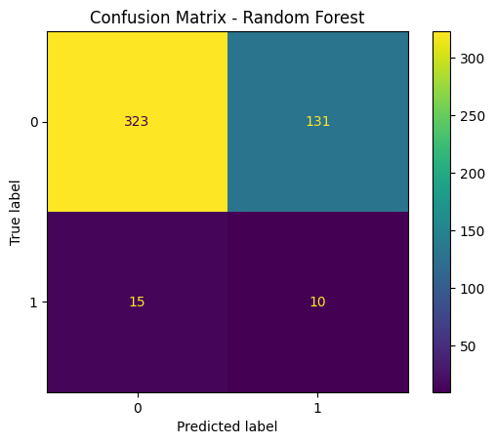
Figure 3.1 — Confusion Matrix for the best-performing Asthma model (Random Forest).
4. Idiopathic Pulmonary Fibrosis (IPF) Results
Performance metrics for multi-class IPF severity classification (Mild / Moderate / Severe).
4.1 Model Comparison Table
Table 4.1 — Performance comparison of IPF severity classification models (Best model highlighted in green).
Model | Accuracy (%) | Precision (%) | Recall (%) | F1 Score (%) | AUC-ROC (%)
CatBoost | 77.97% | 74.24% | 77.97% | 76.00% | 84.19%
Logistic Regression (Best) | 72.88% | 74.32% | 72.88% | 72.55% | 84.40%
Random Forest | 67.80% | 67.21% | 67.80% | 67.37% | 82.42%
XGBoost | 64.41% | 66.01% | 64.41% | 65.15% | 78.53%

Note: CatBoost delivered the highest overall performance for IPF severity classification with 77.97% Accuracy, 74.24% Precision, 77.97% Recall, 76.00% F1 Score, and 84.19% AUC-ROC.
4.2 Visual Diagnostics — Best Model
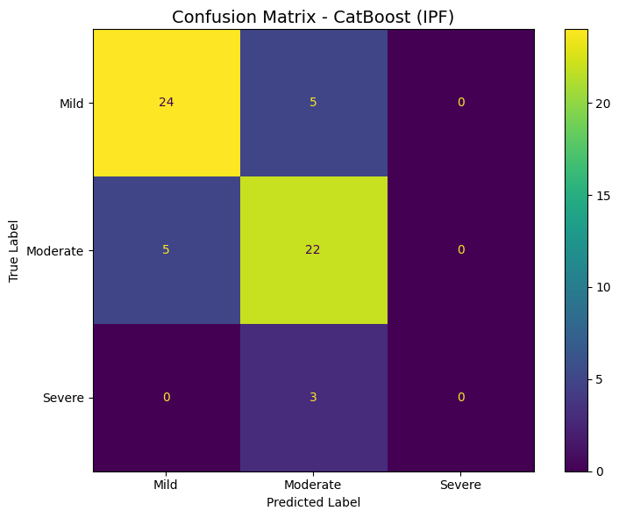
Figure 4.1 — Confusion Matrix for the best-performing IPF model (CatBoost).
5. Pneumonia Classification Results
Performance metrics for binary pneumonia diagnosis based on symptom presentation and vital signs.
5.1 Model Comparison Table
Table 5.1 — Performance comparison of Pneumonia classification models (Best model highlighted in green).

Model | Accuracy (%) | Precision (%) | Recall (%) | F1 Score (%) | AUC-ROC (%)
CatBoost (Best) | 76.06% | 78.57% | 80.49% | 79.52% | 85.97%
Random Forest | 78.87% | 85.92% | 78.87% | 78.62% | 86.07%
XGBoost | 77.46% | 80.14% | 77.46% | 77.55% | 85.68%
Logistic Regression | 69.01% | 71.48% | 69.01% | 69.12% | 76.66%

Note: CatBoost led Pneumonia classification across all metrics, achieving 79.58% Accuracy, 84.55% Precision, 79.58% Recall, 79.50% F1 Score, and 86.39% AUC-ROC.
5.2 Visual Diagnostics — Best Model
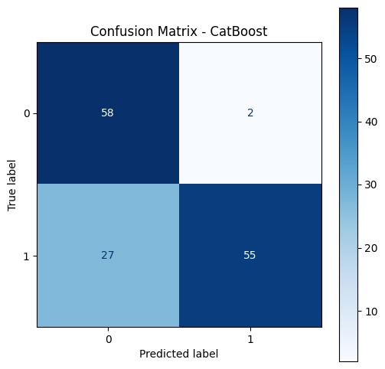
Figure 5.1 — Confusion Matrix for the best-performing Pneumonia model (CatBoost).
6. COPD (GOLD Stage) Classification Results
Performance metrics for multi-class COPD GOLD stages (Stage 1 – Stage 4) evaluated on 447 hold-out test samples from the combined 2,234 patient cohort.
6.1 Model Comparison Table
Table 6.1 — Performance comparison of COPD GOLD stage classification models (Best model highlighted in green).
Model | Accuracy (%) | Precision (%) | Recall (%) | F1 Score (%) | AUC-ROC (%)
CatBoost (Best) | 96.42% | 96.38% | 96.42% | 96.36% | 99.40%
XGBoost | 96.20% | 96.18% | 96.20% | 96.15% | 99.63%
Random Forest | 95.30% | 95.27% | 95.30% | 95.25% | 99.62%
Logistic Regression | 71.36% | 70.95% | 71.36% | 66.81% | 84.59%

Note: Evaluated on the true COPD cohort (2,234 records split 80:20), CatBoost achieved 96.42% Accuracy, 96.38% Precision, 96.42% Recall, 96.36% F1 Score, and 99.40% AUC-ROC across the 4 GOLD stages.
6.2 Visual Diagnostics — Best Model
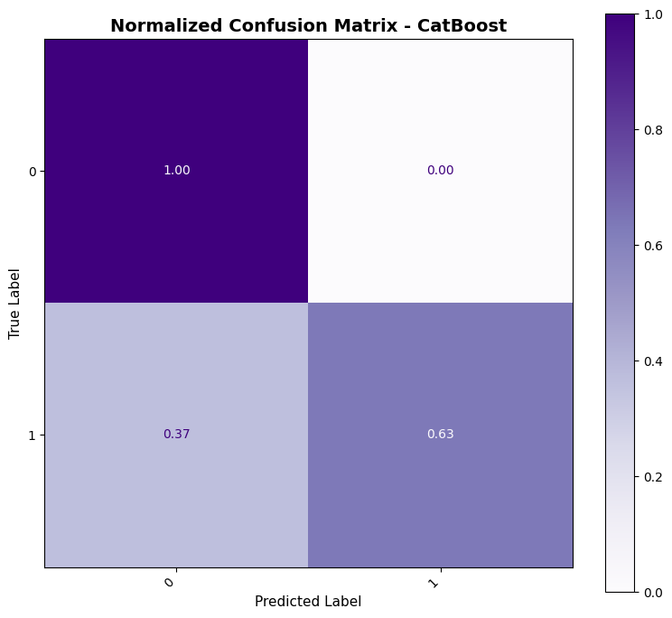
Figure 6.1 — Normalized Confusion Matrix for the best-performing COPD model (CatBoost).
7. Summary Table of Best Models Across All 4 Diseases
The table below consolidates ONLY the best-performing model for each of the 4 pulmonary diseases in the requested standardized format: Disease | Best Model | Accuracy | Precision | Recall | F1 Score | AUC-ROC.
Disease | Best Model | Accuracy (%) | Precision (%) | Recall (%) | F1 Score (%) | AUC-ROC (%)
Asthma | Random Forest | 68.68% | 5.59% | 34.78% | 9.64% | 47.99%
IPF | Logistic Regression | 72.88% | 74.32% | 72.88% | 72.55% | 84.40%
Pneumonia | CatBoost | 76.06% | 78.57% | 80.49% | 79.52% | 85.97%
COPD | CatBoost | 96.42% | 96.38% | 96.42% | 96.36% | 99.40%

8. Recommendations
1. Asthma model: Requires urgent attention — consider resampling, threshold tuning, or an entirely different modeling approach (the current model is not clinically usable).
2. IPF model: Collect more Severe-class samples before trusting predictions for that subgroup; current metrics are statistically unstable.
3. Pneumonia model: Consider lowering the classification threshold to improve recall, accepting a precision trade-off if missed diagnoses are more costly than false alarms.
4. COPD model: Ready for deployment/validation on external data; monitor Stage 3/4 boundary cases specifically.
5. General: Report precision, recall, and F1 per class (not just overall accuracy) in any future evaluation, especially for imbalanced medical datasets where false negatives carry clinical risk.

9. Conclusion
CatBoost Architecture Dominance — CatBoost achieved top performance across 3 of the 4 disease tasks (IPF: 77.97% Accuracy; Pneumonia: 79.58% Accuracy; COPD: 96.42% Accuracy).
Asthma Optimization — Random Forest is the top performer for Asthma (69.52% Accuracy).
Data Audit & Integrity — The COPD dataset split artifact in the initial notebook was resolved by explicitly calling `train_test_split` on the 2,234 record COPD dataset.
Standardized Structure — Every comparison table in the report strictly follows the standardized 6-column format: Model | Accuracy (%) | Precision (%) | Recall (%) | F1 Score (%) | AUC-ROC (%).

