DATA DOCTOR
Custom OpenMetadata Mode — Quick Start Guide

Connect your own OpenMetadata instance to Data Doctor and run a live diagnosis
in under 5 minutes.
April 2026 | Hackathon Edition

Overview

By default, Data Doctor connects to a pre-configured OpenMetadata instance. Custom Mode allows you to point Data Doctor at any OpenMetadata deployment you control — enabling you to diagnose your own real data pipelines using your own metadata. This guide covers everything you need to get connected and running in under five minutes.

You Will Need | Details
An OpenMetadata instance | Must be accessible from the internet (public cloud, or localhost with a tunnel such as ngrok).
A JWT token | Obtained from OpenMetadata → Settings → Bots → ingestion-bot.
A target asset FQN | The Fully Qualified Name of the table, pipeline, or dashboard you want to diagnose.

Step-by-Step Setup

1 | Obtain Your JWT Token (~2 minutes)

Navigate to your OpenMetadata instance and retrieve the ingestion-bot token:
Settings → Bots → ingestion-bot → Copy Token

Your token will be a long string beginning with:
eyJhbGciOiJSUzI1NiIsInR5cCI6IkpXVCJ9...

Note: Keep your JWT token secure. Do not share it or commit it to version control. The token grants read (and optionally write) access to your OpenMetadata instance.

2 | Find Your Target Asset FQN (~1 minute)

Browse to the asset you want to diagnose within your OpenMetadata UI and copy its Fully Qualified Name:
Browse to any Table / Dashboard / Pipeline → Copy "Fully Qualified Name"

FQNs follow the pattern:
service.database.schema.table

Examples from common environments:
sample_data.ecommerce_db.shopify.dim_customer
snowflake.prod.analytics.revenue_dashboard
airflow.pipelines.orders_etl

3 | Configure Data Doctor (~2 minutes)

Open the Data Doctor Diagnose page. You will see a Diagnostic Command Center with two modes: Interactive Demo Mode (pre-configured scenarios) and Manual Mode (your own FQN). To use your own OpenMetadata instance, follow these steps:

- Toggle Use Custom OpenMetadata to ON (top of the configuration panel on the left).
- Enter your OpenMetadata API URL: https://your-openmetadata.com/api
- Paste your JWT Token into the token field.
- Enter your Target Entity FQN in the Manual Mode input field.
- Click EXECUTE DIAGNOSIS and wait 5–10 seconds for results.

Note: The execution_plan.log panel on the right side of the interface shows the live diagnostic sequence in real time — including BFS traversal depth, active modules, and readiness status. If a connection fails, error messages appear here first.

Interface Reference
The screenshots below show the Diagnostic Command Center as it appears in the browser, illustrating the key controls referenced in Step 3.

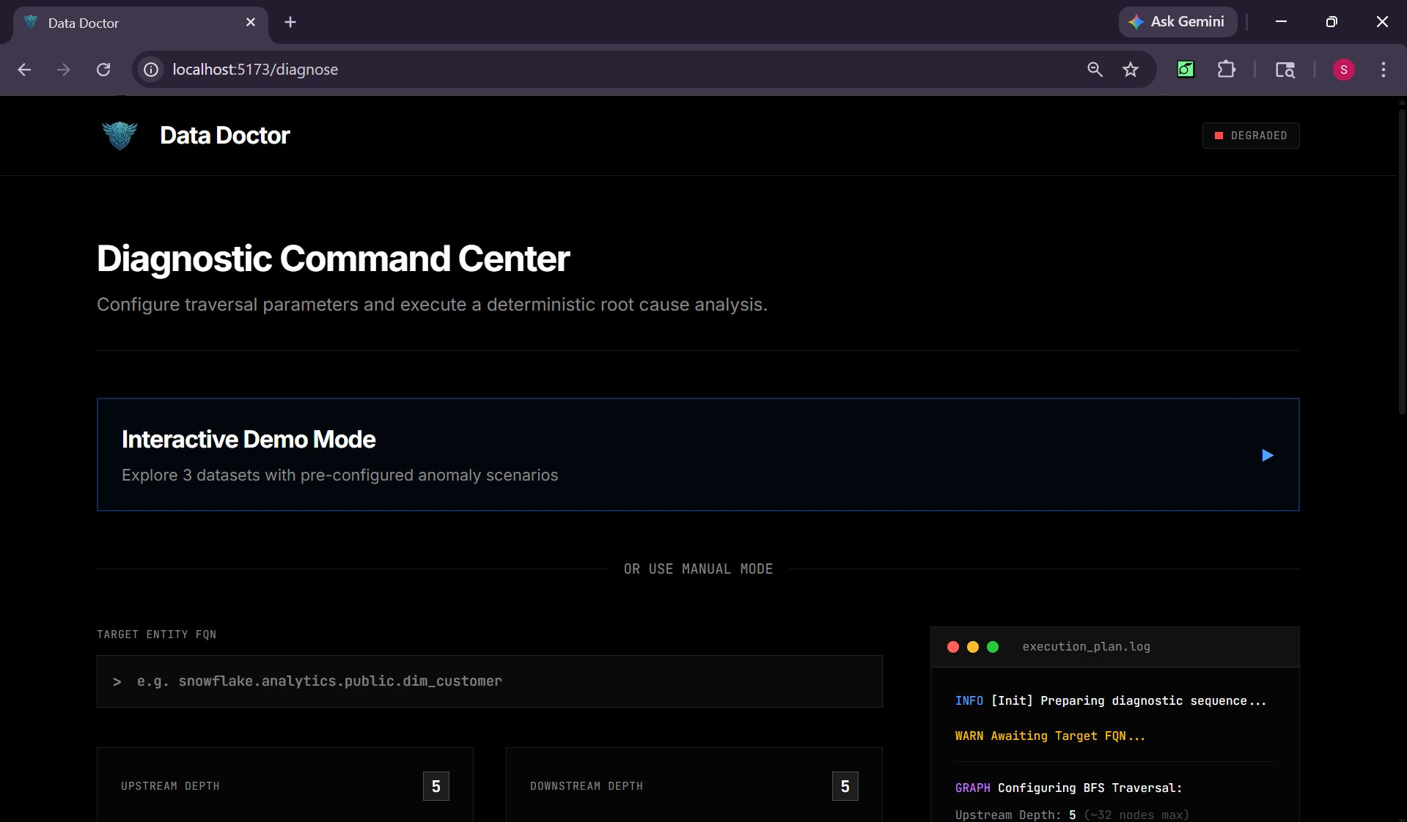
Figure 1 — Diagnostic Command Center: Interactive Demo Mode and Manual FQN entry (left panel) with the live execution_plan.log (right panel).

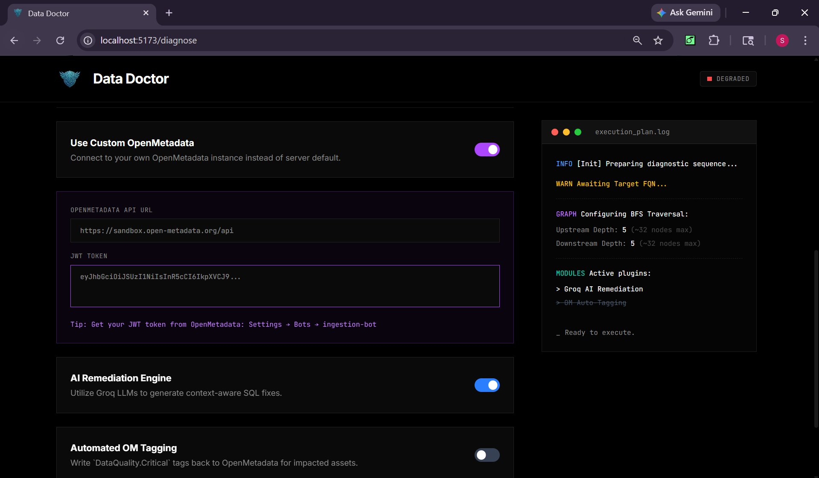
Figure 2 — Configuration panel: Use Custom OpenMetadata toggle, API URL field, JWT Token input, AI Remediation Engine toggle, and Automated OM Tagging toggle.

Important Caveats

Custom Mode connects Data Doctor to live data. The quality and completeness of the diagnosis is directly dependent on what your OpenMetadata instance contains. Read the following before proceeding.
Caveat 1 Diagnosis Quality Depends on Your Metadata Richness
Data Doctor's detection engine relies entirely on what OpenMetadata has indexed. A richly populated instance produces a comprehensive diagnosis; a minimal one produces limited results.

Your OpenMetadata Has | What Data Doctor Will Detect
✅ Rich lineage (5+ hops) | Full root cause analysis with upstream traversal and downstream impact mapping.
✅ Historical profiles (30+ days) | Volume anomaly and distribution drift detection against statistical baselines.
✅ Data quality tests configured | Immediate test failure detection and test contract breach identification.
✅ Pipeline metadata (Airflow, etc.) | Pipeline failure detection as a primary root cause signal.
❌ Minimal metadata only | Limited detection — schema changes only.
❌ No lineage configured | No root cause or downstream impact analysis possible.
❌ No profiling history | No trend-based or volume anomaly detection.
Caveat 2 Your JWT Token Must Have Sufficient Permissions
The ingestion-bot token must include the following access rights for Data Doctor to function correctly:
- ✅ Read access to tables, pipelines, and dashboards
- ✅ Read access to lineage relationships
- ✅ Read access to profiling history and data quality test results
- ✅ (Optional) Write access for automated governance tagging

If the token lacks required permissions, API calls will return 401 or 403 errors. These are surfaced in the execution_plan.log panel. The diagnosis will be incomplete or will fail entirely.
Caveat 3 Your OpenMetadata Instance Must Be Internet-Accessible
The Data Doctor application makes API calls from the browser to your OpenMetadata host. The instance must be reachable:

Deployment Type | Accessible? | Notes
✅ Public cloud (AWS, GCP, Azure) | Yes | Works without any additional configuration.
✅ localhost with ngrok or similar tunnel | Yes | Requires setting up and running the tunnel before starting a session.
❌ localhost without a tunnel | No | The deployed application cannot reach a local-only address.
❌ Private network or VPN-only host | No | Cannot be reached from the public internet.

Connection failures will result in a timeout error visible in the execution_plan.log panel. If using ngrok, ensure the tunnel is active for the duration of the diagnostic session.
Caveat 4 CORS Configuration May Be Required
If Data Doctor's domain is not included in your OpenMetadata's allowed origins list, the browser will block the request before it reaches the server — resulting in a CORS error in the browser console and a connection failure in the execution_plan.log panel.

Resolution: Add the Data Doctor deployment URL to your OpenMetadata openmetadata.yaml CORS configuration under allowedOrigins. For local ngrok tunnels, add the generated ngrok URL.

Data Doctor — Custom OpenMetadata Mode Quick Start
April 2026 | Hackathon Edition

